Table of Contents

UNITED STATES

SECURITIES AND EXCHANGE COMMISSION

WASHINGTON, D.C. 20549

___________________________________________________________________________________________________

FORM 10-Q

___________________________________________________________________________________________________

(Mark One)

- QUARTERLY REPORT PURSUANT TO SECTION 13 OR 15(d) OF THE SECURITIES EXCHANGE ACT OF 1934

For the quarterly period ended October 31, 2024

OR

- TRANSITION REPORT PURSUANT TO SECTION 13 OR 15(d) OF THE SECURITIES EXCHANGE ACT OF 1934

 |  |  |  | For the transition period from to
 |  |  |  | Commission File Number: 001-38933
 |  |  | ___________________________________________________________________________________________________
 |  |  |  | CROWDSTRIKE HOLDINGS, INC.
 |  |  |  | (Exact Name of Registrant as Specified in Its Charter)
 |  |  | ___________________________________________________________________________________________________
 | Delaware |  |  |  |  |  |  | 45-3788918
(State or other jurisdiction of |  |  |  |  |  |  |  |  | (I.R.S. Employer
incorporation or organization) |  |  |  |  |  |  |  |  | Identification Number)
 |  |  |  | 206 E. 9th Street, Suite 1400, Austin, Texas 78701
 |  |  |  | (Address of principal executive offices)
 |  |  | __________________________________________________________________________________________________
 |  |  | Registrant’s telephone number, including area code: (888) 512-8906
 |  |  |  | Securities registered pursuant to Section 12(b) of the Act:
 | Title of each class |  |  |  | Trading symbol(s) |  |  | Name of each exchange on which registered
Class A common stock, par value $0.0005 per share |  |  |  |  | CRWD |  |  |  | The Nasdaq Stock Market LLC
 |  |  |  |  |  |  |  |  | (Nasdaq Global Select Market)

Indicate by check mark whether the registrant (1) has filed all reports required to be filed by Section 13 or 15(d) of the Securities Exchange Act of 1934 during the preceding 12 months (or for such shorter period that the registrant was required to file such reports), and (2) has been subject to such filing requirements for the past 90 days. Yes ☑ No ☐

Indicate by check mark whether the registrant has submitted electronically every interactive Data File required to be submitted pursuant to Rule 405 of Regulation S-T (§232.405 of this chapter) during the preceding 12 months (or for such shorter period that the registrant was required to submit and post such files) Yes ☑ No ☐

Indicate by check mark whether the registrant is a large accelerated filer, an accelerated filer, a non-accelerated filer, a smaller reporting company, or an emerging growth company. See the definitions of “large accelerated filer,” “accelerated filer,” “smaller reporting company” and “emerging growth company” in Rule 12b-2 of the Exchange Act.

Large Accelerated Filer | ☑ | Accelerated Filer | ☐
Non-accelerated Filer | ☐ | Smaller reporting company | ☐
 |  | Emerging growth company | ☐

If an emerging growth company, indicate by check mark if the registrant has elected not to use the extended transition period for complying with any new or revised financial accounting standards provided pursuant to Section 13(a) of the Exchange Act. ☐
Indicate by check mark whether the registrant is a shell company (as defined in Rule 12b-2 of the Exchange Act). Yes ☐ No ☑

As of November 15, 2024, the number of shares of the registrant’s Class A common stock outstanding was 233,851,230, and the number of shares of the registrant’s Class B common stock outstanding was 12,460,182.

Table of Contents

CROWDSTRIKE HOLDINGS, INC.

TABLE OF CONTENTS

 |  |  |  |  |  |  |  |  |  |  |  |  |  |  |  |  |  |  |  |  |  |  |  |  | Page No.
 |  |  |  |  |  |  |  |  |  |  |  |  |  | PART I. FINANCIAL INFORMATION
 | Item 1. |  | Financial Statements (unaudited)
 |  |  | Condensed Consolidated Balance Sheets as of October 31, 2024 and January 31, 2024 |  |  |  |  |  |  |  |  |  |  |  |  |  |  |  |  |  |  |  |  |  | 6
 |  |  | Condensed Consolidated Statements of Operations for the Three and Nine Months Ended October 31, 2024 and October 31, 2023 |  |  |  |  |  |  |  |  |  |  |  |  |  |  |  |  |  |  |  |  |  | 7
 |  |  | Condensed Consolidated Statements of Comprehensive Income for the Three and Nine Months Ended October 31, 2024 and October 31, 2023 |  |  |  |  |  |  |  |  |  |  |  |  |  |  |  |  |  |  |  |  |  | 8
 |  |  | Condensed Consolidated Statements of Stockholders’ Equity for the Three and Nine Months Ended October 31, 2024 and October 31, 2023 |  |  |  |  |  |  |  |  |  |  |  |  |  |  |  |  |  |  |  |  |  | 9
 |  |  | Condensed Consolidated Statements of Cash Flows for the Nine Months Ended October 31, 2024 and October 31, 2023 |  |  |  |  |  |  |  |  |  |  |  |  |  |  |  |  |  |  |  |  |  | 11
 |  |  | Notes to Unaudited Condensed Consolidated Financial Statements |  |  |  |  |  |  |  |  |  |  |  |  |  |  |  |  |  |  |  |  |  | 12
 | Item 2. |  | Management’s Discussion and Analysis of Financial Condition and Results of Operations |  |  |  |  |  |  |  |  |  |  |  |  |  |  |  |  |  |  |  |  |  | 31
 | Item 3. |  | Quantitative and Qualitative Disclosures about Market Risk |  |  |  |  |  |  |  |  |  |  |  |  |  |  |  |  |  |  |  |  |  | 47
 | Item 4. |  | Controls and Procedures |  |  |  |  |  |  |  |  |  |  |  |  |  |  |  |  |  |  |  |  |  | 47
 |  |  |  |  |  |  |  |  |  |  |  |  |  |  | PART II. OTHER INFORMATION
 | Item 1. |  | Legal Proceedings |  |  |  |  |  |  |  |  |  |  |  |  |  |  |  |  |  |  |  |  |  | 48
 | Item 1A. |  | Risk Factors |  |  |  |  |  |  |  |  |  |  |  |  |  |  |  |  |  |  |  |  |  | 48
 | Item 2. |  | Unregistered Shares of Equity Securities and Use of Proceeds |  |  |  |  |  |  |  |  |  |  |  |  |  |  |  |  |  |  |  |  |  | 83
 | Item 3. |  | Defaults Upon Senior Securities |  |  |  |  |  |  |  |  |  |  |  |  |  |  |  |  |  |  |  |  |  | 83
 | Item 4. |  | Mine Safety Disclosures |  |  |  |  |  |  |  |  |  |  |  |  |  |  |  |  |  |  |  |  |  | 83
 | Item 5. |  | Other Information |  |  |  |  |  |  |  |  |  |  |  |  |  |  |  |  |  |  |  |  |  | 83
 | Item 6. |  | Exhibits |  |  |  |  |  |  |  |  |  |  |  |  |  |  |  |  |  |  |  |  |  | 83
 |  |  | Signatures |  |  |  |  |  |  |  |  |  |  |  |  |  |  |  |  |  |  |  |  |  | 85
 |  |  |  |  |  | 2

Table of Contents

SPECIAL NOTE REGARDING FORWARD-LOOKING STATEMENTS

This Quarterly Report on Form 10-Q contains forward-looking statements within the meaning of the Securities Act of 1933, as amended (the “Securities Act”), the Securities Exchange Act of 1934, as amended (the “Exchange Act”), and the Private Securities Litigation Reform Act of 1995. All statements contained in this Quarterly Report on Form 10-Q other than statements of historical fact, including statements regarding our future operating results and financial position, our business strategy and plans and our objectives for future operations, are forward-looking statements. The words “believe,” “may,” “will,” “potentially,” “estimate,” “continue,” “anticipate,” “intend,” “could,” “would,” “project,” “plan,” “expect” and similar expressions that convey uncertainty of future events or outcomes are intended to identify forward-looking statements.

These forward-looking statements include, but are not limited to, statements concerning the following:

- our future financial performance, including our expectations regarding our revenue, cost of revenue, gross profit or gross margin, operating expenses (including changes in sales and marketing, research and development, and general and administrative expenses), and our ability to achieve, and maintain, future profitability;

- market acceptance of our cloud platform;

- the effects of increased competition in our markets and our ability to compete effectively;

- our ability to maintain the security and availability of our cloud platform;

- our ability to maintain and expand our customer base, including by attracting new customers;

- our ability to develop new solutions, or enhancements to our existing solutions, and bring them to market in a timely manner;

- anticipated trends, growth rates and challenges in our business and in the markets in which we operate;

- our business plan and our ability to effectively manage our growth and associated investments;

- beliefs and objectives for future operations;

- our relationships with third parties, including channel partners and technology alliance partners;

- our ability to maintain, protect and enhance our intellectual property rights;

- our ability to successfully defend litigation brought against us and respond to government investigations and inquiries;

- our ability to successfully expand in our existing markets and into new markets;

- sufficiency of cash and cash equivalents to meet cash needs for at least the next 12 months;

- anticipated developments relating to our valuation allowances for our deferred tax assets;

- our ability to expand internationally;

- our ability to comply with laws and regulations that currently apply or become applicable to our business both in the United States and internationally;

- our ability to develop, maintain, and improve our internal control over financial reporting;

- macroeconomic factors, including inflation and instability in the global credit and financial markets;

- our ability to successfully close and integrate acquisitions to contribute to our growth objectives;

- the attraction and retention of qualified employees and key personnel; and

3

Table of Contents

- the July 19 Incident (as defined below), including potential or anticipated developments, our remediation and other efforts in connection with the incident, the outcome of lawsuits, claims and inquiries related to the incident, and the effect on our customer and partner relationships and our business, results of operations and financial condition.

These statements are based on our current plans, estimates and projections in light of information currently available to us. These forward-looking statements may be affected by risks, uncertainties and other factors discussed elsewhere in this Quarterly Report on Form 10-Q, including under “Risk Factors.” Furthermore, new risks and uncertainties emerge from time to time, and it is impossible for us to predict all risks and uncertainties or how they may affect us. If any of these risks or uncertainties materialize, our business, revenue and financial results could be harmed, and the trading price of our Class A common stock could decline. Forward-looking statements made in this Quarterly Report on Form 10-Q speak only as of the date on which such statements are made, and we undertake no obligation to update them in light of new information or future events, except as required by law.

We intend to announce material information to the public through the CrowdStrike Investor Relations website ir.crowdstrike.com, SEC filings, press releases, public conference calls, and public webcasts. We use these channels, as well as social media and our blog, to communicate with our investors, customers, and the public about our company, our offerings, and other issues. It is possible that the information we post on social media and our blog could be deemed to be material information. As such, we encourage investors, the media, and others to follow the channels listed above, including the social media channels listed on our investor relations website, and to review the information disclosed through such channels. Any updates to the list of disclosure channels through which we will announce information will be posted on the investor relations page on our website.

Summary of Risk Factors

Our business is subject to numerous risks and uncertainties, any one of which could materially adversely affect our business, results of operations, financial condition, and growth prospects. Below is a summary of some of these risks. This summary is not complete, and should be read together with the entire section titled “Risk Factors” in this Quarterly Report on Form 10-Q, as well as the other information in this Quarterly Report on Form 10-Q and the other filings that we make with the SEC.

- The July 19 Incident has had, and is expected to continue to have, an adverse effect on our business, sales, customer and partner relations, reputation, results of operations and financial condition.

- We have experienced rapid growth in recent periods, and if we do not manage our future growth, our business and results of operations will be adversely affected.

- We have a history of losses, and while we have achieved profitability in certain periods, including fiscal 2024, we may not be able to achieve or sustain profitability in the future.

- If organizations do not adopt cloud-based SaaS-delivered endpoint security solutions, our ability to grow our business and results of operations may be adversely affected.

- If we are unable to successfully enhance our existing products and services and introduce new products and services in response to rapid technological changes and market developments as well as evolving security threats, our competitive position and prospects will be harmed.

- If we are unable to attract new customers, our future results of operations could be harmed.

- If our customers do not renew their subscriptions for our products and add additional cloud modules to their subscriptions, our future results of operations could be harmed.

- Our sales cycles can be long and unpredictable, and our sales efforts require considerable time and expense.

- We face intense competition and could lose market share to our competitors, which could adversely affect our business, financial condition, and results of operations.

- If our solutions fail or are perceived to fail to detect or prevent incidents or have or are perceived to have defects, errors, or vulnerabilities, our brand and reputation would be harmed, which would adversely affect our business and results of operations.

4

Table of Contents

- As a cybersecurity provider, we have been, and expect to continue to be, a target of cyberattacks. If our or our service providers’ internal networks, systems, or data are or are perceived to have been compromised, our reputation may be damaged and our financial results may be negatively affected.

- We rely on third-party data centers, such as Amazon Web Services, and our own colocation data centers to host and operate our Falcon platform, and any disruption of or interference with our use of these facilities may negatively affect our ability to maintain the performance and reliability of our Falcon platform, which could cause our business to suffer.

- We rely on our key technical, sales and management personnel to grow our business, and the loss of one or more key employees could harm our business.

- If we are unable to attract and retain qualified personnel, our business could be harmed.

- Our results of operations may fluctuate significantly, which could make our future results difficult to predict and could cause our results of operations to fall below expectations.

- If we are not able to maintain and enhance our CrowdStrike and Falcon brand and our reputation as a provider of high-efficacy security solutions, our business and results of operations may be adversely affected.

- Claims by others that we infringe their proprietary technology or other intellectual property rights could result in significant costs and substantially harm our business, financial condition, results of operations, and prospects.

- We are required to comply with stringent, complex and evolving laws, rules, regulations and standards in many jurisdictions, as well as contractual obligations, relating to data privacy and security. Any actual or perceived failure to comply with these requirements could have a material adverse effect on our business.

- Failure to comply with laws and regulations applicable to our business could subject us to fines and penalties and could also cause us to lose customers or negatively impact our ability to contract with customers, including those in the public sector.

- We are currently, and may in the future become, involved in litigation that may adversely affect us.

- We have in the past experienced, and may in the future experience, warranty claims, product returns, and claims related to product liability and product defects from real or perceived defects in our solutions or their misuse by our customers or third parties and indemnity provisions in various agreements potentially expose us to substantial liability for intellectual property infringement and other losses.

- Future acquisitions, strategic investments, partnerships, or alliances could be difficult to identify and integrate, divert the attention of key management personnel, disrupt our business, dilute stockholder value and adversely affect our business, financial condition and results of operations.

5

Table of Contents

PART I. FINANCIAL INFORMATION

ITEM 1. FINANCIAL STATEMENTS

CrowdStrike Holdings, Inc.

Condensed Consolidated Balance Sheets

(in thousands, except per share data)

(unaudited)

 |  | October 31, |  |  | January 31,
 |  | 2024 |  |  | 2024
Assets
Current assets:
Cash and cash equivalents | $ | 4,260,324 |  | $ | 3,375,069
Short-term investments |  | — |  |  | 99,591
Accounts receivable, net of allowance for credit losses of $1.8 million and $2.2 million as of October 31, 2024 and January 31, 2024, respectively |  | 813,922 |  |  | 853,105
Deferred contract acquisition costs, current |  | 294,229 |  |  | 246,370
Prepaid expenses and other current assets |  | 203,852 |  |  | 183,172
Total current assets |  | 5,572,327 |  |  | 4,757,307
Strategic investments |  | 68,246 |  |  | 56,244
Property and equipment, net |  | 746,567 |  |  | 620,172
Operating lease right-of-use assets |  | 46,289 |  |  | 48,211
Deferred contract acquisition costs, noncurrent |  | 421,773 |  |  | 335,933
Goodwill |  | 722,016 |  |  | 638,041
Intangible assets, net |  | 109,354 |  |  | 114,518
Other long-term assets |  | 96,386 |  |  | 76,094
Total assets | $ | 7,782,958 |  | $ | 6,646,520
Liabilities and Stockholders’ Equity
Current liabilities:
Accounts payable | $ | 79,214 |  | $ | 28,180
Accrued expenses |  | 176,598 |  |  | 125,896
Accrued payroll and benefits |  | 324,889 |  |  | 234,624
Operating lease liabilities, current |  | 15,658 |  |  | 14,150
Deferred revenue |  | 2,363,258 |  |  | 2,270,757
Other current liabilities |  | 40,763 |  |  | 23,672
Total current liabilities |  | 3,000,380 |  |  | 2,697,279
Long-term debt |  | 743,610 |  |  | 742,494
Deferred revenue, noncurrent |  | 833,260 |  |  | 783,342
Operating lease liabilities, noncurrent |  | 32,683 |  |  | 36,230
Other liabilities, noncurrent |  | 77,414 |  |  | 50,086
Total liabilities |  | 4,687,347 |  |  | 4,309,431
Commitments and contingencies (Note 8)
Stockholders’ Equity
Preferred stock, $0.0005 par value; 100,000 shares authorized as of October 31, 2024 and January 31, 2024; no shares issued and outstanding as of October 31, 2024 and |  | — |  |  | —
January 31, 2024. |  |  |  |  | —
Class A common stock, $0.0005 par value; 2,000,000 shares authorized as of October 31, 2024 and January 31, 2024; 233,849 shares and 229,380 shares issued and outstanding as
of October 31, 2024 and January 31, 2024, respectively; Class B common stock, $0.0005 par value; 300,000 shares authorized as of October 31, 2024 and January 31, 2024; |  | 124 |  |  | 121
12,460 shares and 12,485 shares issued and outstanding as of October 31, 2024 and January 31, 2024, respectively. |  | 124 |  |  | 121
Additional paid-in capital |  | 4,045,660 |  |  | 3,364,328
Accumulated deficit |  | (985,825) |  |  | (1,058,836)
Accumulated other comprehensive loss |  | (2,026) |  |  | (1,663)
Total CrowdStrike Holdings, Inc. stockholders’ equity |  | 3,057,933 |  |  | 2,303,950
Non-controlling interest |  | 37,678 |  |  | 33,139
Total stockholders’ equity |  | 3,095,611 |  |  | 2,337,089
Total liabilities and stockholders’ equity | $ | 7,782,958 |  | $ | 6,646,520

The accompanying notes are an integral part of these condensed consolidated financial statements.

6

Table of Contents

CrowdStrike Holdings, Inc.

Condensed Consolidated Statements of Operations

(in thousands, except per share data)

(unaudited)

 | Three Months Ended October 31, |  |  |  |  |  |  | Nine Months Ended October 31,
 | 2024 |  |  | 2023 |  |  |  | 2024 |  |  | 2023
Revenue
Subscription | $ | 962,735 |  | $ | 733,463 |  | $ | 2,753,164 |  | $ | 2,074,610
Professional services |  | 47,443 |  |  | 52,551 |  |  | 141,922 |  |  | 135,610
Total revenue |  | 1,010,178 |  |  | 786,014 |  |  | 2,895,086 |  |  | 2,210,220
Cost of revenue
Subscription |  | 216,301 |  |  | 159,830 |  |  | 605,868 |  |  | 455,236
Professional services |  | 38,786 |  |  | 35,174 |  |  | 111,623 |  |  | 91,915
Total cost of revenue |  | 255,087 |  |  | 195,004 |  |  | 717,491 |  |  | 547,151
Gross profit |  | 755,091 |  |  | 591,010 |  |  | 2,177,595 |  |  | 1,663,069
Operating expenses
Sales and marketing |  | 408,267 |  |  | 286,186 |  |  | 1,113,852 |  |  | 850,209
Research and development |  | 275,602 |  |  | 196,072 |  |  | 761,759 |  |  | 554,499
General and administrative |  | 126,945 |  |  | 105,589 |  |  | 337,113 |  |  | 290,027
Total operating expenses |  | 810,814 |  |  | 587,847 |  |  | 2,212,724 |  |  | 1,694,735
Income (loss) from operations |  | (55,723) |  |  | 3,163 |  |  | (35,129) |  |  | (31,666)
Interest expense |  | (6,587) |  |  | (6,503) |  |  | (19,647) |  |  | (19,334)
Interest income |  | 52,201 |  |  | 40,086 |  |  | 149,577 |  |  | 107,245
Other income (expense), net |  | (429) |  |  | (474) |  |  | 6,196 |  |  | (1,978)
Income (loss) before provision for income taxes |  | (10,538) |  |  | 36,272 |  |  | 100,997 |  |  | 54,267
Provision for income taxes |  | 6,281 |  |  | 9,603 |  |  | 24,862 |  |  | 18,623
Net income (loss) |  | (16,819) |  |  | 26,669 |  |  | 76,135 |  |  | 35,644
Net income attributable to non-controlling interest |  | 3 |  |  | 4 |  |  | 3,124 |  |  | 16
Net income (loss) attributable to CrowdStrike | $ | (16,822) |  | $ | 26,665 |  | $ | 73,011 |  | $ | 35,628
Net income (loss) per share attributable to CrowdStrike common stockholders:
Basic | $ | (0.07) |  | $ | 0.11 |  | $ | 0.30 |  | $ | 0.15
Diluted | $ | (0.07) |  | $ | 0.11 |  | $ | 0.29 |  | $ | 0.15
Weighted-average shares used in computing net income (loss) per share attributable to
CrowdStrike common stockholders:
Basic |  | 245,536 |  |  | 239,297 |  |  | 244,017 |  |  | 237,890
Diluted |  | 245,536 |  |  | 243,799 |  |  | 250,747 |  |  | 242,196

The accompanying notes are an integral part of these condensed consolidated financial statements.

7

Table of Contents

CrowdStrike Holdings, Inc.

Condensed Consolidated Statements of Comprehensive Income (Loss)

(in thousands)

(unaudited)

 | Three Months Ended October 31, |  |  |  |  |  |  | Nine Months Ended October 31,
 | 2024 |  |  | 2023 |  |  |  | 2024 |  |  | 2023
Net income (loss) | $ | (16,819) |  | $ | 26,669 |  | $ | 76,135 |  | $ | 35,644
Other comprehensive income (loss):
Foreign currency translation adjustments |  | 700 |  |  | (6,193) |  |  | (754) |  |  | (4,261)
Unrealized gain on cash equivalents and short-term investments, net of tax |  | 376 |  |  | — |  |  | 391 |  |  | —
Other comprehensive income (loss) |  | 1,076 |  |  | (6,193) |  |  | (363) |  |  | (4,261)
Less: Comprehensive income attributable to non-controlling interest |  | 3 |  |  | 4 |  |  | 3,124 |  |  | 16
Total comprehensive income (loss) attributable to CrowdStrike | $ | (15,746) |  | $ | 20,472 |  | $ | 72,648 |  | $ | 31,367

The accompanying notes are an integral part of these condensed consolidated financial statements.

8

Table of Contents

CrowdStrike Holdings, Inc.

Condensed Consolidated Statements of Stockholders’ Equity

Three Months Ended October 31, 2024 and 2023

(in thousands)

(unaudited)

 | Common Stock |  |  |  |  |  |  |  |  |  |  |  | Accumulated Other
 |  |  |  |  |  |  | Additional Paid-in |  |  |  |  |  | Comprehensive Income |  |  | Non-controlling |  |  | Total Stockholders’
 | Shares |  | Amount |  |  |  | Capital |  |  | Accumulated Deficit |  |  | (Loss) |  |  | Interest |  |  | Equity
Balances at July 31, 2024 | 245,122 |  | $ | 123 |  | $ | 3,824,897 |  | $ | (969,003) |  | $ | (3,102) |  | $ | 37,675 |  | $ | 2,890,590
Issuance of common stock upon exercise of options | 116 |  |  | — |  |  | 844 |  |  | — |  |  | — |  |  | — |  |  | 844
Issuance of common stock under RSU and PSU release | 1,068 |  |  | 1 |  |  | (1) |  |  | — |  |  | — |  |  | — |  |  | —
Issuance of common stock for founders holdbacks related to acquisitions | 3 |  |  | — |  |  | 889 |  |  | — |  |  | — |  |  | — |  |  | 889
Issuance of common stock for payment of board of director fees | — |  |  | — |  |  | 86 |  |  | — |  |  | — |  |  | — |  |  | 86
Stock-based compensation expense, net of founder revest | — |  |  | — |  |  | 206,489 |  |  | — |  |  | — |  |  | — |  |  | 206,489
Capitalized stock-based compensation | — |  |  | — |  |  | 12,456 |  |  | — |  |  | — |  |  | — |  |  | 12,456
Net income (loss) | — |  |  | — |  |  | — |  |  | (16,822) |  |  | — |  |  | 3 |  |  | (16,819)
Other comprehensive income | — |  |  | — |  |  | — |  |  | — |  |  | 1,076 |  |  | — |  |  | 1,076
Balances at October 31, 2024 | 246,309 |  | $ | 124 |  | $ | 4,045,660 |  | $ | (985,825) |  | $ | (2,026) |  | $ | 37,678 |  | $ | 3,095,611
 | Common Stock |  |  |  |  |  |  |  |  |  |  |  | Accumulated Other
 |  |  |  |  |  |  | Additional Paid-in |  |  |  |  |  | Comprehensive Income |  |  | Non-controlling |  |  | Total Stockholders’
 | Shares |  | Amount |  |  |  | Capital |  |  | Accumulated Deficit |  |  | (Loss) |  |  | Interest |  |  | Equity
Balances at July 31, 2023 | 238,775 |  | $ | 119 |  | $ | 2,976,375 |  | $ | (1,139,200) |  | $ | 913 |  | $ | 31,893 |  | $ | 1,870,100
Issuance of common stock upon exercise of options | 261 |  |  | 1 |  |  | 2,050 |  |  | — |  |  | — |  |  | — |  |  | 2,051
Issuance of common stock under RSU and PSU release | 955 |  |  | — |  |  | — |  |  | — |  |  | — |  |  | — |  |  | —
Issuance of common stock for restricted stock awards | 125 |  |  | — |  |  | — |  |  | — |  |  | — |  |  | — |  |  | —
Issuance of common stock for founders holdbacks related to acquisitions | 5 |  |  | — |  |  | 888 |  |  | — |  |  | — |  |  | — |  |  | 888
Issuance of common stock for payment of board of director fees | 1 |  |  | — |  |  | 88 |  |  | — |  |  | — |  |  | — |  |  | 88
Stock-based compensation expense, net of founder revest | — |  |  | — |  |  | 158,649 |  |  | — |  |  | — |  |  | — |  |  | 158,649
Capitalized stock-based compensation | — |  |  | — |  |  | 7,943 |  |  | — |  |  | — |  |  | — |  |  | 7,943
Fair value of replacement equity awards attributable to pre-acquisition service | — |  |  | — |  |  | 652 |  |  | — |  |  | — |  |  | — |  |  | 652
Net income | — |  |  | — |  |  | — |  |  | 26,665 |  |  | — |  |  | 4 |  |  | 26,669
Other comprehensive loss | — |  |  | — |  |  | — |  |  | — |  |  | (6,193) |  |  | — |  |  | (6,193)
Balances at October 31, 2023 | 240,122 |  | $ | 120 |  | $ | 3,146,645 |  | $ | (1,112,535) |  | $ | (5,280) |  | $ | 31,897 |  | $ | 2,060,847

The accompanying notes are an integral part of these condensed consolidated financial statements.

9

Table of Contents

CrowdStrike Holdings, Inc.

Condensed Consolidated Statements of Stockholders’ Equity

Nine Months Ended October 31, 2024 and 2023

(in thousands)

(unaudited)

 | Common Stock |  |  |  |  |  | Additional Paid-in |  |  |  |  |  | Accumulated Other |  |  | Non-controlling |  |  | Total Stockholders’
 | Shares |  | Amount |  |  |  | Capital |  |  | Accumulated Deficit |  |  | Comprehensive Loss |  |  | Interest |  |  | Equity
Balances at January 31, 2024 | 241,865 |  | $ | 121 |  | $ | 3,364,328 |  | $ | (1,058,836) |  | $ | (1,663) |  | $ | 33,139 |  | $ | 2,337,089
Issuance of common stock upon exercise of options | 416 |  |  | — |  |  | 3,308 |  |  | — |  |  | — |  |  | — |  |  | 3,308
Issuance of common stock under RSU and PSU release | 3,502 |  |  | 3 |  |  | (3) |  |  | — |  |  | — |  |  | — |  |  | —
Issuance of common stock under employee stock purchase plan | 518 |  |  | — |  |  | 56,099 |  |  | — |  |  | — |  |  | — |  |  | 56,099
Issuance of common stock for founders holdbacks related to acquisitions | 8 |  |  | — |  |  | 2,667 |  |  | — |  |  | — |  |  | — |  |  | 2,667
Issuance of common stock for payment of board of director fees | — |  |  | — |  |  | 261 |  |  | — |  |  | — |  |  | — |  |  | 261
Stock-based compensation expense, net of founder revest | — |  |  | — |  |  | 586,598 |  |  | — |  |  | — |  |  | — |  |  | 586,598
Capitalized stock-based compensation | — |  |  | — |  |  | 31,934 |  |  | — |  |  | — |  |  | — |  |  | 31,934
Fair value of replacement equity awards attributable to pre-acquisition service | — |  |  | — |  |  | 468 |  |  | — |  |  | — |  |  | — |  |  | 468
Net income | — |  |  | — |  |  | — |  |  | 73,011 |  |  | — |  |  | 3,124 |  |  | 76,135
Non-controlling interest | — |  |  | — |  |  | — |  |  | — |  |  | — |  |  | 1,415 |  |  | 1,415
Other comprehensive loss | — |  |  | — |  |  | — |  |  | — |  |  | (363) |  |  | — |  |  | (363)
Balances at October 31, 2024 | 246,309 |  | $ | 124 |  | $ | 4,045,660 |  | $ | (985,825) |  | $ | (2,026) |  | $ | 37,678 |  | $ | 3,095,611
 | Common Stock |  |  |  |  |  | Additional Paid-in |  |  |  |  |  | Accumulated Other |  |  | Non-controlling |  |  | Total Stockholders’
 | Shares |  | Amount |  |  |  | Capital |  |  | Accumulated Deficit |  |  | Comprehensive Loss |  |  | Interest |  |  | Equity
Balances at January 31, 2023 | 235,777 |  | $ | 118 |  | $ | 2,612,705 |  | $ | (1,148,163) |  | $ | (1,019) |  | $ | 23,793 |  | $ | 1,487,434
Issuance of common stock upon exercise of options | 846 |  |  | 1 |  |  | 6,175 |  |  | — |  |  | — |  |  | — |  |  | 6,176
Issuance of common stock under RSU and PSU release | 2,899 |  |  | — |  |  | — |  |  | — |  |  | — |  |  | — |  |  | —
Issuance of common stock under employee stock purchase plan | 450 |  |  | 1 |  |  | 45,431 |  |  | — |  |  | — |  |  | — |  |  | 45,432
Issuance of common stock for restricted stock awards | 125 |  |  | — |  |  | — |  |  | — |  |  | — |  |  | — |  |  | —
Issuance of common stock for founders holdbacks related to acquisitions | 23 |  |  | — |  |  | 3,426 |  |  | — |  |  | — |  |  | — |  |  | 3,426
Issuance of common stock for payment of board of director fees | 2 |  |  | — |  |  | 255 |  |  | — |  |  | — |  |  | — |  |  | 255
Stock-based compensation expense, net of founder revest | — |  |  | — |  |  | 451,590 |  |  | — |  |  | — |  |  | — |  |  | 451,590
Capitalized stock-based compensation | — |  |  | — |  |  | 26,411 |  |  | — |  |  | — |  |  | — |  |  | 26,411
Fair value of replacement equity awards attributable to pre-acquisition service | — |  |  | — |  |  | 652 |  |  | — |  |  | — |  |  | — |  |  | 652
Net income | — |  |  | — |  |  | — |  |  | 35,628 |  |  | — |  |  | 16 |  |  | 35,644
Non-controlling interest | — |  |  | — |  |  | — |  |  | — |  |  | — |  |  | 8,088 |  |  | 8,088
Other comprehensive loss | — |  |  | — |  |  | — |  |  | — |  |  | (4,261) |  |  | — |  |  | (4,261)
Balances at October 31, 2023 | 240,122 |  | $ | 120 |  | $ | 3,146,645 |  | $ | (1,112,535) |  | $ | (5,280) |  | $ | 31,897 |  | $ | 2,060,847

The accompanying notes are an integral part of these condensed consolidated financial statements.

10

Table of Contents

CrowdStrike Holdings, Inc.
Condensed Consolidated Statements of Cash Flows
(in thousands)(unaudited)

 |  | Nine Months Ended October 31,
 | 2024 |  |  |  | 2023
Operating activities
Net income | $ | 76,135 |  | $ | 35,644
Adjustments to reconcile net income to net cash provided by operating activities:
Depreciation and amortization |  | 137,851 |  |  | 89,972
Amortization of intangible assets |  | 18,665 |  |  | 12,913
Amortization of deferred contract acquisition costs |  | 227,713 |  |  | 173,158
Non-cash operating lease cost |  | 11,100 |  |  | 9,725
Stock-based compensation expense |  | 592,890 |  |  | 455,247
Deferred income taxes |  | (2,122) |  |  | (2,355)
Realized gains on strategic investments |  | (6,227) |  |  | —
Non-cash interest expense |  | 2,748 |  |  | 2,337
Accretion of short-term investments purchased at a discount |  | 2,285 |  |  | (1,934)
Changes in operating assets and liabilities, net of impact of acquisitions
Accounts receivable, net |  | 39,184 |  |  | 65,858
Deferred contract acquisition costs |  | (361,412) |  |  | (206,678)
Prepaid expenses and other assets |  | (42,832) |  |  | (21,972)
Accounts payable |  | 34,096 |  |  | 2,361
Accrued expenses and other liabilities |  | 85,667 |  |  | 33,597
Accrued payroll and benefits |  | 89,896 |  |  | 1,810
Operating lease liabilities |  | (11,812) |  |  | (16,147)
Deferred revenue |  | 142,180 |  |  | 185,655
Net cash provided by operating activities |  | 1,036,005 |  |  | 819,191
Investing activities
Purchases of property and equipment |  | (167,641) |  |  | (123,945)
Capitalized internal-use software and website development costs |  | (41,266) |  |  | (38,605)
Purchases of strategic investments |  | (12,702) |  |  | (12,177)
Proceeds from sales of strategic investments |  | 10,895 |  |  | —
Business acquisitions, net of cash acquired |  | (96,381) |  |  | (238,749)
Purchases of intangible assets |  | — |  |  | (526)
Purchases of short-term investments |  | — |  |  | (195,581)
Proceeds from maturities and sales of short-term investments |  | 97,300 |  |  | 250,000
Purchases of deferred compensation investments |  | (1,815) |  |  | (1,462)
Proceeds from sales of deferred compensation investments |  | 41 |  |  | —
Net cash used in investing activities |  | (211,569) |  |  | (361,045)
Financing activities
Proceeds from the issuance of common stock upon exercise stock options |  | 3,308 |  |  | 6,178
Proceeds from issuance of common stock under the employee stock purchase plan |  | 56,099 |  |  | 45,432
Distributions to non-controlling interest holders |  | (4,085) |  |  | —
Capital contributions from non-controlling interest holders |  | 5,500 |  |  | 8,088
Net cash provided by financing activities |  | 60,822 |  |  | 59,698
Effect of foreign exchange rates on cash, cash equivalents and restricted cash |  | (641) |  |  | (3,411)
Net increase in cash, cash equivalents and restricted cash |  | 884,617 |  |  | 514,433
Cash, cash equivalents and restricted cash at beginning of period |  | 3,377,597 |  |  | 2,456,924
Cash, cash equivalents and restricted cash at end of period | $ | 4,262,214 |  | $ | 2,971,357
Cash, cash equivalents and restricted cash at the end of period:
Cash and cash equivalents | $ | 4,260,324 |  | $ | 2,968,872
Restricted cash included in prepaid expenses and other assets |  | 1,890 |  |  | 2,485
Total cash, cash equivalents and restricted cash shown in the condensed consolidated statements of cash flows | $ | 4,262,214 |  | $ | 2,971,357
Supplemental disclosure of cash flow information:
Interest paid | $ | 22,500 |  | $ | 22,500
Income taxes paid, net of refunds received |  | 14,195 |  |  | 17,911
Supplemental disclosure of non-cash investing and financing activities:
Net increase (decrease) in property and equipment included in accounts payable and accrued expenses |  | 22,811 |  |  | (5,866)
Equity consideration for acquisitions |  | 468 |  |  | 652
Operating lease liabilities arising from obtaining operating right-of-use assets |  | 7,009 |  |  | 21,883
Proceeds from sales of strategic investments not yet received |  | 4,808 |  |  | —
Stock-based compensation included in capitalized software development costs and fixed assets |  | 31,934 |  |  | 23,944
Noncash consideration for the purchase of strategic investments |  | 3,319 |  |  | —
Noncash consideration received from sales of strategic investments |  | 3,319 |  |  | —

The accompanying notes are an integral part of these condensed consolidated financial statements.

11

Table of Contents

CrowdStrike Holdings, Inc.

Notes to Unaudited Condensed Consolidated Financial Statements

- Description of Business and Significant Accounting Policies Business

CrowdStrike Holdings, Inc. (and/or its subsidiaries, as applicable, the “Company”) was formed on November 7, 2011. The Company is a global cybersecurity leader that delivers cybersecurity’s AI-native platform for the XDR era, purpose-built to stop breaches. The Company’s unified platform provides cloud-delivered protection of endpoints, cloud workloads, identity, and data via a software as a service (“SaaS”) subscription-based model that spans multiple large security markets, including corporate endpoint security, security and IT operations, managed security services, next-gen SIEM, cloud security, identity protection, threat intelligence, data protection, exposure management and cybersecurity generative AI. The Company conducts its business in the United States, as well as locations internationally, including in Australia, Germany, India, Israel, Japan, Romania, and the United Kingdom.

Basis of Presentation

The accompanying condensed consolidated financial statements have been prepared in conformity with U.S. generally accepted accounting principles (“U.S. GAAP”) and applicable rules and regulations of the Securities and Exchange Commission (“SEC”) regarding interim financial reporting. As permitted under those rules, certain footnotes or other financial information that are normally required by U.S. GAAP have been condensed or omitted, and accordingly the balance sheet as of January 31, 2024, and related disclosures, have been derived from the audited consolidated financial statements at that date but do not include all of the information required by U.S. GAAP for complete consolidated financial statements. These unaudited condensed consolidated financial statements have been prepared on the same basis as the Company’s annual consolidated financial statements and, in the opinion of management, reflect all normal recurring adjustments that are necessary for the fair statement of the Company’s condensed consolidated financial information. The results of operations for the three and nine months ended October 31, 2024 are not necessarily indicative of the results to be expected for the year ending January 31, 2025 or for any other interim period or for any other future year.

The accompanying interim unaudited condensed consolidated financial statements and related financial information should be read in conjunction with Item 8, “Financial Statements and Supplementary Data” included in the Company’s Annual Report on Form 10-K for the fiscal year ended January 31, 2024, filed with the SEC on March 6, 2024.

Principles of Consolidation

The condensed consolidated financial statements include the accounts of the Company and its wholly owned subsidiaries. All intercompany balances and transactions have been eliminated in consolidation.

Use of Estimates

The preparation of financial statements in conformity with U.S. GAAP requires management to make estimates and assumptions that affect the amounts reported and disclosed in the Company’s condensed consolidated financial statements and accompanying notes. These estimates are based on information available as of the date of the condensed consolidated financial statements. On a regular basis, management evaluates these estimates and assumptions. Actual results may differ from these estimates and such differences could be material to the Company’s condensed consolidated financial statements.

Estimates and assumptions used by management include, but are not limited to, revenue recognition, the allowance for credit losses, the useful lives of long-lived assets, the fair values of strategic investments, the period of benefit for deferred contract acquisition costs, the discount rate used for operating leases, the recognition and disclosure of contingent liabilities, income taxes, stock-based compensation, and the fair value of assets acquired and liabilities assumed in business combinations.

Concentration of Credit Risk and Geographic Information

The Company generates revenue from the sale of subscriptions to access its cloud platform and professional services. The Company’s sales team, along with its channel partner network of system integrators and value-added resellers (collectively, “channel partners”), sells the Company’s services worldwide to organizations of all sizes.

12

Table of Contents

Financial instruments that potentially subject the Company to concentrations of credit risk consist of cash, cash equivalents, short-term investments, accounts receivable, and strategic investments. The Company’s cash is placed with high-credit-quality financial institutions and issuers, and at times exceeds federally insured limits. The Company has not experienced any credit loss relating to its cash, cash equivalents, short-term investments, or strategic investments. The Company performs periodic credit evaluations of its customers and generally does not require collateral.

There were no channel partners or direct customers who represented 10% or more of the Company’s accounts receivable as of October 31, 2024 or January 31, 2024.

There were no channel partners or direct customers who represented 10% or more of the Company’s total revenue for each of the three and nine months ended October 31, 2024 or 2023.

Significant Accounting Policies

The Company’s significant accounting policies are described in the Company’s Annual Report on Form 10-K for the year ended January 31, 2024. There have been no significant changes to these policies that have had a material impact on the Company’s condensed consolidated financial statements and related notes for the three and nine months ended October 31, 2024.

Recently Issued Accounting Pronouncements

In November 2024, the FASB issued ASU 2024-03, Income Statement—Reporting Comprehensive Income—Expense Disaggregation Disclosures. The standard requires additional disclosure on specific expense categories included in the expense captions presented on the statements of operations. The new standard can be applied either prospectively or retrospectively, and is effective for annual periods beginning after December 15, 2026 and interim reporting periods beginning after December 15, 2027. Early adoption is permitted. The Company is currently evaluating the impact of this new guidance on its disclosures within the consolidated financial statements.

In December 2023, the FASB issued ASU 2023-09, Improvements to Income Tax Disclosures, a final standard on improvements to income tax disclosures. The standard requires disaggregated information about a reporting entity’s effective tax rate reconciliation as well as information on income taxes paid. The standard is intended to benefit investors by providing more detailed income tax disclosures that would be useful in making capital allocation decisions and applies to all entities subject to income taxes. The new standard is effective for annual periods beginning after December 15, 2024. The Company does not expect the adoption of this new guidance to have a material impact on its disclosures within the consolidated financial statements.

In November 2023, the FASB issued ASU 2023-07, Segment Reporting (Topic 280): Improvements to Reportable Segment Disclosures. The standard requires disclosure of significant segment expenses that are regularly provided to the Chief Operating Decision Maker (“CODM”) and included within each reported measure of segment profit or loss, an amount for other segment items required to reconcile the difference between segment revenue and segment expenses to segment profit or loss along with a description of their composition, and the title and position of the entity’s CODM. The update also expands interim segment disclosure requirements. The new standard is effective for annual periods beginning after December 15, 2023, and interim periods within fiscal years beginning after December 15, 2024, with early adoption permitted, and will be applied retrospectively to all prior periods presented in the condensed consolidated financial statements. The Company is currently evaluating the impact of this new guidance on its disclosures within the consolidated financial statements.

2. Investments and Fair Value Measurements

The Company follows ASC 820, Fair Value Measurements, with respect to cash equivalents, short-term investments, and deferred compensation investments that are measured at fair value on a recurring basis. Under the standard, fair value is defined as the exit price, or the amount that would be received to sell an asset or a liability in an orderly transaction between market participants as of the measurement date. The standard also establishes a hierarchy for inputs used in measuring fair value that maximizes the use of observable inputs and minimizes the use of unobservable inputs by requiring that the most observable inputs be used when available. Observable inputs are inputs market participants would use in valuing the asset or liability based on market data obtained from sources independent of the Company. Unobservable inputs are inputs that reflect the Company’s assumptions about the factors market participants would use in valuing the asset or liability based upon the best information available in the circumstances.

13

Table of Contents

The hierarchy is broken down into three levels as follows:

Level 1 Assets and liabilities whose values are based on unadjusted quoted market prices for identical assets and liabilities in active markets

Level 2 Assets and liabilities whose values are based on quoted prices in markets that are not active or inputs that are observable for substantially the full term of the asset or liability Level 3 Assets and liabilities whose values are based on prices or valuation techniques that require inputs that are both unobservable and significant to the overall fair value measurement

Categorization within the valuation hierarchy is based upon the lowest level of input that is significant to the fair value measurement.

The Company’s fair value hierarchy for its financial assets and liabilities that are measured at fair value on a recurring basis are as follows (in thousands):

 |  |  |  |  | October 31, 2024 |  |  |  |  |  |  |  |  |  |  |  | January 31, 2024
 |  | Level 1 |  |  | Level 2 |  | Level 3 |  |  |  | Total |  |  | Level 1 |  |  | Level 2 |  | Level 3 |  |  |  | Total
Assets
Cash equivalents
Money market funds | $ | 1,460,037 |  | $ | — |  | $ | — |  | $ | 1,460,037 |  | $ | 2,360,173 |  | $ | — |  | $ | — |  | $ | 2,360,173
U.S. Treasury securities |  | — |  |  | 2,488,351 |  |  | — |  |  | 2,488,351 |  |  | — |  |  | 693,599 |  |  | — |  |  | 693,599
Short-term investments
U.S. Treasury securities |  | — |  |  | — |  |  | — |  |  | — |  |  | — |  |  | 99,591 |  |  | — |  |  | 99,591
Other assets
Deferred compensation investments |  | 4,459 |  |  | — |  |  | — |  |  | 4,459 |  |  | 2,271 |  |  | — |  |  | — |  |  | 2,271
Total assets | $ | 1,464,496 |  | $ | 2,488,351 |  | $ | — |  | $ | 3,952,847 |  | $ | 2,362,444 |  | $ | 793,190 |  | $ | — |  | $ | 3,155,634

There were no transfers between the levels of the fair value hierarchy during the periods presented.

As of October 31, 2024 and January 31, 2024, the Company’s U.S. Treasury securities were carried at fair value and there were no material realized or unrealized gains or losses, either individually or in aggregate.

Strategic Investments

The Company’s investments of privately held securities as of October 31, 2024, consisted of the following (in thousands):

 |  | Privately held equity |  |  | Privately held debt and |  |  | Total
 |  | securities |  |  | other securities |  |  | Total
Initial total cost | $ | 62,842 |  | $ | 1,000 |  | $ | 63,842
Cumulative net gains |  | 4,404 |  |  | — |  |  | 4,404
Carrying amount, end of period | $ | 67,246 |  | $ | 1,000 |  | $ | 68,246

The Company’s investments of privately held securities as of January 31, 2024, consisted of the following (in thousands):

 |  |  | Privately held equity |  |  | Privately held debt and |  |  | Total
 |  |  | securities |  |  | other securities |  |  | Total
Initial total cost |  | $ | 50,373 |  | $ | 1,000 |  | $ | 51,373
Cumulative net gains |  |  | 4,871 |  |  | — |  |  | 4,871
Carrying amount, end of period |  | $ | 55,244 |  | $ | 1,000 |  | $ | 56,244
 | 14

Table of Contents

As of October 31, 2024, the cumulative net gains of $4.4 million are comprised of upward adjustments of $8.8 million, less downward adjustments and impairment of $4.4 million. As of January 31, 2024, the cumulative net gains of $4.9 million are comprised of upward adjustments of $9.3 million, less downward adjustments and impairment of $4.4 million.

Gains on Strategic Investments

The components of gains on strategic investments were as follows (in thousands):

 | Three Months Ended October 31, |  |  |  |  |  |  | Nine Months Ended October 31,
 | 2024 |  |  | 2023 |  |  |  | 2024 |  |  | 2023
Realized gains recognized on sales of privately held equity securities | $ | — |  | $ | — |  | $ | 6,227 |  | $ | —
Gains on strategic investments | $ | — |  | $ | — |  | $ | 6,227 |  | $ | —

Realized gains recognized on sales of privately held equity securities reflect the difference between the sale proceeds and the carrying value of the security at the beginning of the period or the purchase date, if later.

- Balance Sheet Components Property and Equipment, Net
Property and equipment, net consisted of the following (in thousands):

 |  | October 31, 2024 |  |  | January 31, 2024
Data center and other computer equipment | $ | 694,817 |  | $ | 525,890
Capitalized internal-use software and website development costs |  | 248,397 |  |  | 183,117
Leasehold improvements |  | 42,083 |  |  | 39,168
Purchased software |  | 15,355 |  |  | 10,907
Furniture and equipment |  | 10,289 |  |  | 8,524
Construction in progress |  | 210,581 |  |  | 190,832
 |  | 1,221,522 |  |  | 958,438
Less: Accumulated depreciation and amortization |  | (474,955) |  |  | (338,266)
Property and equipment, net | $ | 746,567 |  | $ | 620,172

Construction in progress primarily includes data center equipment purchased that has not yet been placed in service. Data center equipment that was purchased but not yet been placed into service was $177.0 million as of October 31, 2024.

Depreciation and amortization expense of property and equipment was $49.0 million and $33.8 million during the three months ended October 31, 2024 and October 31, 2023, respectively, and $137.9 million and $90.0 million during the nine months ended October 31, 2024 and October 31, 2023, respectively.

There was no impairment of property and equipment during the three and nine months ended October 31, 2024 and October 31, 2023. The Company capitalized $27.9 million and $19.8 million in internal-use software and website development costs during the three months ended October 31, 2024 and October 31, 2023, respectively, and $70.4 million and $60.0 million during the nine months ended October 31, 2024 and October 31, 2023, respectively. Amortization expense associated with internal-use software and website development costs totaled $14.8 million and $9.5 million during the three months ended October 31, 2024 and October 31, 2023, respectively, and $41.4 million and $25.4 million during the nine months ended October 31, 2024 and October 31, 2023, respectively. The net book value of capitalized internal-use software and website development costs was $135.8 million and $106.9 million as of October 31, 2024 and January 31, 2024, respectively.

15

Table of Contents

Intangible Assets, Net

Total intangible assets, net consisted of the following (dollars in thousands):

 |  |  |  |  | October 31, 2024 |  |  |  |  | Weighted-Average
 |  |  |  |  |  |  |  |  |  | Remaining
 |  |  |  |  |  |  |  |  |  | Useful
 |  | Gross Carrying Amount |  |  | Accumulated Amortization |  |  | Net Amount |  | Useful
 |  |  |  |  |  |  |  | Net Amount |  | Life
 |  |  |  |  |  |  |  |  |  | (in months)
Developed technology | $ | 144,849 |  | $ | 57,666 |  | $ | 87,183 | 54
Customer relationships |  | 17,029 |  |  | 7,635 |  |  | 9,394 | 62
Intellectual property and other acquired intangible assets |  | 15,843 |  |  | 3,066 |  |  | 12,777 | 115
Total | $ | 177,721 |  | $ | 68,367 |  | $ | 109,354
 |  |  |  |  |  |  |  |  |  | Weighted-Average
 |  |  |  |  | January 31, 2024 |  |  |  |  | Weighted-Average
 |  |  |  |  |  |  |  |  |  | Remaining
 |  |  |  |  |  |  |  |  |  | Useful
 |  | Gross Carrying Amount |  |  | Accumulated Amortization |  |  | Net Amount |  | Useful
 |  |  |  |  |  |  |  | Net Amount |  | Life
 |  |  |  |  |  |  |  |  |  | (in months)
Developed technology | $ | 131,346 |  | $ | 41,854 |  | $ | 89,492 | 60
Customer relationships |  | 17,027 |  |  | 5,825 |  |  | 11,202 | 68
Intellectual property and other acquired intangible assets |  | 15,842 |  |  | 2,018 |  |  | 13,824 | 123
Total | $ | 164,215 |  | $ | 49,697 |  | $ | 114,518

Amortization expense of intangible assets was $6.3 million and $4.6 million during the three months ended October 31, 2024 and October 31, 2023, and $18.7 million and $12.9 million during the nine months ended October 31, 2024 and October 31, 2023, respectively.

The estimated aggregate future amortization expense of intangible assets as of October 31, 2024 was as follows (in thousands):
 |  | Total
Fiscal 2025 (remaining three months) | $ | 6,332
Fiscal 2026 |  | 24,240
Fiscal 2027 |  | 22,065
Fiscal 2028 |  | 21,552
Fiscal 2029 |  | 18,799
Thereafter |  | 16,366
Total amortization expense | $ | 109,354

Developed technology, customer relationships, intellectual property and other acquired intangible assets are amortized over their estimated useful lives, generally on a straight-line basis, for periods ranging from 2 to 20 years.

Goodwill
The change in goodwill during the nine months ended October 31, 2024 consisted of the following (in thousands):
 |  | Amounts
Goodwill as of January 31, 2024 | $ | 638,041
Goodwill acquired ⁽¹⁾ |  | 83,957
Foreign currency translation |  | 18
Goodwill as of October 31, 2024 | $ | 722,016

(1) Goodwill acquired resulted from the acquisition of Flow Security. Refer to Note 9 for additional information.

16

Table of Contents

Accrued Expenses

Accrued expenses consisted of the following (in thousands):

 |  | October 31, 2024 |  |  | January 31, 2024
Web hosting services | $ | 50,545 |  | $ | 40,706
Accrued professional services |  | 28,443 |  |  | 11,867
Accrued marketing |  | 27,387 |  |  | 14,623
Accrued purchases of property and equipment |  | 22,192 |  |  | 16,190
Accrued partner rebates |  | 17,997 |  |  | 4,434
Accrued partner commissions |  | 16,509 |  |  | 13,584
Other accrued expenses |  | 6,658 |  |  | 9,078
Accrued interest expense |  | 4,750 |  |  | 10,375
Accrued health benefits and claims |  | 2,117 |  |  | 5,039
Accrued expenses | $ | 176,598 |  | $ | 125,896
Accrued Payroll and Benefits
Accrued payroll and benefits consisted of the following (in thousands):
 |  | October 31, 2024 |  |  | January 31, 2024
Accrued commissions | $ | 191,241 |  | $ | 116,870
Accrued payroll and related expenses |  | 59,475 |  |  | 58,579
Employee Stock Purchase Plan |  | 37,748 |  |  | 22,315
Accrued bonuses |  | 36,425 |  |  | 36,860
Accrued payroll and benefits | $ | 324,889 |  | $ | 234,624

4. Debt

Secured Revolving Credit Facility

In April 2019, the Company entered into a Credit Agreement with Silicon Valley Bank and other lenders, to provide a revolving line of credit of up to $150.0 million, including a letter of credit sub-facility in the aggregate amount of $10.0 million, and a swingline sub-facility in the aggregate amount of $10.0 million.

On January 4, 2021, the Company amended and restated its existing credit agreement (the “A&R Credit Agreement” and the facility thereunder the “Revolving Facility”) among CrowdStrike, Inc., as borrower, CrowdStrike Holdings, Inc., as guarantor, and Silicon Valley Bank and the other lenders party thereto, providing the Company with a revolving line of credit of up to $750.0 million, including a letter of credit sub-facility in the aggregate amount of $100.0 million, and a swingline sub-facility in the aggregate amount of $50.0 million. The Company also has the option to request an incremental facility of up to an additional $250.0 million from one or more of the lenders under the A&R Credit Agreement. The A&R Credit Agreement is guaranteed by all of the Company’s material domestic subsidiaries. The A&R Credit Agreement extended the maturity date of April 19, 2022 to January 2, 2026.

On January 6, 2022, the Company modified the A&R Credit Agreement (the “Amended A&R Credit Agreement”) among CrowdStrike, Inc., as borrower, CrowdStrike Holdings, Inc., as guarantor, and Silicon Valley Bank and the other lenders party thereto. There were no changes to the borrowing amounts or maturity date. Under the Amended A&R Credit Agreement, revolving loans are Alternate Base Rate (“ABR”) Loans. Outstanding ABR Loans incur interest at the highest of (a) the Prime Rate, as published by the Wall Street Journal, (b) the federal funds rate in effect on such day plus 0.50%, and (c) the Term Secured Overnight Finance Rate (the “Term SOFR”) for a one-month tenor in effect on such day plus 1.00%, in each case plus a margin between (0.25)% and 0.25%, depending on the senior secured leverage ratio. The Company will be charged a commitment fee of 0.15% to 0.25% per year for committed but unused amounts, depending on the senior

secured leverage ratio. The financial covenants require the Company to maintain a minimum consolidated interest coverage ratio of 3.00:1.00 and a maximum total leverage ratio of 5.50:1.00 stepping down to 3.50:1.00 over time. The Company was in compliance with all of its financial covenants as of October 31, 2024.

17

Table of Contents

The Amended A&R Credit Agreement is secured by substantially all of the Company’s current and future consolidated assets, property and rights, including, but not limited to, intellectual property, cash, goods, equipment, contractual rights, financial assets, and intangible assets of the Company and certain of its subsidiaries. The Amended A&R Credit Agreement contains customary covenants limiting the Company’s ability and the ability of its subsidiaries to, among other things, dispose of assets, undergo a change in control, merge or consolidate, make acquisitions, incur debt, incur liens, pay dividends, repurchase stock, and make investments, in each case subject to certain exceptions.

No amounts were outstanding under the Amended A&R Credit Agreement as of October 31, 2024 or January 31, 2024.

Senior Notes

On January 20, 2021, the Company issued $750.0 million in aggregate principal amount of 3.00% Senior Notes maturing in February 2029 (the “Senior Notes”). The Senior Notes are guaranteed by the Company’s subsidiary, CrowdStrike, Inc. and will be guaranteed by each of the Company’s existing and future domestic subsidiaries that becomes a borrower or guarantor under the A&R Credit Agreement. The Senior Notes were issued at par and bear interest at a rate of 3.00% per annum. Interest payments are payable semiannually on February 15 and August 15 of each year, commencing on August 15, 2021. The Company may voluntarily redeem the Senior Notes, in whole or in part, 1) at any time prior to February 15, 2024 at (a) 100.00% of their principal amount, plus a “make whole” premium or (b) with the net cash proceeds received from an equity offering at a redemption price equal to 103.00% of the principal amount, provided the aggregate principal amount of all such redemptions does not exceed 40% of the original aggregate principal amount of the Senior Notes; 2) at any time on or after February 15, 2024 at a prepayment price equal to 101.50% of the principal amount; 3) at any time on or after February 15, 2025 at a prepayment price equal to 100.75% of the principal amount; and 4) at any time on or after February 15, 2026 at a prepayment price equal to 100.00% of the principal amount; in each case, plus accrued and unpaid interest, if any, to but excluding, the date of redemption.

The net proceeds from the debt offering were $738.0 million after deducting the underwriting commissions of $9.4 million and $2.6 million of issuance costs. The debt issuance costs are being amortized to interest expense using the effective interest method over the term of the Senior Notes. Interest expense related to contractual interest expense, amortization of debt issuance costs, and accretion of debt discount was $6.0 million during the three months ended October 31, 2024 and 2023 and $18.0 million during the nine months ended October 31, 2024 and 2023.

In certain circumstances involving a change of control event, the Company will be required to make an offer to repurchase all or, at the holder’s option, any part, of each holder’s notes of that series at 101% of the aggregate principal amount thereof, plus accrued and unpaid interest, if any, to, but excluding, the repurchase date.

The indenture governing the Senior Notes (the “Indenture”) contains covenants limiting the Company’s ability and the ability of its subsidiaries to create liens on certain assets to secure debt; grant a subsidiary guarantee of certain debt without also providing a guarantee of the Senior Notes; declare dividends; and consolidate or merge with or into, or sell or otherwise dispose of all or substantially all of its assets to, another person. These covenants are subject to a number of limitations and exceptions. Certain of these covenants will not apply during any period in which the notes are rated investment grade by Fitch Ratings, Inc. (“Fitch”), Moody’s Investors Service, Inc. (“Moody’s”), and Standard & Poor’s Ratings Services (“S&P”).

As of October 31, 2024, the Company was in compliance with all of its financial covenants under the Indenture associated with the Senior Notes.

Based on the trading prices of the Senior Notes, the fair value of the Senior Notes was approximately $683.6 million and $671.2 million as of October 31, 2024 and January 31, 2024, respectively. While the Senior Notes are recorded at cost, the fair value of the Senior Notes was determined based on quoted prices in markets that are not active; accordingly, the Senior Notes are categorized as Level 2 for purposes of the fair value measurement hierarchy.

18

Table of Contents

5. Income Taxes

The Company’s provision for income taxes during interim reporting periods has generally been calculated using an estimated annual effective tax rate, adjusted for discrete items. When a reliable estimate cannot be made, the actual tax or benefit applicable may be reported as a discrete item in the interim period. For the three and nine months ended October 31, 2024, the Company was unable to reliably estimate the annual effective tax rate for its U.S. jurisdiction, due to the sensitivity of the tax rate as a result of minor changes in forecasted income. As a result, the Company has computed its U.S. tax provision on a discrete basis. The Company recognized income tax expense of $6.3 million and $9.6 million for the three months ended October 31, 2024 and October 31, 2023, respectively, and $24.9 million and $18.6 million for the nine months ended October 31, 2024 and October 31, 2023, respectively. The tax expense for the three and nine months ended October 31, 2024 and October 31, 2023 was primarily attributable to the income tax expense from pre-tax earnings and withholding taxes related to customer payments in certain foreign jurisdictions in which the Company conducts business, offset by the tax benefit for the settlement of certain unrecognized tax benefits. The Company’s effective tax rates of (59.6)% and 26.5% for the three months ended October 31, 2024 and October 31, 2023, respectively, and 24.6% and 34.3% for the nine months ended October 31, 2024 and October 31, 2023, respectively, differ from the U.S. statutory tax rate primarily due to income taxes in foreign jurisdictions, withholding taxes related to customer payments in certain foreign jurisdictions in which the Company conducts business, and valuation allowance in the U.S. and certain foreign jurisdictions.

Total gross unrecognized tax benefits were $74.4 million and $58.9 million as of October 31, 2024 and January 31, 2024, respectively, which is primarily attributable to research and development credits. As of October 31, 2024 and January 31, 2024, approximately $12.3 million and $12.7 million, respectively of unrecognized tax benefits, which, if recognized, would affect the Company’s effective tax rate due to the full valuation allowance. The Company’s policy is to classify interest and penalties related to unrecognized tax benefits as part of the income tax provision in the condensed consolidated statements of operations. The Company had incurred $2.3 million and $1.4 million of interest and penalties related to unrecognized tax benefits as of October 31, 2024 and January 31, 2024. The potential change in unrecognized tax benefits during the next 12 months is not expected to be material.

In accordance with the guidance on the accounting for uncertainty in income taxes, for all U.S. and other tax jurisdictions, the Company recognizes potential liabilities for anticipated tax audit issues based on the Company’s estimate of whether, and the extent to which, additional taxes and interest will be due. The Company files income tax returns in the U.S. federal, and various state jurisdictions, as well as various foreign jurisdictions. Tax years 2011 and onwards remain subject to examination by taxing authorities. If the Company’s estimate of income tax liabilities proves to be less than the ultimate assessment, a further charge to expense would be required. If events occur and the payment of these amounts ultimately proves to be unnecessary, the reversal of the liabilities would result in tax benefits being recognized in the period when the Company determines the liabilities are no longer necessary. The Company includes interest and penalties related to unrecognized tax benefits within the provision for income taxes in the condensed consolidated statements of operations. Accrued interest and penalties are included within other liabilities, noncurrent on the condensed consolidated balance sheets.

The Company maintains a full valuation allowance on U.S. federal and state and certain foreign deferred tax assets, including net operating loss carryforwards and tax credits, which the Company has determined are not realizable on a more-likely-than-not basis. The Company regularly evaluates the need for a valuation allowance.

- Stock-Based Compensation Stock Incentive Plan

In May 2019, the Company’s board of directors adopted, and the stockholders approved, the CrowdStrike Holdings, Inc. 2019 Equity Incentive Plan (the “2019 Plan”) with the purpose of granting stock-based awards to employees, directors, officers, and consultants, including stock options, restricted stock awards, restricted stock units (“RSUs”), and performance-based restricted stock units (“PSUs”). A total of 8,750,000 shares of Class A common stock were initially available for issuance under the 2019 Plan. The Company’s compensation committee administers the 2019 Plan. The number of shares of the Company’s common stock available for issuance under the 2019 Plan is subject to an annual increase on the first day of each fiscal year beginning on February 1, 2020, equal to the lesser of: (i) two percent (2%) of outstanding shares of the Company’s capital stock as of the last day of the immediately preceding fiscal year or (ii) such other amount as the Company’s board of directors may determine.

19

Table of Contents

The 2011 Plan was terminated on June 10, 2019, which was the business day prior to the effectiveness of the Company’s registration statement on Form S-1 used in connection with the Company’s IPO, and stock-based awards are no longer granted under the 2011 Plan. Any shares underlying stock options that expire, terminate, or are forfeited or repurchased under the 2011 Plan will be automatically transferred to the 2019 Plan.

Stock Options

The Company records compensation expense for employee stock options based on the estimated fair value of the options on the date of grant using the Black-Scholes option-pricing model.

Stock options granted during the nine months ended October 31, 2024 and October 31, 2023 were immaterial.

The following table is a summary of stock option activity for the nine months ended October 31, 2024:

 | Number of |  |  |  | Weighted-Average
 | Number of |  |  |  | Exercise Price
 | Shares |  |  |  | Per Share
 | (in thousands)
Options outstanding at January 31, 2024 |  | 1,754 | $ |  | 9.37
Granted |  | 14 | $ |  | 3.25
Exercised |  | (416) | $ |  | 7.95
Canceled |  | (18) | $ |  | 12.43
Options outstanding at October 31, 2024 |  | 1,334 | $ |  | 9.74
Options vested and expected to vest at October 31, 2024 |  | 1,334 | $ |  | 9.74
Options exercisable at October 31, 2024 |  | 1,309 | $ |  | 9.66

There were no options that were unvested and exercisable as of October 31, 2024.

The aggregate intrinsic value of options vested and exercisable was $375.9 million and $451.0 million as of October 31, 2024 and January 31, 2024, respectively. The weighted-average remaining contractual term of options vested and exercisable was 3.6 years and 4.2 years as of October 31, 2024 and January 31, 2024, respectively.

The weighted-average grant date fair values of all options granted was $325.22 per share and $126.00 during the nine months ended October 31, 2024 and October 31, 2023, respectively. The total intrinsic value of all options exercised was $32.0 million and $43.9 million during the three months ended October 31, 2024 and October 31, 2023, respectively, and $135.7 million and $118.4 million during the nine months ended October 31, 2024 and October 31, 2023, respectively.

The aggregate intrinsic value of stock options outstanding as of October 31, 2024 and January 31, 2024 was $383.2 million and $496.7 million, respectively, which represents the excess of the fair value of the Company’s common stock over the exercise price of the options multiplied by the number of options outstanding. The weighted-average remaining contractual term of stock options outstanding was 3.7 years and 4.3 years as of October 31, 2024 and January 31, 2024, respectively.

Total unrecognized stock-based compensation expense related to unvested options was $5.0 million as of October 31, 2024. This expense is expected to be amortized over a weighted-average vesting period of 1.8 years.

Restricted Stock Units

RSUs granted under the 2019 Plan are generally subject to only a service-based vesting condition. The service-based vesting condition is generally satisfied based on one of the following vesting schedules: (i) vesting of one-fourth of the RSUs on the first “Company vest date” (defined as March 20, June 20, September 20, or December 20) on or following the one-year anniversary of the vesting commencement date with the remainder of the RSUs vesting in twelve equal quarterly installments thereafter, subject to continued service, (ii) vesting in sixteen equal quarterly installments, subject to continued service, or (iii) vesting in sixteen quarterly installments with 10% in the first year, 15% in the second year, 25% in the third year and 50% in the fourth year, subject to continued service. The valuation of these RSUs is based solely on the fair value of the Company’s stock on the date of grant.

Total unrecognized stock-based compensation expense related to unvested RSUs was $2.2 billion as of October 31, 2024. This expense is expected to be amortized over a weighted-average vesting period of 2.8 years.

20

Table of Contents

Performance-based Stock Units

PSUs granted under the 2019 Plan are generally subject to both a service-based vesting condition and a performance-based vesting condition. PSUs will vest upon the achievement of specified performance targets and subject to continued service through the applicable vesting dates. The stock-based compensation expense relating to PSUs is recognized using the accelerated attribution method over the requisite service period when it is probable that the performance condition will be satisfied.

Total unrecognized stock-based compensation expense related to unvested PSUs was $54.8 million as of October 31, 2024, which reflects the Company's updated assessment of the likelihood of satisfying the performance conditions. This expense is expected to be amortized over a weighted-average vesting period of 1.2 years.

Special PSU Awards

In fiscal 2022 the Company’s board of directors granted 655,000 performance stock units (the “Special PSU Awards”) to certain executives under the 2019 Plan. The Special PSU Awards vest upon the satisfaction of the Company’s achievement of specified stock price hurdles, which are based on the average of the closing stock price per share of the Company’s Class A common stock during any 45 consecutive trading day period during the applicable performance period, and a service-based vesting condition. The service condition applicable to each tranche of the Special PSU Awards will be satisfied in installments as follows, subject to continued employment with the Company through each applicable vesting date: (i) 50% of the Special PSU Awards underlying the applicable tranche will service vest on the first anniversary of the vesting commencement date applicable to such tranche of the Special PSU Awards (i.e., February 1, 2022, February 1, 2023, February 1, 2024 and February 1, 2025) and (ii) the remaining PSUs with respect to such tranche will thereafter service vest in four equal quarterly installments of 12.5%.

The Company measured the fair value of the Special PSU Awards on the grant date using a Monte Carlo simulation valuation model. The risk-free interest rates used were 0.85% -1.51%, which were based on the zero-coupon-risk-free interest rate derived from the Treasury Constant Maturities yield curve for the expected term of the award on the grant date. The expected volatility was a blended volatility rate of 54.89% - 55.36%, which includes 50% weight on the Company’s historical volatility calculated from daily stock returns over a 2.21- 2.58 year look-back from the grant date and 50% weight based on the Company’s implied volatility as of the grant date.

Total unrecognized stock-based compensation expense related to the unvested portion of the Special PSU Awards was $15.5 million as of October 31, 2024. This expense is expected to be amortized over a weighted-average vesting period of 1.0 years.

The following table is a summary of RSUs, PSUs and the Special PSU Awards activities for the nine months ended October 31, 2024:

 |  |  |  | Weighted-
 | Number of |  |  | Average Grant
 | Number of |  |  | Date Fair Value
 | Shares |  |  | Per Share
 | (in thousands)
RSUs and PSUs outstanding at January 31, 2024 | 10,968 | $ |  | 167.84
Granted | 4,719 | $ |  | 302.18
Released | (3,502) | $ |  | 161.19
Performance adjustment ⁽¹⁾ | 241 | $ |  | 132.83
Forfeited | (579) | $ |  | 197.03
RSUs and PSUs outstanding at October 31, 2024 | 11,847 | $ |  | 221.18
RSUs and PSUs expected to vest at October 31, 2024 ⁽²⁾ | 11,057 | $ |  | 220.13

- The performance adjustment represents adjustments in shares outstanding due to the actual achievement of performance-based awards, the achievement of which was based upon pre-defined financial performance targets.

- Excludes in progress PSUs and Special PSUs where pre-defined targets have not yet been achieved.

21

Table of Contents

Employee Stock Purchase Plan

In May 2019, the board of directors adopted, and the stockholders approved the CrowdStrike Holdings, Inc. 2019 Employee Stock Purchase Plan (“ESPP”), which became effective on June 10, 2019, which was the business day prior to the effectiveness of the Company’s registration statement on Form S-1 used in connection with the Company’s IPO. A total of 3,500,000 shares of Class A common stock were initially reserved for issuance under the ESPP. The Company’s compensation committee administers the ESPP. The number of shares of common stock available for issuance under the ESPP is subject to an annual increase on the first day of each fiscal year beginning on February 1, 2020, equal to the lesser of: (i) one percent (1%) of the outstanding shares of the Company’s capital stock as of the last day of the immediately preceding fiscal year or (ii) such other amount as its board of directors may determine. In May 2021, the Company’s compensation committee adopted an amendment and restatement of the ESPP, which was approved by the Company’s stockholders in June 2021. The amended and restated ESPP clarified the original intent that the annual increase will in no event exceed 5,000,000 shares of the Company’s Class A common stock in any year.

The ESPP provides for consecutive offering periods that will typically have a duration of approximately 24 months in length and are comprised of four purchase periods of approximately six months in length. The offering periods are scheduled to start on the first trading day on or after June 11 and December 11 of each year. The first offering period commenced on June 11, 2019 and ended on June 10, 2021.

The ESPP provides eligible employees with an opportunity to purchase shares of the Company’s Class A common stock through payroll deductions of up to 15% of their eligible compensation. A participant may purchase a maximum of 2,500 shares of common stock during a purchase period. Amounts deducted and accumulated by the participant are used to purchase shares of common stock at the end of each six-month purchase period. The purchase price of the shares is 85% of the lower of the fair market value of the Class A common stock on (i) the first trading day of the applicable offering period and (ii) the last trading day of each purchase period in the related offering period. Participants may end their participation at any time during an offering period and will be paid their accrued contributions that have not yet been used to purchase shares of common stock. Participation ends automatically upon termination of employment. The ESPP allows for up to one increase in contribution during each purchase period. If an employee elects to increase his or her contribution, the Company treats this as an accounting modification. The ESPP also offers a two-year look-back feature, as well as a rollover feature that provides for an offering period to be rolled over to a new lower-priced offering if the offering price of the new offering period is less than that of the current offering period. Contribution modifications during the nine months ended October 31, 2024 were $7.2 million, which will be recognized over the remaining offering periods.

Employee payroll contributions ultimately used to purchase shares are reclassified to stockholders’ equity on the purchase date. ESPP employee payroll contributions accrued as of October 31, 2024 and January 31, 2024 totaled $37.7 million and $22.3 million, respectively, and are included within accrued payroll and benefits in the condensed consolidated balance sheets.

The following table summarizes the assumptions used in the Black-Scholes option-pricing model to determine the fair value of employee stock purchase rights granted under the Company’s ESPP:

 |  | Nine Months Ended October 31,
 |  | 2024 |  | 2023
Expected term (in years) |  | 0.5 – 2.0 |  | 0.5 – 2.0
Risk-free interest rate |  | 3.4% – 5.3% |  | 0.2% – 5.2%
Expected stock price volatility |  | 40.8% – 59.8% |  | 46.3% – 61.2%
Dividend yield |  | — % |  | — %
 | 22

Table of Contents
Stock-Based Compensation Expense
Stock-based compensation expense included in the condensed consolidated statements of operations is as follows (in thousands):
 |  | Three Months Ended October 31, |  |  |  |  |  |  | Nine Months Ended October 31,
 |  | 2024 |  |  | 2023 |  |  |  | 2024 |  |  | 2023
Subscription cost of revenue |  | $ | 18,613 |  | $ | 11,477 |  | $ | 49,261 |  | $ | 30,575
Professional services cost of revenue |  |  | 7,498 |  |  | 5,645 |  |  | 21,115 |  |  | 16,020
Sales and marketing |  |  | 56,251 |  |  | 42,544 |  |  | 165,914 |  |  | 129,725
Research and development |  |  | 81,874 |  |  | 52,388 |  |  | 224,467 |  |  | 143,754
General and administrative |  |  | 44,652 |  |  | 47,560 |  |  | 132,133 |  |  | 135,173
Total stock-based compensation expense |  | $ | 208,888 |  | $ | 159,614 |  | $ | 592,890 |  | $ | 455,247

7. Revenue, Deferred Revenue and Remaining Performance Obligations

The following table summarizes revenue by region based on the shipping address of customers who have contracted to use the Company’s platform or service (in thousands, except percentages):

 |  |  |  |  | Three Months Ended October 31, |  |  |  |  |  |  |  |  |  |  |  | Nine Months Ended October 31,
 |  | 2024 |  |  |  |  |  | 2023 |  |  |  |  |  | 2024 |  |  |  |  |  |  | 2023
 |  | Amount |  |  | % Revenue |  |  | Amount |  |  | % Revenue |  |  | Amount |  |  | % Revenue |  |  | Amount |  |  | % Revenue
United States | $ | 683,476 |  |  | 68 % |  | $ | 537,880 |  |  | 69 % |  | $ | 1,968,503 |  |  | 68 % |  | $ | 1,513,569 |  |  | 69 %
Europe, Middle East, and Africa |  | 160,574 |  |  | 16 % |  |  | 119,158 |  |  | 15 % |  |  | 451,037 |  |  | 16 % |  |  | 335,619 | 15 %
Asia Pacific |  | 102,837 |  |  | 10 % |  |  | 81,459 |  |  | 10 % |  |  | 294,573 |  |  | 10 % |  |  | 228,876 | 10 %
Other |  | 63,291 |  |  | 6 % |  |  | 47,517 |  |  | 6 % |  |  | 180,973 |  |  | 6 % |  |  | 132,156 | 6 %
Total revenue | $ | 1,010,178 |  |  | 100 % |  | $ | 786,014 |  |  | 100 % |  | $ | 2,895,086 |  |  | 100 % |  | $ | 2,210,220 |  |  | 100 %

No single country other than the United States represented 10% or more of the Company’s total revenue during the three and nine months ended October 31, 2024 and October 31, 2023.

Contract Balances

Contract liabilities consist of deferred revenue and include payments received in advance of performance under the contract. Such amounts are recognized as revenue over the contractual period. The Company recognized revenue of $880.5 million and $685.9 million for the three months ended October 31, 2024 and October 31, 2023, respectively, and $1,945.4 million and $1,465.5 million for the nine months ended October 31, 2024 and October 31, 2023, respectively which was included in the corresponding contract liability balance at the beginning of the period.

The Company receives payments from customers based upon contractual billing schedules. Accounts receivable are recorded when the right to consideration becomes unconditional. Payment terms on invoiced amounts are typically 30 – 60 days. Contract assets include amounts related to the contractual right to consideration for both completed and partially completed performance obligations that may not have been invoiced.

23

Table of Contents
Changes in deferred revenue were as follows (in thousands):
 |  |  | Three Months Ended October 31, |  |  |  |  |  | Nine Months Ended October 31,
 |  |  | 2024 |  |  | 2023 |  |  | 2024 |  |  | 2023
 |  |  | Carrying Amount |  |  |  |  |  | Carrying Amount
Beginning balance |  | $ | 3,093,197 |  | $ | 2,507,642 |  | $ | 3,054,099 |  | $ | 2,355,113
Additions to deferred revenue |  |  | 1,113,499 |  |  | 821,488 |  |  | 3,037,505 |  |  | 2,398,223
Recognition of deferred revenue |  |  | (1,010,178) |  |  | (786,014) |  |  | (2,895,086) |  |  | (2,210,220)
Ending balance |  | $ | 3,196,518 |  | $ | 2,543,116 |  | $ | 3,196,518 |  | $ | 2,543,116

Remaining Performance Obligations

The Company’s subscription contracts with its customers have a typical term of one to three years and most subscription contracts are non-cancellable. Customers generally have the right to terminate their contracts for cause as a result of the Company’s failure to perform. As of October 31, 2024, the aggregate amount of the transaction price allocated to remaining performance obligations was $5.4 billion. The Company expects to recognize approximately 57% of the remaining performance obligations in the 12 months following October 31, 2024, and 39% of the remaining performance obligations between 13 to 36 months, with the remainder to be recognized thereafter.

Costs to Obtain and Fulfill a Contract

The Company capitalizes referral fees paid to partners and sales commissions and associated payroll taxes paid to internal sales personnel, contractors or sales agents that are incremental to the acquisition of channel partner and direct customer contracts and would not have occurred absent the customer contract. These costs are recorded as deferred contract acquisition costs, current and deferred contract acquisition costs, noncurrent on the condensed consolidated balance sheets.

Sales commissions for renewal of a contract are not considered commensurate with the commissions paid for the acquisition of the initial contract or follow-on upsell given the substantive difference in commission rates in proportion to their respective contract values. Commissions, including referral fees paid to referral partners, earned upon the initial acquisition of a contract or subsequent upsell are amortized over an estimated period of benefit of four years, while commissions earned for renewal contracts are amortized over the contractual term of the renewals. Sales commissions associated with professional service contracts are amortized ratably over an estimated period of benefit of five months and are included in sales and marketing expense in the condensed consolidated statements of operations. In determining the period of benefit for commissions paid for the acquisition of the initial contract, the Company took into consideration the expected subscription term and expected renewals of customer contracts, the historical duration of relationships with customers, customer retention data, and the life of the developed technology. The Company periodically reviews the carrying amount of deferred contract acquisition costs to determine whether events or changes in circumstances have occurred that could impact the period of benefit of these deferred costs. The Company did not recognize any material impairment losses of deferred contract acquisition costs during the three and nine months ended October 31, 2024 or October 31, 2023.

The following table summarizes the activity of deferred contract acquisition costs (in thousands):

 | Three Months Ended October 31, |  |  |  |  |  |  | Nine Months Ended October 31,
 | 2024 |  |  | 2023 |  |  |  | 2024 |  |  | 2023
Beginning balance | $ | 592,785 |  | $ | 458,685 |  | $ | 582,303 |  | $ | 447,088
Capitalization of contract acquisition costs |  | 203,079 |  |  | 84,671 |  |  | 361,412 |  |  | 209,145
Amortization of deferred contract acquisition costs |  | (79,862) |  |  | (60,281) |  |  | (227,713) |  |  | (173,158)
Ending balance | $ | 716,002 |  | $ | 483,075 |  | $ | 716,002 |  | $ | 483,075
Deferred contract acquisition costs, current | $ | 294,229 |  | $ | 209,216 |  | $ | 294,229 |  | $ | 209,216
Deferred contract acquisition costs, noncurrent |  | 421,773 |  |  | 273,859 |  |  | 421,773 |  |  | 273,859
Total deferred contract acquisition costs | $ | 716,002 |  | $ | 483,075 |  | $ | 716,002 |  | $ | 483,075
 |  | 24

Table of Contents

- Commitments and Contingencies July 19 Incident

On July 19, 2024, the Company released a content configuration update for its Falcon sensor that resulted in system crashes for certain Windows systems (the “July 19 Incident”). The Company is subject to a number of legal proceedings in connection with the July 19 Incident, including:

- On July 30, 2024, a putative class action lawsuit was filed against the Company and certain of the Company’s officers in federal court in the Western District of Texas alleging violations of federal securities laws, including that the defendants made false or misleading statements. The complainants seek certification of a class of all persons who purchased or otherwise acquired the Company’s securities during specified periods of time and are seeking unspecified monetary damages, costs and attorneys’ fees.

- On August 5, 2024, a putative class action lawsuit was filed against CrowdStrike, Inc. in federal court in the Western District of Texas alleging, among other things, negligence and violations of the California Unfair Competition Law. The complainants seek certification of a nationwide class, as well as sub-classes of certain California, Ohio, and Pennsylvania citizens, who had a flight delayed or canceled during a specified period of time and are seeking unspecified monetary damages, certain injunctive relief, costs and attorneys’ fees. On November 6, 2024, this lawsuit was consolidated with the August 19, 2024 lawsuit described below, and interim class counsel was appointed. A consolidated complaint is required to be filed within 30 days of the consolidation order.

- On August 19, 2024, a putative class action lawsuit was filed against the Company and CrowdStrike, Inc. in federal court in the Western District of Texas alleging, among other things, negligence in the design and testing of the Falcon sensor and tortious interference between certain airline customers and their airline. The complainants seek certification of a nationwide class (or alternatively a class of Iowa citizens) who had a flight delayed or canceled on a specified airline during a specific period of time and are seeking unspecified monetary damages, costs and attorneys’ fees. On November 6, 2024, this lawsuit was consolidated with the lawsuit filed on August 5, 2024 described above and was administratively closed.

- On September 4, September 11, and September 20, 2024, three derivative lawsuits were filed against certain of the Company’s officers and directors, and against the Company as nominal defendant, in federal court in the Western District of Texas alleging breach of fiduciary duty under Delaware law and violations of federal securities laws, including that the defendants made false or misleading statements in violation of Sections 10(b) and 14(a) of the Exchange Act and SEC Rules 10b-5 and 14a-9. One of the lawsuits also brings a claim against certain of the defendants for contribution under Sections 10(b) and 21D of the Exchange Act. The complainants seek monetary and non-monetary relief purportedly on behalf of the Company.

- On October 25, 2024, Delta Airlines, Inc. (“Delta”) filed a complaint against CrowdStrike, Inc. in the Superior Court for Fulton County, Georgia, alleging, among other things, computer trespass, trespass to personalty, breach of contract, intentional misrepresentation/fraud by omission, strict-liability product defect, gross negligence, and deceptive and unfair business practices. Delta is seeking unspecified monetary damages, attorneys’ fees and unspecified punitive damages. On November 22, 2024, CrowdStrike, Inc. filed an unopposed motion to transfer the case to the Metro Atlanta Business Case Division.

Additionally, some customers and third parties have asserted claims or publicly threatened litigation against the Company. The Company has also received inquiries from governmental authorities and other third parties related to the July 19 Incident. The Company is cooperating and providing information in connection with these inquiries.

For any claims and legal proceedings for which the Company believes a liability is both probable and reasonably estimable, the Company records a liability in the period for which it makes this determination. For claims and legal proceedings where a loss may be reasonably possible, but not probable, or is probable but not reasonably estimable, no accrual is established. While the Company believes it is reasonably possible that it could incur losses associated with the claims, proceedings and inquiries described above, it is not possible to estimate the amount of any loss or range of possible loss that might result from adverse judgments, settlements, penalties or other resolutions of these claims, proceedings and inquiries based on their early stage, and the lack of resolution on significant factual and legal issues. Because the final outcome of any of these matters cannot be predicted with certainty, unfavorable or unexpected developments or outcomes could result in a material impact to the Company’s results of operations.

25

Table of Contents

The Company expects to incur significant legal and professional services and other expenses associated with the July 19 Incident in future periods. These expenses will be recognized as incurred. Certain costs may be recoverable under the Company’s insurance policies in effect at the date of the July 19 Incident. Any amounts recoverable under such policies will be reflected in future periods in which recovery is considered probable.

Amounts accrued and expenses incurred, net of insurance receivable recorded, relating to the July 19 Incident during the three months ended October 31, 2024 were as follows (in thousands):

 |  | Amounts
Balance at July 31, 2024 | $ | 4,291
Expenses incurred, net of insurance receivable recorded ⁽¹⁾ |  | 33,922
Payments made/ cash received |  | (16,404)
Balance at October 31, 2024 | $ | 21,809

Amounts accrued and expenses incurred, net of insurance receivable recorded, relating to the July 19 Incident during the nine months ended October 31, 2024 were as follows (in thousands):

 |  | Amounts
Balance at January 31, 2024 | $ | —
Expenses incurred, net of insurance receivable recorded ⁽¹⁾ |  | 39,054
Payments made/ cash received |  | (17,245)
Balance at October 31, 2024 | $ | 21,809

- These expenses were included in the Company’s condensed consolidated statements of operations as sales and marketing expenses, research and development expenses, and general and administrative expenses. Accruals were recorded in accrued expenses in the Company’s condensed consolidated balance sheets. Insurance receivable was recorded in prepaid expenses and other current assets in the Company's condensed consolidated balance sheets.

Other Legal Proceedings

In March 2022, Webroot, Inc. and Open Text, Inc. (collectively, “Webroot”) filed a lawsuit against the Company and CrowdStrike, Inc. in federal court in the Western District of Texas alleging that certain of the Company’s products infringe six patents held by them. In the complaint, Webroot sought unspecified damages, attorneys’ fees and a permanent injunction. In May 2022, CrowdStrike, Inc. asserted counterclaims alleging that certain of Webroot’s products infringe two of its patents. In the filing, CrowdStrike, Inc. sought unspecified damages, reasonable fees and costs, and a permanent injunction. In September 2022, Webroot amended its complaint to assert six additional patents. In November 2023, CrowdStrike, Inc. entered into an agreement that provided for, among other things, the settlement and dismissal of the parties’ claims and filed for dismissal. The amount attributable to the settlement was not material.

In addition, the Company is involved in various other legal proceedings and subject to claims that arise in the ordinary course of business. For any claims for which the Company believes a liability is both probable and reasonably estimable, the Company records a liability in the period for which it makes this determination. Other than as discussed above, there is no pending or threatened legal proceeding to which the Company is a party that, in the Company’s opinion, is reasonably possible to have a material effect on its condensed consolidated financial statements; however, the results of litigation and claims are inherently unpredictable. Regardless of the outcome, litigation can have an adverse impact on the Company’s business because of defense and settlement costs, diversion of management resources, and other factors. In addition, the costs of litigation and the timing of these costs from period to period are difficult to estimate, subject to change and could adversely affect the Company’s condensed consolidated financial statements.

26

Table of Contents

Purchase Obligations

In the normal course of business, the Company enters into non-cancellable purchase commitments with various parties to purchase products and services such as data center capacity, advertising, technology, equipment, office renovations, corporate events, and consulting services. A summary of non-cancellable purchase obligations in excess of one year as of October 31, 2024, with expected date of payment is as follows (in thousands):

 |  | Total
 |  | Commitments
Fiscal 2025 (remaining three months) | $ | 121,148
Fiscal 2026 |  | 548,720
Fiscal 2027 |  | 542,639
Fiscal 2028 |  | 544,780
Fiscal 2029 |  | 545,831
Thereafter |  | 493,489
Total purchase commitments | $ | 2,796,607

Unfunded Loan Commitments

The Company provides financing arrangements for certain qualified end-users to purchase its products and services. When the Company enters into these financing arrangements with the end-users, the funds provided by the Company for the sales transactions do not always occur immediately upon signing, depending on the terms of the arrangements. The Company estimates an allowance for credit losses on these off-balance sheet credit exposures at each reporting period on the contractual period over which the Company is exposed to credit risk via a contractual obligation to extend credit, unless that obligation is unconditionally cancellable by the Company. As of October 31, 2024, the Company had non-cancellable unfunded commitments totaling approximately $49.3 million.

Warranties and Indemnification

The Company’s cloud computing services are typically warranted to perform in a manner consistent with general industry standards that are reasonably applicable and materially in accordance with the Company’s online help documentation under normal use and circumstances. In addition, for its Falcon Complete customers, the Company offers a limited warranty, subject to certain conditions, to cover certain costs incurred by the customer in case of a cybersecurity breach. The Company has entered into an insurance policy to reduce its potential liability arising from such limited warranty arrangements. The Company’s customer arrangements generally include certain provisions for indemnifying customers against losses suffered or incurred as a result of third-party claims that the Company’s products or services infringe a third party’s intellectual property rights. From time to time, the Company has also agreed to certain other indemnifications and warranties. The Company has not incurred any material costs because of such obligations and has not accrued any liabilities related to such obligations in the condensed consolidated financial statements as of October 31, 2024 or January 31, 2024.

The Company has also agreed to indemnify its directors and certain executive officers for costs associated with any fees, expenses, judgments, fines and settlement amounts incurred by any of these persons in any action or proceeding to which any of those persons is, or is threatened to be, made a party by reason of the person’s service as a director or officer, including any action by the Company, arising out of that person’s services as the Company’s director or officer or that person’s services provided to any other company or enterprise at the Company’s request. The Company maintains director and officer insurance coverage that would generally enable the Company to recover a portion of any future amounts paid. The Company may also be subject to indemnification obligations by law with respect to the actions of its employees under certain circumstances and in certain jurisdictions. No liabilities have been accrued associated with this indemnification provision as of October 31, 2024 or January 31, 2024.

27

Table of Contents

- Acquisitions Flow Security
On March 26, 2024, the Company acquired 100% of the equity interest of Flow Security Ltd. (“Flow Security”), a leading provider of data security solutions.

The acquisition has been accounted for as a business combination. The total consideration transferred consisted of $96.4 million in cash, net of $0.8 million of cash acquired, and $0.5 million representing the fair value of replacement equity awards attributable to pre-acquisition service. The remaining fair value of these replacement awards attributed to post-combination service was excluded from the purchase price. The purchase price was allocated on a preliminary basis, subject to working capital adjustment and continuing management analysis, to developed technology of $13.5 million with a useful life of 72 months, net tangible liabilities acquired of $0.6 million, and goodwill of $84.0 million, which was allocated to the Company’s one reporting unit and represents the excess of the purchase price over the fair value of net tangible and intangible assets acquired. The goodwill was primarily attributable to the assembled workforce of Flow Security, planned growth in new markets, and synergies expected to be achieved from the integration of Flow Security. Goodwill is not deductible for income tax purposes.

Per the terms of the share purchase agreement with Flow Security, certain unvested stock options held by Flow Security employees were canceled and exchanged for replacement stock options under the 2019 Plan. Additionally, certain shares of Flow Security stock held by Flow Security employees were exchanged for the right to receive shares of the Company’s Class A common stock, subject to service-based vesting and other conditions. Further, the Company agreed to grant RSUs and PSUs under the 2019 Plan to certain continuing employees. The awards that are subject to continued service are recognized ratably as stock-based compensation cost over the requisite service period. The awards that are subject to both continued service and specified performance targets are recognized over the requisite service period when it is probable that the performance condition will be satisfied.

Acquisition costs incurred during the nine months ended October 31, 2024 were $3.0 million and are primarily recorded in general and administrative expenses on the Company’s condensed consolidated statements of operations.

The results of operations for the acquisition have been included in the Company’s condensed consolidated financial statements from the date of acquisition. The acquisition of Flow Security did not have a material impact on the Company’s condensed consolidated financial statements, and therefore historical and pro forma disclosures have not been presented.

Bionic

On September 28, 2023, the Company acquired 100% of the equity interest of Bionic Stork, Ltd. (“Bionic”), a privately-held company that provides an Application Security Posture Management platform designed to proactively reduce and mitigate security, data privacy, and operational risks by analyzing application architecture and dependencies that run in production.

The acquisition has been accounted for as a business combination. The total consideration transferred consisted of $239.0 million in cash, net of $25.7 million of cash acquired, and $0.7 million representing the fair value of replacement equity awards attributable to pre-acquisition service. The remaining fair value of these replacement awards attributed to post-combination service was excluded from the purchase price. The purchase price was allocated to identified intangible assets, which include developed technology and customer relationships of $34.9 million, net tangible liabilities acquired of $2.7 million, and goodwill of $207.5 million, which was allocated to the Company’s one reporting unit and represents the excess of the purchase price over the fair value of net tangible and intangible assets acquired. The goodwill was primarily attributable to the assembled workforce of Bionic, planned growth in new markets, and synergies expected to be achieved from the integration of Bionic. Goodwill is not deductible for income tax purposes.

Per the terms of the share purchase agreement with Bionic, certain unvested stock options held by Bionic employees were canceled and exchanged for replacement stock options under the 2019 Plan. Additionally, certain shares of Bionic stock held by Bionic employees were exchanged for shares of the Company’s Class A common stock, subject to service-based vesting and other conditions. Further, the Company granted RSUs and PSUs under the 2019 Plan to certain continuing employees. The awards that are subject to continued service are recognized ratably as stock-based compensation expense over the requisite service period. The awards that are subject to both continued service and specified performance targets are recognized over the requisite service period when it is probable that the performance condition will be satisfied.

28

Table of Contents

The following table sets forth the components of identifiable intangible assets acquired and their estimated useful lives as of the date of acquisition (dollars in thousands):

 |  | Fair Value |  | Useful Life
 |  |  |  | (in months)
Developed technology | $ | 29,900 | 72
Customer relationships |  | 5,000 | 96
Total intangible assets acquired | $ | 34,900

Acquisition costs during the nine months ended October 31, 2024 were immaterial.

The results of operations for the acquisition have been included in the Company’s condensed consolidated financial statements from the date of acquisition. The acquisition of Bionic did not have a material impact on the Company’s condensed consolidated financial statements, and therefore historical and pro forma disclosures have not been presented.

10. Net Income (Loss) Per Share Attributable to Common Stockholders

Basic and diluted net income (loss) per share attributable to CrowdStrike’s common stockholders is computed in conformity with the two-class method required for participating securities. Basic net income (loss) per share attributable to CrowdStrike common stockholders is computed by dividing the net income (loss) attributable to CrowdStrike by the weighted-average number of shares of common stock outstanding during the period. Diluted net income per share attributable to CrowdStrike common stockholders is calculated by dividing net income by the combination of the weighted-average number of common shares outstanding and the effect of the weighted-average number of dilutive common share equivalents during the period. The dilutive potential shares of common stock are comprised of outstanding stock options, RSUs, PSUs, Special PSUs, ESPP obligations, and founder holdbacks, and are computed using the treasury stock method. The effects of the outstanding stock options, RSUs, PSUs, Special PSUs, ESPP obligations, and founders holdbacks are excluded from the computation of the diluted net income per share in periods in which the effect would be anti-dilutive. Diluted net loss per share is the same as basic net loss per share for the three months ended October 31, 2024 because the effects of potentially dilutive items were antidilutive given the Company’s net loss position during the three months ended October 31, 2024.

The rights of the holders of Class A and Class B common stock are identical, except with the respect to voting and conversion rights. As such, the undistributed earnings are allocated equally to each share of common stock without class distinction and the resulting basic and diluted net income per share attributable to CrowdStrike common stockholders are the same for shares of Class A and Class B common stock.

The following table sets forth the computation of basic and diluted net income (loss) per share attributable to CrowdStrike common stockholders (in thousands, except per share data):

 |  | Three Months Ended October 31, |  |  |  |  |  | Nine Months Ended October 31,
 |  | 2024 |  |  | 2023 |  |  | 2024 |  |  | 2023
Numerator:
Net income (loss) attributable to CrowdStrike | $ | (16,822) |  | $ | 26,665 |  | $ | 73,011 |  | $ | 35,628
Denominator:
Weighted-average shares used in computing net income (loss) per share
attributable to CrowdStrike common stockholders, basic |  | 245,536 |  |  | 239,297 |  |  | 244,017 |  |  | 237,890
Dilutive effect of common stock equivalents |  | — |  |  | 4,502 |  |  | 6,730 |  |  | 4,306
Weighted-average shares used in computing net income (loss) per share |  | 245,536 |  |  | 243,799 |  |  | 250,747 |  |  | 242,196
attributable to CrowdStrike common stockholders, dilutive |  | 245,536 |  |  | 243,799 |  |  | 250,747 |  |  | 242,196
Net income (loss) per share attributable to CrowdStrike common stockholders, | $ | (0.07) |  | $ | 0.11 |  | $ | 0.30 |  | $ | 0.15
basic | $ | (0.07) |  | $ | 0.11 |  | $ | 0.30 |  | $ | 0.15
Net income (loss) per share attributable to CrowdStrike common stockholders,
 | $ | (0.07) |  | $ | 0.11 |  | $ | 0.29 |  | $ | 0.15
diluted | $ | (0.07) |  | $ | 0.11 |  | $ | 0.29 |  | $ | 0.15
 |  | 29

Table of Contents

The potential shares of common stock that were excluded from the computation of diluted net income (loss) per share attributable to common stockholders for the periods presented because including them would have been antidilutive are as follows (in thousands):

 | Three Months Ended October 31, |  |  |  |  |  | Nine Months Ended October 31,
 | 2024 | 2023 |  |  |  |  | 2024 |  | 2023
RSUs and PSUs subject to future vesting |  | 11,057 |  |  | 2,436 |  | 773 |  | 4,105
Shares of common stock issuable from stock options |  | 1,309 |  |  | — |  | — |  | 3
Share purchase rights under the Employee Stock Purchase Plan |  | 350 |  |  | 104 |  | 80 |  | 408
Potential common shares excluded from diluted net income per share |  | 12,716 |  |  | 2,540 |  | 853 |  | 4,516

The above table excludes founder holdbacks related to business combinations where a variable number of shares will be issued upon vesting to settle a fixed monetary amount of $19.3 million, contingent upon continued employment with the Company. The share price will be determined based on the Company’s average stock price or the volume weighted average stock price five days prior to each vesting date. During the three and nine months ended October 31, 2024, 3,316 shares and 8,356 shares, respectively, were issued to settle founder holdbacks at a weighted average price of $268.05 per share and $319.12 per share, respectively.

The above table also excludes 482,605 and 503,669 weighted average shares of in progress PSUs and Special PSUs where pre-defined targets have not yet been achieved during the three and nine months ended October 31, 2024, respectively.

11. Subsequent Events

On November 5, 2024, the Company entered into an agreement to acquire all of the ownership interests in A.S. Adaptive Shield Ltd. (“Adaptive Shield”), a SaaS-based cybersecurity company that offers customers comprehensive SaaS security posture management (“SSPM”) solutions. The acquisition of Adaptive Shield closed on November 20, 2024 and the total consideration transferred consisted of $213.8 million in cash, net of $13.8 million of cash acquired, and $0.7 million representing the fair value of replacement equity awards attributable to pre-acquisition service, subject to customary net working capital and purchase price adjustments. The Company is in the process of finalizing the intangible assets valuation and purchase price allocation.

30

Table of Contents

ITEM 2. MANAGEMENT’S DISCUSSION AND ANALYSIS OF FINANCIAL CONDITION AND RESULTS OF OPERATIONS

The following discussion and analysis of our financial condition and results of operations should be read in conjunction with the condensed consolidated financial statements and related notes thereto included elsewhere in this Quarterly Report on Form 10-Q and our Annual Report on Form 10-K for the year ended January 31, 2024, filed with the SEC. Some of the information contained in this discussion and analysis or set forth elsewhere in this Quarterly Report on Form 10-Q, including information with respect to our plans and strategy for our business, includes forward-looking statements that involve risks and uncertainties as described under the heading Special Note Regarding Forward-Looking Statements following the Table of Contents of this Quarterly Report on Form 10-Q. You should review the disclosure under Part II, Item 1A, “Risk Factors” in this Quarterly Report on Form 10-Q for a discussion of important factors that could cause actual results to differ materially from the results described in or implied by the forward-looking statements contained in the following discussion and analysis.

Overview

CrowdStrike Holdings, Inc. is a global cybersecurity leader that delivers cybersecurity’s AI-native platform for the XDR era, purpose-built to stop breaches. Founded in 2011, we reinvented cybersecurity for the cloud era and transformed the way cybersecurity is delivered and experienced by customers. When we started CrowdStrike, cyberattackers had an asymmetric advantage over legacy cybersecurity products that could not keep pace with the rapid changes in adversary tactics. We took a fundamentally different approach to solve this problem with the AI-native CrowdStrike Falcon XDR platform – the first, true cloud-native unified platform built with AI at the core, capable of harnessing vast amounts of security and enterprise data to deliver highly modular solutions through a single lightweight agent.

We believe our approach has defined a new category called the Security Cloud, which has the power to transform the cybersecurity industry the same way the cloud has transformed the customer relationship management, human resources, and service management industries. Using cloud-scale AI, our Security Cloud enriches and correlates trillions of cybersecurity events per week with indicators of attack, threat intelligence, and enterprise data (including data from across endpoints, workloads, identities, DevOps, IT assets, and configurations) to create actionable data, identify shifts in adversary tactics, and automatically prevent threats in real-time across our customer base. The more data that is fed into our Falcon platform, the more intelligent our Security Cloud becomes, and the more our customers benefit, creating a powerful network effect that increases the overall value we provide.

Our Go-To-Market Strategy

We sell subscriptions to our Falcon platform and cloud modules to organizations across multiple industries. We primarily sell subscriptions to our Falcon platform and cloud modules through our direct sales team that leverages our network of channel partners. Our direct sales team is comprised of field sales and inside sales professionals who are segmented by a customer’s number of endpoints.

We have a low friction land-and-expand sales strategy. When customers deploy our Falcon platform, they can start with any number of cloud modules and easily add additional cloud modules. Once customers experience the benefits of our Falcon platform, they often expand their adoption over time by adding more endpoints or purchasing additional modules. We also use our sales team to identify current customers who may be interested in free trials of additional cloud modules, which serves as a powerful driver of our land-and-expand model. By segmenting our sales teams, we can deploy a low-touch sales model that efficiently identifies prospective customers.

We began as a solution for large enterprises, but the flexibility and scalability of our Falcon platform has enabled us to seamlessly offer our solution to customers of any size. We have expanded our sales focus to include any sized organization without the need to modify our Falcon platform for small and medium sized businesses.

A substantial majority of our customers purchase subscriptions with a term of one year. Our subscriptions are generally priced on a per-endpoint and per-module basis. We recognize revenue from our subscriptions ratably over the term of the subscription. We also generate revenue from our incident response and proactive professional services, which are generally priced on a time and materials basis. We view our professional services business primarily as an opportunity to cross-sell subscriptions to our Falcon platform and cloud modules.

31

Table of Contents

Certain Factors Affecting Our Performance

Adoption of Our Solutions. We believe our future success depends in large part on the growth in the market for cloud-based SaaS-delivered endpoint security solutions. Many organizations have not yet abandoned the on-premise legacy products in which they have invested substantial personnel and financial resources to design and maintain. As a result, it is difficult to predict customer adoption rates and demand for our cloud-based solutions.

New Customer Acquisition. Our future growth depends in large part on our ability to acquire new customers. If our efforts to attract new customers are not successful, our revenue and rate of revenue growth may decline. We believe that our go-to-market strategy and the flexibility and scalability of our Falcon platform allow us to rapidly expand our customer base. Our incident response and proactive services also help drive new customer acquisitions, as many of these professional services customers subsequently purchase subscriptions to our Falcon platform. Many organizations have not yet adopted cloud-based security solutions, and since our Falcon platform has offerings for organizations of all sizes, worldwide, and across industries, we believe this presents a significant opportunity for growth.

Maintain Customer Retention and Increase Sales. Our ability to increase revenue depends in large part on our ability to retain our existing customers and increase the ARR of their subscriptions. We focus on increasing sales to our existing customers by expanding their deployments to more endpoints and selling additional cloud modules for increased functionality. Over time we have transitioned our platform from a single offering into highly-integrated offerings of multiple cloud modules.

Invest in Growth. We believe that our market opportunity is large and requires us to continue to invest significantly in sales and marketing efforts to further grow our customer base, both domestically and internationally. Our open cloud architecture and single data model have allowed us to rapidly build and deploy new cloud modules, and we expect to continue investing in those efforts to further enhance our technology platform and product functionality. In addition to our ongoing investment in research and development, we may also pursue acquisitions of businesses, technologies, and assets that complement and expand the functionality of our Falcon platform, add to our technology or security expertise, or bolster our leadership position by gaining access to new customers or markets. Furthermore, we expect our general and administrative expenses to increase in dollar amount for the foreseeable future given the additional expenses for accounting, compliance, and investor relations as we grow as a public company.

July 19 Incident. On July 19, 2024, we released a content configuration update for our Falcon sensor that resulted in system crashes for certain Windows systems (the “July 19 Incident”). As a result of the July 19 Incident, we are subject to lawsuits, claims and inquiries as described in Note 8, “Commitments and Contingencies,” to our condensed consolidated financial statements in Part I, Item 1 of this Quarterly Report on Form 10-Q. We have incurred, and expect to continue to incur, significant legal and professional services and other general and administrative expenses associated with the July 19 Incident in future periods. It is not reasonably possible to quantify the precise impact of the July 19 Incident, but the incident has adversely affected our results of operations, and we currently expect a number of factors relating to the incident to adversely affect our key metrics and results of operations in future periods. While we have not experienced high levels of customer churn following the incident, we have experienced delays in creating sales opportunities and longer sales cycles, including delays in customer purchasing decisions. We expect sales cycles to continue to be elongated in future periods. In addition, because our customers typically sign contracts with terms of twelve months or longer, customer churn and any corresponding impact to our key metrics and revenue may occur in future periods. Customer commitment packages introduced following the July 19 Incident may include discounting, additional modules, professional services, flexible payment terms or subscription period extensions. Our customer commitment packages have resulted, and are expected to continue to result, in increased contraction, due to elongated subscription terms, and decreased upsell dollar values.

32

Table of Contents

Key Metrics

We monitor the following key metrics to help us evaluate our business, identify trends affecting our business, formulate business plans, and make strategic decisions.

Annual Recurring Revenue (“ARR”)

ARR is calculated as the annualized value of our customer subscription contracts as of the measurement date, assuming any contract that expires during the next 12 months is renewed on its existing terms. To the extent that we are negotiating a renewal with a customer after the expiration of the subscription, we continue to include that revenue in ARR if we are actively in discussion with such organization for a new subscription or renewal, or until such organization notifies us that it is not renewing its subscription.

The following table sets forth our ARR as of the dates presented (dollars in thousands):

 |  | As of October 31,
 |  | 2024 |  |  | 2023
Annual recurring revenue | $ | 4,017,540 |  | $ | 3,153,243
Year-over-year growth |  | 27 % |  |  | 35 %

ARR grew to $4.0 billion as of October 31, 2024, of which $153.0 million and $582.3 million was net new ARR added for the three and nine months ended October 31, 2024, respectively. ARR grew to $3.2 billion as of October 31, 2023, of which $223.1 million and $593.5 million was net new ARR added for the three and nine months ended October 31, 2023, respectively.

While we normally recognize ARR contraction in the quarter a transaction is subject to renew, in the third quarter of fiscal 2025, we excluded approximately $26.0 million from ARR after a distributor in the federal space provided notice of its intention to exercise transferability rights with respect to a transaction, and we concluded that the transaction would not recur.

Dollar-Based Net Retention Rate

Our dollar-based net retention rate compares our ARR from a set of subscription customers against the same metric for those subscription customers from the prior year. Our dollar-based net retention rate reflects customer renewals, expansion, contraction, and churn, and excludes revenue from our incident response and proactive services. We calculate our dollar-based net retention rate as of period end by starting with the ARR from all subscription customers as of 12 months prior to such period end, or Prior Period ARR. We then calculate the ARR from these same subscription customers as of the current period end, or Current Period ARR. Current Period ARR includes any expansion and is net of contraction or churn over the trailing 12 months but excludes revenue from new subscription customers in the current period. We then divide the Current Period ARR by the Prior Period ARR to arrive at our dollar-based net retention rate. For the purposes of calculating our dollar-based net retention rate, we define a subscription customer as a separate legal entity that has entered into a distinct subscription agreement for access to our Falcon platform for which the term has not ended or with which we are negotiating a renewal contract. We do not consider our channel partners as customers, and we treat managed service security providers, who may purchase our products on behalf of multiple companies, as a single customer.

Our dollar-based net retention rate was 115% as of October 31, 2024. Our dollar-based net retention rate can fluctuate from period to period due to large customer contracts in a given period and ongoing increased contraction associated with our customer commitment packages, which may reduce our dollar-based net retention rate in subsequent periods.

33

Table of Contents

Components of Our Results of Operations

Revenue

Subscription Revenue. Subscription revenue primarily consists of subscription fees for our Falcon platform and additional cloud modules that are supported by our cloud-based platform. Subscription revenue is driven primarily by the number of subscription customers, the number of endpoints per customer, and the number of cloud modules included in the subscription. We recognize subscription revenue ratably over the term of the agreement, which is generally one to three years. Because the majority of our subscription customers are billed upfront, we have recorded significant deferred revenue. Consequently, a substantial portion of the revenue that we report in each period is attributable to the recognition of deferred revenue relating to subscriptions that we entered into during previous periods. The majority of our customers are invoiced annually in advance or multi-year in advance.

Professional Services Revenue. Professional services revenue includes incident response and proactive services, forensic and malware analysis, and attribution analysis. Professional services are generally sold separately from subscriptions to our Falcon platform, although customers frequently enter into a separate arrangement to purchase subscriptions to our Falcon platform at the conclusion of a professional services arrangement. Professional services are available through hourly rate and fixed fee contracts, one-time and ongoing engagements, and retainer-based agreements. For time and materials and retainer-based arrangements, revenue is recognized as services are performed. Fixed fee contracts account for an immaterial portion of our revenue.

Cost of Revenue

Subscription Cost of Revenue. Subscription cost of revenue consists primarily of costs related to hosting our cloud-based Falcon platform in data centers, amortization of our capitalized internal-use software, employee-related costs such as salaries and bonuses, stock-based compensation expense, benefits costs associated with our operations and support personnel, software license fees, property and equipment depreciation, amortization of acquired intangibles, and an allocated portion of facilities and administrative costs.

As new customers subscribe to our platform and existing subscription customers increase the number of endpoints on our Falcon platform, our cost of revenue will increase due to greater cloud hosting costs related to powering new cloud modules and the incremental costs for storing additional data collected for such cloud modules and employee-related costs. We intend to continue to invest additional resources in our cloud platform and our customer support organizations as we grow our business. The level and timing of investment in these areas could affect our cost of revenue in the future.

Professional Services Cost of Revenue. Professional services cost of revenue consists primarily of employee-related costs, such as salaries and bonuses, stock-based compensation expense, consulting expense, and an allocated portion of facilities and administrative costs.

Gross Profit and Gross Margin

Gross profit and gross margin have been and will continue to be affected by various factors, including the timing of our acquisition of new subscription customers, renewals from existing subscription customers, sales of additional modules to existing subscription customers, the data center and bandwidth costs associated with operating our cloud platform, the extent to which we expand our customer support and cloud operations organizations, and the extent to which we can increase the efficiency of our technology, infrastructure, and data centers through technological improvements. We expect our gross profit to increase in dollar amount and our gross margin to increase modestly over the long term as we grow our business, although our gross margin could fluctuate from period to period depending on the interplay of these factors. Demand for our incident response services is driven by the number of breaches experienced by non-customers. Also, we view our professional services solutions in the context of our larger business and as a significant lead generator for new subscriptions. Because of these factors, our services revenue and gross margin may fluctuate over time.

Operating Expenses

Our operating expenses consist of sales and marketing, research and development and general administrative expenses. For each of these categories of expense, employee-related expenses are the most significant component, which include salaries, employee bonuses, sales commissions, and employer payroll tax. Operating expenses also include an allocated portion of overhead costs for facilities and IT.

34

Table of Contents

Sales and Marketing. Sales and marketing expenses primarily consist of employee-related expenses such as salaries, commissions, and bonuses. Sales and marketing expenses also include stock-based compensation; expenses related to our marketing programs; an allocated portion of facilities and administrative expenses; amortization of acquired intangibles; and cloud hosting and related services costs related to proof of value efforts. Sales and marketing expenses also include sales commissions and any other incremental payments made upon the initial acquisition of a subscription or upsells to existing customers, which are capitalized and amortized over the estimated customer life. We also capitalize and amortize any such expenses paid for the renewal of a subscription over the term of the renewal.

We expect sales and marketing expenses to increase in dollar amount as we continue to make significant investments in our sales and marketing organization to drive additional revenue, further penetrate the market, and expand our global customer base. However, we anticipate sales and marketing expenses to decrease as a percentage of our total revenue over time as we grow our business, although our sales and marketing expenses may fluctuate as a percentage of our total revenue from period to period depending on the timing of these expenses.

Research and Development. Research and development expenses primarily consist of employee-related expenses such as salaries and bonuses; stock-based compensation; cloud hosting and related costs; and an allocated portion of facilities and administrative expenses. Our cloud platform is software-driven, and our research and development teams employ software engineers in the design, and the related development, testing, certification, and support of these solutions.

We expect research and development expenses to increase in dollar amount as we continue to increase investments in our technology architecture and software platform. However, we anticipate research and development expenses to decrease as a percentage of our total revenue over time as we grow our business, although our research and development expenses may fluctuate as a percentage of our total revenue from period to period depending on the timing of these expenses.

General and Administrative. General and administrative expenses consist of employee-related expenses such as salaries and bonuses; stock-based compensation; and related expenses for our executive, finance, human resources, and legal organizations. In addition, general and administrative expenses include outside legal, accounting, and other professional fees; and an allocated portion of facilities and administrative expenses.

We expect general and administrative expenses to increase in dollar amount over time. General and administrative expenses may fluctuate as a percentage of our total revenue from period to period depending on the timing of these expenses.

Interest Expense. Interest expense consists primarily of amortization of debt issuance costs, contractual interest expense for our Senior Notes issued in January 2021, and amortization of debt issuance costs on our Revolving Facility.

Interest Income. Interest income consists primarily of income earned on our cash, cash equivalents, and short-term investments.

Other Income (Expense), Net. Other income (expense), net consists primarily of gains and losses on strategic investments and foreign currency transaction gains and losses.

Provision for Income Taxes. Provision for income taxes consists of state income taxes in the United States, foreign income taxes, and withholding taxes related to customer payments in certain foreign jurisdictions in which we conduct business. We maintain a full valuation allowance on our U.S. federal and state and certain foreign deferred tax assets, including net operating loss carryforwards and tax credits, which we have determined are not realizable on a more-likely-than-not basis. We regularly evaluate the need for a valuation allowance. For the three and nine months ended October 31, 2024, we computed our U.S. tax provision on a discrete basis.

Net Income Attributable to Non-controlling Interest. Net income attributable to non-controlling interest consists of the Falcon Funds’ non-controlling interest share of gains and losses and interest income from our strategic investments.

35

Table of Contents

Results of Operations

The following tables set forth our condensed consolidated statements of operations for each period presented (in thousands, except percentages):

 |  | Three Months Ended October 31, |  |  |  |  |  | Change |  | Change |  |  | Nine Months Ended October 31, |  |  |  |  |  | Change |  | Change
 |  | 2024 |  |  | 2023 |  |  | $ |  | % |  |  | 2024 |  |  | 2023 |  |  | $ |  | %
Revenue
Subscription | $ | 962,735 |  | $ | 733,463 | $ |  | 229,272 |  | 31 % |  | $ | 2,753,164 |  | $ | 2,074,610 | $ |  | 678,554 |  | 33 %
Professional services |  | 47,443 |  |  | 52,551 |  |  | (5,108) |  | (10)% |  |  | 141,922 |  |  | 135,610 |  |  | 6,312 |  | 5 %
Total revenue |  | 1,010,178 |  |  | 786,014 |  |  | 224,164 |  | 29 % |  |  | 2,895,086 |  |  | 2,210,220 |  |  | 684,866 |  | 31 %
Cost of revenue
Subscription |  | 216,301 |  |  | 159,830 |  |  | 56,471 |  | 35 % |  |  | 605,868 |  |  | 455,236 |  |  | 150,632 |  | 33 %
Professional services |  | 38,786 |  |  | 35,174 |  |  | 3,612 |  | 10 % |  |  | 111,623 |  |  | 91,915 |  |  | 19,708 |  | 21 %
Total cost of revenue |  | 255,087 |  |  | 195,004 |  |  | 60,083 |  | 31 % |  |  | 717,491 |  |  | 547,151 |  |  | 170,340 |  | 31 %
Gross profit |  | 755,091 |  |  | 591,010 |  |  | 164,081 |  | 28 % |  |  | 2,177,595 |  |  | 1,663,069 |  |  | 514,526 |  | 31 %
Operating expenses
Sales and marketing |  | 408,267 |  |  | 286,186 |  |  | 122,081 |  | 43 % |  |  | 1,113,852 |  |  | 850,209 |  |  | 263,643 |  | 31 %
Research and development |  | 275,602 |  |  | 196,072 |  |  | 79,530 |  | 41 % |  |  | 761,759 |  |  | 554,499 |  |  | 207,260 |  | 37 %
General and administrative |  | 126,945 |  |  | 105,589 |  |  | 21,356 |  | 20 % |  |  | 337,113 |  |  | 290,027 |  |  | 47,086 |  | 16 %
Total operating expenses |  | 810,814 |  |  | 587,847 |  |  | 222,967 |  | 38 % |  |  | 2,212,724 |  |  | 1,694,735 |  |  | 517,989 |  | 31 %
Income (loss) from operations |  | (55,723) |  |  | 3,163 |  |  | (58,886) |  | (1,862)% |  |  | (35,129) |  |  | (31,666) |  |  | (3,463) |  | 11 %
Interest expense |  | (6,587) |  |  | (6,503) |  |  | (84) |  | 1 % |  |  | (19,647) |  |  | (19,334) |  |  | (313) |  | 2 %
Interest income |  | 52,201 |  |  | 40,086 |  |  | 12,115 |  | 30 % |  |  | 149,577 |  |  | 107,245 |  |  | 42,332 |  | 39 %
Other income (expense), net |  | (429) |  |  | (474) |  |  | 45 |  | (9)% |  |  | 6,196 |  |  | (1,978) |  |  | 8,174 |  | (413)%
Income (loss) before provision for income taxes |  | (10,538) |  |  | 36,272 |  |  | (46,810) |  | (129)% |  |  | 100,997 |  |  | 54,267 |  |  | 46,730 |  | 86 %
Provision for income taxes |  | 6,281 |  |  | 9,603 |  |  | (3,322) |  | (35)% |  |  | 24,862 |  |  | 18,623 |  |  | 6,239 |  | 34 %
Net income (loss) |  | (16,819) |  |  | 26,669 |  |  | (43,488) |  | (163)% |  |  | 76,135 |  |  | 35,644 |  |  | 40,491 |  | 114 %
Net income attributable to non-controlling interest |  | 3 |  |  | 4 |  |  | (1) |  | (25)% |  |  | 3,124 |  |  | 16 |  |  | 3,108 |  | 19,425 %
Net income (loss) attributable to CrowdStrike | $ | (16,822) |  | $ | 26,665 | $ |  | (43,487) |  | (163)% |  | $ | 73,011 |  | $ | 35,628 | $ |  | 37,383 |  | 105 %

36

Table of Contents

The following table presents the components of our condensed consolidated statements of operations as a percentage of total revenue for the periods presented:

 | Three Months Ended October 31, |  |  |  |  |  | Nine Months Ended October 31,
 | 2024 |  |  | 2023 |  |  | 2024 |  |  | 2023
 |  | % |  |  |  |  | %
Revenue
Subscription |  | 95 % |  |  | 93 % |  | 95 % |  |  | 94 %
Professional services |  | 5 % |  |  | 7 % |  | 5 % |  |  | 6 %
Total revenue |  | 100 % |  |  | 100 % |  | 100 % |  |  | 100 %
Cost of revenue
Subscription |  | 21 % |  |  | 20 % |  | 21 % |  |  | 21 %
Professional services |  | 4 % |  |  | 4 % |  | 4 % |  |  | 4 %
Total cost of revenue |  | 25 % |  |  | 25 % |  | 25 % |  |  | 25 %
Gross profit |  | 75 % |  |  | 75 % |  | 75 % |  |  | 75 %
Operating expenses
Sales and marketing |  | 40 % |  |  | 36 % |  | 38 % |  |  | 38 %
Research and development |  | 27 % |  |  | 25 % |  | 26 % |  |  | 25 %
General and administrative |  | 13 % |  |  | 13 % |  | 12 % |  |  | 13 %
Total operating expenses |  | 80 % |  |  | 75 % |  | 76 % |  |  | 77 %
Income (loss) from operations |  | (6)% |  |  | — % |  | (1)% |  |  | (1)%
Interest expense |  | (1)% |  |  | (1)% |  | (1)% |  |  | (1)%
Interest income |  | 5 % |  |  | 5 % |  | 5 % |  |  | 5 %
Other income (expense), net |  | — % |  |  | — % |  | — % |  |  | — %
Income (loss) before provision for income taxes |  | (1)% |  |  | 5 % |  | 3 % |  |  | 2 %
Provision for income taxes |  | 1 % |  |  | 1 % |  | 1 % |  |  | 1 %
Net income (loss) |  | (2)% |  |  | 3 % |  | 3 % |  |  | 2 %
Net income attributable to non-controlling interest |  | — % |  |  | — % |  | — % |  |  | — %
Net income (loss) attributable to CrowdStrike |  | (2)% |  |  | 3 % |  | 3 % |  |  | 2 %

Comparison of the Three Months Ended October 31, 2024 and 2023

Revenue

The following shows total revenue from subscriptions and professional services for the three months ended October 31, 2024 as compared to the three months ended October 31, 2023 (in thousands, except percentages):

 | Three Months Ended October 31, |  |  |  |  |  |  | Change |  | Change
 | 2024 |  |  | 2023 |  |  |  | $ | %
Subscription | $ | 962,735 |  | $ | 733,463 |  | $ | 229,272 |  | 31 %
Professional services |  | 47,443 |  |  | 52,551 |  |  | (5,108) | (10)%
Total revenue | $ | 1,010,178 |  | $ | 786,014 |  | $ | 224,164 | 29 %

Total revenue increased by $224.2 million, or 29%, for the three months ended October 31, 2024 compared to the three months ended October 31, 2023. Subscription revenue accounted for 95% and 93% of our total revenue for the three months ended October 31, 2024 and October 31, 2023, respectively. Professional services revenue accounted for 5% and 7% of our total revenue for the three months ended October 31, 2024 and October 31, 2023, respectively.

Subscription revenue increased by $229.3 million, or 31%, for the three months ended October 31, 2024 compared to the three months ended October 31, 2023, which was primarily driven by a combination of the addition of new customers and the sale of additional sensors and modules to existing customers.

37

Table of Contents

Professional services revenue decreased by $5.1 million, or 10%, for the three months ended October 31, 2024, compared to the three months ended October 31, 2023, which was primarily driven by a decrease in services provided based on billable and non-billable hours.

Cost of Revenue, Gross Profit, and Gross Margin

The following shows cost of revenue related to subscriptions and professional services for the three months ended October 31, 2024 as compared to the three months ended October 31, 2023 (in thousands, except percentages):

 | Three Months Ended October 31, |  |  |  |  |  |  | Change |  | Change
 | 2024 |  |  | 2023 |  |  |  | $ | %
Subscription | $ | 216,301 |  | $ | 159,830 |  | $ | 56,471 |  | 35 %
Professional services |  | 38,786 |  |  | 35,174 |  |  | 3,612 | 10 %
Total cost of revenue | $ | 255,087 |  | $ | 195,004 |  | $ | 60,083 | 31 %

Total cost of revenue increased by $60.1 million, or 31%, for the three months ended October 31, 2024 compared to the three months ended October 31, 2023. Subscription cost of revenue increased by $56.5 million, or 35%, for the three months ended October 31, 2024, compared to the three months ended October 31, 2023. The increase in subscription cost of revenue was primarily due to an increase in employee-related expenses of $13.9 million driven by a 30% increase in average headcount, an increase in cloud hosting and related services cost of $10.5 million, an increase in depreciation of data center equipment of $9.4 million, an increase in stock-based compensation expense of $7.1 million, an increase in allocated overhead costs of $5.5 million, an increase in amortization of internal-use software of $5.4 million, an increase in hardware maintenance costs of $1.4 million, and an increase in employee benefits of $1.2 million.

Professional services cost of revenue increased by $3.6 million, or 10%, for the three months ended October 31, 2024, compared to the three months ended October 31, 2023. The increase in professional services cost of revenue was primarily due to an increase in employee-related expenses of $3.2 million driven by an 20% increase in average headcount, an increase in stock-based compensation expense of $1.9 million, and an increase in allocated overhead costs of $1.6 million, partially offset by a decrease in consulting expense of $3.3 million.

The following shows gross profit and gross margin for subscriptions and professional services for the three months ended October 31, 2024 as compared to the three months ended October 31, 2023 (in thousands, except percentages):

 | Three Months Ended October 31, |  |  |  |  |  |  |  |  | Change |  |  |  |  | Change
 | 2024 |  |  |  | 2023 |  |  |  |  | $ |  |  |  | %
Subscription gross profit | $ | 746,434 |  |  | $ | 573,633 |  |  |  | $ | 172,801 |  |  | 30 %
Professional services gross profit |  | 8,657 |  |  |  | 17,377 |  |  |  |  | (8,720) |  |  | (50)%
Total gross profit | $ | 755,091 |  |  | $ | 591,010 |  |  |  | $ | 164,081 |  |  | 28 %
 |  |  |  |  | Three Months Ended October 31, |  |  |  |  |  |  |  |  |  | Change
 |  |  |  |  | 2024 |  |  |  |  | 2023 |  |  |  | %
Subscription gross margin |  |  |  |  |  | 78 % |  |  |  |  | 78 % |  |  |  | — %
Professional services gross margin |  |  |  |  |  | 18 % |  |  |  |  | 33 % |  |  | (15)%
Total gross margin |  |  |  |  |  | 75 % |  |  |  |  | 75 % |  |  |  | — %

Subscription gross margin was flat for the three months ended October 31, 2024, compared to the three months ended October 31, 2023.

Professional services gross margin decreased by 15% for the three months ended October 31, 2024, compared to the three months ended October 31, 2023. The decrease in professional services gross margin was primarily due to an increase in consulting expense and decreased utilization during the three months ended October 31, 2024.

38

Table of Contents

Operating Expenses

Sales and Marketing

The following shows sales and marketing expenses for the three months ended October 31, 2024 as compared to the three months ended October 31, 2023 (in thousands, except percentages):

 |  | Three Months Ended October 31, |  |  |  |  |  | Change |  | Change
 |  | 2024 |  |  | 2023 |  |  | $ |  | %
Sales and marketing expenses | $ | 408,267 |  | $ | 286,186 |  | $ | 122,081 |  | 43 %

Sales and marketing expenses increased by $122.1 million, or 43%, for the three months ended October 31, 2024 compared to the three months ended October 31, 2023. The increase in sales and marketing expenses was primarily due to an increase in employee-related expenses of $46.8 million driven by a 16% increase in average headcount, an increase in marketing programs of $22.9 million, $15.1 million of expenses relating to the July 19 Incident, an increase in stock-based compensation expense of $13.7 million, an increase in allocated overhead costs of $8.9 million, an increase in travel expenses of $3.8 million, an increase in cloud hosting and related costs of $1.5 million, an increase in employee benefits of $1.5 million, an increase in term-based software licenses of $1.3 million, and an increase in other labor expenses of $1.1 million.

Research and Development

The following shows research and development expenses for the three months ended October 31, 2024 as compared to the three months ended October 31, 2023 (in thousands, except percentages):

 |  | Three Months Ended October 31, |  |  |  |  |  | Change |  | Change
 |  | 2024 |  |  | 2023 |  |  | $ |  | %
Research and development expenses | $ | 275,602 |  | $ | 196,072 |  | $ | 79,530 |  | 41 %

Research and development expenses increased by $79.5 million, or 41%, for the three months ended October 31, 2024 compared to the three months ended October 31, 2023. This increase was primarily due to an increase in stock-based compensation expense of $29.5 million, an increase in employee-related expenses of $22.8 million driven by a 20% increase in average headcount, an increase in cloud hosting and related costs of $11.6 million, an increase in allocated overhead costs of $7.4 million, $3.5 million of expenses relating to the July 19 Incident, an increase in term-based software licenses of $1.5 million, and an increase in employee benefits of $1.0 million, partially offset by a decrease in other labor expenses of $2.7 million.

General and Administrative

The following shows general and administrative expenses for the three months ended October 31, 2024 as compared to the three months ended October 31, 2023 (in thousands, except percentages):

 |  | Three Months Ended October 31, |  |  |  |  |  | Change |  | Change
 |  | 2024 |  |  | 2023 |  |  | $ |  | %
General and administrative expenses | $ | 126,945 |  | $ | 105,589 |  | $ | 21,356 |  | 20 %

General and administrative expenses increased by $21.4 million, or 20%, for the three months ended October 31, 2024 compared to the three months ended October 31, 2023. The increase in general and administrative expenses was primarily due to $15.3 million of expenses relating to the July 19 Incident, an increase in employee-related expenses of $6.6 million driven by a 19% increase in average headcount, an increase in corporate insurance of $3.6 million, an increase in allocated overhead costs of $2.0 million, an increase in term-based software licenses of $1.0 million, and an increase in leased airfare costs of $1.0 million, partially offset by a decrease in stock-based compensation expense of $2.9 million, a decrease in legal expense of $4.9 million unrelated to the July 19 Incident, and a decrease in consulting expense of $1.8 million.

39

Table of Contents

Interest Expense, Interest Income, and Other Expense, Net

The following shows interest expense, interest income, and other expense, net for the three months ended October 31, 2024 as compared to the three months ended October 31, 2023 (in thousands, except percentages):

 |  | Three Months Ended October 31, |  |  |  |  |  | Change |  | Change
 |  | 2024 |  |  | 2023 |  |  | $ |  | %
Interest expense | $ | (6,587) |  | $ | (6,503) |  | $ | (84) |  | 1 %
Interest income | $ | 52,201 |  | $ | 40,086 |  | $ | 12,115 |  | 30 %
Other expense, net | $ | (429) |  | $ | (474) |  | $ | 45 |  | (9)%

Interest expense consists primarily of amortization of debt issuance costs, contractual interest expense, accretion of debt discount for our Senior Notes issued in January 2021, and amortization of debt issuance costs on our Revolving Facility.

The increase in interest income for the three months ended October 31, 2024 compared to the three months ended October 31, 2023 was driven by an increase in our cash and cash equivalents.

The decrease in other expense, net for the three months ended October 31, 2024 compared to the three months ended October 31, 2023 was primarily due to gains on deferred compensation assets and fluctuations in foreign currency transaction gains and losses.

Provision for Income Taxes

The following shows the provision for income taxes for the three months ended October 31, 2024 as compared to the three months ended October 31, 2023 (in thousands, except percentage):

 | Three Months Ended October 31, |  |  |  |  |  |  | Change |  | Change
 | 2024 |  |  | 2023 |  |  |  | $ |  | %
Provision for income taxes | $ | 6,281 |  | $ | 9,603 |  | $ | (3,322) |  | (35)%

The decrease in provision for income taxes of $3.3 million during the three months ended October 31, 2024 compared to the three months ended October 31, 2023 was primarily attributable to the tax benefit of effective settlement, offset by income taxes from pre-tax earnings and withholding taxes related to customer payments in certain foreign jurisdictions in which the Company conducts business.

Comparison of the Nine Months Ended October 31, 2024 and 2023

Revenue

The following shows total revenue from subscriptions and professional services for the nine months ended October 31, 2024 as compared to the nine months ended October 31, 2023 (in thousands, except percentages):

 | Nine Months Ended October 31, |  |  |  |  |  |  | Change |  | Change
 | 2024 |  |  | 2023 |  |  |  | $ | %
Subscription | $ | 2,753,164 |  | $ | 2,074,610 |  | $ | 678,554 |  | 33 %
Professional services |  | 141,922 |  |  | 135,610 |  |  | 6,312 | 5 %
Total revenue | $ | 2,895,086 |  | $ | 2,210,220 |  | $ | 684,866 | 31 %

Total revenue increased by $684.9 million, or 31%, for the nine months ended October 31, 2024 compared to the nine months ended October 31, 2023. Subscription revenue accounted for 95% and 94% of our total revenue for the nine months ended October 31, 2024 and October 31, 2023, respectively. Professional services revenue accounted for 5% and 6% of our total revenue for the nine months ended October 31, 2024 and October 31, 2023, respectively.

40

Table of Contents

Subscription revenue increased by $678.6 million, or 33%, for the nine months ended October 31, 2024 compared to the nine months ended October 31, 2023, which was primarily driven by a combination of the addition of new customers and the sale of additional sensors and modules to existing customers.

Professional services revenue increased by $6.3 million, or 5%, for the nine months ended October 31, 2024, compared to the nine months ended October 31, 2023, which was primarily attributable to an increase in the number of professional service hours performed.

Cost of Revenue, Gross Profit, and Gross Margin

The following shows cost of revenue related to subscriptions and professional services for the nine months ended October 31, 2024 as compared to the nine months ended October 31, 2023 (in thousands, except percentages):

 | Nine Months Ended October 31, |  |  |  |  |  |  | Change |  | Change
 | 2024 |  |  | 2023 |  |  |  | $ | %
Subscription | $ | 605,868 |  | $ | 455,236 |  | $ | 150,632 |  | 33 %
Professional services |  | 111,623 |  |  | 91,915 |  |  | 19,708 | 21 %
Total cost of revenue | $ | 717,491 |  | $ | 547,151 |  | $ | 170,340 | 31 %

Total cost of revenue increased by $170.3 million, or 31%, for the nine months ended October 31, 2024 compared to the nine months ended October 31, 2023. Subscription cost of revenue increased by $150.6 million, or 33%, for the nine months ended October 31, 2024, compared to the nine months ended October 31, 2023. The increase in subscription cost of revenue was primarily due to an increase in employee-related expenses of $43.0 million driven by a 29% increase in average headcount, an increase in depreciation of data center equipment of $28.0 million, an increase in stock-based compensation expense of $18.7 million, an increase in cloud hosting and related services cost of $18.5 million, an increase in amortization of internal-use software of $16.3 million, an increase in allocated overhead costs of $14.4 million, an increase in hardware maintenance costs of $4.7 million, and an increase in employee health benefits of $2.4 million.

Professional services cost of revenue increased by $19.7 million, or 21%, for the nine months ended October 31, 2024, compared to the nine months ended October 31, 2023. The increase in professional services cost of revenue was primarily due to an increase in employee-related expenses of $9.5 million driven by a 19% increase in average headcount, an increase in stock-based compensation expense of $5.1 million, and an increase in allocated overhead costs of $3.5 million.

The following shows gross profit and gross margin for subscriptions and professional services for the nine months ended October 31, 2024 as compared to the nine months ended October 31, 2023 (in thousands, except percentages):

 | Nine Months Ended October 31, |  |  |  |  |  |  |  |  | Change |  |  |  |  | Change
 | 2024 |  |  |  | 2023 |  |  |  |  | $ |  |  |  | %
Subscription gross profit | $ | 2,147,296 |  |  | $ | 1,619,374 |  |  |  | $ | 527,922 |  |  | 33 %
Professional services gross profit |  | 30,299 |  |  |  | 43,695 |  |  |  |  | (13,396) |  |  | (31)%
Total gross profit | $ | 2,177,595 |  |  | $ | 1,663,069 |  |  |  | $ | 514,526 |  |  | 31 %
 |  |  |  |  | Nine Months Ended October 31, |  |  |  |  |  |  |  |  |  | Change
 |  |  |  |  | 2024 |  |  |  |  | 2023 |  |  |  | %
Subscription gross margin |  |  |  |  |  | 78 % |  |  |  |  | 78 % |  |  |  | — %
Professional services gross margin |  |  |  |  |  | 21 % |  |  |  |  | 32 % |  |  | (11)%
Total gross margin |  |  |  |  |  | 75 % |  |  |  |  | 75 % |  |  |  | — %

Subscription gross margin was flat for the nine months ended October 31, 2024, compared to the nine months ended October 31, 2023.

Professional services gross margin decreased by 11% for the nine months ended October 31, 2024 compared to the nine months ended October 31, 2023. The decrease in professional services gross margin was primarily due to an increase in consulting expenses and decreased utilization during the nine months ended October 31, 2024.

41

Table of Contents

Operating Expenses

Sales and Marketing

The following shows sales and marketing expenses for the nine months ended October 31, 2024 as compared to the nine months ended October 31, 2023 (in thousands, except percentages):

 |  | Nine Months Ended October 31, |  |  |  |  |  | Change |  | Change
 |  | 2024 |  |  | 2023 |  |  | $ |  | %
Sales and marketing expenses | $ | 1,113,852 |  | $ | 850,209 |  | $ | 263,643 |  | 31 %

Sales and marketing expenses increased by $263.6 million, or 31%, for the nine months ended October 31, 2024 compared to the nine months ended October 31, 2023. The increase in sales and marketing expenses was primarily due to an increase in employee-related expenses of $108.3 million driven by a 13% increase in average headcount, an increase in marketing programs of $43.4 million, an increase in stock-based compensation expense of $36.2 million, an increase in allocated overhead costs of $19.5 million, $18.2 million of expenses relating to the July 19 Incident, an increase in travel expenses of $9.3 million, an increase in company events expenses of $5.4 million, an increase in term-based software licenses of $3.8 million, an increase in cloud hosting and related costs of $3.4 million, an increase in employee health benefits of $2.8 million, an increase in other labor expenses of $2.5 million, and an increase in consulting expense of $1.5 million, partially offset by a decrease in taxes and licenses of $1.3 million.

Research and Development

The following shows research and development expenses for the nine months ended October 31, 2024 as compared to the nine months ended October 31, 2023 (in thousands, except percentages):

 | Nine Months Ended October 31, |  |  |  |  |  |  | Change |  | Change
 | 2024 |  |  | 2023 |  |  |  | $ |  | %
Research and development expenses | $ | 761,759 |  | $ | 554,499 |  | $ | 207,260 |  | 37 %

Research and development expenses increased by $207.3 million, or 37%, for the nine months ended October 31, 2024 compared to the nine months ended October 31, 2023. This increase was primarily due an increase in stock-based compensation expense of $80.7 million, an increase in employee-related expenses of $69.3 million driven by a 15% increase in average headcount, an increase in cloud hosting and related costs of $21.9 million, an increase in allocated overhead costs of $17.7 million, $4.6 million of expenses relating to the July 19 Incident, an increase in term-based software licenses of $3.0 million, an increase in employee related benefits of $2.5 million, an increase in travel expenses of $2.4 million, and an increase in consulting expense of $1.1 million.

General and Administrative

The following shows general and administrative expenses for the nine months ended October 31, 2024 as compared to the nine months ended October 31, 2023 (in thousands, except percentages):

 |  | Nine Months Ended October 31, |  |  |  |  |  | Change |  | Change
 |  | 2024 |  |  | 2023 |  |  | $ |  | %
General and administrative expenses | $ | 337,113 |  | $ | 290,027 |  | $ | 47,086 |  | 16 %

General and administrative expenses increased by $47.1 million, or 16%, for the nine months ended October 31, 2024 compared to the nine months ended October 31, 2023. The increase in general and administrative expenses was primarily due to an increase in employee-related expenses of $21.0 million driven by an 17% increase in average headcount, $16.3 million of expenses relating to the July 19 Incident, an increase in allocated overhead costs of $4.4 million, an increase in consulting expense of $2.8 million, an increase in leased airfare costs of $2.6 million, an increase in tax and licenses of $1.6 million, and an increase in company events expenses of $1.0 million, partially offset by a decrease in legal expense of $7.5 million unrelated to the July 19 Incident.

42

Table of Contents

Interest Expense, Interest Income, and Other Income (Expense), Net

The following shows interest expense, interest income, and other income (expense), net for the nine months ended October 31, 2024 as compared to the nine months ended October 31, 2023 (in thousands, except percentages):

 | Nine Months Ended October 31, |  |  |  |  |  |  | Change |  | Change
 | 2024 |  |  | 2023 |  |  |  | $ |  | %
Interest expense | $ | (19,647) |  | $ | (19,334) |  | $ | (313) |  | 2 %
Interest income | $ | 149,577 |  | $ | 107,245 |  | $ | 42,332 |  | 39 %
Other income (expense), net | $ | 6,196 |  | $ | (1,978) |  | $ | 8,174 |  | (413)%

Interest expense consists primarily of amortization of debt issuance costs, contractual interest expense, accretion of debt discount for our Senior Notes issued in January 2021, and amortization of debt issuance costs on our Revolving Facility.

The increase in interest income for the nine months ended October 31, 2024 compared to the nine months ended October 31, 2023 was driven by increases in market interest rates and an increase in our cash and cash equivalents.

The increase in other income (expense), net for the nine months ended October 31, 2024 compared to the nine months ended October 31, 2023 was primarily due to gains on sales of our strategic investments of $6.2 million and an increase in net foreign currency transaction gains of $1.1 million.

Provision for Income Taxes

The following shows the provision for income taxes for the nine months ended October 31, 2024 as compared to the nine months ended October 31, 2023 (in thousands, except percentage):

 |  | Nine Months Ended October 31, |  |  |  |  |  | Change |  | Change
 |  | 2024 |  |  | 2023 |  |  | $ |  | %
Provision for income taxes | $ | 24,862 |  | $ | 18,623 |  | $ | 6,239 |  | 34 %

The increase in provision for income taxes of $6.2 million during the nine months ended October 31, 2024 compared to the nine months ended October 31, 2023 was primarily attributable to the increase in pre-tax earnings and withholding taxes related to customer payments in certain foreign jurisdictions in which the Company conducts business.

Liquidity and Capital Resources

Our primary sources of liquidity as of October 31, 2024, consisted of: (i) $4.3 billion in cash and cash equivalents, which mainly consists of cash on hand and highly liquid investments in money market funds and U.S. Treasury bills, (ii) cash we expect to generate from operations, and (iii) available capacity under our $750.0 million Revolving Facility. It is not currently possible to reasonably estimate the amount of loss or range of possible loss that might result from adverse judgments, settlements, penalties, or other resolution of proceedings resulting from the July 19 Incident. However, despite such uncertainties, we expect that the combination of our existing cash and cash equivalents, cash flows from operations, and the Revolving Facility will be sufficient to meet our anticipated cash needs for working capital and capital expenditures for at least the next 12 months.

Our short-term and long-term liquidity requirements primarily arise from: (i) business acquisitions and investments we may make from time to time, (ii) working capital requirements, (iii) interest and principal payments related to our outstanding indebtedness, (iv) research and development and capital expenditure needs, and (v) license and service arrangements integral to our business operations. Our ability to fund these requirements will depend, in part, on our future cash flows, which are determined by our future operating performance and, therefore, subject to prevailing global macroeconomic conditions and financial, business and other factors, some of which are beyond our control.

We have historically generated operating losses prior to fiscal 2024 and during the three months ended October 31, 2024, which corresponds to the third quarter of fiscal 2025, as reflected in our accumulated deficit of $1.0 billion as of October 31, 2024. We expect to continue to make investments, particularly in sales and marketing and research and development. As a result, we may require additional capital resources in the future to execute strategic initiatives to grow our business.

43

Table of Contents

We typically invoice our subscription customers annually in advance. Therefore, a substantial source of our cash is from such prepayments, which are included on our condensed consolidated balance sheets as deferred revenue. Deferred revenue primarily consists of billed fees for our subscriptions, prior to satisfying the criteria for revenue recognition, which are subsequently recognized as revenue in accordance with our revenue recognition policy. As of October 31, 2024, we had deferred revenue of $3.2 billion, of which $2.4 billion was recorded as a current liability and is expected to be recorded as revenue in the next 12 months, provided all other revenue recognition criteria have been met.

We do not have any relationships with unconsolidated entities or financial partnerships, such as entities often referred to as structured finance or special purpose entities. We do not have any outstanding derivative financial instruments, off-balance sheet guarantees, interest rate swap transactions, or foreign currency forward contracts.

Cash Flows
The following table summarizes our cash flows for the periods presented (in thousands):
 | Nine Months Ended October 31,
 | 2024 |  |  | 2023
Net cash provided by operating activities | $ | 1,036,005 |  | $ | 819,191
Net cash used in investing activities |  | (211,569) |  |  | (361,045)
Net cash provided by financing activities |  | 60,822 |  |  | 59,698
Net change in cash, cash equivalents and restricted cash |  | 884,617 |  |  | 514,433

Operating Activities

Net cash provided by operating activities during the nine months ended October 31, 2024 was $1,036.0 million, which resulted from net income of $76.1 million, adjusted for non-cash charges of $984.9 million and net cash outflow of $25.0 million from changes in operating assets and liabilities. Non-cash charges primarily consisted of $592.9 million in stock-based compensation expense, $227.7 million of amortization of deferred contract acquisition costs, $137.9 million of depreciation and amortization, $18.7 million of amortization of intangibles assets, $11.1 million of non-cash operating lease costs, $2.7 million of non-cash interest expense, and $2.3 million of accretion of short-term investments purchased at a discount, partially offset by $6.2 million realized gains on strategic investments and $2.1 million of deferred income taxes. The net cash outflow from changes in operating assets and liabilities was primarily due to a $361.4 million increase in deferred contract acquisition costs, a $42.8 million increase in prepaid expenses and other assets, and a $11.8 million decrease in operating lease liabilities, partially offset by a $142.2 million increase in deferred revenue, an $89.9 million increase in accrued payroll and benefits, an $85.7 million increase in accrued expenses and other liabilities, a $39.2 million decrease in accounts receivable, and a $34.1 million increase in accounts payable.

Investing Activities

Net cash used in investing activities of $211.6 million during the nine months ended October 31, 2024 was primarily due to purchases of property and equipment of $167.6 million, business acquisitions, net of cash acquired, of $96.4 million, which was related to the Flow Security acquisition, capitalized internal-use software and website development costs of $41.3 million, purchases of strategic investments of $12.7 million, and purchases of deferred compensation investments of $1.8 million, partially offset by proceeds from maturities of short-term investments of $97.3 million and proceeds from sales of strategic investments of $10.9 million.

Financing Activities

Net cash provided by financing activities of $60.8 million during the nine months ended October 31, 2024 was primarily due to proceeds from our employee stock purchase plan of $56.1 million, capital contributions from non-controlling interests of $5.5 million, and proceeds from the exercise of stock options of $3.3 million, partially offset by distributions to non-controlling interest holders of $4.1 million.

44

Table of Contents

Supplemental Guarantor Financial Information

Our Senior Notes are guaranteed on a senior, unsecured basis by CrowdStrike, Inc., a wholly owned subsidiary of CrowdStrike Holdings, Inc. (the “subsidiary guarantor,” and together with CrowdStrike Holdings, Inc., the “Obligor Group”). The guarantee is full and unconditional and is subject to certain conditions for release. See Note 4, “Debt,” to our condensed consolidated financial statements in Part I, Item 1 of this Quarterly Report on Form 10-Q, for a brief description of the Senior Notes.

We conduct our operations almost entirely through our subsidiaries. Accordingly, the Obligor Group’s cash flows and ability to service the notes will depend on the earnings of our subsidiaries and the distribution of those earnings to the Obligor Group, whether by dividends, loans or otherwise. Holders of the guaranteed registered debt securities will have a direct claim only against the Obligor Group.

Summarized financial information is presented below for the Obligor Group on a combined basis after elimination of intercompany transactions and balances within the Obligor Group and equity in the earnings from and investments in any non-guarantor subsidiary. The revenue amounts presented in the summarized financial information include substantially all of our condensed consolidated revenue, and there is no intercompany revenue from the non-guarantor subsidiaries. This summarized financial information has been prepared and presented pursuant to Regulation S-X Rule 13-01, “Financial Disclosures about Guarantors and Issuers of Guaranteed Securities” and is not intended to present the financial position or results of operations of the Obligor Group in accordance with U.S. GAAP.

Statement of Operations |  | Nine Months Ended
Statement of Operations |  | October 31, 2024
 |  | (in thousands)
Revenue | $ | 2,891,704
Cost of revenue |  | 740,626
Operating expenses |  | 2,197,725
Loss from operations |  | (46,647)
Net income |  | 63,365
Net income attributable to CrowdStrike |  | 63,365

 |  |  | October 31, 2024 |  |  | January 31, 2024
 |  |  | (in thousands)
Current assets (excluding current intercompany receivables from non-Guarantors) | $ |  | 5,403,852 |  | $ | 4,563,521
Current intercompany receivables from non-Guarantors |  |  | 25,660 |  |  | 24,716
Noncurrent assets (excluding noncurrent intercompany receivables from non-Guarantors) |  |  | 1,796,543 |  |  | 1,605,308
Noncurrent intercompany receivables from non-Guarantors |  |  | 392,279 |  |  | 280,426
Current liabilities (excluding current intercompany payables to non-Guarantors) |  |  | 2,882,966 |  |  | 2,605,892
Current intercompany payables to non-Guarantors |  |  | 506 |  |  | —
Noncurrent liabilities (excluding noncurrent intercompany payables to non-Guarantors) |  |  | 1,663,028 |  |  | 1,586,566
Noncurrent intercompany payables to non-Guarantors |  |  | 23,363 |  |  | —
 | 45

Table of Contents

Strategic Investments

In July 2019, we agreed to commit up to $10.0 million to a newly formed entity, CrowdStrike Falcon Fund LLC (the “Original Falcon Fund”) in exchange for 50% of the sharing percentage of any distribution by the Original Falcon Fund. In December 2021, we agreed to commit an additional $50.0 million to a newly formed entity, CrowdStrike Falcon Fund II LLC (“Falcon Fund II”) in exchange for 50% of the sharing percentage of any distribution by Falcon Fund II. Further, entities associated with Accel also agreed to commit up to $10.0 million and $50.0 million, respectively, to the Original Falcon Fund and Falcon Fund II (collectively, the “Falcon Funds”), and collectively own the remaining 50% of the sharing percentage of the Falcon Funds. Both Falcon Funds are in the business of purchasing, selling, and investing in minority equity and convertible debt securities of privately-held companies that develop applications that have potential for substantial contribution to us and our platform. We are the manager of the Falcon Funds and control their investment decisions and day-to-day operations and accordingly have consolidated each of the Falcon Funds. Each Falcon Fund has a duration of ten years and may be extended for three additional years. At dissolution, the Falcon Funds will be liquidated, and the remaining assets will be distributed to the investors based on their respective sharing percentage.

Contractual Obligations and Commitments

During the nine months ended October 31, 2024, there were no significant changes to our debt obligations related to the Senior Notes or our contractual obligations under our non-cancelable real estate arrangements, as presented in Part II, Item 7, Management’s Discussion and Analysis of Financial Condition and Results of Operations included in our Annual Report on Form 10-K for the fiscal year ended January 31, 2024.

We have non-cancellable purchase commitments with various parties to purchase products and services entered in the normal course of business totaling $2.8 billion as of October 31, 2024, with remaining terms in excess of 12 months. We expect to fund these obligations with cash flows from operations and cash and cash equivalents on our balance sheet.

As of October 31, 2024, our unrecognized tax benefits included $12.3 million, which were classified as long-term liabilities due to the inherent uncertainty with respect to the timing of future cash outflows associated with our unrecognized tax benefits.

As of October 31, 2024, we had non-cancellable unfunded commitments from our financing arrangements totaling approximately $49.3 million.

On November 5, 2024, we entered into an agreement to acquire all of the ownership interests in A.S. Adaptive Shield Ltd. The acquisition was closed on November 20, 2024 and the total consideration transferred consisted of $213.8 million in cash, net of $13.8 million of cash acquired, and $0.7 million representing the fair value of replacement equity awards attributable to pre-acquisition service, subject to customary net working capital and purchase price adjustments. We are in the process of finalizing the intangible assets valuation and purchase price allocation.

Critical Accounting Policies and Estimates

Our condensed consolidated financial statements were prepared in accordance with U.S GAAP. The preparation of the condensed consolidated financial statements requires our management to make estimates and assumptions that affect the amounts reported in the financial statements and accompanying notes. We base our estimates and judgments on our historical experience, knowledge of factors affecting our business and our belief as to what could occur in the future considering available information and assumptions that are believed to be reasonable under the circumstances.

The accounting estimates we use in the preparation of our condensed consolidated financial statements will change as new events occur, more experience is acquired, additional information is obtained and our operating environment changes. Changes in estimates are made when circumstances warrant. Such changes in estimates and refinements in estimation methodologies are reflected in our reported results of operations and, if material, the effects of changes in estimates are disclosed in the notes to our condensed consolidated financial statements. By their nature, these estimates and judgments are subject to an inherent degree of uncertainty and actual results could differ materially from the amounts reported based on these estimates.

There have been no significant changes in our critical accounting policies and estimates during the nine months ended October 31, 2024, as compared to the critical accounting policies and estimates disclosed in Management’s Discussion and Analysis of Financial Condition and Results of Operations included in our Annual Report on Form 10-K for the year ended January 31, 2024, filed with the SEC on March 6, 2024.

46

Table of Contents

Backlog

We enter into both single and multi-year subscription contracts for our solutions. We generally invoice our customers at contract signing prior to commencement of subscription period. Until such time as these amounts are invoiced, they are not recorded in deferred revenue or elsewhere in our condensed consolidated financial statements, and are considered by us to be backlog. As of October 31, 2024, we had backlog of approximately $2.2 billion. We expect backlog will change from period to period for several reasons, including the timing and duration of customer agreements, varying billing cycles of subscription agreements, and the timing and duration of customer renewals. Because revenue for any period is a function of revenue recognized from deferred revenue under contracts in existence at the beginning of the period, as well as contract renewals and new customer contracts during the period, backlog at the beginning of any period is not necessarily indicative of future revenue performance. We do not utilize backlog as a key management metric internally.

Seasonality

Given the annual budget approval processes of many of our customers, we see seasonal patterns in our business. Net new ARR generation is typically greater in the second half of the year, particularly in the fourth quarter, as compared to the first half of the year. In addition, we also experience seasonality in our operating margin, typically with a lower margin in the first half of our fiscal year due to a step up in costs for payroll taxes and annual sales and marketing events. This also impacts the timing of operating cash flow.

Employees

As of October 31, 2024, we had 9,666 full-time employees. We also engage temporary employees and consultants as needed to support our operations. None of our employees in the United States are represented by a labor union or subject to a collective bargaining agreement. In certain countries in which we operate, we are subject to local labor law requirements which may automatically make our employees subject to industry-wide collective bargaining agreements. We have not experienced any work stoppages, and we consider our relations with our employees to be good.

Corporate Information

Our principal executive offices are located at 206 E. 9th Street, Suite 1400, Austin, Texas 78701 and our telephone number is (888) 512-8906. We are a holding company and all of our business operations are conducted through our subsidiaries, including CrowdStrike, Inc. Our website address is www.crowdstrike.com. Information contained on, or that can be accessed through, our website does not constitute part of this Quarterly Report on Form 10-Q.

Recently Issued Accounting Pronouncements

See Note 1, “Description of Business and Significant Accounting Policies,” to our condensed consolidated financial statements in Part I, Item 1 of this Quarterly Report on Form 10-Q, for more information about the impact of certain recent accounting pronouncements on our condensed consolidated financial statements.

ITEM 3. QUANTITATIVE AND QUALITATIVE DISCLOSURES ABOUT MARKET RISK

There have been no material changes to our market risks during the three and nine months ended October 31, 2024 compared to our disclosures in Part II, Item 7A of our Annual Report on Form 10-K for the fiscal year ended January 31, 2024.

ITEM 4. CONTROLS AND PROCEDURES

Evaluation of Disclosure Controls and Procedures

We maintain “disclosure controls and procedures,” as defined in Rule 13a–15(e) and Rule 15d–15(e) under the Exchange Act that are designed to provide reasonable assurance that information required to be disclosed by us in the reports that we file or submit under the Exchange Act is recorded, processed, summarized and reported, within the time periods specified in the SEC’s rules and forms. Disclosure controls and procedures include, without limitation, controls and procedures designed to provide reasonable assurance that information required to be disclosed by us in the reports that we file or submit under the Exchange Act is accumulated and communicated to our management, including our Chief Executive Officer and Chief Financial Officer, as appropriate to allow timely decisions regarding required disclosure.

47

Table of Contents

Our management, with the participation of our Chief Executive Officer and Chief Financial Officer, has evaluated the effectiveness of our disclosure controls and procedures as of October 31, 2024. Based on such evaluation of our disclosure controls and procedures as of October 31, 2024, our Chief Executive Officer and Chief Financial Officer concluded that, as of such date, our disclosure controls and procedures were effective at the reasonable assurance level.

Changes in Internal Control Over Financial Reporting

There was no change in our internal control over financial reporting identified in connection with the evaluation required by Rule 13a-15(d) and Rule 15d-15(d) of the Exchange Act that occurred during the period covered by this Quarterly Report on Form 10-Q that has materially affected, or is reasonably likely to materially affect, our internal control over financial reporting.

Inherent Limitations on Effectiveness of Controls

A control system, no matter how well conceived and operated, can provide only reasonable, not absolute, assurance that the objectives of the control system are met. Further, the design of a control system must reflect the fact that there are resource constraints, and the benefits of controls must be considered relative to their costs. Inherent limitations in all control systems include the realities that judgments in decision making can be faulty, and that breakdowns can occur because of a simple error or mistake. Additionally, controls can be circumvented by the individual acts of some persons, by collusion of two or more people or by management override of the controls. The design of any system of controls also is based in part upon certain assumptions about the likelihood of future events, and there can be no assurance that any design will succeed in achieving its stated goals under all potential future conditions; over time, controls may become inadequate because of changes in conditions, or the degree of compliance with policies or procedures may deteriorate. Because of the inherent limitations in a cost–effective control system, misstatements due to error or fraud may occur and not be detected.

PART II. OTHER INFORMATION

ITEM 1. LEGAL PROCEEDINGS

We are currently a party to, and may from time to time in the future be involved in, various litigation matters and subject to claims that arise in the ordinary course of business, including claims asserted by third parties in the form of letters and other communications. For information regarding legal proceedings and other claims asserted against us, including in relation to the July 19 Incident, see Note 8, “Commitments and Contingencies,” to our condensed consolidated financial statements in Part I, Item 1 of this Quarterly Report on Form 10-Q.

For any claims for which we believe a liability is both probable and reasonably estimable, we record a liability in the period in which we make this determination. Other than as disclosed in Note 8, there is no pending or threatened legal proceeding to which we are a party that, in our opinion, is likely to have a material adverse effect on our business and our condensed consolidated financial statements; however, the results of legal proceedings and claims are inherently unpredictable. Regardless of the outcome, litigation can have an adverse impact on our business because of defense and settlement costs, diversion of management resources, and other factors. In addition, the expense of litigation and the timing of this expense from period to period are difficult to estimate, subject to change and could adversely affect our condensed consolidated financial statements.

ITEM 1A. RISK FACTORS

A description of the risks and uncertainties associated with our business is set forth below. You should carefully consider the risks and uncertainties described below, as well as the other information in this Quarterly Report on Form 10-Q, including our condensed consolidated financial statements and the related notes and “Management’s Discussion and Analysis of Financial Condition and Results of Operations.” The occurrence of any of the events or developments described below, or of additional risks and uncertainties not presently known to us or that we currently deem immaterial, could materially and adversely affect our business, results of operations, financial condition and growth prospects. In such an event, the market price of our Class A common stock could decline, and you could lose all or part of your investment.

48

Table of Contents

Risks Related to Our Business and Industry

The July 19 Incident has had, and is expected to continue to have, an adverse effect on our business, sales, customer and partner relations, reputation, results of operations and financial condition.

On July 19, 2024, we released a content configuration update for our Falcon sensor that resulted in system crashes for certain Windows systems (the “July 19 Incident”). We have incurred, and expect to continue to incur, significant costs and expenses related to the incident, including in connection with remediation efforts, customer and partner relations, measures taken to address the damage to our reputation, and other measures taken in response to the incident. Our management and other personnel are devoting significant time and resources to address the impacts of the July 19 Incident. We may also hire additional personnel to assist with our ongoing efforts. Any real or perceived failure, by us or the third-party service providers we engage, to remediate and respond to the July 19 Incident could adversely impact our business. While we are investing in enhancements to software resiliency, testing and customer controls following the July 19 Incident, we cannot guarantee that such enhancements will be effective, or that our products do not have or will not have defects, errors, or vulnerabilities.

The July 19 Incident has harmed, and is expected to continue to harm, our business, sales, customer and partner relations, and our reputation. As a result of the incident, certain of our existing or prospective customers have elected to, and may in the future elect to, defer purchasing decisions relating to our products and services or not purchase our products and services at all. Customers have also decided, and may in the future decide, to terminate or not renew their agreements with us. The July 19 Incident has negatively impacted, and may in the future negatively impact, our existing or prospective partners’ ability or willingness to promote our products or services. Certain of our competitors have aggressively approached our current and prospective customers and partners to attempt to capitalize on the incident, and may continue to do so. Furthermore, we have agreed to, and expect to agree to in the future, provide incentives in connection with our commercial arrangements with our customers, including subscription period extensions, discounts or promotional modules. The July 19 Incident has received negative media coverage and harmed our reputation and brand. If we are unable to regain the trust of our current and prospective customers and partners, or if negative media coverage and publicity continues, our reputation and brand may suffer further, exacerbating the effects discussed herein. These factors may result in harm to our business, results of operations and financial condition.

We are party to a number of legal proceedings relating to the July 19 Incident, such as lawsuits filed by or on behalf of third parties, including securities litigation brought on behalf of certain purchasers of our Class A common stock, derivative litigation asserting claims against certain officers and directors, and putative class actions brought by individual consumers. We have also received inquiries from governmental authorities and other third parties, and governmental authorities may seek to impose undertakings, injunctive relief, consent decrees or other penalties, which could, among other things, materially increase our expenses or otherwise require us to alter how we operate our business. Third parties, including governmental authorities, may take certain actions in response to the July 19 Incident that may negatively impact our business and operations and may result in additional costs and expenses relating to compliance, product development or other matters. Some customers and other third parties claiming to have been impacted by the incident have asserted claims against us or otherwise communicated their intent to seek indemnification or compensation from us. Additional claims may also be asserted by or on behalf of customers, customers’ insurers, partners, stockholders or others seeking monetary damages or other relief. These lawsuits, claims and inquiries are resulting, and are expected to result in the future, in the incurrence of significant costs and expenses, the diversion of management’s attention from the operation of our business and other negative impacts on our business and operations.

While we maintain insurance policies that may cover certain costs, claims and liabilities in connection with the July 19 Incident, we expect that our insurance coverage will not cover all costs, claims and liabilities actually incurred, and we cannot be certain that our insurance will continue to be available to us on commercially reasonable terms, or at all, or that any insurer will not deny coverage as to any future claim. The successful assertion of one or more large claims against us that exceed available insurance coverage, or the occurrence of changes in our insurance policies, including premium increases or the imposition of large deductible or co-insurance requirements, could have a material adverse effect on our business, including our financial condition, results of operations and reputation.

49

Table of Contents

We have experienced rapid growth in recent periods, and if we do not manage our future growth, our business and results of operations will be adversely affected.

We have experienced rapid revenue growth in recent periods and we expect to continue to invest broadly across our organization to support our growth. For example, our headcount grew from 4,965 employees as of January 31, 2022, to 9,666 employees as of October 31, 2024. Although we have experienced rapid growth historically, we may not sustain our current growth rates and our investments to support our growth may not be successful. The growth and expansion of our business will require us to invest significant financial and operational resources and the continuous dedication of our management team. Our future success will depend in part on our ability to manage our growth effectively, which will require us to, among other things:

- effectively attract, integrate, and retain a large number of new employees, particularly members of our sales and marketing and research and development teams;

- further improve our Falcon platform, including our cloud modules, and IT infrastructure, including expanding and optimizing our data centers, to support our business needs;

- enhance our information and communication systems to ensure that our employees and offices around the world are well coordinated and can effectively communicate with each other and our growing base of channel partners and customers; and

- improve our financial, management, and compliance systems and controls.

If we fail to achieve these objectives effectively, our ability to manage our expected growth, ensure uninterrupted operation of our Falcon platform and key business systems, and comply with the rules and regulations applicable to our business could be impaired. Additionally, the quality of our platform and services could suffer and we may not be able to adequately address competitive challenges. Any of the foregoing could adversely affect our business, results of operations, and financial condition.

We have a history of losses, and while we have achieved profitability in certain periods, including fiscal 2024, we may not be able to achieve or sustain profitability in the future.

We have incurred net losses each year prior to fiscal 2024, and we may not achieve or maintain profitability in the future. We experienced net gains of $89.3 million for fiscal 2024, and net losses of $183.2 million, and $234.8 million for fiscal 2023, and fiscal 2022, respectively. As of October 31, 2024, we had an accumulated deficit of $1.0 billion. While we have experienced significant growth in revenue in recent periods, and have achieved profitability during certain periods, including fiscal 2024, we cannot assure you when or whether we will reach sustained profitability. We also expect our operating expenses to increase in the future as we continue to invest for our future growth, which will negatively affect our results of operations if our total revenue does not increase. We cannot assure you that these investments will result in substantial increases in our total revenue or improvements in our results of operations. We also have incurred and expect to continue to incur significant additional legal, accounting, and other expenses as a public company. Any failure to increase our revenue as we invest in our business or to manage our costs could prevent us from achieving or maintaining profitability or positive cash flow.

If organizations do not adopt cloud-based SaaS-delivered endpoint security solutions, our ability to grow our business and results of operations may be adversely affected.

We believe our future success will depend in large part on the growth, if any, in the market for cloud-based SaaS-delivered endpoint security solutions. The use of SaaS solutions to manage and automate security and IT operations is at an early stage and rapidly evolving. As such, it is difficult to predict its potential growth, if any, customer adoption and retention rates, customer demand for our solutions, customer consolidation on our platform, or the success of existing competitive products. Any expansion in our market depends on a number of factors, including the cost, performance, and perceived value associated with our solutions and those of our competitors. If our solutions do not achieve widespread adoption or there is a reduction in demand for our solutions due to a lack of customer acceptance, technological challenges, damage to our reputation including as a result of the July 19 Incident, competing products, privacy concerns, decreases in corporate spending, weakening economic conditions or otherwise, it could result in early terminations, reduced customer retention rates, or decreased revenue, any of which would adversely affect our business, results of operations, and financial results. We do not know whether the trend in adoption of cloud-based SaaS-delivered endpoint security solutions we have experienced in the past will continue in the future. Furthermore, to the extent we or other SaaS security providers experience security incidents, loss or disclosure of customer data, disruptions in delivery, or other problems, the market for SaaS solutions as a whole, including our security solutions, could be negatively

50

Table of Contents

affected. You should consider our business and prospects in light of the risks and difficulties we encounter in this new and evolving market.

If we are unable to successfully enhance our existing products and services and introduce new products and services in response to rapid technological changes and market developments as well as evolving security threats, our competitive position and prospects will be harmed.

Our ability to increase revenue from existing customers and attract new customers will depend in significant part on our ability to anticipate and respond effectively to rapid technological changes and market developments as well as evolving security threats. The success of our Falcon platform depends on our ability to take such changes into account and invest effectively in our research and development organization to increase the reliability, availability and scalability of our existing solutions and introduce new solutions. If we fail to effectively anticipate, identify or respond to such changes in a timely manner, or at all, our business could be harmed. Even if we adequately fund our research and development efforts there is no guarantee that we will realize a return on such efforts.

Success in delivering enhancements and new solutions depends on several factors, including the timely completion, introduction and market acceptance of the enhancement or new solution, the risk that such enhancement or new solution may have quality or other defects or deficiencies (such as we experienced in connection with the July 19 Incident), especially in the early stages of introduction, as well as our ability to seamlessly integrate all of our product and service offerings and develop adequate sales capabilities in new markets. Failure to effectively deliver, integrate, and manage perceptions with respect to enhancements and new solutions could erode our competitive position, significantly impair our revenue growth, and negatively impact our operating results.

If we are unable to attract new customers, our future results of operations could be harmed.

To expand our customer base, we need to convince potential customers to allocate a portion of their discretionary budgets to purchase our Falcon platform. Our sales efforts often involve educating our prospective customers about the uses and benefits of our Falcon platform. Enterprises and governments that use legacy security products, such as signature-based or malware-based products, firewalls, intrusion prevention systems, and antivirus, for their IT security may be hesitant to purchase our Falcon platform if they believe that these products are more cost effective, provide substantially the same functionality as our Falcon platform or provide a level of IT security that is sufficient to meet their needs. We may have difficulty convincing prospective customers of the value of adopting our solution. Even if we are successful in convincing prospective customers that a cloud native platform like ours is critical to protect against cyberattacks, they may not decide to purchase our Falcon platform for a variety of reasons, some of which are out of our control. For example, any deterioration in general economic conditions, including as a result of the geopolitical environment, the outbreak of diseases or other public health crises, volatility in the banking and financial services sector, or inflation (as well as government policies such as raising interest rates in response to inflation), have in the past and may in the future cause our current and prospective customers to delay or cut their overall security and IT operations spending, and such delays or cuts may fall disproportionately on cloud-based security solutions like ours. Economic weakness, customer financial difficulties, constrained spending on security and IT operations, and the impact of the July 19 Incident may result in decreased revenue, reduced sales, an increase in multi-phase subscription start dates, shorter terms for customer subscriptions, lengthened sales cycles, increased churn, lower demand for our products, and adversely affect our results of operations and financial conditions. Furthermore, we may need to exercise more flexibility in customer payment terms as customers navigate a more challenging economic environment. Additionally, if the incidence of cyberattacks were to decline, or be perceived to decline, or if organizations adopt endpoints that use operating systems we do not adequately support, our ability to attract new customers and expand sales of our solutions to existing customers could be adversely affected. If organizations do not continue to adopt our Falcon platform, our sales will not grow as quickly as anticipated, or at all, and our business, results of operations, and financial condition would be harmed.

If our customers do not renew their subscriptions for our products and add additional cloud modules to their subscriptions, our future results of operations could be harmed.

In order for us to maintain or improve our results of operations, it is important that our customers renew their subscriptions for our Falcon platform when existing contract terms expire, and that we expand our commercial relationships with our existing customers by selling additional cloud modules and by deploying to more endpoints in their environments. Our customers have no obligation to renew their subscription for our Falcon platform after the expiration of their contractual subscription period, which is generally one year, and in the normal course of business, some customers have elected not to renew. In addition, customers that previously signed multi-year subscription contracts may renew for shorter contract subscription lengths, and customers may cease using certain cloud modules altogether. Even if customers choose to renew their subscription of certain cloud modules, they may

51

Table of Contents

decline to purchase additional cloud modules or choose not to consolidate onto our Falcon platform. Our customer retention and expansion may decline or fluctuate as a result of a number of factors, including our customers’ satisfaction with our services, our pricing, customer security and networking issues and requirements, our customers’ spending levels, decreases in the number of endpoints to which our customers deploy our solutions, mergers and acquisitions involving our customers, industry developments, competition, the impact of the July 19 Incident, and general economic and geopolitical conditions. If our efforts to maintain and expand our relationships with our existing customers are not successful, our business, results of operations, and financial condition may materially suffer.

Our sales cycles can be long and unpredictable, and our sales efforts require considerable time and expense.

Our revenue recognition is difficult to predict because of the length and unpredictability of the sales cycle for our Falcon platform. Customers often view the subscription to our Falcon platform as a significant strategic decision and, as a result, frequently require considerable time to evaluate, test and qualify our Falcon platform prior to entering into or expanding a relationship with us. Large enterprises and government entities in particular often undertake a significant evaluation process that further lengthens and adds uncertainty to our sales cycle. In addition, uncertain economic conditions may lead to additional scrutiny of budgets by current and prospective customers, which has resulted in, for example, longer sales cycles for products and services, and may result in shifting demand for IT products and services, and slower adoption of new technologies. We have also experienced, and expect to continue to experience, longer sales cycles in connection with the July 19 Incident.

Our direct sales team develops relationships with our customers, and works with our channel partners on account penetration, account coordination, sales and overall market development. We spend substantial time and resources on our sales efforts without any assurance that our efforts will produce a sale. Security solution purchases are frequently subject to budget constraints, multiple approvals and unanticipated administrative, processing and other delays. As a result, it is difficult to predict whether and when a sale will be completed. The failure of our efforts to secure sales after investing resources in a lengthy sales process could adversely affect our business and results of operations.

We face intense competition and could lose market share to our competitors, which could adversely affect our business, financial condition, and results of operations.

The market for security and IT operations solutions is intensely competitive, fragmented, and characterized by rapid changes in technology, customer requirements, industry standards, increasingly sophisticated attackers, and by frequent introductions of new or improved products or services to combat security threats. We expect to continue to face intense competition from current competitors, as well as from new entrants into the market. If we are unable to anticipate or react to these challenges, our competitive position could weaken, and we could experience a decline in revenue or reduced revenue growth, and loss of market share that would adversely affect our business, financial condition, and results of operations. Our ability to compete effectively depends upon numerous factors, many of which are beyond our control, including, but not limited to:

- product capabilities, including performance and reliability, of our Falcon platform, including our cloud modules, services, and features compared to those of our competitors;

- our ability, and the ability of our competitors, to improve existing products, services, and features, or to develop new ones to address evolving customer needs;

- our ability to attract, retain, and motivate talented employees;

- our ability to establish and maintain relationships with channel partners and direct customers;

- the strength of our sales and marketing efforts;

- the strength of our reputation and brand, including the impact to our reputation and brand as a result of the July 19 Incident; and

- acquisitions or consolidation within our industry, which may result in more formidable competitors.

Our competitors include the following by general category:

- legacy antivirus product providers who offer a broad range of approaches and solutions including traditional signature-based anti-virus protection; 52

Table of Contents

- alternative endpoint security providers who generally offer a mix of on-premise and cloud-hosted products that rely heavily on malware-only or application whitelisting techniques;

- network security vendors who are supplementing their core perimeter-based offerings with endpoint or cloud security solutions;

- cloud security vendors, including those who focus on public cloud infrastructure and services;

- identity security vendors that seek to identify and secure user accounts and related activities; and

- professional service providers who offer cybersecurity response services.

Many of our competitors have greater financial, technical, marketing, sales, and other resources, greater name recognition, longer operating histories, and a larger base of customers than we do. They may be able to devote greater resources to the development, promotion, and sale of services than we can, and they may offer lower pricing than we do. Further, they may have greater resources for research and development of new technologies, the provision of customer support, and the pursuit of acquisitions. Our larger competitors have substantially broader and more diverse product and services offerings as well as routes to market, which allows them to leverage their relationships based on other products or incorporate functionality into existing products to gain business in a manner that discourages users from purchasing our platform, including our cloud modules. Conditions in our market could change rapidly and significantly as a result of technological advancements, including with respect to AI. Our competitors may more successfully incorporate AI into their products, gain or leverage superior access to certain AI technologies, and achieve higher market acceptance of their AI solutions. Conditions in our market could also change rapidly and significantly due to partnering or acquisitions by our competitors or continuing market consolidation. Some of our competitors have recently made acquisitions of businesses or have established cooperative relationships that may allow them to offer more directly competitive and comprehensive solutions than were previously offered and adapt more quickly to new technologies and customer needs. These competitive pressures in our market or our failure to compete effectively may result in price reductions, fewer orders, reduced revenue and gross margins, increased net losses and loss of market share. Further, competitors that specialize in providing protection from a single type of security threat may be able to deliver these targeted security products to the market quicker than we can or convince organizations that these limited products meet their needs. Even if there is significant demand for cloud-based security solutions like ours, if our competitors include functionality that is, or is perceived to be, equivalent to or better than ours in legacy products that are already generally accepted as necessary components of an organization’s IT security architecture, we may have difficulty increasing the market penetration of our solutions. Furthermore, even if the functionality offered by other security and IT operations providers is more limited than the functionality of our platform, organizations may elect to accept such limited functionality in lieu of adding products from additional vendors like us. If we are unable to compete successfully, or if competing successfully requires us to take aggressive pricing or other actions, our business, financial condition, and results of operations would be adversely affected.

Competitive pricing pressure may reduce our gross profits and adversely affect our financial results.

If we are unable to maintain our pricing due to competitive pressures or other factors, our margins will be reduced and our gross profits, business, results of operations, and financial condition would be adversely affected. The subscription prices for our Falcon platform, cloud modules, and professional services may decline for a variety of reasons, including competitive pricing pressures, discounts, anticipation of the introduction of new solutions by our competitors, or promotional programs offered by us or our competitors. The cybersecurity market remains very competitive, and competition may further increase in the future. Competitors may reduce the price of products or subscriptions that compete with ours or may bundle them with other products and subscriptions.

If our solutions fail or are perceived to fail to detect or prevent incidents or have or are perceived to have defects, errors, or vulnerabilities, our brand and reputation would be harmed, which would adversely affect our business and results of operations.

Real or perceived defects, errors or vulnerabilities in our Falcon platform and cloud modules, the failure of our platform to detect or prevent incidents, including advanced and newly developed attacks, misconfiguration of our solutions, or the failure of customers to take action on attacks identified by our platform could harm our reputation and adversely affect our business, financial position and results of operations. Because our cloud native security platform is complex, it has contained, and may in the future contain defects, errors or vulnerabilities that are not detected until after deployment. For example, the July 19 Incident harmed our brand and reputation, business and results of operations. If we fail to timely detect defects or errors before deployment in the future, our brand and reputation, business and results of operations will suffer further. We cannot assure you that our

53

Table of Contents

products will detect all cyberattacks, especially in light of the rapidly changing security threat landscape that our solution seeks to address. Due to a variety of both internal and external factors, including, without limitation, defects or misconfigurations of our or third-party solutions, our solutions could be or become vulnerable to security incidents (both from intentional attacks and accidental causes) that cause them to fail to secure endpoints and detect and block attacks. Furthermore, any defects, errors or vulnerabilities in third-party technology or solutions we rely on could result in disruptions to our operations and adversely impact our business, financial condition and results of operations. In addition, because the techniques used by computer hackers to access or sabotage networks and endpoints change frequently and generally are not recognized until launched against a target, there is a risk that an advanced attack could emerge that our cloud native security platform is unable to detect or prevent until after some of our customers are affected. Additionally, our Falcon platform may falsely indicate a cyberattack or threat that does not actually exist, which may lessen customers’ trust in our solutions.

Moreover, as our cloud native security platform is adopted by an increasing number of enterprises and governments, individuals and organizations behind advanced cyberattacks may intensify their efforts to defeat our security platform. If this happens, our systems and subscription customers could be specifically targeted by attackers and could result in vulnerabilities in our platform or undermine the market acceptance of our Falcon platform and could adversely affect our reputation as a provider of security solutions. Because we host customer data on our cloud platform, which in some cases may contain personally-identifiable information or potentially confidential information, a security compromise, or an accidental or intentional misconfiguration or malfunction of our platform or third-party platforms, could result in personally-identifiable information and other customer data being accessible such as to attackers or to other customers. Further, if a high profile security breach occurs with respect to another next-generation or cloud-based security system, our customers and potential customers may lose trust in cloud solutions generally, and cloud-based security solutions such as ours in particular.

Organizations are increasingly subject to a wide variety of attacks on their networks, systems, and endpoints. No security solution, including our Falcon platform, can address all possible security threats or block all methods of penetrating a network or otherwise perpetrating a security incident. If any of our customers experiences a successful cyberattack while using our solutions or services, such customer could be disappointed with our Falcon platform, regardless of whether our solutions or services blocked the theft of any of such customer’s data, if the customer failed to protect its own credentials, or if the attack would have otherwise been mitigated or prevented if the customer had fully deployed aspects of our Falcon platform. Similarly, if our solutions detect attacks against a customer but the customer does not address the vulnerability, customers and the public may erroneously believe that our solutions were not effective. Security breaches against customers that use our solutions may result in customers and the public believing that our solutions failed. Our Falcon platform may fail to detect or prevent malware, viruses, worms or similar threats for any number of reasons, including our failure to enhance and expand our Falcon platform to reflect the increasing sophistication of malware, viruses and other threats. Real or perceived security breaches of our customers’ networks could cause disruption or damage to their networks or other negative consequences and could result in negative publicity to us, damage to our reputation, and other customer relations issues, and may adversely affect our revenue and results of operations.

As a cybersecurity provider, we have been, and expect to continue to be, a target of cyberattacks. If our or our service providers’ internal networks, systems, or data are or are perceived to have been compromised, our reputation may be damaged and our financial results may be negatively affected.

As a provider of security solutions, we have in the past been, and may in the future be, specifically targeted by bad actors for attacks intended to circumvent our security capabilities or to exploit our Falcon platform as an entry point into customers’ endpoints, networks, or systems. In particular, because we have been involved in the identification of organized cybercriminals and nation-state actors, we have been the subject of intense efforts by sophisticated cyber adversaries who seek to compromise our systems. Such efforts may also intensify as geopolitical tensions increase. In addition, bad actors have attempted to leverage the July 19 Incident to facilitate malicious activity, including, for example, through sending phishing emails posing as CrowdStrike support. Such activity, whether or not successful, could result in additional harm to our business. We are also susceptible to inadvertent compromises of our systems and data, including those arising from process, coding, or human errors. Moreover, we utilize third-party service providers to, among other things, host, transmit, or otherwise process electronic data in connection with our business activities, including our supply chain, operations, and communications. Our third-party service providers and other vendors have faced and may continue to face cyberattacks, compromises, interruptions in service, or other security incidents from a variety of sources. A successful attack or other incident that results in an interruption of service or that compromises our or our service providers’ internal networks, systems, or data could have a significant negative effect on our operations, reputation, financial resources, and the value of our intellectual property. We cannot assure you that any of our efforts to manage this risk, including adoption of a comprehensive incident response plan and process for detecting, mitigating, and investigating security incidents that we regularly test through table-top exercises, testing of our security protocols through additional techniques, such as penetration testing, debriefing after security incidents, to improve our security and responses, and

54

Table of Contents

regular briefing of our directors and officers on our cybersecurity risks, preparedness, and management, will be effective in protecting us from such attacks.

It is virtually impossible for us to entirely eliminate the risk of such attacks, compromises, interruptions in service, or other security incidents affecting our internal systems or data, or that of our third-party service providers and vendors. Organizations are subject to a wide variety of attacks on their supply chain, networks, systems, and endpoints, and techniques used to sabotage or to obtain unauthorized access to networks in which data is stored or through which data is transmitted change frequently. Furthermore, employee error or malicious activity could compromise our systems. As a result, we may be unable to anticipate these techniques or implement adequate measures to prevent an intrusion into our networks, which could result in unauthorized access to customer data, intellectual property including access to our source code, and information about vulnerabilities in our product, which in turn, could reduce the effectiveness of our solutions, or lead to cyberattacks or other intrusions of our customers’ networks, litigation, governmental audits and investigations and significant legal fees, any or all of which could damage our relationships with our existing customers and could have a negative effect on our ability to attract and retain new customers. We have expended, and anticipate continuing to expend, significant resources in an effort to prevent security breaches and other security incidents impacting our systems and data. Since our business is focused on providing reliable security services to our customers, we believe that an actual or perceived security incident affecting our internal systems or data or data of our customers would be especially detrimental to our reputation, customer confidence in our solution, and our business.

In addition, while we maintain insurance policies that may cover certain liabilities in connection with a cybersecurity incident, we cannot be certain that our insurance coverage will be adequate for liabilities actually incurred, that insurance will continue to be available to us on commercially reasonable terms, or at all, or that any insurer will not deny coverage as to any future claim. The successful assertion of one or more large claims against us that exceed available insurance coverage, or the occurrence of changes in our insurance policies, including premium increases or the imposition of large deductible or co-insurance requirements, could have a material adverse effect on our business, including our financial condition, results of operations and reputation.

We rely on third-party data centers, such as Amazon Web Services, and our own colocation data centers to host and operate our Falcon platform, and any disruption of or interference with our use of these facilities may negatively affect our ability to maintain the performance and reliability of our Falcon platform which could cause our business to suffer.

Our customers depend on the continuous availability of our Falcon platform. We currently host our Falcon platform and serve our customers using a mix of third-party data centers, primarily Amazon Web Services, Inc., or AWS, and our data centers, hosted in colocation facilities. Consequently, we may be subject to service disruptions as well as failures to provide adequate support for reasons that are outside of our direct control. We have experienced, and expect that in the future we may experience interruptions, delays and outages in service and availability from time to time due to a variety of factors, including infrastructure changes, human or software errors, website hosting disruptions and capacity constraints.

The following factors, many of which are beyond our control, can affect the delivery, availability, and the performance of our Falcon platform:

- the development and maintenance of the infrastructure of the internet;

- the performance and availability of third-party providers of cloud infrastructure services, such as AWS, with the necessary speed, data capacity and security for providing reliable internet access and services;

- decisions by the owners and operators of the data centers where our cloud infrastructure is deployed to terminate our contracts, discontinue services to us, shut down operations or facilities, increase prices, change service levels, limit bandwidth, declare bankruptcy or prioritize the traffic of other parties;

- physical or electronic break-ins, acts of war or terrorism, human error or interference (including by disgruntled employees, former employees or contractors) and other catastrophic events;

- cyberattacks, including denial of service attacks, targeted at us, our data centers, or the infrastructure of the internet;

- failure by us to maintain and update our cloud infrastructure to meet our data capacity requirements;

55

Table of Contents

- errors, defects or performance problems in our software, including third-party software incorporated in our software;

- improper deployment or configuration of our solutions;

- the failure of our redundancy systems, in the event of a service disruption at one of our data centers, to provide failover to other data centers in our data center network; and

- the failure of our disaster recovery and business continuity arrangements.

The adverse effects of any service interruptions on our reputation, results of operations, and financial condition may be disproportionately heightened due to the nature of our business and the fact that our customers have a low tolerance for interruptions of any duration. Interruptions or failures in our service delivery could result in a cyberattack or other security threat to us or to one of our customers during such periods of interruption or failure. Additionally, interruptions or failures in our service could cause customers to terminate their subscriptions with us, adversely affect our renewal rates, and harm our ability to attract new customers. Our business would also be harmed if our customers believe that a cloud-based SaaS-delivered endpoint security solution is unreliable. We have experienced, and may in the future experience, service interruptions and other performance problems due to a variety of factors. The occurrence of any of these factors, or if we are unable to rapidly and cost-effectively fix such errors or other problems that may be identified, could damage our reputation, negatively affect our relationship with our customers or otherwise harm our business, results of operations and financial condition.

We rely on our key technical, sales and management personnel to grow our business, and the loss of one or more key employees could harm our business.

Our future success is substantially dependent on our ability to attract, retain, and motivate the members of our management team and other key employees throughout our organization. In particular, we are highly dependent on the services of George Kurtz, our President and Chief Executive Officer, who is critical to our future vision and strategic direction. We rely on our leadership team in the areas of operations, security, research and development, marketing, sales, support and general and administrative functions. Although we have entered into employment agreements with our key personnel, our employees, including our executive officers, work for us on an “at-will” basis, which means they may terminate their employment with us at any time. Leadership transitions can be inherently difficult to manage. In particular, they can cause operational and administrative inefficiencies, and could impact relationships with key customers and vendors. If Mr. Kurtz, or one or more of our key employees, or members of our management team resigns or otherwise ceases to provide us with their service, our business could be harmed.

If we are unable to attract and retain qualified personnel, our business could be harmed.

There is significant competition for personnel with the skills and technical knowledge that we require across our technology, cyber, sales, professional services, and administrative support functions. Competition for these personnel is intense, especially for experienced sales professionals and for engineers experienced in designing and developing cloud applications and security software. We have from time to time experienced, and we expect to continue to experience, difficulty in hiring and retaining employees with appropriate qualifications. For example, in recent years, recruiting, hiring and retaining employees with expertise in the cybersecurity industry has become increasingly difficult as the demand for cybersecurity professionals has increased as a result of the recent cybersecurity attacks on global corporations and governments. Additionally, our incident response and proactive services team is small and comprised of personnel with highly technical skills and experience, who are in high demand, and who would be difficult to replace. More generally, the technology industry is subject to substantial and continuous competition for engineers with high levels of experience in designing, developing and managing software and Internet-related services. Many of the companies with which we compete for experienced personnel have greater resources than we have. Our competitors also may be successful in recruiting and hiring members of our management team or other key employees, and it may be difficult for us to find suitable replacements on a timely basis, on competitive terms, or at all. We have in the past, and may in the future, be subject to allegations that employees we hire have been improperly solicited, or that they have divulged proprietary or other confidential information or that their former employers own such employees’ inventions or other work product, or that they have been hired in violation of non-compete provisions or non-solicitation provisions.

In addition, job candidates and existing employees often consider the value of the equity awards they receive in connection with their employment. Therefore, volatility or lack of performance in our stock price could affect our ability to attract and retain our key employees. Also, many of our employees have become, or will soon become, vested in a substantial amount of equity awards, which may give them a substantial amount of personal wealth. This may make it more difficult for us to retain and motivate these employees, and this wealth could affect their decision about whether or not they continue to work for us. Any

56

Table of Contents

failure to successfully attract, integrate or retain qualified personnel to fulfill our current or future needs could adversely affect our business, results of operations and financial condition.

If we do not effectively expand and train our direct sales force, we may be unable to add new customers or increase sales to our existing customers, and our business will be adversely affected.

We depend on our direct sales force to obtain new customers and increase sales with existing customers. Our ability to achieve significant revenue growth will depend, in large part, on our success in recruiting, training and retaining sufficient numbers of sales personnel, particularly in international markets. We have expanded our sales organization significantly in recent periods and expect to continue to add additional sales capabilities in the near term. There is significant competition for sales personnel with the skills and technical knowledge that we require. New hires require significant training and may take significant time before they achieve full productivity, and this delay is accentuated by our long sales cycles. Our recent hires and planned hires may not become productive as quickly as we expect, and we may be unable to hire or retain sufficient numbers of qualified individuals in the markets where we do business or plan to do business. In addition, a large percentage of our sales force is new to our company and selling our solutions, and therefore this team may be less effective than our more seasoned sales personnel. Furthermore, hiring sales personnel in new countries, or expanding our existing presence, requires upfront and ongoing expenditures that we may not recover if the sales personnel fail to achieve full productivity. We cannot predict whether, or to what extent, our sales will increase as we expand our sales force or how long it will take for sales personnel to become productive. If we are unable to hire and train a sufficient number of effective sales personnel, or the sales personnel we hire are not successful in obtaining new customers or increasing sales to our existing customer base, our business and results of operations will be adversely affected.

Because we recognize revenue from subscriptions to our platform over the term of the subscription, downturns or upturns in new business will not be immediately reflected in our results of operations.

We generally recognize revenue from customers ratably over the terms of their subscription, which is generally one year. As a result, a substantial portion of the revenue we report in each period is attributable to the recognition of deferred revenue relating to agreements that we entered into during previous periods. Consequently, any increase or decline in new sales or renewals in any one period will not be immediately reflected in our revenue for that period. Any such change, however, would affect our revenue in future periods. Accordingly, the effect of downturns or upturns in new sales and potential changes in our rate of renewals, including as a result of the July 19 Incident, may not be fully reflected in our results of operations until future periods. In addition, customer commitment packages introduced following the July 19 Incident that extend subscription periods will lengthen the applicable term over which we recognize revenue, which has adversely affected, and is expected to continue to adversely affect, our results. We may also be unable to timely reduce our cost structure in line with a significant deterioration in sales or renewals that would adversely affect our results of operations and financial condition.

Our results of operations may fluctuate significantly, which could make our future results difficult to predict and could cause our results of operations to fall below expectations.

Our results of operations may vary significantly from period to period, which could adversely affect our business, financial condition and results of operations. Our results of operations have varied significantly from period to period, and we expect that our results of operations will continue to vary as a result of a number of factors, many of which are outside of our control and may be difficult to predict, including:

- our ability to attract new and retain existing customers;

- the budgeting cycles, seasonal buying patterns, and purchasing practices of customers;

- economic difficulties confronting our customers, which may impact the number of modules or endpoint deployments they are willing or able to purchase;

- insolvency or credit difficulties confronting our customers, affecting their ability to purchase or pay for our solutions, including in connection with our customer and end-user financing arrangements;

- the timing and length of our sales cycles;

- changes in customer or channel partner requirements or market needs;

57

Table of Contents

- any disruption in our relationship with channel partners;

- changes in the growth rate of the cloud-based SaaS-delivered endpoint security solutions market;

- the timing and success of new product and service introductions by us or our competitors or any other competitive developments, including consolidation among our customers or competitors;

- decisions by organizations to purchase security solutions from larger, more established security vendors or from their primary IT equipment vendors;

- changes in our pricing policies or those of our competitors;

- the level of awareness of cybersecurity threats, particularly advanced cyberattacks, and the market adoption of our Falcon platform;

- significant security breaches of, technical difficulties with or interruptions to, the use of our Falcon platform;

- the impact to our business from the July 19 Incident;

- negative media coverage or publicity;

- our ability to successfully expand our business domestically and internationally;

- the amount and timing of operating costs (including new hires), tightening of labor markets and capital expenditures related to the expansion of our business;

- extraordinary expenses such as litigation or other dispute-related settlement payments or outcomes;

- increases or decreases in our expenses caused by fluctuations in foreign currency exchange rates;

- future accounting pronouncements or changes in our accounting policies or practices;

- developments relating to our valuation allowances for our deferred tax assets;

- deteriorating or volatile conditions in the global economy and financial markets, including as a result of weak or negative gross domestic product growth, uncertainty or disruptions in the capital and credit markets, changing interest rates, inflation, bank failures or adverse conditions impacting financial institutions, and supply-chain disruptions; and

- political events, geopolitical unrest or tension, acts of war and terrorism.

In addition, we experience seasonal fluctuations in our financial results as we typically receive a higher percentage of our annual orders from new customers, as well as renewal orders from existing customers, in the second half of the fiscal year as compared to the first half of the year due to the annual budget approval processes of many of our customers. In addition, we also experience seasonality in our operating margin, typically with a lower margin in the first half of our fiscal year. Any of the above factors, individually or in the aggregate, may result in significant fluctuations in our financial and other results of operations from period to period. As a result of this variability, our historical results of operations should not be relied upon as an indication of future performance. Moreover, this variability and unpredictability could result in our failure to meet our operating plan or the expectations of investors or analysts for any period. If we fail to meet such expectations for these or other reasons, our stock price could fall substantially, and we could face costly lawsuits, including securities class action suits. For example, we are currently party to securities litigation brought in connection with the July 19 Incident on behalf of certain purchasers of our Class A common stock.

58

Table of Contents

If we are not able to maintain and enhance our CrowdStrike and Falcon brand and our reputation as a provider of high-efficacy security solutions, our business and results of operations may be adversely affected.

We believe that maintaining and enhancing our CrowdStrike and Falcon brand and our reputation as a provider of high-efficacy security solutions is critical to our relationship with our existing customers, channel partners, and technology alliance partners and our ability to attract new customers and partners. The successful promotion of our CrowdStrike and Falcon brand depends on a number of factors, including our marketing efforts, our ability to continue to develop additional cloud modules and features for our Falcon platform, our ability to successfully differentiate our Falcon platform from competitive cloud-based or legacy security solutions and, ultimately, our ability to detect and stop breaches. Although we believe it is important for our growth, our brand promotion activities may not be successful or yield increased revenue.

In addition, independent industry or financial analysts and research firms often test our solutions and provide reviews of our Falcon platform, as well as the products of our competitors, and perception of our Falcon platform in the marketplace may be significantly influenced by these reviews. If these reviews are negative, or less positive as compared to those of our competitors’ products, our brand may be adversely affected. Our solutions may fail to detect or prevent threats in any particular test for a number of reasons that may or may not be related to the efficacy of our solutions in real world environments. To the extent potential customers, industry analysts or testing firms believe that the occurrence of a failure to detect or prevent any particular threat is a flaw or indicates that our solutions or services do not provide significant value, we may lose customers, and our reputation, financial condition and business would be harmed. Additionally, the performance of our channel partners and technology alliance partners may affect our brand and reputation if customers do not have a positive experience with these partners. In addition, we have in the past worked, and continue to work, with high profile private and public customers as well as assist in analyzing and remediating high profile cyberattacks, which sometimes involve nation-state actors. Our work with such customers has exposed us to publicity and media coverage. Changing political environments in the United States and abroad may amplify the media and political scrutiny we face. Negative publicity about us, including about our management, the efficacy and reliability of our Falcon platform, our products offerings, our professional services, and the customers we work with, even if inaccurate, has in the past adversely affected, and may in the future adversely affect, our reputation and brand. For example, the July 19 Incident, which received significant media attention and negative publicity, harmed our reputation and brand.

If we are unable to maintain successful relationships with our channel partners and technology alliance partners, or if our channel partners or technology alliance partners fail to perform, our ability to market, sell and distribute our Falcon platform will be limited, and our business, financial position and results of operations will be harmed.

In addition to our direct sales force, we rely on our channel partners to sell and support our Falcon platform. The vast majority of sales of our Falcon platform flow through our channel partners, and we expect this to continue for the foreseeable future. Additionally, we have entered, and intend to continue to enter, into technology alliance partnerships with third parties to support our future growth plans. The loss of a substantial number of our channel partners or technology alliance partners, or the failure to recruit additional partners, could adversely affect our results of operations. Our ability to achieve revenue growth in the future will depend in part on our success in maintaining successful relationships with our channel partners and in training our channel partners to independently sell and deploy our Falcon platform. If we fail to effectively manage our existing sales channels, or if our channel partners are unsuccessful in fulfilling the orders for our solutions, or if we are unable to enter into arrangements with, and retain a sufficient number of, high quality channel partners in each of the regions in which we sell solutions and keep them motivated to sell our products, our ability to sell our products and results of operations will be harmed.

Our international operations and plans for future international expansion expose us to significant risks, and failure to manage those risks could adversely impact our business.

We derived approximately 28%, 30%, 32% and 32% of our total revenue from our international customers for fiscal 2022, fiscal 2023, fiscal 2024 and the nine months ended October 31, 2024, respectively. We are continuing to adapt to and develop strategies to address international markets and our growth strategy includes expansion into target geographies, but there is no guarantee that such efforts will be successful. We expect that our international activities will continue to grow in the future, as we continue to pursue opportunities in international markets. These international operations will require significant management attention and financial resources and are subject to substantial risks, including:

- greater difficulty in negotiating contracts with standard terms, enforcing contracts and managing collections, and longer collection periods;

- higher costs of doing business internationally, including costs incurred in establishing and maintaining office space and equipment for our international operations;

59

Table of Contents

- management communication and integration problems resulting from cultural and geographic dispersion;

- risks associated with trade restrictions and foreign legal requirements, including any importation, certification, and localization of our Falcon platform that may be required in foreign countries;

- greater risk of unexpected changes in regulatory practices, tariffs, and tax laws and treaties;

- compliance with anti-bribery laws, including, without limitation, compliance with the U.S. Foreign Corrupt Practices Act of 1977, as amended, or FCPA, the U.S. Travel Act and the U.K. Bribery Act 2010, or Bribery Act, violations of which could lead to significant fines, penalties, and collateral consequences for our company;

- heightened risk of unfair or corrupt business practices in certain geographies and of improper or fraudulent sales arrangements that may impact financial results and result in restatements of, or irregularities in, financial statements;

- the uncertainty of protection for intellectual property rights in some countries;

- general economic and political conditions in these foreign markets;

- foreign exchange controls or tax regulations that might prevent us from repatriating cash earned outside the United States;

- political and economic instability in some countries;

- double taxation of our international earnings and potentially adverse tax consequences due to changes in the tax laws of the United States or the foreign jurisdictions in which we operate;

- unexpected costs for the localization of our services, including translation into foreign languages and adaptation for local practices and regulatory requirements (including, but not limited to data localization requirements);

- requirements to comply with foreign privacy, data protection, and information security laws and regulations and the risks and costs of noncompliance;

- greater difficulty in identifying, attracting and retaining local qualified personnel, and the costs and expenses associated with such activities;

- greater difficulty identifying qualified channel partners and maintaining successful relationships with such partners;

- differing employment practices and labor relations issues; and

- difficulties in managing and staffing international offices and increased travel, infrastructure, and legal compliance costs associated with multiple international locations.

Additionally, nearly all of our sales contracts are currently denominated in U.S. dollars. However, a strengthening of the U.S. dollar could increase the cost of our solutions to our international customers, which could adversely affect our business and results of operations. In addition, an increasing portion of our operating expenses is incurred outside the United States; is denominated in foreign currencies, such as the Australian Dollar, British Pound, Canadian Dollar, Euro, Indian Rupee, and Japanese Yen; and is subject to fluctuations due to changes in foreign currency exchange rates. If we become more exposed to currency fluctuations and are not able to successfully hedge against the risks associated with currency fluctuations, our results of operations could be adversely affected.

As we continue to develop and grow our business globally, our success will depend in large part on our ability to anticipate and effectively manage these risks. The expansion of our existing international operations and entry into additional international markets will require significant management attention and financial resources. Our failure to successfully manage our international operations and the associated risks could limit the future growth of our business.

60

Table of Contents

Our business depends, in part, on sales to government organizations, and significant changes in the contracting or fiscal policies of such government organizations could have an adverse effect on our business and results of operations.

Our future growth depends, in part, on increasing sales to government organizations. Demand from government organizations is often unpredictable, subject to budgetary uncertainty and typically involves long sales cycles. We have made significant investment to address the government sector, but we cannot assure you that these investments will be successful, or that we will be able to maintain or grow our revenue from the government sector. U.S. federal, state and local government sales as well as foreign government sales are subject to a number of challenges and risks that may adversely impact our business.

Sales to such government entities include, but are not limited to, the following risks:

- selling to governmental agencies can be highly competitive, expensive and time consuming, often requiring significant upfront time and expense without any assurance that such efforts will generate a sale;

- we may be required to obtain personnel security clearances and facility clearances to perform on classified contracts for government agencies, and there is no guarantee that we will be able to obtain or maintain such clearances;

- government certification, software supply chain, or source code transparency requirements applicable to us or our products are constantly evolving and, in doing so, restrict our ability to sell to certain government customers until we have attained the new or revised certification or meet other applicable requirements, which we are not guaranteed to do. For example, although we are currently certified under the U.S. Federal Risk and Authorization Management Program, or FedRAMP, such certification is costly to maintain and if we lose our certification, it would restrict our ability to sell to government customers;

- government product requirements are often technically complex and assessors may require us to make costly changes to our products to meet such requirements without any assurance that such changes will generate a sale or improve the efficacy of our products;

- government demand and payment for our Falcon platform may be impacted by public sector budgetary cycles and funding authorizations, with funding reductions or delays in the government appropriations or procurement processes adversely affecting public sector demand for our Falcon platform, including as a result of abrupt events such as war, incidents of terrorism, natural disasters, and public health concerns or epidemics;

- government attitudes towards us as a company, our platform or the capabilities that we offer as a viable software solution may change, and reduce interest in our products and services as acceptable solutions;

- changes in the political environment, including before or after a change to the leadership within the government administration, can create uncertainty or changes in policy or priorities and reduce available funding for our products and services;

- third parties may compete intensely with us on pending, new or existing contracts with government products, which can also lead to appeals, disputes, or litigation relating to government procurement, including but not limited to bid protests by unsuccessful bidders on potential or actual awards of contracts to us or our partners by the government;

- even if we are awarded a sale, the terms of such contracts may be unusually burdensome;

- governments routinely investigate and audit government contractors’ administrative processes, and any unfavorable audit could result in the government refusing to continue buying our Falcon platform, which would adversely impact our revenue and results of operations, or institute fines or civil or criminal liability if the audit were to uncover improper or illegal activities; and

61

Table of Contents

- governments may require certain products to be manufactured, hosted, or accessed solely in their country or in other relatively high-cost manufacturing locations, and we may not manufacture all products in locations that meet these requirements, affecting our ability to sell these products to governmental agencies.

The occurrence of any of the foregoing risks could cause governments and governmental agencies to delay or refrain from purchasing our solutions in the future or otherwise have an adverse effect on our business and results of operations.

We may not timely and cost-effectively scale and adapt our existing technology to meet our customers’ performance and other requirements.

Our future growth is dependent upon our ability to continue to meet the needs of new customers and the expanding needs of our existing customers as their use of our solutions grow. As our customers gain more experience with our solutions, the number of endpoints and events, the amount of data transferred, processed and stored by us, the number of locations where our platform and services are being accessed, have in the past, and may in the future, expand rapidly. In order to meet the performance and other requirements of our customers, we intend to continue to make significant investments to increase capacity and to develop and implement new technologies in our service and cloud infrastructure operations. These technologies, which include databases, applications and server optimizations, network and hosting strategies, and automation, are often advanced, complex, new and untested. We may not be successful in developing or implementing these technologies. In addition, as our business grows, we must continue to improve and expand our information technology infrastructure. It takes a significant amount of time to plan, develop and test improvements to our technologies and infrastructure, and we may not be able to accurately forecast demand or predict the results we will realize from such improvements. We rely on external ecosystems, such as operating systems, to operate and make our products and services available to customers. If we are unable to adapt to product or policy changes in such ecosystems, or if we do not effectively operate with such ecosystems, demand for and availability of our products or services could decline. To the extent that we do not effectively scale our operations and infrastructure to meet the needs of our business, our growing customer base and to maintain performance as our customers expand their use of our solutions, we may not be able to grow as quickly as we anticipate, our customers may reduce or cancel use of our solutions and we may be unable to compete as effectively and our business and results of operations may be harmed.

Additionally, we have and will continue to make substantial investments to support growth at our data centers and improve the profitability of our cloud platform. For example, because of the importance of AWS’ services to our business and AWS’ position in the cloud-based server industry, any renegotiation or renewal of our agreement with AWS may be on terms that are significantly less favorable to us than our current agreement. If our cloud-based server costs were to increase, our business, results of operations and financial condition may be adversely affected. Although we expect that we could receive similar services from other third parties, if any of our arrangements with AWS are terminated, we could experience interruptions on our Falcon platform and in our ability to make our solutions available to customers, as well as delays and additional expenses in arranging alternative cloud infrastructure services. Ongoing improvements to cloud infrastructure may be more expensive than we anticipate, and may not yield the expected savings in operating costs or the expected performance benefits. In addition, we may be required to re-invest any cost savings achieved from prior cloud infrastructure improvements in future infrastructure projects to maintain the levels of service required by our customers. We may not be able to maintain or achieve cost savings from our investments, which could harm our financial results.

Our ability to maintain customer satisfaction depends in part on the quality of our customer support.

Once our Falcon platform is deployed within our customers’ networks, our customers depend on our customer support services to resolve any issues relating to the implementation and maintenance of our Falcon platform. If we do not provide effective ongoing support, customer renewals and our ability to sell additional modules as part of our Falcon platform to existing customers could be adversely affected and our reputation with potential customers could be damaged. Many of our larger organizational customers have more complex networks and require higher levels of support than smaller customers and we offer premium services for these customers. Failure to maintain high-quality customer support could have a material adverse effect on our business, results of operations, and financial condition.

62

Table of Contents

We may need to raise additional capital to expand our operations and invest in new solutions, which capital may not be available on terms acceptable to us, or at all, and which could reduce our ability to compete and could harm our business.

We expect that our existing cash and cash equivalents will be sufficient to meet our anticipated cash needs for working capital and capital expenditures for at least the next 12 months. Retaining or expanding our current levels of personnel and product and service offerings may require additional funds to respond to business challenges, including the need to develop new products or services and enhancements to our Falcon platform, improve our operating infrastructure, or acquire complementary businesses and technologies. Our failure to raise additional capital or generate the significant capital necessary to expand our operations and invest in new products or services could reduce our ability to compete and could harm our business. Accordingly, we may need to engage in additional equity or debt financings to secure additional funds. If we raise additional equity financing, our stockholders may experience significant dilution of their ownership interests and the market price of our Class A common stock could decline. If we engage in additional debt financing, the holders of such debt would have priority over the holders of our Class A common stock, and we may be required to accept terms that further restrict our operations or our ability to incur additional indebtedness or to take other actions that would otherwise be in the interests of the debt holders. Any of the above could harm our business, results of operations, and financial condition.

If we cannot maintain our company culture as we grow, we could lose the innovation, teamwork, passion, and focus on execution that we believe contribute to our success and our business may be harmed.

We believe that our corporate culture has been a contributor to our success, which we believe fosters innovation, teamwork, passion and focus on building and marketing our Falcon platform. As we grow, we may find it difficult to maintain our corporate culture. Any failure to preserve our culture could harm our future success, including our ability to retain and recruit personnel, innovate and operate effectively and execute on our business strategy. Additionally, our productivity and the quality of our solutions may be adversely affected if we do not integrate and train our new employees quickly and effectively. If we experience any of these effects in connection with future growth, it could impair our ability to attract new customers, retain existing customers and expand their use of our Falcon platform, all of which would adversely affect our business, financial condition and results of operations.

We rely on a limited number of suppliers for certain components of the equipment we use to operate our cloud platform. Supply chain disruptions could delay our ability to expand or increase the capacity of our global data center network, replace defective equipment in our existing data centers and impact our operating costs.

We rely on a limited number of suppliers for several components of the equipment we use to operate our cloud platform and provide services to our customers. We generally purchase these components on a purchase order basis, and do not have long-term contracts guaranteeing supply. Our reliance on these suppliers exposes us to risks, including reduced control over production costs and constraints based on the then current availability, terms and pricing of these components. If we experience disruption or delay from our suppliers, we may not be able to obtain supplies or components from alternative suppliers on a timely basis or on terms that are favorable to us, if at all. The technology industry has experienced widespread component shortages and delivery delays, including as a result of geopolitical tensions, public health crises and natural disasters. While we have taken steps to mitigate our supply chain risk, supply chain disruptions and delays could nevertheless adversely impact our operations by, among other things, causing us to delay opening new data centers, delay increasing capacity or replacing defective equipment at existing data centers, and experience increased operating costs.

We are exposed to the credit risks of certain of our customers and end-users, which could adversely impact our business, financial condition or results of operations.

We provide financing arrangements for certain of our customers and end-users to purchase our products and services. Such financing activities expose us to the credit risks of our customers and end-users and these risks may be more pronounced if our customers and end-users are negatively impacted by a global economic downturn or periods of economic uncertainty. There can be no assurance that our efforts to monitor and mitigate these credit risks will be effective. If we are unable to adequately control these risks, our business, financial condition or results of operations could be harmed.

63

Table of Contents

Risks Related to Intellectual Property, Legal, and Regulatory Matters

The success of our business depends in part on our ability to protect and enforce our intellectual property rights.

We believe our intellectual property is an essential asset of our business, and our success and ability to compete depend in part upon protection of our intellectual property rights. We rely on a combination of patent, copyright, trademark and trade secret laws, as well as confidentiality procedures and contractual provisions, to establish and protect our intellectual property rights in the United States and abroad, all of which provide only limited protection. The efforts we have taken to protect our intellectual property may not be sufficient or effective, and our trademarks, copyrights and patents may be held invalid or unenforceable. Moreover, we cannot assure you that any patents will be issued with respect to our currently pending patent applications in a manner that gives us adequate defensive protection or competitive advantages, or that any patents issued to us will not be challenged, invalidated or circumvented. We have filed for patents in the United States and in certain non-U.S. jurisdictions, but such protections may not be available in all countries in which we operate or in which we seek to enforce our intellectual property rights, or may be difficult to enforce in practice. For example, many foreign countries have compulsory licensing laws under which a patent owner must grant licenses to third parties. In addition, many countries limit the enforceability of patents against certain third parties, including government agencies or government contractors. In these countries, patents may provide limited or no benefit. Moreover, we may need to expend additional resources to defend our intellectual property rights in these countries, and our inability to do so could impair our business or adversely affect our international expansion. Our currently issued patents and any patents that may be issued in the future with respect to pending or future patent applications may not provide sufficiently broad protection or they may not prove to be enforceable in actions against alleged infringers.

We may not be effective in policing unauthorized use of our intellectual property, and even if we do detect violations, litigation or technical changes to our products may be necessary to enforce our intellectual property rights. Protecting against the unauthorized use of our intellectual property rights, technology and other proprietary rights is expensive and difficult, particularly outside of the United States. Any enforcement efforts we undertake, including litigation, could be time-consuming and expensive and could divert management’s attention, which could harm our business and results of operations. Further, attempts to enforce our rights against third parties could also provoke these third parties to assert their own intellectual property or other rights against us, or result in a holding that invalidates or narrows the scope of our rights, in whole or in part. The inability to adequately protect and enforce our intellectual property and other proprietary rights could seriously harm our business, results of operations and financial condition. Even if we are able to secure our intellectual property rights, we cannot assure you that such rights will provide us with competitive advantages or distinguish our services from those of our competitors or that our competitors will not independently develop similar technology, duplicate any of our technology, or design around our patents.

Claims by others that we infringe their proprietary technology or other intellectual property rights could result in significant costs and substantially harm our business, financial condition, results of operations, and prospects.

Claims by others that we infringe their proprietary technology or other intellectual property rights could harm our business. A number of companies in our industry hold a large number of patents and also protect their copyright, trade secret and other intellectual property rights, and companies in the networking and security industry frequently enter into litigation based on allegations of patent infringement or other violations of intellectual property rights. As we face increasing competition and grow, the possibility of intellectual property rights claims against us also grows. In addition, to the extent we hire personnel from competitors, we may be subject to allegations that such personnel have divulged proprietary or other confidential information to us. From time to time, third parties have in the past and may in the future assert claims of infringement of intellectual property rights against us.

Third parties may in the future also assert claims against our customers or channel partners, whom our standard license and other agreements obligate us to indemnify against claims that our solutions infringe the intellectual property rights of third parties. As the number of products and competitors in the security and IT operations market increases and overlaps occur, claims of infringement, misappropriation, and other violations of intellectual property rights may increase. While we intend to increase the size of our patent portfolio, many of our competitors and others may now and in the future have significantly larger and more mature patent portfolios than we have. In addition, future litigation may involve non-practicing entities, companies or other patent owners who have no relevant product offerings or revenue and against whom our own patents may therefore provide little or no deterrence or protection. Any claim of intellectual property infringement by a third party, even a claim without merit, could cause us to incur substantial costs defending against such claim, could distract our management from our business and could require us to cease use of such intellectual property.

64

Table of Contents

Additionally, our insurance may not cover intellectual property rights infringement claims that may be made. In the event that we fail to successfully defend ourselves against an infringement claim, a successful claimant could secure a judgment or otherwise require payment of legal fees, settlement payments, ongoing royalties or other costs or damages; or we may agree to a settlement that prevents us from offering certain services or features; or we may be required to obtain a license, which may not be available on reasonable terms, or at all, to use the relevant technology. If we are prevented from using certain technology or intellectual property, we may be required to develop alternative, non-infringing technology, which could require significant time, effort and expense and may ultimately not be successful. Additionally, we may be unable to continue to offer our affected services or features while developing such technology.

Although third parties may offer a license to their technology or other intellectual property, the terms of any offered license may not be acceptable, and the failure to obtain a license or the costs associated with any license could cause our business, financial condition and results of operations to be adversely affected. In addition, some licenses may be nonexclusive, and therefore our competitors may have access to the same technology licensed to us. If a third party does not offer us a license to its technology or other intellectual property on reasonable terms, or at all, we could be enjoined from continued use of such intellectual property. As a result, we may be required to develop alternative, non-infringing technology, which could require significant time, effort and expense and may ultimately not be successful. Additionally, we may be unable to continue to offer our affected products, subscriptions or services, while developing such technology. Furthermore, a successful claimant could secure a judgment or we may agree to a settlement that prevents us from distributing certain products, providing certain subscriptions or performing certain services. Any such judgment or settlement could also require us to pay substantial damages, royalties or other fees. Any of these events could harm our business, financial condition and results of operations.

We license technology from third parties, and our inability to maintain those licenses could harm our business.

We currently incorporate, and will in the future incorporate, technology that we license from third parties, including software, into our solutions. We cannot be certain that our licensors do not or will not infringe on the intellectual property rights of third parties or that our licensors have or will have sufficient rights to the licensed intellectual property in all jurisdictions in which we may sell our Falcon platform. Some of our agreements with our licensors may be terminated by them for convenience, or otherwise provide for a limited term. If we are unable to continue to license technology because of intellectual property infringement claims brought by third parties against our licensors or against us, or if we are unable to continue our license agreements or enter into new licenses on commercially reasonable terms, our ability to develop and sell solutions and services containing or dependent on that technology would be limited, and our business could be harmed. Additionally, if we are unable to license technology from third parties, we may be forced to acquire or develop alternative technology, which we may be unable to do in a commercially feasible manner or at all, and may require us to use alternative technology of lower quality or performance standards. This could limit or delay our ability to offer new or competitive solutions and increase our costs. As a result, our margins, market share, and results of operations could be significantly harmed.

We are required to comply with stringent, complex and evolving laws, rules, regulations and standards in many jurisdictions, as well as contractual obligations, relating to data privacy and security. Any actual or perceived failure to comply with these requirements could have a material adverse effect on our business.

We are required to comply with stringent, complex and evolving laws, rules, regulations and standards in many jurisdictions, as well as contractual obligations, relating to data privacy and security. Ensuring compliance with such requirements may increase operating costs, impact our data processing practices and policies and the development of new products or services, and reduce operational efficiency, any of which could adversely affect our business and operations.

In the United States, there are numerous federal, state and local data privacy and security laws, rules, and regulations governing the collection, sharing, use, retention, disclosure, security, transfer, storage and other processing of personal information, including federal and state data privacy and security laws, data breach notification laws, and data disposal laws. For example, at the federal level, we are subject to, among other laws and regulations, the rules and regulations promulgated under the authority of the Federal Trade Commission (which has the authority to regulate and enforce against unfair or deceptive acts or practices in or affecting commerce, including acts and practices with respect to data privacy and security), as well as the Electronic Communication Privacy Act, the Computer Fraud and Abuse Act, the Health Insurance Portability and Accountability Act, and the Gramm Leach Bliley Act. The United States Congress also has considered, is currently considering, and may in the future consider, various proposals for comprehensive federal data privacy and security legislation, to which we may become subject if passed.

65

Table of Contents

At the state level, we are subject to laws and regulations such as the California Consumer Privacy Act, as amended by the California Privacy Rights Act (collectively, the “CCPA”). The CCPA broadly defines personal information and gives California residents expanded privacy rights and protections, such as affording them the right to access and request deletion of their information and to opt out of certain sharing and sales of personal information. The CCPA provides for severe civil penalties and statutory damages for violations and a private right of action for certain data breaches that result in the loss of unencrypted personal information. This private right of action is expected to increase the likelihood of, and risks associated with, data breach litigation. Numerous other states have also enacted, or are in the process of enacting or considering, comprehensive state-level data privacy and security laws, rules, and regulations that share similarities with the CCPA. Moreover, laws in all 50 U.S. states require businesses to provide notice under certain circumstances to consumers whose personal information has been disclosed as a result of a data breach.

Internationally, virtually every jurisdiction in which we operate has established its own data privacy and security legal framework with which we must comply. For example, we are required to comply with the European Union (“EU”) General Data Protection Regulation (“GDPR”) and its equivalent in the U.K. (“U.K. GDPR”), which impose stringent obligations regarding the collection, control, use, sharing, disclosure and other processing of personal data and create mandatory breach notification requirements under certain circumstances. While the GDPR and U.K. GDPR remain substantially similar for the time being, the U.K. government has announced that it would seek to chart its own path on data protection and reform its relevant laws, including in ways that may differ from the GDPR. While these developments increase uncertainty with regard to data protection regulation in the U.K., even in their current, substantially similar form, the GDPR and U.K. GDPR can expose businesses to divergent parallel regimes that may be subject to potentially different interpretations and enforcement actions for certain violations and related uncertainty. Failure to comply with the GDPR or the U.K. GDPR can result in significant fines and other liability, including, under the GDPR, fines of up to EUR 20 million (or GBP 17.5 million under the U.K. GDPR) or four percent (4%) of annual global revenue, whichever is greater. European data protection authorities have already imposed fines for GDPR violations of up to, in some cases, hundreds of millions of Euros.

Legal developments in the European Economic Area (“EEA”) have created complexity and uncertainty regarding processing and transfers of personal data from the EEA to the United States and other so-called third countries outside the EEA, including in the context of website cookies. Similar complexities and uncertainties also apply to transfers from the U.K. to third countries. While we have taken steps to mitigate the impact on us, such as implementing the European Commission’s standard contractual clauses (“SCCs”) and the U.K.’s international Data Transfer Agreement (or the U.K.’s international data transfer addendum that can be used with the SCCs), the efficacy and longevity of these mechanisms remains uncertain. On July 10, 2023, the European Commission adopted an adequacy decision concluding that the U.S. ensures an adequate level of protection for personal data transferred from the EU to the U.S. under the recently adopted EU-U.S. Data Privacy Framework (followed on October 12, 2023 with the adoption of an adequacy decision in the U.K. for the U.K.-U.S. Data Bridge); however, such new adequacy decision has been challenged in EU courts, and is likely to face additional challenges. Moreover, although the U.K. currently has an adequacy decision from the European Commission, such that SCCs are not required for the transfer of personal data from the EEA to the U.K., that decision will sunset in June 2025 unless extended and it may be revoked in the future by the European Commission if the U.K. data protection regime is reformed in ways that deviate substantially from the GDPR. The EU has also proposed legislation that would regulate non-personal data and establish new cybersecurity standards, and other countries, including the U.K., may similarly do so in the future. If we are otherwise unable to transfer data, including personal data, between and among countries and regions in which we operate, it could affect the manner in which we provide our services, the geographical location or segregation of our relevant systems and operations, and could adversely affect our financial results. While we have implemented new controls and procedures designed to comply with the requirements of the GDPR, U.K. GDPR and the data privacy and security laws of other jurisdictions in which we operate, such procedures and controls may not be effective in ensuring compliance or preventing unauthorized transfers of personal data.

Moreover, while we strive to publish and prominently display privacy policies that are accurate, comprehensive, and compliant with applicable laws, rules regulations and industry standards, we cannot ensure that our privacy policies and other statements regarding our practices will be sufficient to protect us from claims, proceedings, liability or adverse publicity relating to data privacy and security. Although we endeavor to comply with our privacy policies, we may at times fail to do so or be alleged to have failed to do so. If our public statements about our use, collection, disclosure and other processing of personal information, whether made through our privacy policies, information provided on our website, press statements or otherwise, are alleged to be deceptive, unfair or misrepresentative of our actual practices, we may be subject to potential government or legal investigation or action, including by the Federal Trade Commission or applicable state attorneys general.

66

Table of Contents

Our compliance efforts are further complicated by the fact that data privacy and security laws, rules, regulations and standards around the world are rapidly evolving, may be subject to uncertain or inconsistent interpretations and enforcement, and may conflict among various jurisdictions. In many jurisdictions, enforcement actions and consequences for non-compliance with data privacy and security laws, rules, regulations, standards, certifications, contractual requirements or other obligations are rising. Data subjects may also have a private right of action, as well as support from consumer privacy advocates or organizations, to lodge complaints with supervisory authorities, seek judicial remedies and obtain compensation for damages resulting from violations of applicable data privacy and security laws, rules and regulations. In addition, privacy advocates and industry groups have proposed, and may propose in the future, self-regulatory standards that may legally or contractually apply to us or be alleged to apply to us. Any failure or perceived failure by us or any third parties with which we do business to comply with applicable privacy policies, data privacy or security laws, rules, regulations, standards, certifications or contractual obligations, or any compromise of security that results in unauthorized access to, or unauthorized loss, destruction, use, modification, acquisition, disclosure, release, transfer or other processing of personal information, may result in requirements to modify or cease certain operations or practices, the expenditure of substantial costs, time and other resources, proceedings or actions against us, legal liability, governmental investigations, enforcement actions, claims, fines, judgments, awards, penalties, sanctions and costly litigation (including class actions). There also has been increased regulatory scrutiny from the SEC with respect to adequately disclosing risks concerning cybersecurity and data privacy. Such scrutiny from the SEC increases the risk of investigations into the cybersecurity practices, and related disclosures, of companies within its jurisdiction. Any of the foregoing could harm our reputation, distract our management and technical personnel, increase our costs of doing business, adversely affect the demand for our products and services, and ultimately result in the imposition of liability, any of which could have a material adverse effect on our business, financial condition and results of operations.

Failure to comply with laws and regulations applicable to our business could subject us to fines and penalties and could also cause us to lose customers or negatively impact our ability to contract with customers, including those in the public sector.

Our business is subject to regulation by various federal, state, local and foreign governmental agencies, including agencies responsible for monitoring and enforcing data privacy and security laws and regulations, employment and labor laws, workplace safety, product safety, environmental laws, consumer protection laws, anti-bribery laws, import and export controls, federal securities laws and tax laws and regulations. In certain jurisdictions, these regulatory requirements may be more stringent than in the United States. Increased scrutiny may also lead to new laws and regulations, or new applications of existing laws and regulations, that target topics such as AI, critical infrastructure software resiliency and concentration risk. Noncompliance by us, our employees, representatives, contractors, channel partners, agents, intermediaries, or other third parties with applicable regulations or requirements could subject us to:

- investigations, enforcement actions and sanctions;

- mandatory changes to our Falcon platform;

- disgorgement of profits, fines and damages;

- civil and criminal penalties or injunctions;

- claims for damages by our customers or channel partners;

- termination of contracts;

- loss of intellectual property rights;

- loss of our license to do business in the jurisdictions in which we operate; or

- temporary or permanent debarment from sales to government organizations.

If any governmental sanctions are imposed, or if we do not prevail in any possible civil or criminal litigation, our business, results of operations and financial condition could be adversely affected. In addition, responding to any action will likely result in a significant diversion of management’s attention and resources and an increase in professional fees. Enforcement actions and sanctions could harm our business, results of operations and financial condition.

67

Table of Contents

We endeavor to properly classify employees as exempt versus non-exempt under applicable law. Although there are no pending or threatened material claims or investigations against us asserting that some employees are improperly classified as exempt, the possibility exists that some of our current or former employees could have been incorrectly classified as exempt employees.

These laws and regulations impose added costs on our business, and failure by us, our employees, representatives, contractors, channel partners, agents, intermediaries, or other third parties to comply with these or other applicable regulations and requirements could lead to claims for damages, penalties, termination of contracts, loss of exclusive rights in our intellectual property and temporary suspension or permanent debarment from government contracting. Any such damages, penalties, disruptions or limitations in our ability to do business with customers, including those in the public sector, could result in reduced sales of our products or services, substantial product inventory write-offs, reputational damage, penalties, and other sanctions, any of which could harm our business, reputation, and results of operations.

We are subject to governmental export controls and economic sanctions laws that could impair our ability to compete in international markets and subject us to liability if we are not in full compliance with applicable laws.

Our products, services and business activities, including our collection of information about cyber threats, are subject to various restrictions under U.S. export controls and trade and economic sanctions laws, including the U.S. Commerce Department’s Export Administration Regulations and economic and trade sanctions regulations maintained by the U.S. Treasury Department’s Office of Foreign Assets Control. The U.S. export control laws and U.S. economic sanctions laws include prohibitions on the sale or supply of certain products and services to U.S. embargoed or sanctioned countries, governments, persons and entities and also require authorization for the export of encryption items. In addition, various countries regulate the import of certain encryption technology, including through import and licensing requirements, and have enacted laws that could limit our ability to distribute our products or service or could limit our customers’ ability to implement our service in those countries. Changes in our products or services or changes in these laws and regulations may create delays in the introduction of our products or services into international markets, prevent our customers with international operations from deploying our products or services globally or, in some cases, prevent the export or import of our products or services to certain countries, governments or persons altogether. Any decreased use of our products or services or limitation on our ability to export to or sell our products or services in international markets would likely adversely affect our business, financial condition, and operating results. Obtaining the necessary authorizations, including any required license, for a particular transaction may be time-consuming, is not guaranteed, and may result in the delay or loss of sales opportunities. If we fail to comply with these laws and regulations, we and certain of our employees could be subject to civil or criminal penalties, including the possible loss of export privileges and monetary penalties. Although we take precautions to prevent our products or services from being provided in violation of such laws, our products or services may have been in the past, and could in the future be, provided in violation of such laws, despite the precautions we take. This could result in negative consequences to us, including government investigations, penalties and harm to our reputation.

We are subject to anti-corruption, anti-bribery and similar laws, and non-compliance with such laws can subject us to criminal penalties or significant fines and harm our business and reputation.

We are subject to the U.S. Foreign Corrupt Practices Act of 1977, as amended (“FCPA”), the U.K. Bribery Act 2010 and other anti-corruption, anti-bribery, anti-money laundering and similar laws in the United States and other countries in which we conduct activities. Anti-corruption and anti-bribery laws have been enforced aggressively in recent years and are interpreted broadly and prohibit companies and their employees and agents from promising, authorizing, making or offering improper payments or other benefits to government officials and others in the private sector. As we increase our international sales and business, our risks under these laws may increase.

In addition, we use channel partners, agents and other third-parties to sell our products or conduct business on our behalf. We or such third parties may have direct or indirect interactions with officials and employees of government agencies or state-owned or affiliated entities and under certain circumstances we could be held liable for the corrupt or other illegal activities of such partners, and our employees, representatives, contractors, partners, and agents, even if we do not explicitly authorize such activities. We have implemented an anti-corruption compliance program but cannot ensure that all our employees and agents, as well as those companies to which we outsource certain of our business operations, will not take actions in violation of our policies and applicable law, for which we may be ultimately held responsible.

68

Table of Contents

Noncompliance with the FCPA, other applicable anti-corruption, anti-bribery, or anti-money laundering laws could subject us to investigations, whistleblower complaints, sanctions, settlements, prosecution, and other enforcement actions within the U.S. and internationally. Any violation of these laws could result in disgorgement of profits, significant fines, damages, other civil and criminal penalties or injunctions, adverse media coverage, loss of export privileges, severe criminal or civil sanctions, suspension or debarment from U.S. government contracts and other consequences, any of which could have a material adverse effect on our reputation, business, results of operations, and financial condition.

Some of our technology incorporates “open source” software, which could negatively affect our ability to sell our Falcon platform and subject us to possible litigation.

Our products and subscriptions contain third-party open source software components, and failure to comply with the terms of the underlying open source software licenses could restrict our ability to sell our products and subscriptions. The use and distribution of open source software may entail greater risks than the use of third-party commercial software, as open source licensors generally do not provide warranties or other contractual protections regarding infringement claims or the quality of the code and they can change the license terms on which they offer the open source software. Many of the risks associated with use of open source software cannot be eliminated and could negatively affect our business. In addition, the wide availability of source code used in our solutions could expose us to security vulnerabilities.

Some open source licenses contain requirements that we make available source code for modifications or derivative works we create based upon the type of open source software we use. If we combine our proprietary software with open source software in a certain manner, we could, under certain open source licenses, be required to release the source code of our proprietary software to the public, including authorizing further modification and redistribution, or otherwise be limited in the licensing of our services, each of which could provide an advantage to our competitors or other entrants to the market, create security vulnerabilities in our solutions, require us to re-engineer all or a portion of our Falcon platform, and could reduce or eliminate the value of our services. This would allow our competitors to create similar products with lower development effort and time and ultimately could result in a loss of sales for us.

The terms of many open source licenses have not been interpreted by U.S. courts, and there is a risk that these licenses could be construed in ways that could impose unanticipated conditions or restrictions on our ability to commercialize products and subscriptions incorporating such software. Moreover, we cannot assure you that our processes for controlling our use of open source software in our products and subscriptions will be effective. From time to time, we may face claims from third parties asserting ownership of, or demanding release of, the open source software or derivative works that we developed using such software (which could include our proprietary source code), or otherwise seeking to enforce the terms of the applicable open source license. These claims could result in litigation. Litigation could be costly for us to defend, have a negative effect on our results of operations and financial condition or require us to devote additional research and development resources to change our solutions. Responding to any infringement or noncompliance claim by an open source vendor, regardless of its validity, discovering certain open source software code in our Falcon platform, or a finding that we have breached the terms of an open source software license, could harm our business, results of operations and financial condition, by, among other things:

- resulting in time-consuming and costly litigation;

- diverting management’s time and attention from developing our business;

- requiring us to pay monetary damages or enter into royalty and licensing agreements that we would not normally find acceptable;

- causing delays in the deployment of our Falcon platform or service offerings to our customers;

- requiring us to stop offering certain services or features of our Falcon platform;

- requiring us to redesign certain components of our Falcon platform using alternative non-infringing or non-open source technology, which could require significant effort and expense;

- requiring us to disclose our software source code and the detailed program commands for our software; and

- requiring us to satisfy indemnification obligations to our customers.

69

Table of Contents

We utilize AI, which could expose us to liability or adversely affect our business.

We incorporate novel uses of AI technologies, including generative AI, into our products and operations, such as our Falcon platform. AI is complex and rapidly evolving, and we face significant competition from other companies who may incorporate AI into their products more quickly or more successfully than us, as well as an evolving regulatory landscape. The introduction of AI, and particularly generative AI, a relatively new and emerging technology in the early stages of commercial use, into new or existing products, and our operations, may result in new or enhanced governmental or regulatory scrutiny, litigation, confidentiality, ethical concerns, or other complications that could adversely affect our business, reputation, or financial results. For example, generative AI has been known to produce a false or “hallucinatory” interferences or output, and certain generative AI uses machine learning and predictive analytics, which may be flawed, insufficient, of poor quality, reflect unwanted forms of bias, or contain other errors or inadequacies, any of which may not be easily detectable. Our customers or others may rely on or use this flawed content to their detriment, which may expose us to brand or reputational harm, competitive harm, and/or legal liability. In addition, the use of AI by other companies has resulted in, and may in the future result in, data breaches and cybersecurity incidents that implicate the personal information of AI users. Further, the use of AI presents emerging ethical and social issues, and if we enable or offer solutions that draw scrutiny or controversy due to their perceived or actual impact on customers or on society as a whole, we may experience brand or reputational harm, competitive harm, and/or legal liability.

The technologies underlying AI and its uses are subject to a variety of laws and regulations, including intellectual property, privacy, data protection cybersecurity, consumer protection, competition, and equal opportunity laws and regulations, and are expected to be subject to new laws and regulations or new applications of existing laws and regulations. AI is the subject of ongoing review by various U.S. governmental and regulatory agencies, and various U.S. states and other foreign jurisdictions are applying, or are considering applying, their cybersecurity and data protection laws to AI or are considering general legal frameworks for AI. For example, in Europe, the EU’s AI Act was published in the Official Journal of the EU on July 12, 2024 and entered into force on August 1, 2024. The AI Act establishes, among other things, a risk-based governance framework for regulating AI systems in the EU by categorizing AI systems, based on the risks associated with such AI systems’ intended purposes, as creating unacceptable or high risks, with all other AI systems being considered low risk. This regulatory framework is expected to have a material impact on the way AI is regulated in the EU and beyond. As further indication of a trend in increased regulatory and legislative oversight of the use and development of AI, in 2024, California enacted a range of laws regulating the use and development of AI, which generally relate to transparency, privacy and fairness, among other concerns.

As a fast-evolving and complicated technology subject to significant government attention, AI-related legislation and regulation may be developed and apply to AI in unexpected ways. We may not be able to anticipate how to respond to or comply with these rapidly evolving frameworks, and we may need to expend resources to adjust our offerings in certain jurisdictions if the legal frameworks are inconsistent across jurisdictions. The cost to comply with such frameworks could be significant and may increase our operating expenses. Additionally, if we do not have sufficient rights to use the data or other material or content on which our AI technologies rely, we may incur liability through the violation of applicable laws or regulations, third-party intellectual property, privacy or other rights, or contracts to which we are a party. Further, any content or other output created by our use of AI-powered tools may not be subject to copyright protection, which may adversely affect our ability to enforce our intellectual property rights. Because AI technology itself is highly complex and rapidly developing, it is not possible to predict all of the legal, operational or technological risks that may arise relating to the use of AI.

We provide service level commitments under some of our customer contracts. If we fail to meet these contractual commitments, we could be obligated to provide credits for future service and our business could suffer.

Certain of our customer agreements contain service level commitments, which contain specifications regarding the availability and performance of our Falcon platform. Any failure of or disruption to our infrastructure could impact the performance of our Falcon platform and the availability of services to customers. To the extent we are unable to meet our stated service level commitments or to the extent we suffer extended periods of poor performance or unavailability of our Falcon platform, we may be contractually obligated to provide affected customers with service credits for future subscriptions, and, in certain cases, refunds. To date, there has not been a material failure to meet our service level commitments, and we do not currently have any material liabilities accrued on our balance sheets for such commitments. Our revenue, other results of operations and financial condition could be harmed to the extent we suffer performance issues or downtime that exceeds the service level commitments under our agreements with our customers.

70

Table of Contents

We are currently, and may in the future become, involved in litigation that may adversely affect us.

We are regularly subject to claims, suits, and government investigations and other proceedings including patent, product liability, class action, whistleblower, personal injury, property damage, labor and employment (including allegations of wage and hour violations), commercial disputes, securities litigation, compliance with laws and regulatory requirements and other matters, and we may become subject to additional types of claims, suits, investigations and proceedings as our business develops or in connection with the July 19 Incident. Such claims, suits, and government investigations and proceedings are inherently uncertain and their results cannot be predicted with certainty. Regardless of the outcome, any of these types of legal proceedings can have an adverse impact on us because of legal costs and diversion of management attention and resources, and could cause us to incur significant expenses or liability, adversely affect our brand recognition, and/or require us to change our business practices. The expense of litigation and the timing of this expense from period to period are difficult to estimate, subject to change and could adversely affect our results of operations. It is possible that a resolution of one or more such proceedings could result in substantial damages, settlement costs, fines and penalties that could adversely affect our business, condensed consolidated financial position, results of operations, or cash flows in a particular period. These proceedings could also result in reputational harm, sanctions, consent decrees, or orders requiring a change in our business practices. Because of the potential risks, expenses and uncertainties of litigation, we may, from time to time, settle disputes, even where we have meritorious claims or defenses, by agreeing to settlement agreements. Because litigation is inherently unpredictable, we cannot assure you that the results of any of these actions will not have a material adverse effect on our business, financial condition, results of operations, and prospects. Any of these consequences could adversely affect our business and results of operations.

We have in the past experienced, and may in the future experience, warranty claims, product returns, and claims related to product liability and product defects from real or perceived defects in our solutions or their misuse by our customers or third parties and indemnity provisions in various agreements potentially expose us to substantial liability for intellectual property infringement and other losses.

We may be subject to liability claims for damages related to errors or defects in our solutions, and we are currently subject to claims, and may in the future become subject to additional claims, arising out of the July 19 Incident. A material liability claim or other occurrence that harms our reputation or decreases market acceptance of our products may harm our business and results of operations. Although we generally have limitation of liability provisions in our terms and conditions of sale, these provisions may not cover all of our indemnification obligations and they may not fully or effectively protect us from claims as a result of federal, state, or local laws or ordinances, or unfavorable judicial decisions in the United States or other countries. The sale and support of our products also entail the risk of product liability claims.

Additionally, our agreements with customers and other third parties typically include indemnification or other provisions under which we agree to indemnify or otherwise be liable to them for losses suffered or incurred as a result of claims regarding intellectual property infringement, breach of agreement, including confidentiality, privacy and security obligations, violation of applicable laws, damages caused by failures of our solutions or to property or persons, or other liabilities relating to or arising from our products and services, or other acts or omissions. These contractual provisions often survive termination or expiration of the applicable agreement. We have received, and may continue to receive, claims in connection with the July 19 Incident.

If our customers or other third parties we do business with make intellectual property rights or other indemnification claims against us, we will incur significant legal expenses and may have to pay damages, license fees, and/or stop using technology found to be in violation of the third party’s rights. We may also have to seek a license for the technology. Such license may not be available on reasonable terms, if at all, and may significantly increase our operating expenses or may require us to restrict our business activities and limit our ability to deliver certain solutions or features. We may also be required to develop alternative non-infringing technology, which could require significant effort and expense and/or cause us to alter our products and services, which could harm our business. Large indemnity obligations, whether for intellectual property or other claims, could harm our business, results of operations, and financial condition.

Additionally, our Falcon platform may be used by our customers and other third parties who obtain access to our solutions for purposes other than for which our platform was intended. For example, our Falcon platform might be misused by a customer to monitor its employee’s activities in a manner that violates the employee’s privacy rights under applicable law.

During the course of performing certain solution-related services and our professional services, our teams may have significant access to our customers’ networks. We cannot be sure that an employee may not take advantage of such access which may make our customers vulnerable to malicious activity by such employee. Any such misuse of our Falcon platform could result in negative press coverage and negatively affect our reputation, which could result in harm to our business, reputation, and results of operations.

71

Table of Contents

We maintain insurance to mitigate potential losses arising from certain claims associated with the use of our products, but our insurance coverage may not adequately cover all claims asserted against us, including our liability related to the July 19 Incident. In addition, even claims that ultimately are unsuccessful could result in our expenditure of funds in litigation, divert management’s time and other resources, and harm our business and reputation. We offer our Falcon Complete customers a limited warranty, subject to certain conditions. While we maintain insurance relating to our warranty, we cannot be certain that our insurance coverage will be adequate to cover such claims, that such insurance will continue to be available to us on commercially reasonable terms, or at all, or that any insurer will not deny coverage as to any claim. Any failure or refusal of our insurance providers to provide the expected insurance benefits to us after we have paid the warranty claims would cause us to incur significant expense or cause us to cease offering this warranty which could damage our reputation, cause us to lose customers, expose us to liability claims by our customers, negatively impact our sales and marketing efforts, and have an adverse effect on our business, financial condition and results of operations.

Risks Related to Ownership of Our Class A Common Stock

The market price of our Class A common stock may be volatile regardless of our operating performance, and you could lose all or part of your investment.

We cannot predict the prices at which our Class A common stock will trade. The market price of our Class A common stock depends on a number of factors, including those described in this “Risk Factors” section, many of which are beyond our control and may not be related to our operating performance. These fluctuations could cause you to lose all or part of your investment in our Class A common stock. Factors that could cause fluctuations in the market price of our Class A common stock include the following:

- actual or anticipated changes or fluctuations in our results of operations;

- the financial projections we may provide to the public, any changes in these projections or our failure to meet these projections;

- announcements by us or our competitors of new products or services or new or terminated significant contracts, commercial relationships or capital commitments;

- industry or financial analyst or investor reaction to our press releases, other public announcements and filings with the SEC;

- rumors and market speculation involving us or other companies in our industry;

- price and volume fluctuations in the overall stock market from time to time;

- changes in operating performance and stock market valuations of other technology companies generally, or those in our industry in particular;

- failure of industry or financial analysts to maintain coverage of us, changes in financial estimates by any analysts who follow our company, or our failure to meet these estimates or the expectations of investors;

- actual or anticipated developments in our business or our competitors’ businesses or the competitive landscape generally;

- litigation involving us, our industry or both, or investigations by regulators into our operations or those of our competitors;

- developments or disputes concerning our intellectual property rights or our solutions, or third-party proprietary rights;

- announced or completed acquisitions of businesses or technologies by us or our competitors;

- new laws or regulations or new interpretations of existing laws or regulations applicable to our business;

- any major changes in our management or our board of directors, particularly with respect to Mr. Kurtz;

72

Table of Contents

- effects of public health crises, pandemics and epidemics;

- the emergence of new or different information relating to the impact of the July 19 Incident;

- general economic conditions and slow or negative growth of our markets; and

- other events or factors, including those resulting from war, incidents of terrorism or responses to these events.

In addition, the stock market in general, and the market for technology companies in particular, has experienced

extreme price and volume fluctuations that have often been unrelated or disproportionate to the operating performance of those companies. Broad market and industry factors may seriously affect the market price of our Class A common stock, regardless of our actual operating performance. In addition, in the past, following periods of volatility in the overall market and the market prices of a particular company’s securities, securities class action litigation has often been instituted against that company. We are currently party to securities litigation asserted against us arising out of the July 19 Incident. Any securities litigation could result in substantial costs and divert our management’s attention and resources from our business. This could have an adverse effect on our business, results of operations and financial condition.

Sales of substantial amounts of our Class A common stock in the public markets, or the perception that they might occur, could reduce the price that our Class A common stock might otherwise attain and may dilute your voting power and your ownership interest in us.

Sales of a substantial number of shares of our Class A common stock in the public market, including shares of Class A stock that have been converted from shares of Class B common stock, and particularly sales by our directors, executive officers and significant stockholders, or the perception that these sales could occur, could adversely affect the market price of our Class A common stock. As of November 15, 2024, we had 233,851,230 shares of Class A common stock outstanding and 12,460,182 shares of Class B common stock outstanding.

In addition, certain holders of our Class B common stock are entitled to rights with respect to registration of these shares under the Securities Act pursuant to our amended and restated registration rights agreement. If these holders of our Class B common stock, by exercising their registration rights, sell a large number of shares, they could adversely affect the market price for our Class A common stock.

We may also issue our shares of Class A common stock or securities convertible into shares of our Class A common stock from time to time in connection with a financing, acquisition, investments or otherwise. Any such issuance could result in substantial dilution to our existing stockholders and cause the market price of our Class A common stock to decline.

If industry or financial analysts do not publish research or reports about our business, or if they issue inaccurate or unfavorable research regarding our Class A common stock, our stock price and trading volume could decline.

The trading market for our Class A common stock will be influenced by the research and reports that industry or financial analysts publish about us or our business. We do not control these analysts or the content and opinions included in their reports. If any of the analysts who cover us issues an inaccurate or unfavorable opinion regarding our stock price, our stock price would likely decline. In addition, the stock prices of many companies in the technology industry have declined significantly after those companies have failed to meet, or significantly exceed, the financial guidance publicly announced by the companies or the expectations of analysts. If our financial results fail to meet, or significantly exceed, our announced guidance or the expectations of analysts or public investors, analysts could downgrade our Class A common stock or publish unfavorable research about us. If one or more of these analysts cease coverage of our company or fail to publish reports on us regularly, our visibility in the financial markets could decrease, which in turn could cause our stock price or trading volume to decline.

The dual class structure of our common stock has the effect of concentrating voting control with those stockholders who held our capital stock (or options or other securities convertible into or exercisable for our capital stock) prior to the completion of our initial public offering, including our executive officers, employees, directors, principal stockholders, and their affiliates, which will limit your ability to influence the outcome of matters submitted to our stockholders for approval.

Our Class B common stock has 10 votes per share, and our Class A common stock has one vote per share. The dual class structure of our common stock has the effect of concentrating voting control with those stockholders who held our capital stock (or options or other securities convertible into or exercisable for our capital stock) prior to our initial public offering, including our executive officers, employees, directors, principal stockholders, and their affiliates, which will limit your ability to influence the

73

Table of Contents

outcome of matters submitted to our stockholders for approval, including the election of our directors and the approval of any change in control transaction. Future transfers by holders of Class B common stock will generally result in those shares converting to Class A common stock, which will have the effect, over time, of increasing the relative voting power of those holders of Class B common stock who retain their shares in the long term.

As of October 31, 2024, our executive officers, directors, one of our current stockholders and its respective affiliates held, in aggregate, 35% of the voting power of our outstanding capital stock. As a result, these stockholders, acting together, have control over most matters that require approval by our stockholders, including the election of directors and approval of significant corporate transactions. They may also have interests that differ from yours and may vote in a way with which you disagree and which may be adverse to your interests. This concentration of ownership may have the effect of delaying, preventing or deterring a change of control or other liquidity event of our company, could deprive our stockholders of an opportunity to receive a premium for their shares of common stock as part of a sale or other liquidity event and might ultimately affect the market price of our common stock.

Further, our amended and restated certificate of incorporation provides that, to the fullest extent permitted by law, the doctrine of “corporate opportunity” does not apply to Accel, or its respective affiliates, in a manner that would prohibit them from investing in competing businesses or doing business with our partners or customers.

We do not intend to pay dividends in the foreseeable future. As a result, your ability to achieve a return on your investment will depend on appreciation in the price of our Class A common stock.

We have never declared or paid any cash dividends on our capital stock. We currently intend to retain all available funds and any future earnings for use in the operation of our business and do not anticipate paying any dividends in the foreseeable future. Any determination to pay dividends in the future will be at the discretion of our board of directors. Additionally, our ability to pay dividends is limited by restrictions on our ability to pay dividends or make distributions under the terms of our credit facility. Accordingly, investors must rely on sales of their Class A common stock after price appreciation, which may never occur, as the only way to realize any future gains on their investments.

Certain provisions in our charter documents and under Delaware law could make an acquisition of our company more difficult, limit attempts by our stockholders to replace or remove members of our board of directors or current management, and may adversely affect the market price of our Class A common stock.

Our amended and restated certificate of incorporation and amended and restated bylaws contain provisions that could delay or prevent a change in control of our company. These provisions could also make it difficult for stockholders to elect directors that are not nominated by the current members of our board of directors or take other corporate actions, including effecting changes in our management. These provisions include:

- our dual class common stock structure, which provides our holders of Class B common stock with the ability to significantly influence the outcome of matters requiring stockholder approval, even if they own significantly less than a majority of the shares of our outstanding Class A and Class B common stock;

- a classified board of directors with three-year staggered terms, which could delay the ability of stockholders to change the membership of a majority of our board of directors;

- the ability of our board of directors to issue shares of preferred stock and to determine the price and other terms of those shares, including preferences and voting rights, without stockholder approval, which could be used to significantly dilute the ownership of a hostile acquirer;

- the exclusive right of our board of directors to elect a director to fill a vacancy created by the expansion of our board of directors or the resignation, death or removal of a director, which prevents stockholders from being able to fill vacancies on our board of directors;

- a prohibition on stockholder action by written consent, which forces stockholder action to be taken at an annual or special meeting of our stockholders, which prohibition will take effect on the first date on which the number of outstanding shares of our Class B common stock represents less than 10% of the aggregate number of outstanding shares of our Class A common stock and our Class B common stock, taken together as a single class;

74

Table of Contents

- the requirement that a special meeting of stockholders may be called only by the chairperson of our board of directors, chief executive officer or by the board of directors acting pursuant to a resolution adopted by a majority of our board of directors, which could delay the ability of our stockholders to force consideration of a proposal or to take action, including the removal of directors;

- certain amendments to our amended and restated certificate of incorporation require the approval of two-thirds of the then-outstanding voting power of our capital stock; and

- advance notice procedures with which stockholders must comply to nominate candidates to our board of directors or to propose matters to be acted upon at a stockholders’ meeting, which may discourage or deter a potential acquirer from conducting a solicitation of proxies to elect the acquirer’s own slate of directors or otherwise attempting to obtain control of us.

These provisions may prohibit large stockholders, in particular those owning 15% or more of our outstanding voting stock, from merging or combining with us for a certain period of time.

Our amended and restated bylaws provide that the Court of Chancery of the State of Delaware, and to the extent enforceable, the federal district courts of the United States, will be the exclusive forum for certain disputes between us and our stockholders, which could limit our stockholders’ ability to obtain a favorable judicial forum for disputes with us or our directors, officers or employees.

Our amended and restated bylaws provide that the Court of Chancery of the State of Delaware is the exclusive forum for:

- any derivative action or proceeding brought on our behalf;

- any action asserting a breach of fiduciary duty;

- any action asserting a claim against us arising under the Delaware General Corporation Law, our amended and restated certificate of incorporation or our amended and restated bylaws;

- any action to interpret, apply, enforce or determine the validity of our amended and restated certificate of incorporation or our amended and restated bylaws; and

- any action asserting a claim against us that is governed by the internal-affairs doctrine.

However, this exclusive forum provision does not apply to suits brought to enforce a duty or liability created by the Exchange Act. In addition, our amended and restated bylaws provide that the federal district courts of the United States will be the exclusive forum for resolving any complaint asserting a cause of action arising under the Securities Act, subject to and contingent upon a final adjudication in the State of Delaware of the enforceability of such exclusive forum provision.

These exclusive-forum provisions may limit a stockholder’s ability to bring a claim in a judicial forum that it finds favorable for disputes with us or our directors, officers or other employees, which may discourage lawsuits against us and our directors, officers and other employees.

Risks Related to our Indebtedness

Our indebtedness could adversely affect our financial condition.

As of October 31, 2024, we had $750.0 million principal amount of indebtedness outstanding (excluding intercompany indebtedness), and there is additional availability under our revolving facility of up to $750.0 million (excluding issued but undrawn letters of credit). Our indebtedness could have important consequences, including:

- limiting our ability to obtain additional financing to fund future working capital, capital expenditures, acquisitions or other general corporate requirements;

- requiring a portion of our cash flows to be dedicated to debt service payments instead of other purposes, thereby reducing the amount of cash flows available for working capital, capital expenditures, acquisitions and other general corporate purposes;

75

Table of Contents

- increasing our vulnerability to adverse changes in general economic, industry and competitive conditions; and

- exposing us to the risk of increased interest rates as certain of our borrowings, including borrowings under our revolving facility, are at variable rates of interest; and increasing our cost of borrowing.

We may not be able to generate sufficient cash to service all of our indebtedness, including the notes, and may be forced to take other actions to satisfy our obligations under our indebtedness, which may not be successful.

Our ability to make scheduled payments on or to refinance our debt obligations, including the Senior Notes, depends on our financial condition and results of operations, which in turn are subject to prevailing economic and competitive conditions and to certain financial, business and other factors beyond our control. We may not be able to maintain a level of cash flows from operating activities sufficient to permit us to pay the principal, premium, if any, and interest on our indebtedness, including the notes.

If our cash flows and capital resources are insufficient to fund our debt service obligations, we could face substantial liquidity problems and may be forced to reduce or delay investments and capital expenditures, or to sell assets, seek additional capital or restructure or refinance our indebtedness, including the Senior Notes. Our ability to restructure or refinance our debt will depend on, among other things, the condition of the capital markets and our financial condition at such time. Any refinancing of our debt could be at higher interest rates and may require us to comply with more onerous covenants, which could further restrict our business operations. The terms of existing or future debt instruments and the indenture that governs the Senior Notes may restrict us from adopting some of these alternatives. In addition, any failure to make payments of interest and principal on our outstanding indebtedness on a timely basis would likely result in a reduction of our credit rating, which could harm our ability to incur additional indebtedness. In the absence of such cash flows and resources, we could face substantial liquidity problems and might be required to dispose of material assets or operations to meet our debt service and other obligations.

Further, our credit agreement contains provisions that restrict our ability to dispose of assets and use the proceeds from any such disposition. We may not be able to consummate those dispositions or to obtain the proceeds that we could realize from them and these proceeds may not be adequate to meet any debt service obligations then due. These alternative measures may not be successful and may not permit us to meet our scheduled debt service obligations.

If we cannot make scheduled payments on our indebtedness, we will be in default and holders of our Senior Notes could declare all outstanding principal and interest to be due and payable, the lenders under our revolving facility could terminate their commitments to loan money, our secured lenders could foreclose against the assets securing their borrowings and we could be forced into bankruptcy or liquidation. If we breach the covenants under our debt instruments, we would be in default under such instruments. The holders of such indebtedness could exercise their rights, as described above, and we could be forced into bankruptcy or liquidation.

Our revolving facility and the indenture that governs our Senior Notes contain terms which restrict our current and future operations, particularly our ability to respond to changes or to take certain actions.

Our revolving facility and the indenture that governs our Senior Notes contain a number of restrictive covenants that impose significant operating and financial restrictions on us and may limit our ability to engage in acts that may be in our long-term best interest, including, among other things, restrictions on our ability to:

- incur additional indebtedness and guarantee indebtedness;

- prepay, redeem or repurchase certain indebtedness;

- sell or otherwise dispose of assets;

- incur liens;

- enter into transactions with affiliates;

- alter the businesses we conduct;

- enter into agreements restricting our subsidiaries’ ability to pay dividends; and

76

Table of Contents

- consolidate, merge with, or sell all or substantially all of our assets to, another person.

The covenants in the indenture and supplemental indenture that govern the Senior Notes are subject to exceptions and qualifications.

In addition, the restrictive covenants in the credit agreement governing our revolving facility require us to maintain specified financial ratios and satisfy other financial condition tests. Our ability to meet those financial ratios and tests can be affected by events beyond our control, and we may not be able to meet them. These restrictive covenants could adversely affect our ability to:

- finance our operations;

- make needed capital expenditures;

- make strategic acquisitions or investments or enter into joint ventures;

- withstand a future downturn in our business, the industry or the economy in general;

- engage in business activities, including future opportunities, that may be in our best interest; and

- plan for or react to market conditions or otherwise execute our business strategies.

These restrictions may affect our ability to expand our business, which could have a material adverse effect on our business, financial condition and results of operations.

As a result of these restrictions, we will be limited as to how we conduct our business and we may be unable to raise additional debt or equity financing to compete effectively or to take advantage of new business opportunities. The terms of any future indebtedness we may incur could include more restrictive covenants. We cannot assure you that we will be able to maintain compliance with these covenants in the future and, if we fail to do so, that we will be able to obtain waivers from the lenders and/or amend the covenants.

Our failure to comply with the restrictive covenants described above and/or the terms of any future indebtedness from time to time could result in an event of default, which, if not cured or waived, could result in our being required to repay these borrowings before their due date. If we are forced to refinance these borrowings on less favorable terms or cannot refinance these borrowings, our business, financial condition and results of operations could be adversely affected.

Our revolving facility and the indenture that governs our Senior Notes contain cross-default provisions that could result in the acceleration of all of our indebtedness.

A breach of the covenants under our revolving facility or the indenture that governs our Senior Notes could result in an event of default under the applicable indebtedness. Such a default may allow the creditors to accelerate the related indebtedness and may result in the acceleration of any other indebtedness to which a cross-acceleration or cross-default provision applies. In addition, an event of default under the credit agreement governing our revolving facility would permit the lenders under our revolving facility to terminate all commitments to extend further credit under that facility. Furthermore, if we were unable to repay amounts due and payable under our revolving facility, those lenders could proceed against the collateral granted to them to secure that indebtedness. In the event our lenders or noteholders accelerate the repayment of our borrowings, we and our guarantors may not have sufficient assets to repay that indebtedness. Additionally, we may not be able to borrow money from other lenders to enable us to refinance our indebtedness.

77

Table of Contents

General Risk Factors

If we fail to maintain an effective system of internal controls, our ability to produce timely and accurate financial statements or comply with applicable regulations could be impaired.

We are subject to the reporting requirements of the Exchange Act, the Sarbanes-Oxley Act of 2002 (“Sarbanes-Oxley Act”), the rules and regulations of Nasdaq, and other securities rules and regulations that impose various requirements on public companies. Our management and other personnel devote substantial time and resources to comply with these rules and regulations. Such compliance has increased, and will continue to increase our legal, accounting and financial compliance costs; make some activities more difficult, time-consuming and costly, and place significant strain on our personnel, systems and resources. The Sarbanes-Oxley Act requires, among other things, that we maintain effective disclosure controls and procedures and internal control over financial reporting. We are continuing to develop and refine our disclosure controls, internal control over financial reporting and other procedures that are designed to ensure information required to be disclosed by us in our condensed consolidated financial statements and in the reports that we file with the SEC is recorded, processed, summarized and reported within the time periods specified in SEC rules and forms, and information required to be disclosed in reports under the Exchange Act is accumulated and communicated to our principal executive and financial officers.

Our current controls and any new controls we develop may become inadequate because of changes in conditions in our business. Additionally, to the extent we acquire other businesses, the acquired company may not have a sufficiently robust system of internal controls and we may uncover new deficiencies. Weaknesses in our internal controls may be discovered in the future. Any failure to develop or maintain effective controls, or any difficulties encountered in their implementation or improvement, could harm our results of operations, may result in a restatement of our condensed consolidated financial statements for prior periods, cause us to fail to meet our reporting obligations, and could result in an adverse opinion regarding our internal control over financial reporting from our independent registered public accounting firm, and lead to investigations or sanctions by regulatory authorities.

Section 404 of the Sarbanes-Oxley Act requires our management to certify financial and other information in our quarterly and annual reports and provide an annual management report on the effectiveness of our internal control over financial reporting. We are also required to have our independent registered public accounting firm attest to, and issue an opinion on, the effectiveness of our internal control over financial reporting. If we are unable to assert that our internal control over financial reporting is effective, or if, when required, our independent registered public accounting firm is unable to express an opinion on the effectiveness of our internal control over financial reporting, we could lose investor confidence in the accuracy and completeness of our financial reports, which would cause the price of our Class A common stock to decline.

Any failure to maintain effective disclosure controls and internal control over financial reporting could have a material and adverse effect on our business and results of operations and could cause a decline in the price of our stock.

Future acquisitions, strategic investments, partnerships, or alliances could be difficult to identify and integrate, divert the attention of key management personnel, disrupt our business, dilute stockholder value and adversely affect our business, financial condition, and results of operations.

As part of our business strategy, we have in the past made, and expect to continue to make, investments in and/or acquire complementary companies, services or technologies. Our ability as an organization to acquire and integrate other companies, services or technologies in a successful manner in the future is not guaranteed. We may not be able to find suitable acquisition candidates, and we may not be able to complete such acquisitions on favorable terms, if at all. If we do complete acquisitions, we may not ultimately strengthen our competitive position or ability to achieve our business objectives, and any acquisitions we complete could be viewed negatively by our end-customers or investors. In addition, our due diligence may fail to identify all of the problems, liabilities or other shortcomings or challenges of an acquired business, product or technology, including issues related to intellectual property, product quality or product architecture, regulatory compliance practices, revenue recognition or other accounting practices or issues with employees or customers. If we are unsuccessful at integrating such acquisitions, or the technologies associated with such acquisitions, into our company, the revenue and results of operations of the combined company could be adversely affected. Any integration process may require significant time and resources, and we may not be able to manage the process successfully. We may not successfully evaluate or utilize the acquired technology or personnel, or accurately forecast the financial impact of an acquisition transaction, causing unanticipated write-offs or accounting charges. We may have to pay cash, incur debt or issue equity securities to pay for any such acquisition, each of which could adversely affect our financial condition and the market price of our Class A common stock. The sale of equity or issuance of debt to finance any such acquisitions could result in dilution to our stockholders. The incurrence of indebtedness would result in increased fixed obligations and could also include covenants or other restrictions that would impede our ability to manage our operations.

78

Table of Contents

Additional risks we may face in connection with acquisitions include:

- diversion of management time and focus from operating our business to addressing acquisition integration challenges;

- coordination of research and development and sales and marketing functions;

- integration of administrative systems, employee, product and service offerings;

- retention of key employees from the acquired company;

- changes in relationships with strategic partners as a result of product acquisitions or strategic positioning resulting from the acquisition;

- the need to implement or improve controls, procedures, and policies at a business that prior to the acquisition may have lacked sufficiently effective controls, procedures and policies;

- additional legal, regulatory or compliance requirements;

- financial reporting, revenue recognition or other financial or control deficiencies of the acquired company that we do not adequately address and that cause our reported results to be incorrect;

- liability for activities of the acquired company before the acquisition, including intellectual property infringement claims, violations of laws, commercial disputes, tax liabilities and other known and unknown liabilities; and

- litigation or other claims in connection with the acquired company, including claims from terminated employees, customers, former stockholders or other third parties.

Our failure to address these risks or other problems encountered in connection with acquisitions and investments could cause us to fail to realize the anticipated benefits of these acquisitions or investments, cause us to incur unanticipated liabilities, and harm our business generally.

Our corporate structure and intercompany arrangements are subject to the tax laws of various jurisdictions, and we could be obligated to pay additional taxes, which would harm our results of operations.

We are expanding our international operations and staff to support our business in international markets. We generally conduct our international operations through wholly-owned subsidiaries and are or may be required to report our taxable income in various jurisdictions worldwide based upon our business operations in those jurisdictions. Our intercompany relationships are subject to complex transfer pricing regulations administered by taxing authorities in various jurisdictions. The amount of taxes we pay in different jurisdictions may depend on the application of the tax laws of the various jurisdictions, including the United States, to our international business activities, changes in tax rates, new or revised tax laws or interpretations of existing tax laws and policies, and our ability to operate our business in a manner consistent with our corporate structure and intercompany arrangements. The relevant taxing authorities may disagree with our determinations as to the income and expenses attributable to specific jurisdictions. If such a disagreement were to occur, and our position was not sustained, we could be required to pay additional taxes, interest and penalties, which could result in one-time tax charges, higher effective tax rates, reduced cash flows and lower overall profitability of our operations.

We are subject to federal, state, and local income, sales, and other taxes in the United States and income, withholding, transaction, and other taxes in numerous foreign jurisdictions. Significant judgment is required in evaluating our tax positions and our worldwide provision for taxes. During the ordinary course of business, there are many activities and transactions for which the ultimate tax determination may be uncertain. In addition, our tax obligations and effective tax rates could be adversely affected, among other things, by (i) changes in the relevant tax, accounting and other laws, regulations, principles and interpretations, including increases in corporate tax rates and greater taxation of international income and changes relating to income tax nexus, (ii) recognizing tax losses or lower than anticipated earnings in jurisdictions where we have lower statutory rates and higher than anticipated earnings in jurisdictions where we have higher statutory rates, (iii) changes in foreign currency exchange rates, or (iv) changes in the valuation of our deferred tax assets and liabilities. We may be audited in various jurisdictions, and such jurisdictions may assess additional taxes, sales taxes and value added taxes against us. Although we believe our tax estimates are reasonable, the final determination of any tax audits or litigation could be materially different from our historical tax provisions

79

Table of Contents

and accruals, which could have an adverse effect on our results of operations or cash flows in the period or periods for which a determination is made.

In addition, the Organization for Economic Cooperation and Development (“OECD”) has published proposals covering a number of issues, including country-by-country reporting, permanent establishment rules, transfer pricing rules, tax treaties and taxation of the digital economy. On October 8, 2021, the OECD/G20 inclusive framework on Base Erosion and Profit Shifting (the “Inclusive Framework”) published a statement updating and finalizing the key components of a two-pillar plan on global tax reform originally agreed on July 1, 2021, and a timetable for implementation by 2023. The timetable for implementation has since been extended to 2024 and, with respect to certain components of the plan, to 2025. Under Pillar Two, the Inclusive Framework has agreed on a global minimum corporate tax rate of 15% for companies with revenue above €750 million, calculated on a jurisdictional basis. While substantial work remains to be completed by the OECD and national governments on the implementation of these proposals, future tax reform resulting from these developments may result in changes to long-standing tax principles, which could adversely affect our effective tax rate or result in higher cash tax liabilities. On February 1, 2023, the U.S. Financial Accounting Standards Board ("FASB") indicated that they believe the minimum tax imposed under Pillar Two is an alternative minimum tax, and, accordingly, deferred tax assets and liabilities associated with the minimum tax would not be recognized or adjusted for the estimated future effects of the minimum tax but would be recognized in the period incurred. In addition, the OECD’s proposed solution envisages new international tax rules and the removal of all Digital Services Taxes (“DST”). Notwithstanding this, some countries, in the European Union and beyond, continue to operate existing DST regimes to capture tax revenue on digital services more immediately. Such laws may increase our tax obligations in those countries or change the manner in which we operate our business. We have analyzed jurisdictional Pillar Two regulations, as well as the OECD Model Rules, and have assessed no material Pillar Two impact on the income tax provision for the nine months ended October 31, 2024.

Our ability to use our net operating loss carryforwards and certain other tax attributes may be limited.

As of January 31, 2024, we had aggregate U.S. federal and California net operating loss carryforwards of $1.5 billion and $243.9 million, respectively, which may be available to offset future taxable income for income tax purposes. The federal net operating losses are carried forward indefinitely, and California net operating loss carryforwards will begin to expire in fiscal 2032. As of January 31, 2024, we had net operating loss carryforwards for other states of $0.8 billion that will begin to expire in fiscal 2025. As of January 31, 2024, we had federal and California research and development credit carryforwards of $113.9 million and $27.4 million, respectively. The federal research and development credit carryforwards will begin to expire in fiscal 2036, and the California carryforwards are carried forward indefinitely. As of January 31, 2024, we had aggregate United Kingdom net operating loss carryforwards of $78.0 million and Israel net operating loss carryforwards of $51.5 million, which are carried forward indefinitely. Realization of these net operating loss and research and development credit carryforwards depends on future income, and there is a risk that our existing carryforwards could expire unused and be unavailable to offset future income tax liabilities, which could adversely affect our results of operations.

In addition, under Sections 382 and 383 of the Internal Revenue Code, if a corporation undergoes an “ownership change,” generally defined as a greater than 50% change (by value) in ownership by “5 percent shareholders” over a rolling three-year period, the corporation’s ability to use its pre-change net operating loss carryovers and other pre-change tax attributes, such as research and development credits, to offset its post-change income or taxes may be limited. We may experience ownership changes in the future as a result of shifts in our stock ownership. As a result, if we earn net taxable income, our ability to use our pre-change net operating loss carryforwards to offset U.S. federal taxable income may be subject to limitations, which could potentially result in increased future tax liability to us.

Taxing authorities may successfully assert that we should have collected or in the future should collect sales and use, value added or similar taxes, and we could be subject to liability with respect to past or future sales, which could adversely affect our results of operations.

We do not collect sales and use, value added or similar taxes in all jurisdictions in which we have sales because we have been advised that such taxes are not applicable to our services in certain jurisdictions. Sales and use, value added, and similar tax laws and rates vary greatly by jurisdiction. Certain jurisdictions in which we do not collect such taxes may assert that such taxes are applicable, which could result in tax assessments, penalties and interest, to us or our customers for the past amounts, and we may be required to collect such taxes in the future. If we are unsuccessful in collecting such taxes from our customers, we could be held liable for such costs, which may adversely affect our results of operations.

80

Table of Contents

If our estimates or judgments relating to our critical accounting policies prove to be incorrect or financial reporting standards or interpretations change, our results of operations could be adversely affected.

The preparation of financial statements in conformity with U.S. GAAP requires management to make estimates and assumptions that affect the amounts reported in our condensed consolidated financial statements and accompanying notes. We base our estimates on historical experience and on various other assumptions that we believe to be reasonable under the circumstances, as discussed in the section titled “Management’s Discussion and Analysis of Financial Condition and Results of Operations.” The results of these estimates form the basis for making judgments about the carrying values of assets, liabilities and equity, and the amount of revenue and expenses that are not readily apparent from other sources. Significant assumptions and estimates used in preparing our condensed consolidated financial statements include those related to revenue recognition; allowance for credit losses; valuation of common stock and redeemable convertible preferred stock warrants; carrying value and useful lives of long-lived assets; loss contingencies; and the provision for income taxes and related deferred taxes. Our results of operations may be adversely affected if our assumptions change or if actual circumstances differ from those in our assumptions, which could cause our results of operations to fall below the expectations of industry or financial analysts and investors, resulting in a decline in the market price of our Class A common stock.

Additionally, we regularly monitor our compliance with applicable financial reporting standards and review new pronouncements and drafts thereof that are relevant to us. As a result of new standards, changes to existing standards and changes in their interpretation, we might be required to change our accounting policies, alter our operational policies and implement new or enhance existing systems so that they reflect new or amended financial reporting standards, or we may be required to restate our published financial statements. Such changes to existing standards or changes in their interpretation may have an adverse effect on our reputation, business, financial position and profit, or cause an adverse deviation from our revenue and operating profit target, which may negatively impact our financial results.

We are subject to risks associated with our equity investments, including partial or complete loss of invested capital, and significant changes in the fair value of this portfolio could adversely impact our financial results.

Through our Falcon Funds, we invest in early to late stage private companies, and we may not realize a return on our equity investments. Many such companies generate net losses and the market for their products, services, or technologies may be slow to develop or never materialize. These companies are often dependent on the availability of later rounds of financing from banks or investors on favorable terms to continue their operations. The financial success of our investment in any company is typically dependent on a liquidity event, such as a public offering, acquisition, or other favorable market event reflecting appreciation to the cost of our initial investment. The capital markets for public offerings and acquisitions are dynamic and the likelihood of liquidity events for the companies in which we have invested could deteriorate, which could result in a loss of all or a substantial part of our investment in these companies. In addition, our ability to realize gains on investments may be impacted by our contractual obligations to hold securities for a set period of time. For example, to the extent a company we have invested in undergoes an initial public offering, we may be subject to a lock-up agreement that restricts our ability to sell our securities for a period of time after the public offering or otherwise impedes our ability to mitigate market volatility in such securities.

Further, valuations of non-marketable equity investments are inherently complex due to the lack of readily available market data. In addition, we may experience additional volatility to our statements of operations due to changes in market prices of our marketable equity investments, the valuation and timing of observable price changes or impairments of our non-marketable equity investments, and changes in the proportionate share of earnings and losses or impairment of our equity investments accounted for under the equity method. This volatility could be material to our results in any given quarter and may cause our stock price to decline.

Expectations of our performance relating to environmental, social and governance factors may impose additional costs and expose us to new risks.

There is an increasing focus from regulators, certain investors, and other stakeholders concerning environmental, social and governance (“ESG”) matters, both in the United States and internationally. We have undertaken and expect to continue to undertake certain ESG-related initiatives, goals and commitments, which we have communicated on our website, in our SEC filings and elsewhere. These initiatives, goals, or commitments could be difficult to achieve and costly to implement. We could fail to achieve, or be perceived to fail to achieve, our ESG-related initiatives, goals, or commitments. In addition, we could be criticized for the timing, scope or nature of these initiatives, goals, or commitments, or for any revisions to them. Stakeholders could also challenge the accuracy, adequacy, or completeness of our ESG-related disclosures. Our actual or perceived failure to achieve some or all of our ESG-related initiatives, goals, or commitments or maintain ESG practices that meet evolving stakeholder expectations or regulatory requirements could harm our reputation, adversely impact our ability to attract and retain

81

Table of Contents

employees or customers and expose us to increased scrutiny from ESG-focused investors, regulatory authorities and others, or subject us to liability. Damage to our reputation or reduced demand for our products may adversely impact our business, financial condition, or results of operations.

Our business is subject to the risks of catastrophic events, including, but not limited to, natural events such as earthquakes, fire, floods, and the outbreak of diseases, as well as man-made problems such as power disruptions, computer viruses or data security breaches.

Our principal executive offices are located in Austin, Texas, and we also maintain other office locations around the world, including in California and India, that are prone to natural disasters including severe weather and seismic activity. A significant natural disaster, such as an earthquake, a fire, a flood, or significant power outage and other catastrophic events, including the occurrence of a contagious disease or illness, such as COVID-19, could have a material adverse impact on our business, results of operations, and financial condition. Natural disasters and other catastrophic events such as public health crises, could affect our personnel, recovery of our assets, data centers, supply chain, manufacturing vendors, or logistics providers’ ability to provide materials and perform services such as manufacturing products or assisting with shipments on a timely basis. In addition, climate change could result in an increase in the frequency or severity of natural disasters. If our or our service providers’ information technology systems or manufacturing or logistics abilities are hindered by any of the events discussed above, shipments could be delayed, resulting in missed financial targets, such as revenue and shipment targets, for a particular quarter. In addition, computer malware, viruses and computer hacking, fraudulent use attempts, and phishing attacks have become more prevalent in our industry and may be further enhanced in frequency or effectiveness through threat actors’ use of AI, and our internal systems may be victimized by such attacks. Although we maintain incident management and disaster response plans, in the event of a major disruption caused by a catastrophic event, such as a natural disaster, or man-made problem, we may be unable to continue our operations and may endure system interruptions, reputational harm, delays in our development activities, lengthy interruptions in service, breaches of data security and loss of critical data, and our insurance may not cover such events or may be insufficient to compensate us for the potentially significant losses we may incur. All of the aforementioned risks may be further increased if the disaster recovery plans for us and our suppliers prove to be inadequate. To the extent that any of the above should result in delays or cancellations of customer orders, delays in the manufacture, deployment or shipment of our products, or delays in the rendering of our services, our business, financial condition and results of operations would be adversely affected.

82

Table of Contents

ITEM 2. UNREGISTERED SALES OF EQUITY SECURITIES AND USE OF PROCEEDS

The following table provides information with respect to purchases by the Company of shares of Class A Common Stock during the three months ended October 31, 2024:

 |  | (a) Total number of shares (or |  | (b) Average price paid per share (or
Period |  | units) purchased ⁽¹⁾ |  | unit)
August 1, 2024 to August 31, 2024 |  | — |  | $ | —
September 1, 2024 to September 30, 2024 |  | 23 |  | $ | 309.85
October 1, 2024 to October 31, 2024 |  | — |  | $ | —

(c) Total number of shares (or |  | (d) Maximum number (or
units) purchased as part of |  | approximate dollar value) of shares
publicly announced plans or |  | (or units) that may yet be purchased
programs |  | under the plans or programs
— |  | —
— |  | —
— |  | —

(1) We repurchased, in open market transactions, 23 shares in connection with the administration of the 2019 Plan.

ITEM 3. DEFAULTS UPON SENIOR SECURITIES

Not applicable.

ITEM 4. MINE SAFETY DISCLOSURES

Not applicable.

ITEM 5. OTHER INFORMATION

On November 26, 2024, the Company’s board of directors adopted and approved, effective immediately, amended and restated bylaws of the Company (as amended and restated, the “Amended and Restated Bylaws”). The amendments set forth in the Amended and Restated Bylaws, among other things, enhance and clarify certain procedural and disclosure requirements related to shareholder nominations of directors and submissions of proposals regarding other business at annual or special meetings of shareholders, including with respect to (x) the information about any such shareholders and Stockholder Associated Persons (as defined in the Amended and Restated Bylaws) required to be disclosed to the Company and (y) certain other updates in light of the “universal proxy” rules adopted by the SEC pursuant to Rule 14a-19 of the Exchange Act. The Amended and Restated Bylaws also include updates to matters related to officer appointments and removals, and certain other technical, clarifying and conforming changes.

The foregoing summary of the Amended and Restated Bylaws does not purport to be complete and is qualified in its entirety by reference to the full text of the Amended and Restated Bylaws, which is attached as Exhibit 3.2 to this Quarterly Report on Form 10-Q and incorporated herein by reference.

ITEM 6. EXHIBITS

We have filed the exhibits listed on the accompanying Exhibit Index, which is incorporated herein by reference.

83

Table of Contents

Index to Exhibits

 |  |  |  |  |  |  |  |  |  |  |  |  |  |  |  |  |  |  |  |  |  |  |  |  |  | Incorporated by Reference
Exhibit |  |  |  |  |  |  |  |  | Exhibit Description |  |  |  |  |  |  |  |  |  |  |  |  | Form |  | File No. |  | Exhibit |  | Filing |  | Filed
Number |  |  |  |  |  |  |  |  |  |  |  |  |  |  |  |  |  |  |  |  |  |  |  |  |  |  |  | Date |  | Herewith
3.1 |  |  |  |  |  |  |  | Amended and Restated Certificate of Incorporation of the Registrant, as |  |  |  |  |  |  |  |  |  |  |  |  |  | 8-K |  | 001-38933 |  | 3.1 |  | June 14, 2019
 |  |  |  |  |  |  |  | currently in effect.
 |  |  | 3.2 |  |  |  |  | Amended and Restated Bylaws of the Registrant, as currently in effect. |  |  |  |  |  |  |  |  |  |  |  |  |  |  |  |  |  |  |  |  |  | X
 |  | 22.1 |  |  |  |  |  | List of Subsidiary Guarantors |  |  |  |  |  |  |  |  |  |  |  |  |  | S-3ASR |  | 333-252007 |  | 22.1 |  | January 11, 2021
 |  | 31.1 |  |  |  |  |  | Certification of the Principal Executive Officer pursuant to Exchange |  |  |  |  |  |  |  |  |  |  |  |  |  |  |  |  |  |  |  |  |  | X
 |  |  |  |  |  |  |  | Act Rules 13a14(a) and 15d14(a), as adopted pursuant to Section 302 |  |  |  |  |  | of
 |  |  |  |  |  |  |  | the Sarbanes-Oxley Act of 2002.
31.2 |  |  |  |  |  |  |  | Certification of the Principal Financial Officer pursuant to Exchange Act |  |  |  |  |  |  |  |  |  |  |  |  |  |  |  |  |  |  |  |  |  | X
 |  |  |  |  |  |  |  | Rules 13a14(a) and 15d14(a), as adopted pursuant to Section 302 of the
 |  |  |  |  |  |  |  | Sarbanes-Oxley Act of 2002.
32.1* |  |  |  |  |  |  |  | Certification of the Principal Executive Officer and Principal Financial |  |  |  |  |  |  |  |  |  |  |  |  |  |  |  |  |  |  |  |  |  | X
 |  |  |  |  |  |  |  | Officer pursuant to 18 U.S.C. Section 1350, as adopted pursuant to
 |  |  |  |  |  |  |  | Section 906 of the Sarbanes-Oxley Act of 2002.
101.INS |  |  |  |  |  |  |  | Inline XBRL Instance Document |  |  |  |  |  |  |  |  |  |  |  |  |  |  |  |  |  |  |  |  |  | X
101.SCH |  |  |  |  |  |  |  | Inline XBRL Taxonomy Extension Schema Document |  |  |  |  |  |  |  |  |  |  |  |  |  |  |  |  |  |  |  |  |  | X
101.CAL |  |  |  |  |  |  |  | Inline XBRL Taxonomy Extension Calculation Linkbase Document |  |  |  |  |  |  |  |  |  |  |  |  |  |  |  |  |  |  |  |  |  | X
101.DEF |  |  |  |  |  |  |  | Inline XBRL Taxonomy Extension Definition Linkbase Document |  |  |  |  |  |  |  |  |  |  |  |  |  |  |  |  |  |  |  |  |  | X
101.LAB |  |  |  |  |  |  |  | Inline XBRL Taxonomy Extension Label Linkbase Document |  |  |  |  |  |  |  |  |  |  |  |  |  |  |  |  |  |  |  |  |  | X
101.PRE |  |  |  |  |  |  |  | Inline XBRL Taxonomy Extension Presentation Linkbase Document |  |  |  |  |  |  |  |  |  |  |  |  |  |  |  |  |  |  |  |  |  | X
  - Cover Page Interactive Data File – the cover page XBRL tags are embedded within the Inline Instance XBRL document

- Indicates management contract or compensatory plan, contract or agreement.

- The certifications furnished in Exhibit 32.1 hereto are deemed to accompany this Quarterly Report on Form 10-Q and will not be deemed “filed” or purposes of Section 18 of the Securities Exchange Act of 1934, as amended, and are not to be incorporated by reference into any of CrowdStrike Holdings, Inc.’s filings under the Securities Act of 1933, as amended, irrespective of any general incorporation language contained in such filing.

84

Table of Contents

SIGNATURES

Pursuant to the requirements of the Securities Exchange Act of 1934, the Registrant has duly caused this report to be signed on its behalf by the undersigned, thereunto duly authorized on the day of November 26, 2024.

CROWDSTRIKE HOLDINGS, INC.

By: /s/ Burt W. Podbere

Burt W. Podbere

Chief Financial Officer (Principal Financial Officer)

By: /s/ Anurag Saha

Anurag Saha

Chief Accounting Officer (Principal Accounting Officer)

85

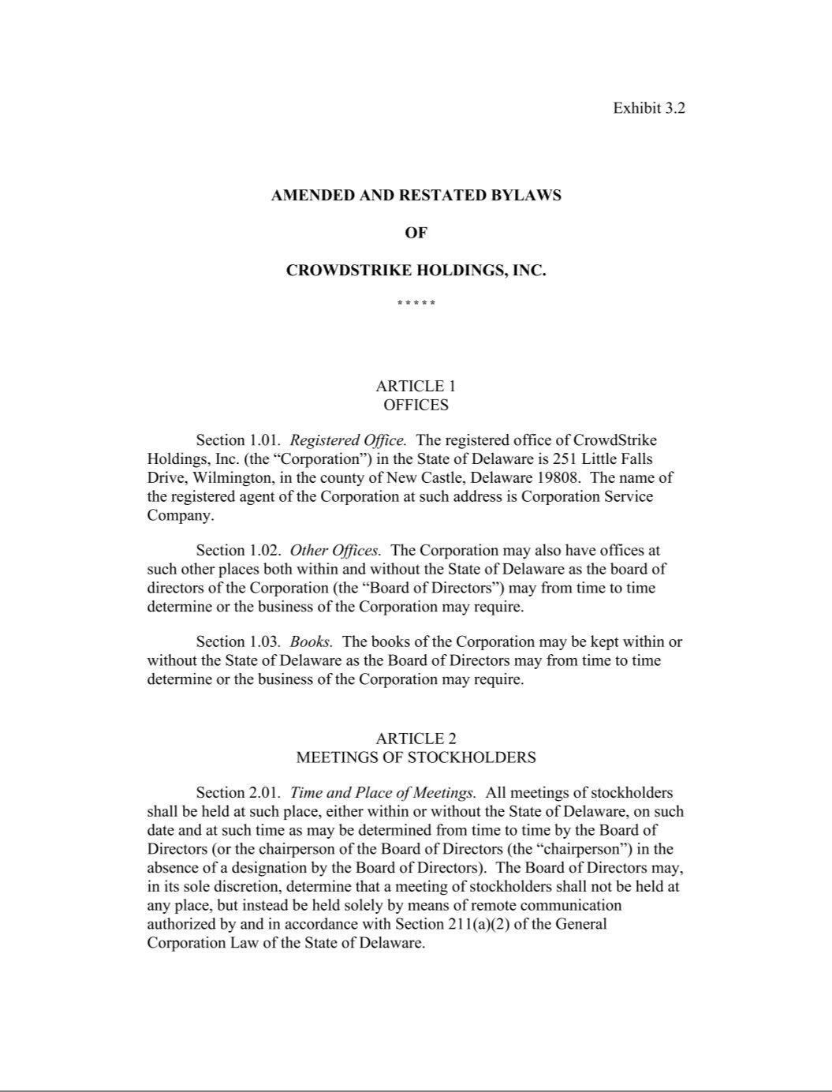

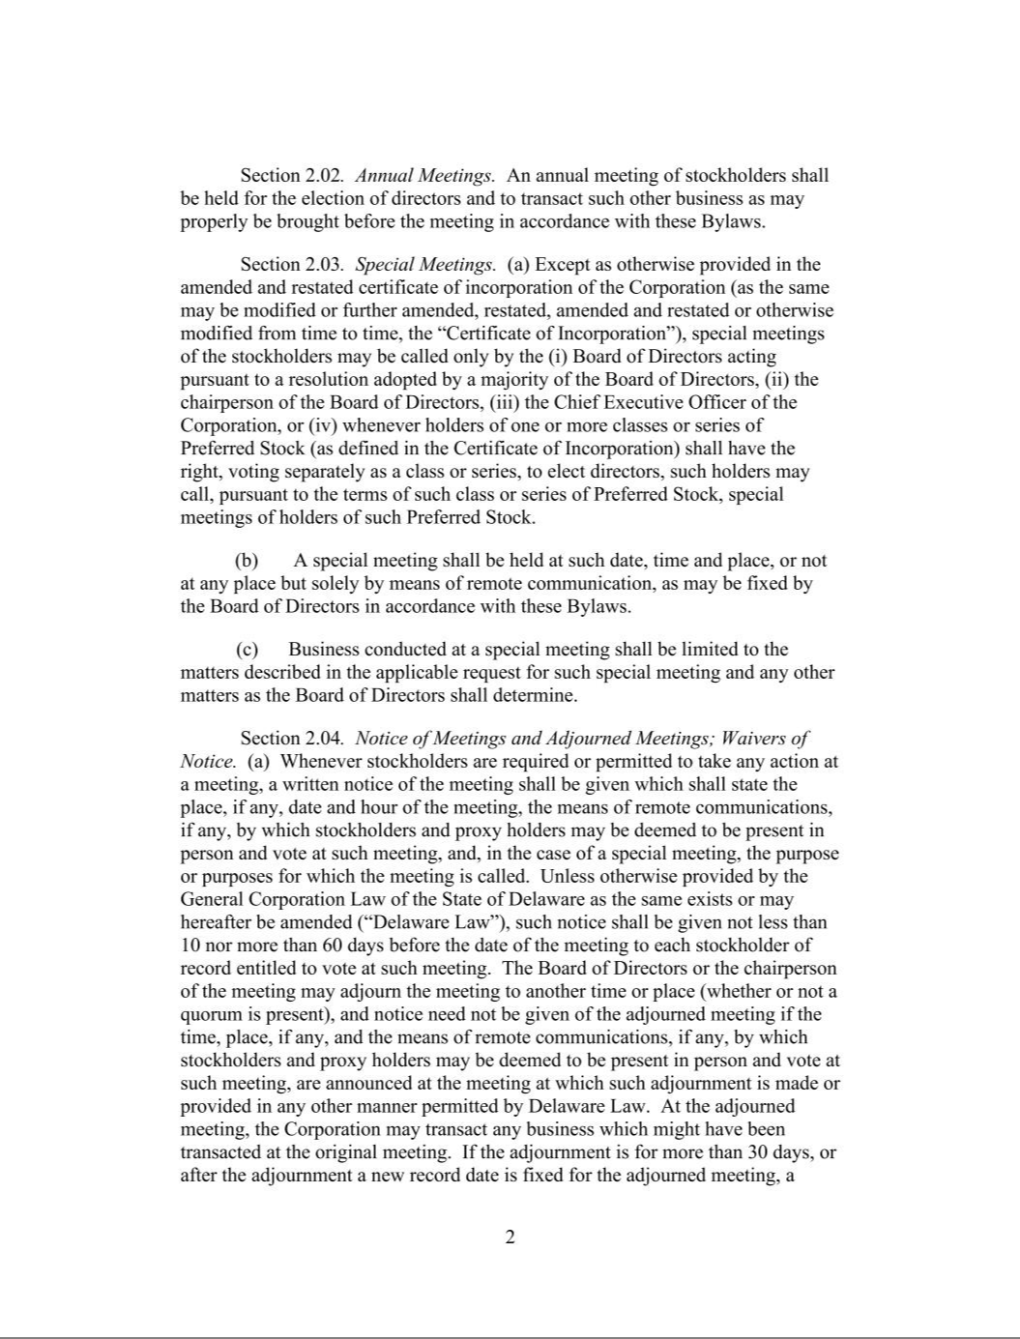

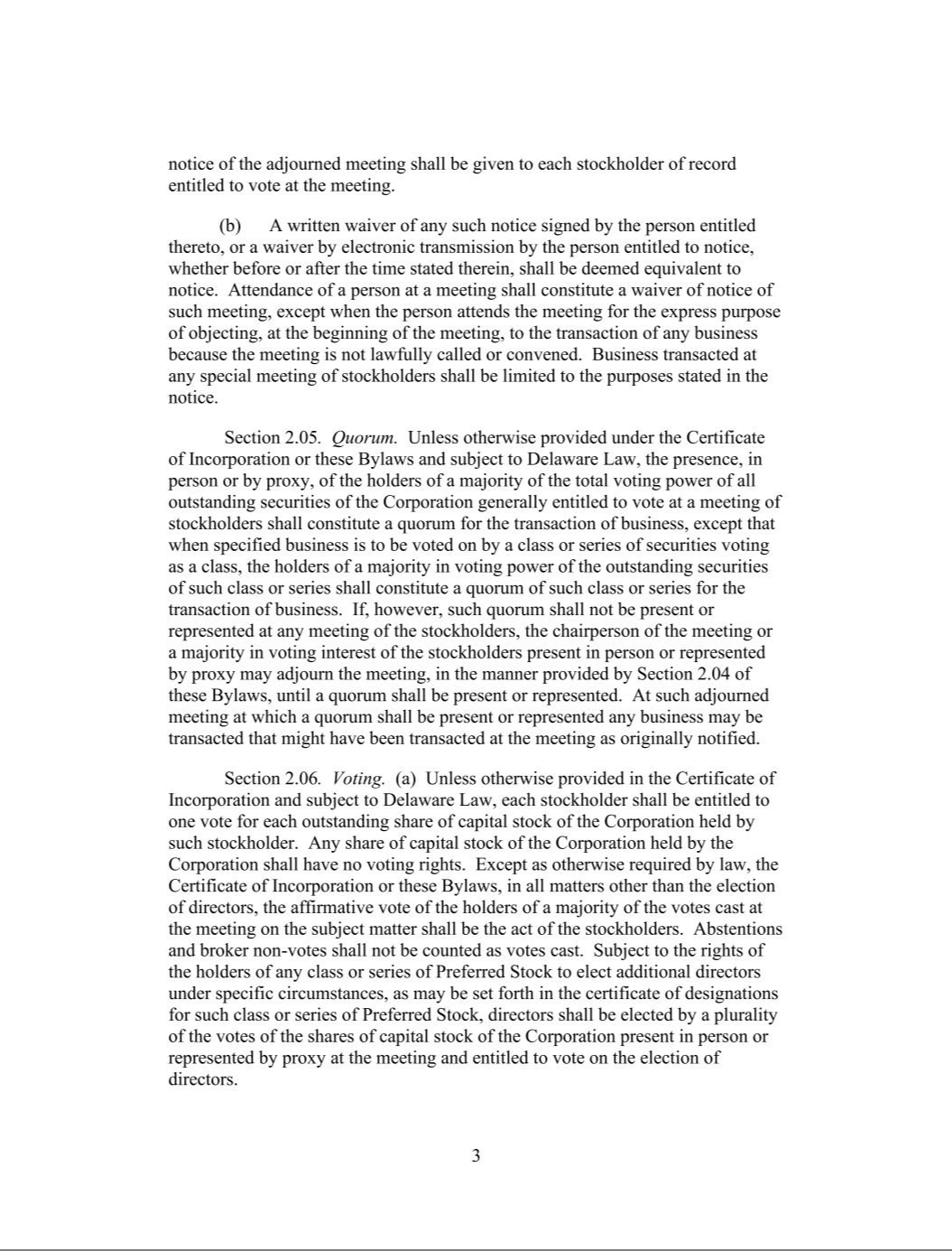

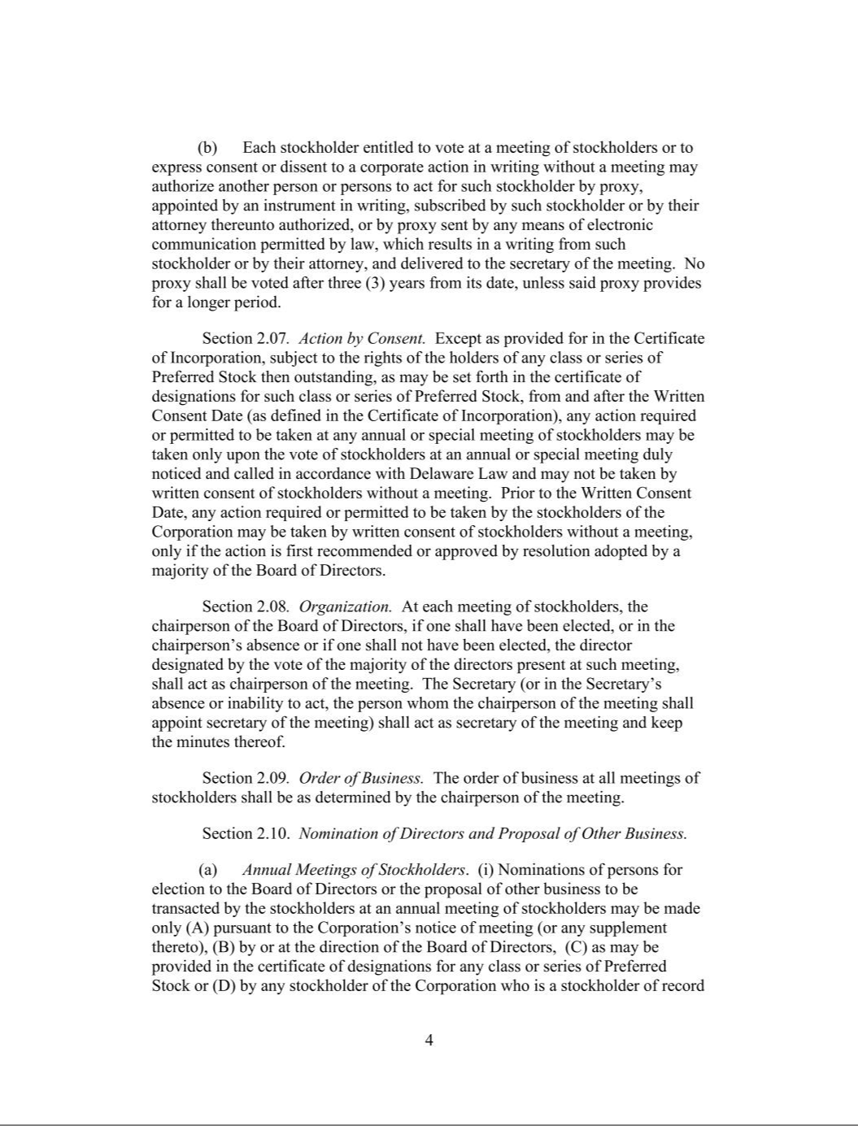

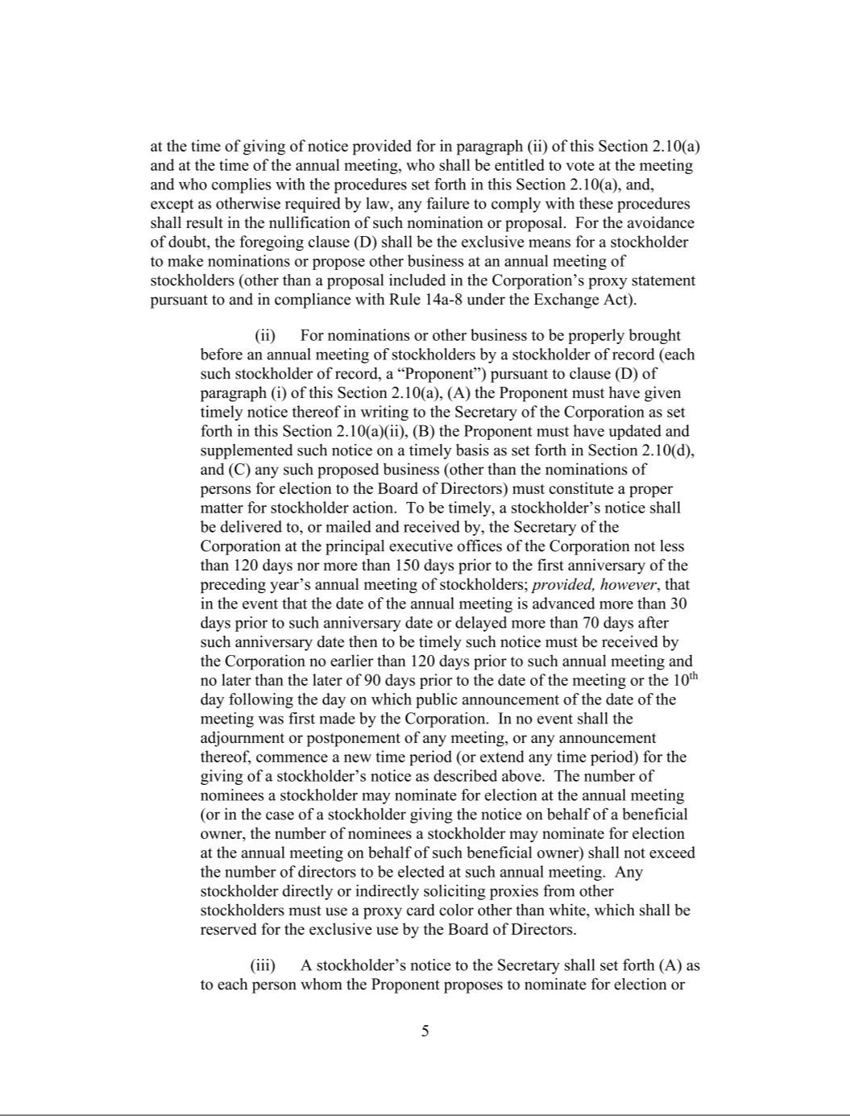

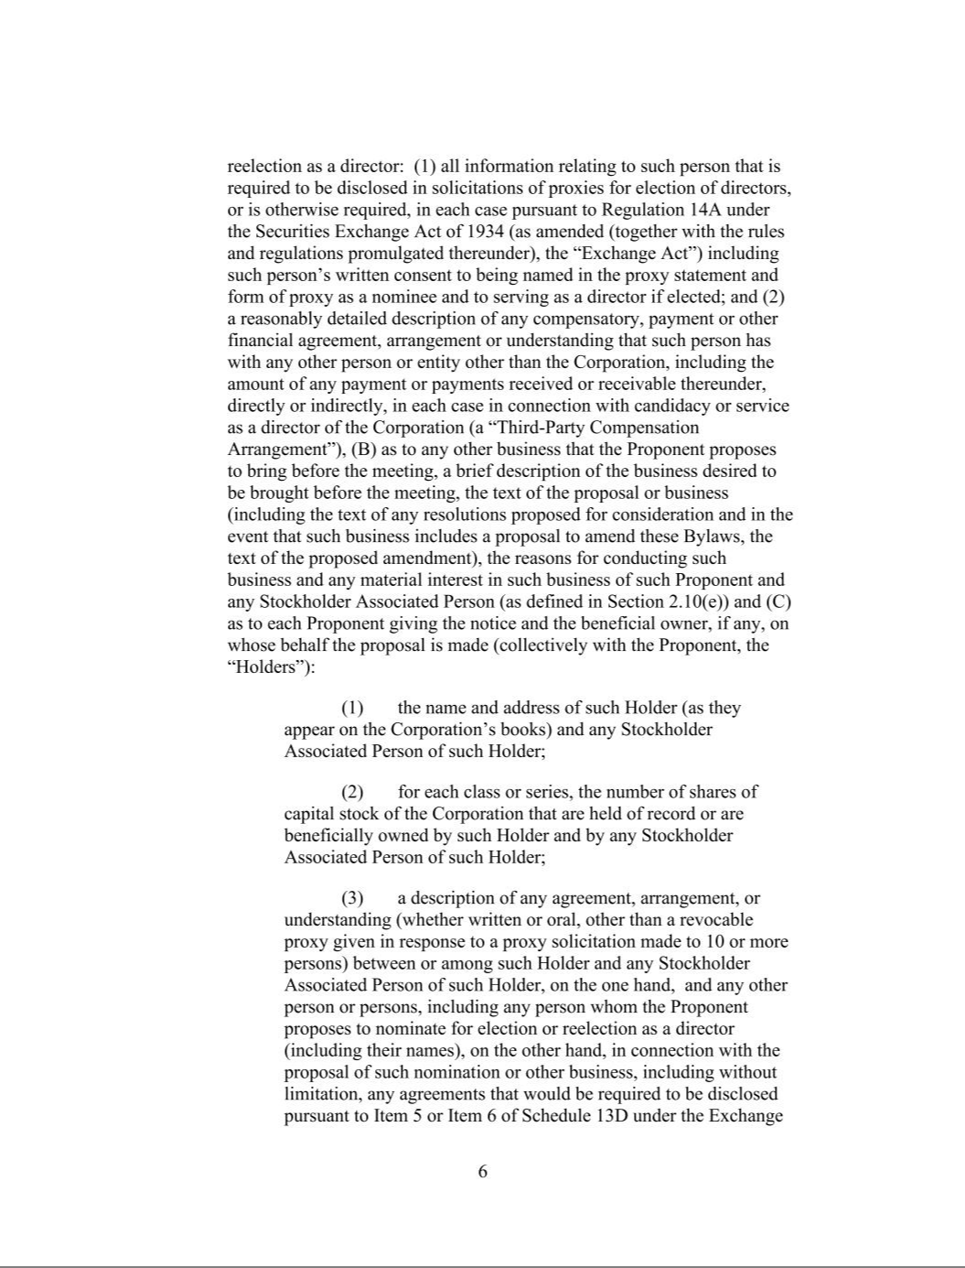

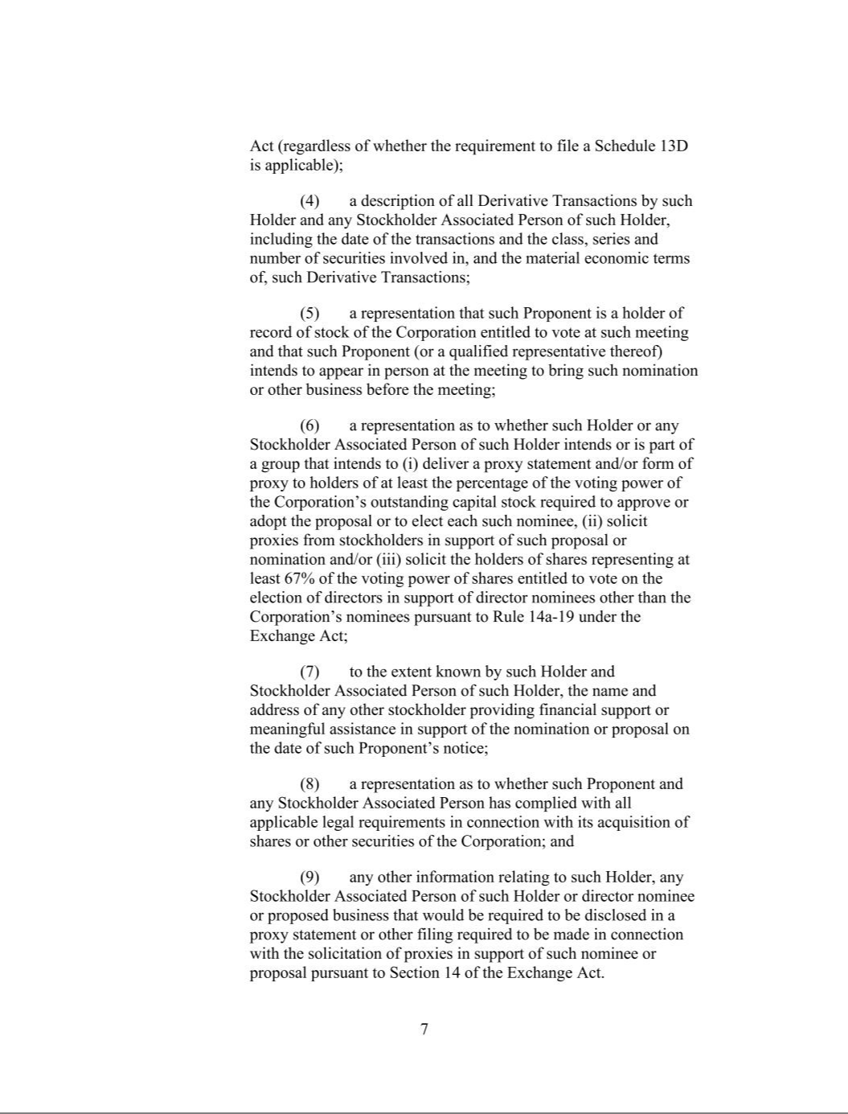

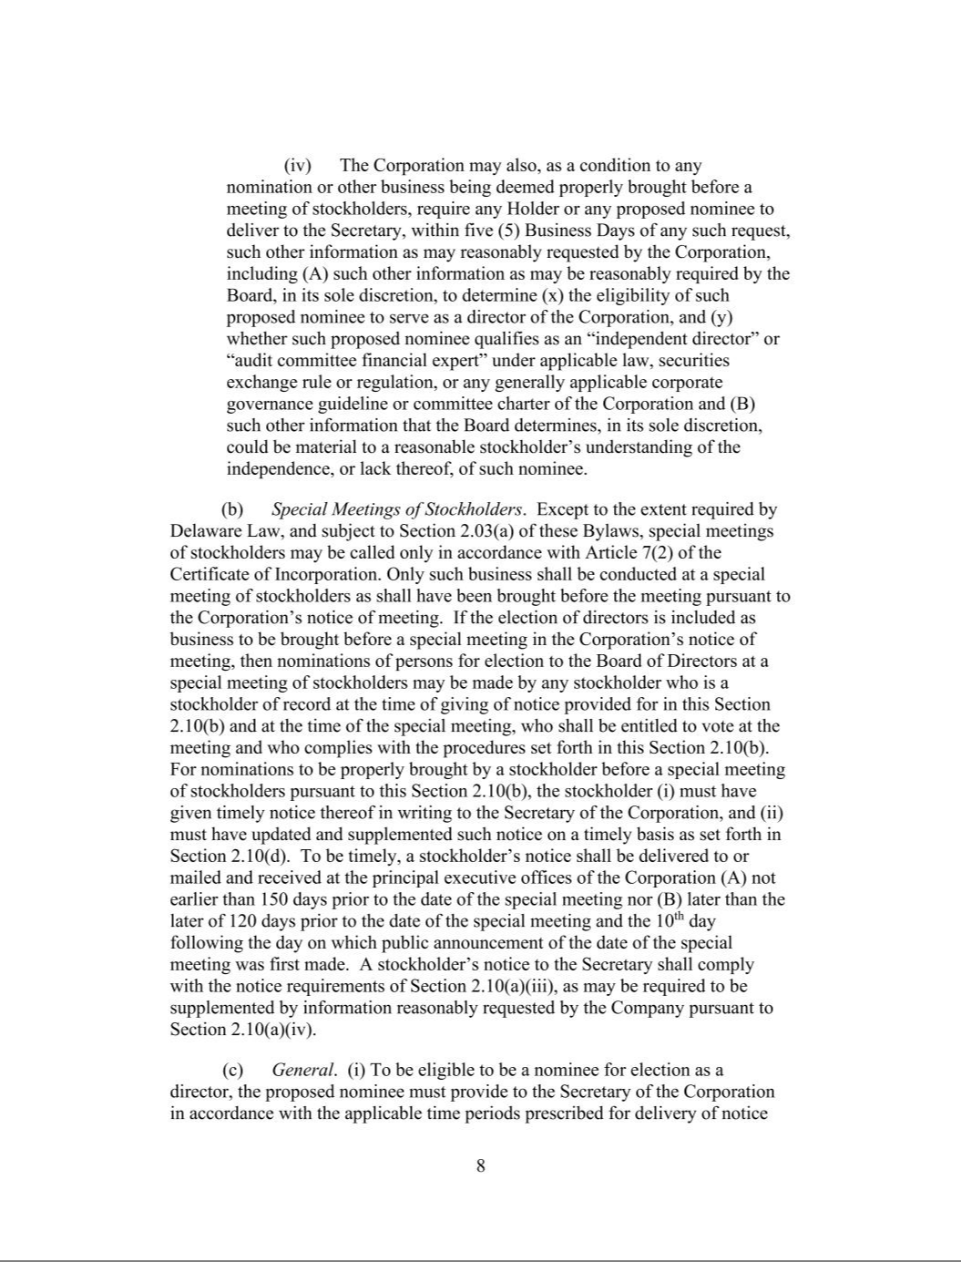

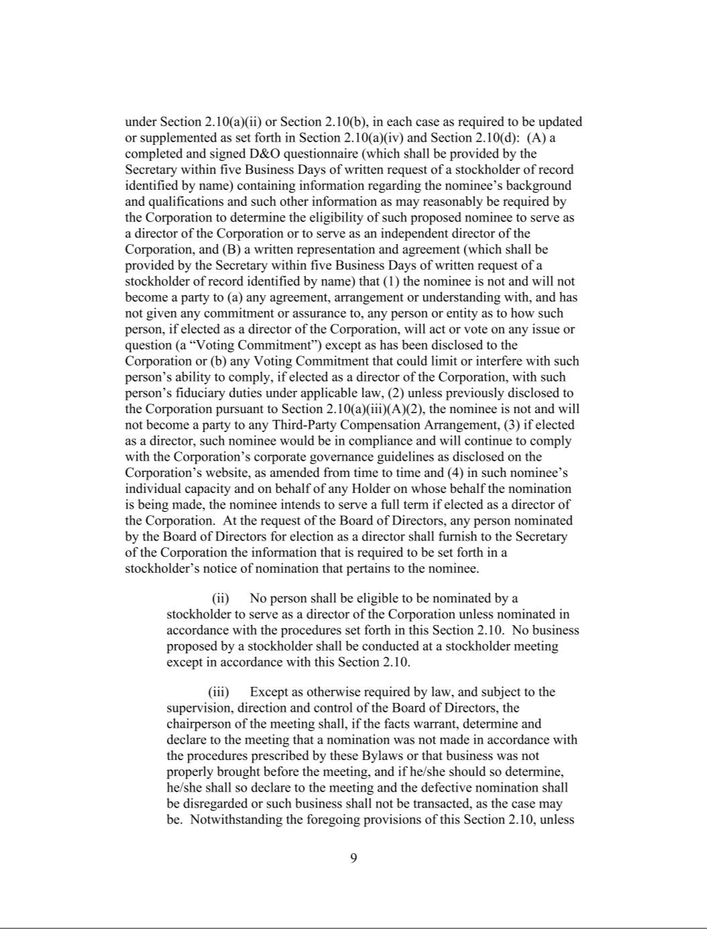

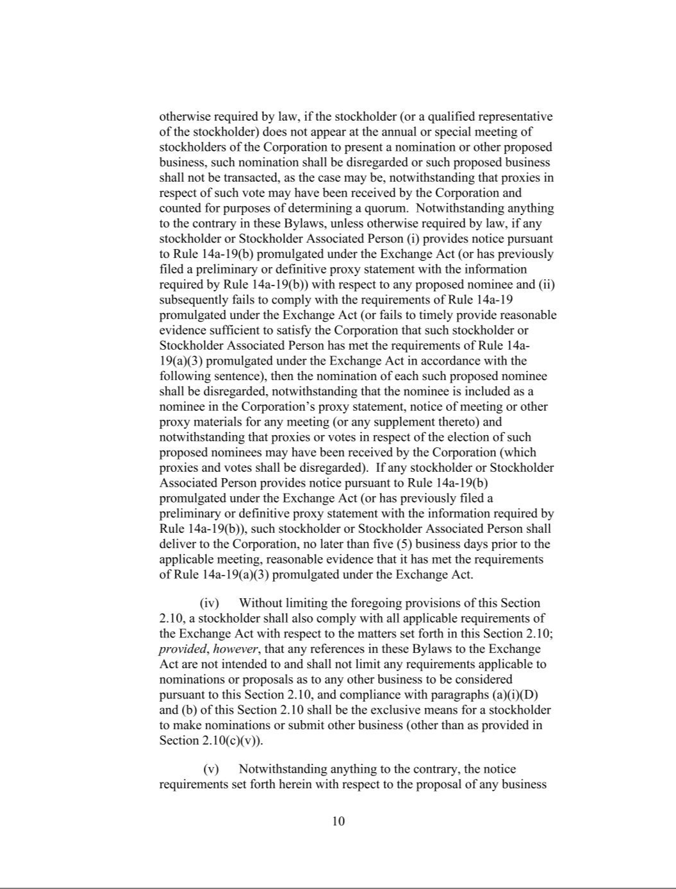

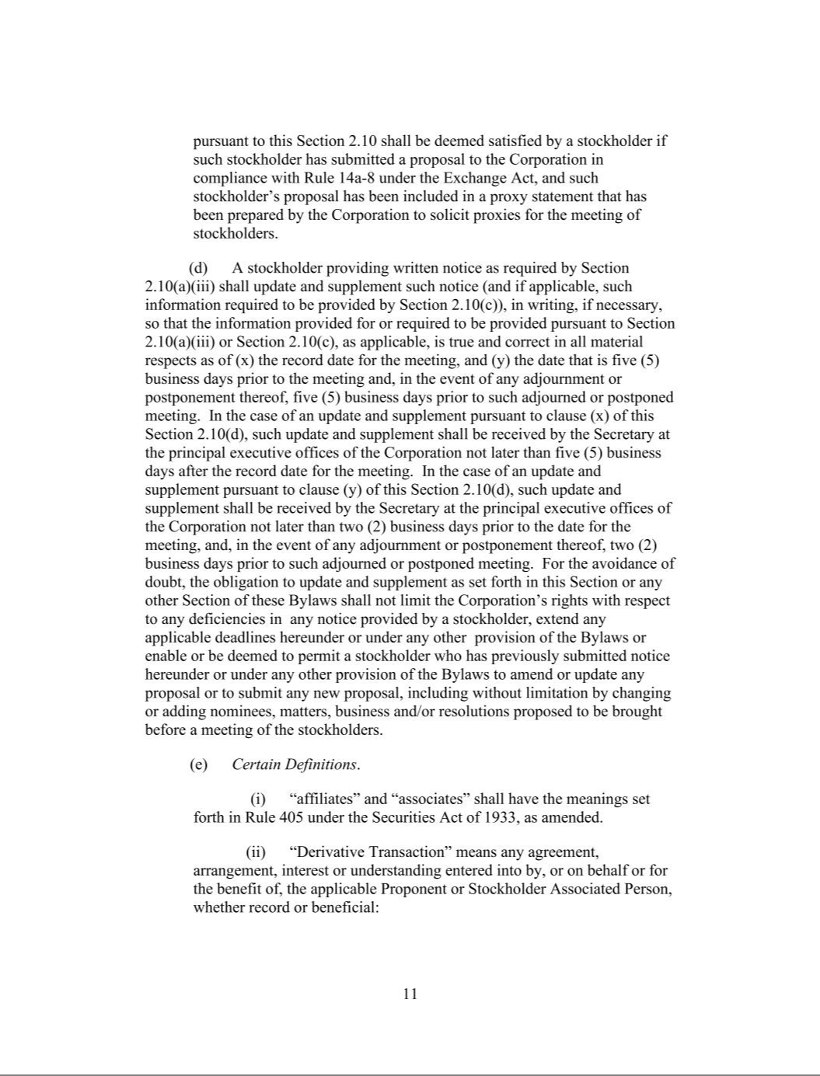

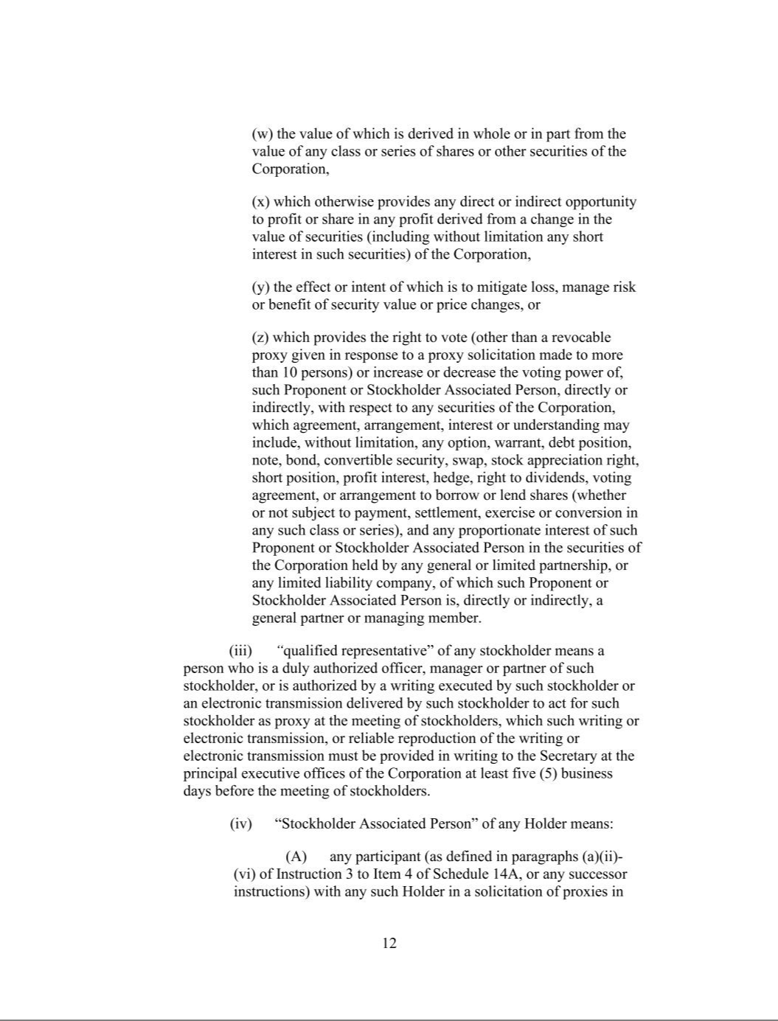

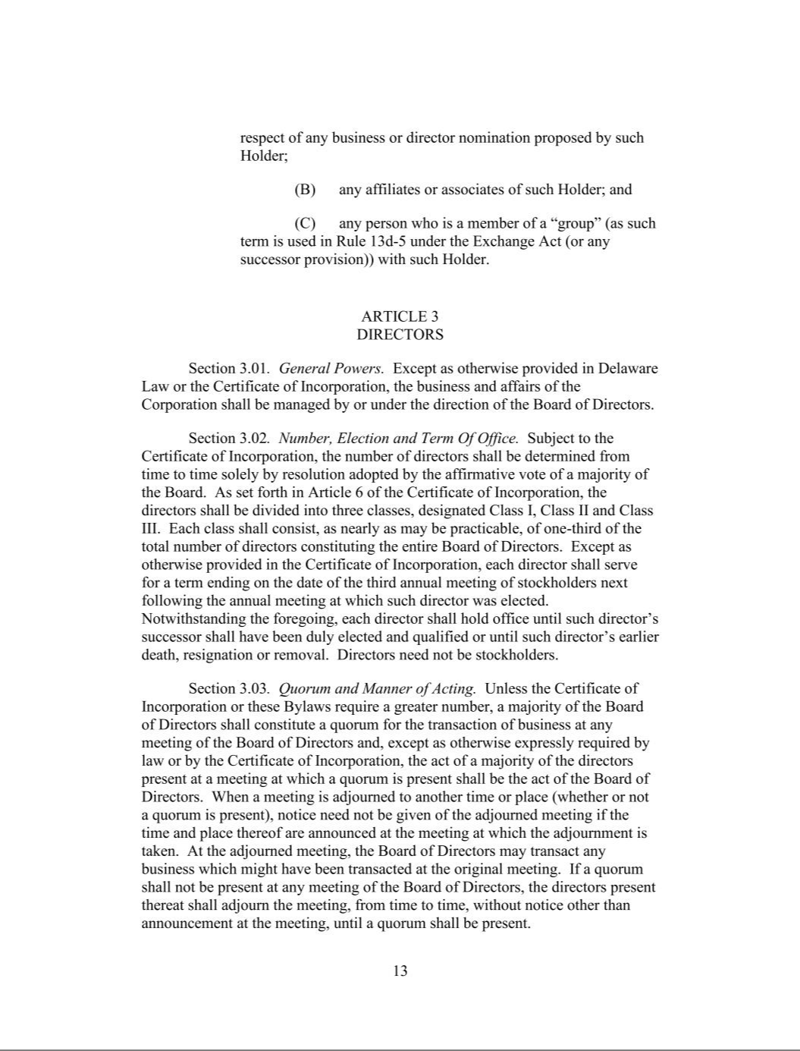

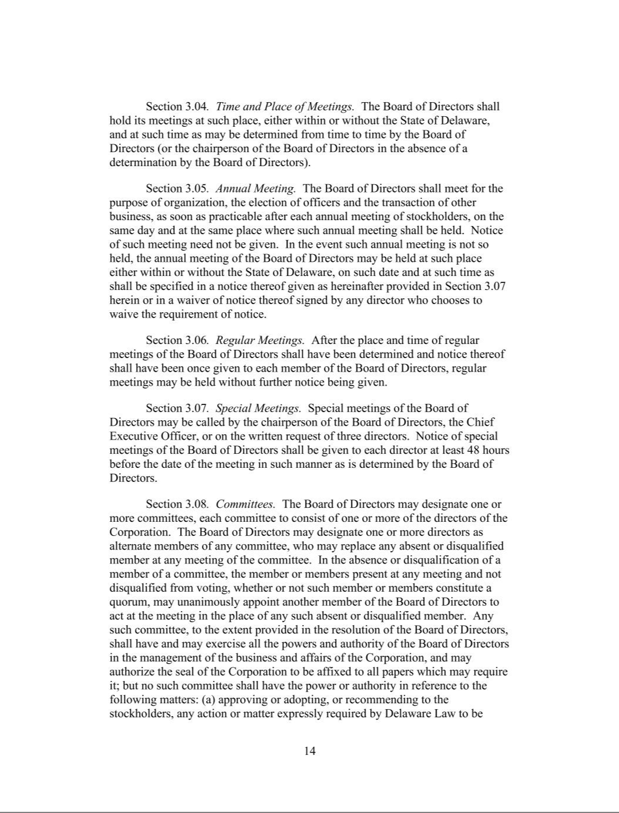

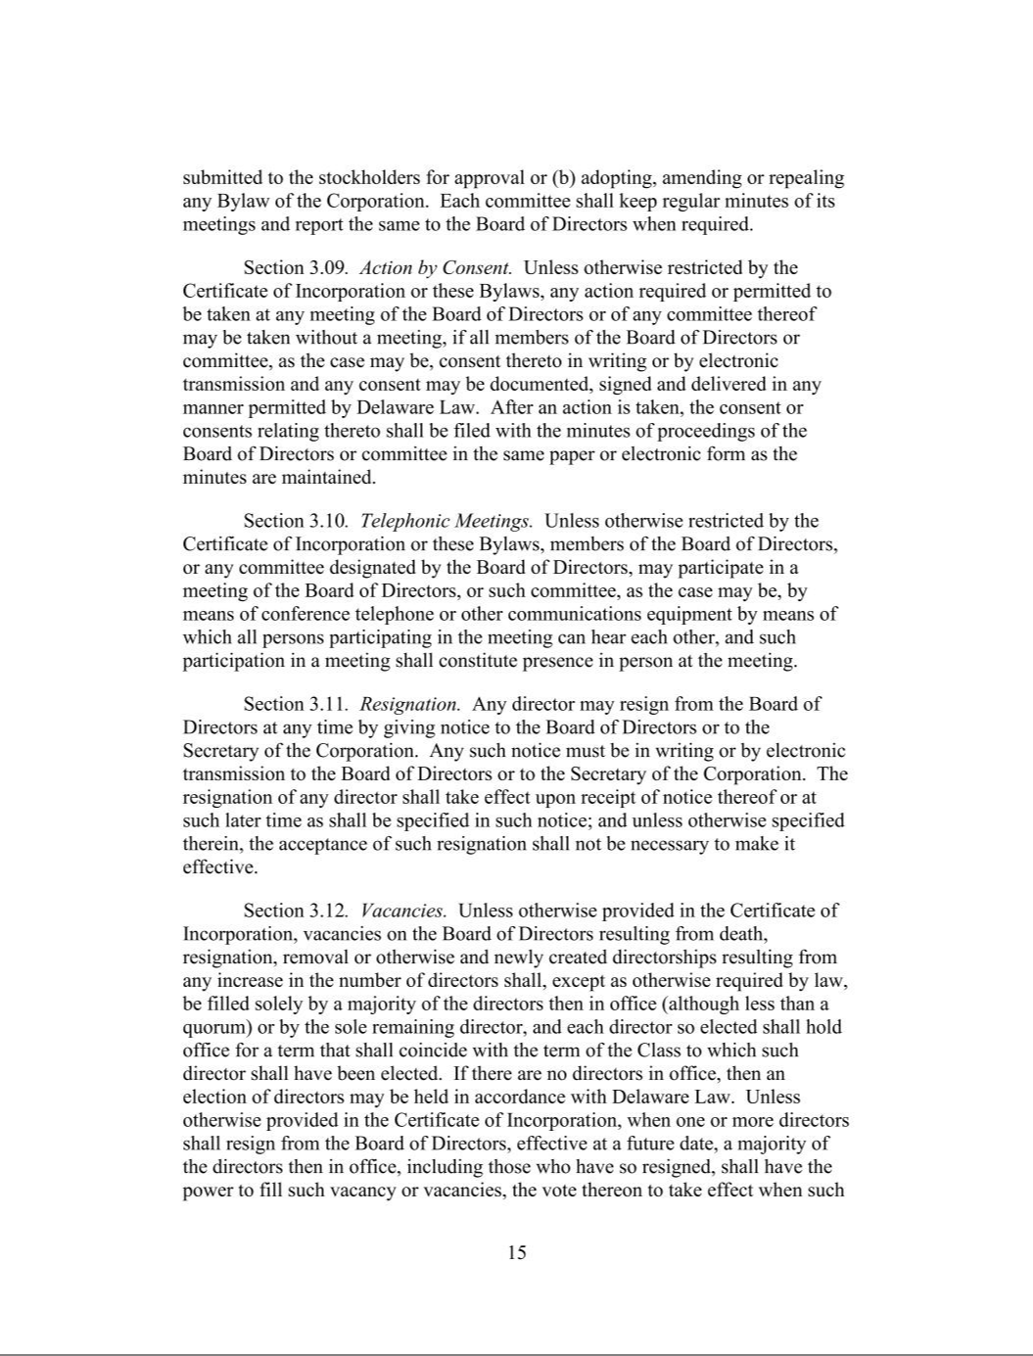

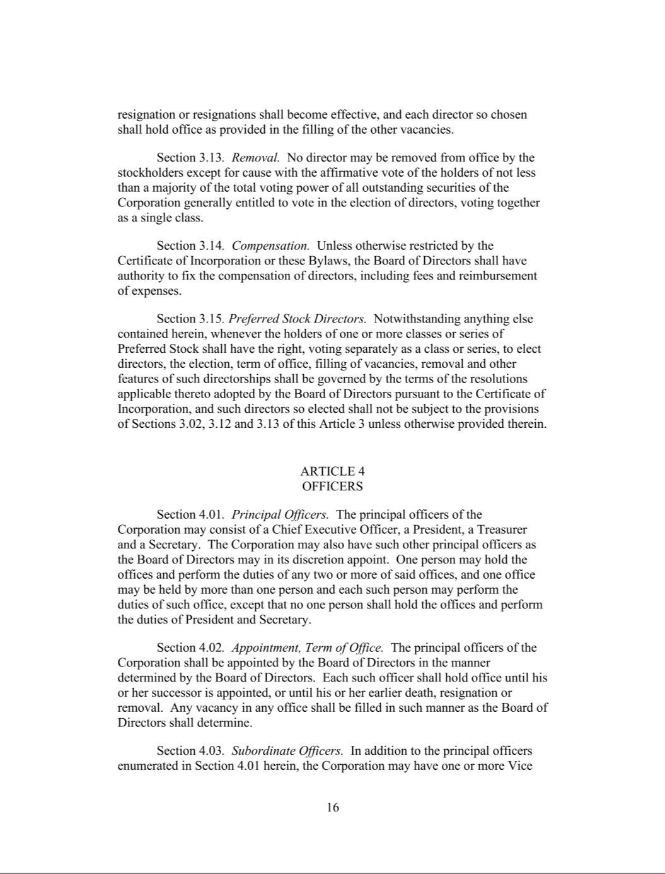

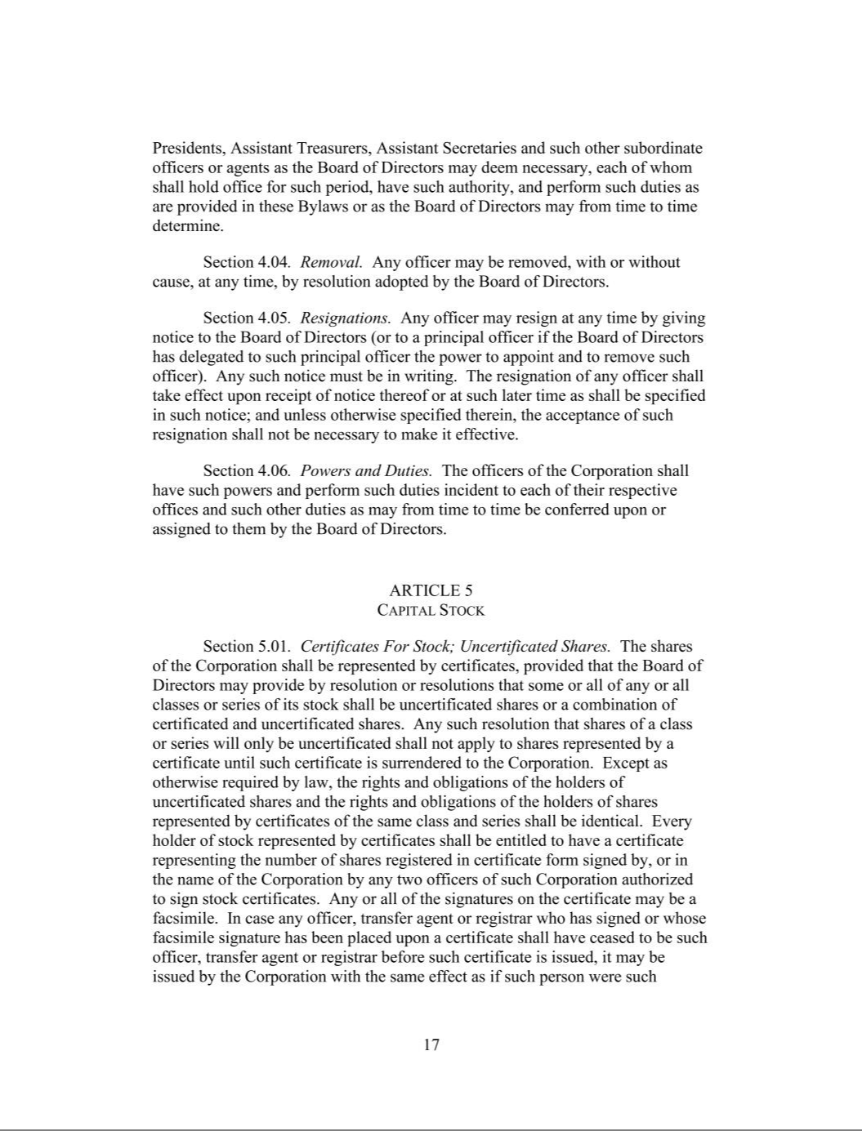

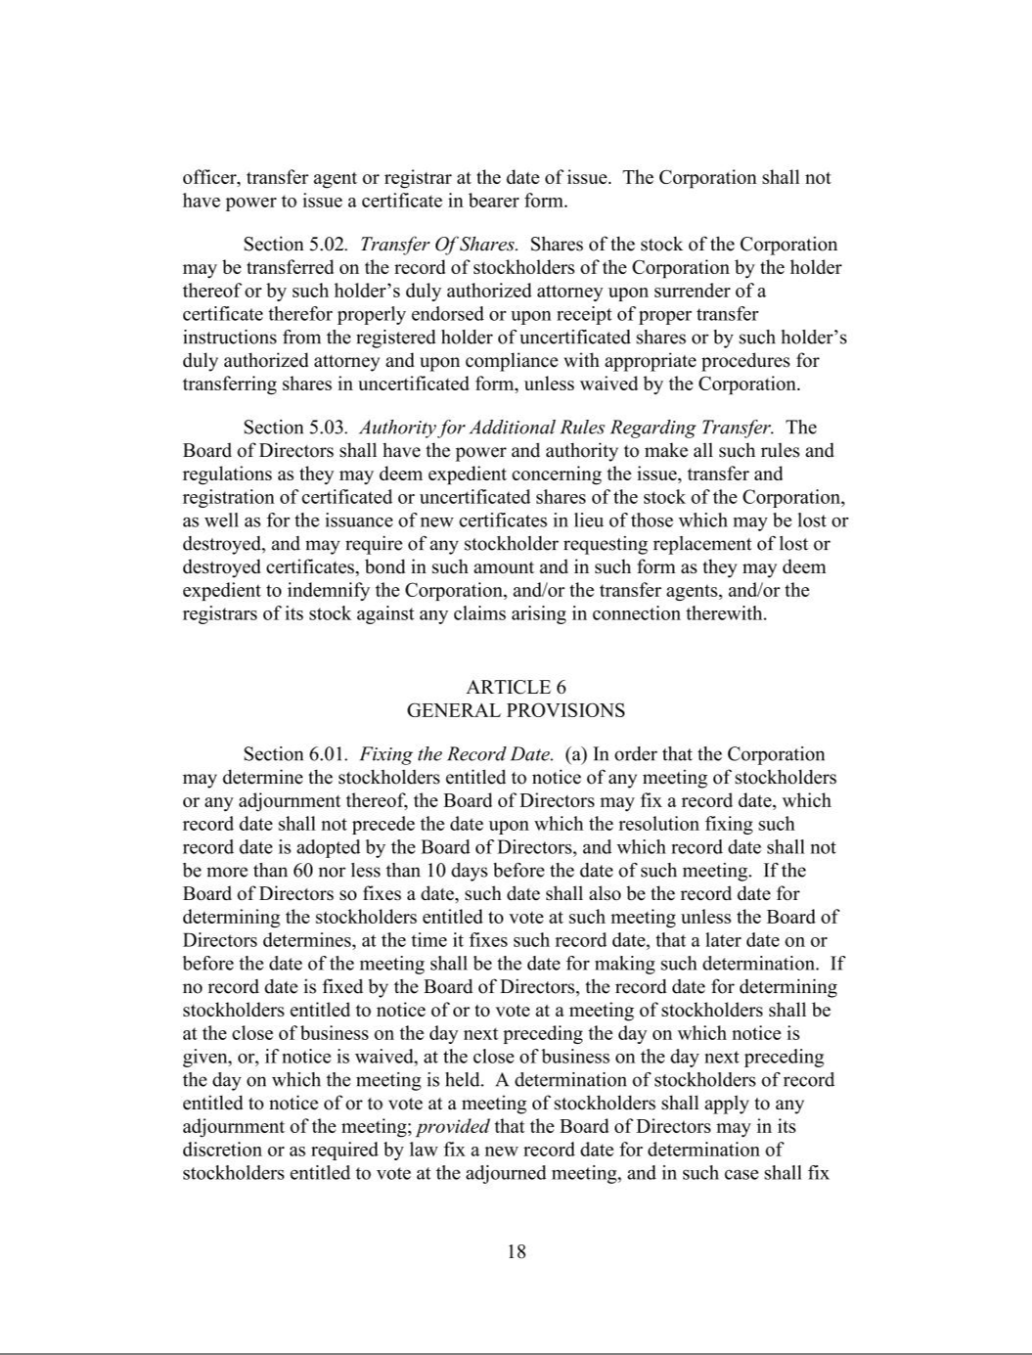

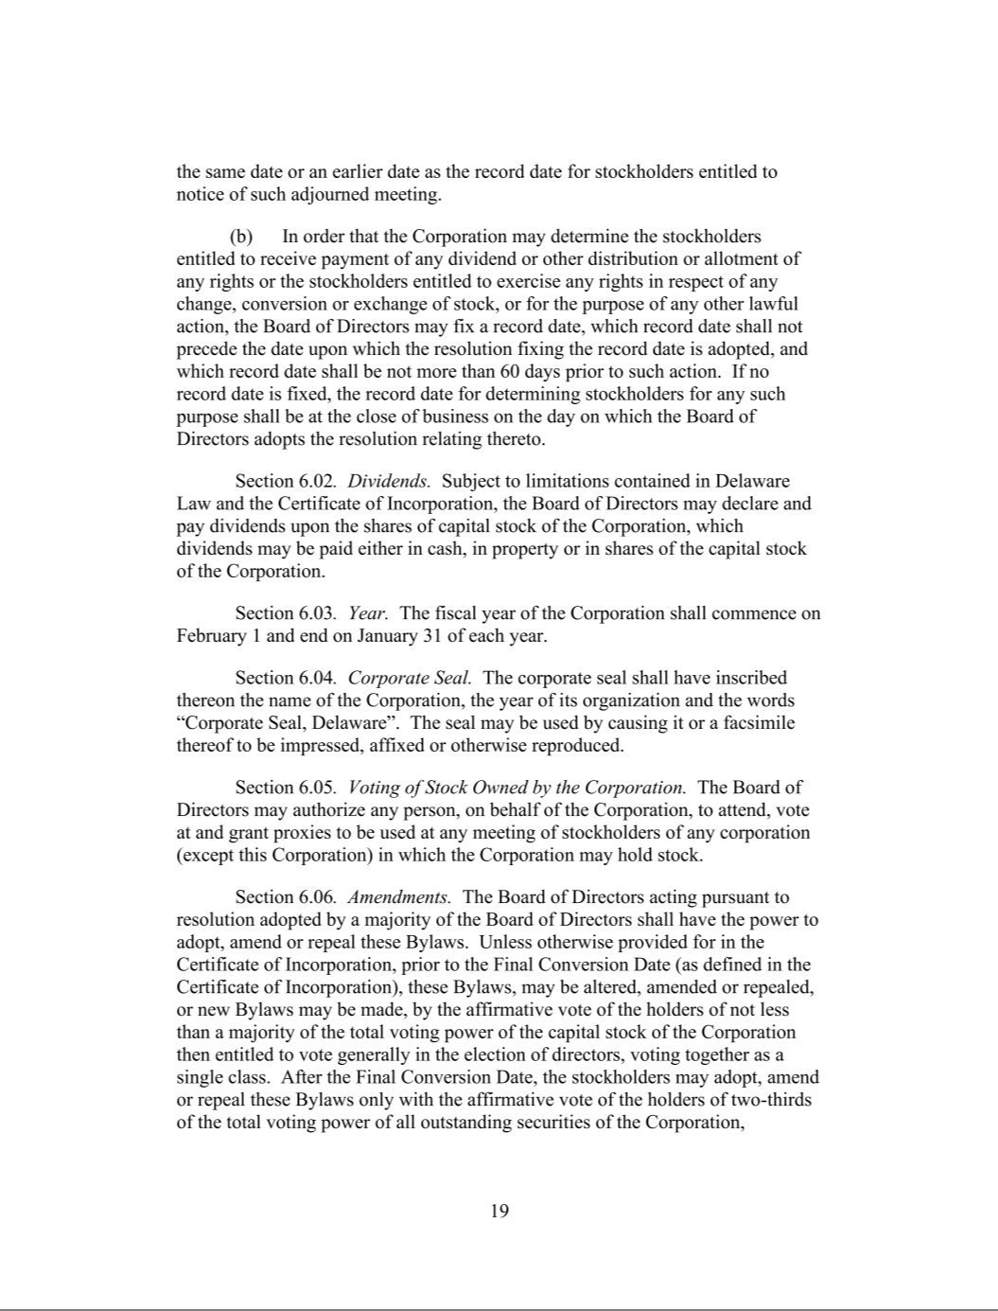

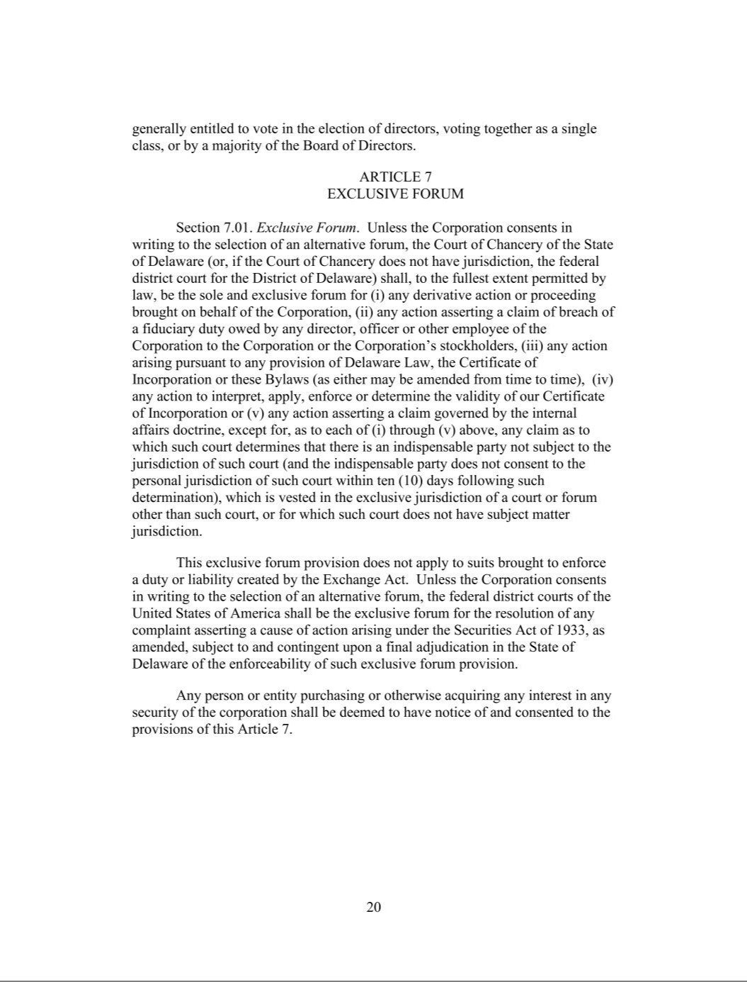

Exhibit 31.1

CERTIFICATION OF PRINCIPAL EXECUTIVE OFFICER PURSUANT TO EXCHANGE ACT RULES 13a-14(a) AND 15d-14(a), AS ADOPTED PURSUANT TO SECTION 302 OF THE SARBANES-OXLEY ACT OF 2002

I, George Kurtz, certify that:

- I have reviewed this Quarterly Report on Form 10-Q of CrowdStrike Holdings, Inc.;

- Based on my knowledge, this report does not contain any untrue statement of a material fact or omit to state a material fact necessary to make the statements made, in light of the circumstances under which such statements were made, not misleading with respect to the period covered by this report;

- Based on my knowledge, the financial statements, and other financial information included in this report, fairly present in all material respects the financial condition, results of operations and cash flows of the registrant as of, and for, the periods presented in this report;

- The registrant's other certifying officer(s) and I are responsible for establishing and maintaining disclosure controls and procedures (as defined in Exchange Act Rules 13a-15(e) and 15d-15(e)) and internal control over financial reporting (as defined in Exchange Act Rules 13a-15(f) and 15d-15(f)) for the registrant and have:

  - Designed such disclosure controls and procedures, or caused such disclosure controls and procedures to be designed under our supervision, to ensure that material information relating to the registrant, including its consolidated subsidiaries, is made known to us by others within those entities, particularly during the period in which this report is being prepared;

  - Designed such internal control over financial reporting, or caused such internal control over financial reporting to be designed under our supervision, to provide reasonable assurance regarding the reliability of financial reporting and the preparation of financial statements for external purposes in accordance with generally accepted accounting principles;

  - Evaluated the effectiveness of the registrant's disclosure controls and procedures and presented in this report our conclusions about the effectiveness of the disclosure controls and procedures, as of the end of the period covered by this report based on such evaluation; and

  - Disclosed in this report any change in the registrant's internal control over financial reporting that occurred during the registrant's most recent fiscal quarter (the registrant's fourth fiscal quarter in the case of an annual report) that has materially affected, or is reasonably likely to materially affect, the registrant's internal control over financial reporting; and

- The registrant's other certifying officer(s) and I have disclosed, based on our most recent evaluation of internal control over financial reporting, to the registrant's auditors and the audit committee of the registrant's board of directors (or persons performing the equivalent functions):

  - All significant deficiencies and material weaknesses in the design or operation of internal control over financial reporting which are reasonably likely to adversely affect the registrant's ability to record, process, summarize and report financial information; and

  - Any fraud, whether or not material, that involves management or other employees who have a significant role in the registrant's internal control over financial reporting.

Date: November 26, 2024

CROWDSTRIKE HOLDINGS, INC.

By: | /s/ George Kurtz
Name: | George Kurtz
Title: | President, Chief Executive Officer, and Director
 | (Principal Executive Officer)

Exhibit 31.2

CERTIFICATION OF PRINCIPAL FINANCIAL OFFICER PURSUANT TO EXCHANGE ACT RULES 13a-14(a) AND 15d-14(a), AS ADOPTED PURSUANT TO SECTION 302 OF THE SARBANES-OXLEY ACT OF 2002

I, Burt W. Podbere, certify that:

- I have reviewed this Quarterly Report on Form 10-Q of CrowdStrike Holdings, Inc.;

- Based on my knowledge, this report does not contain any untrue statement of a material fact or omit to state a material fact necessary to make the statements made, in light of the circumstances under which such statements were made, not misleading with respect to the period covered by this report;

- Based on my knowledge, the financial statements, and other financial information included in this report, fairly present in all material respects the financial condition, results of operations and cash flows of the registrant as of, and for, the periods presented in this report;

- The registrant's other certifying officer(s) and I are responsible for establishing and maintaining disclosure controls and procedures (as defined in Exchange Act Rules 13a-15(e) and 15d-15(e)) and internal control over financial reporting (as defined in Exchange Act Rules 13a-15(f) and 15d-15(f)) for the registrant and have:

  - Designed such disclosure controls and procedures, or caused such disclosure controls and procedures to be designed under our supervision, to ensure that material information relating to the registrant, including its consolidated subsidiaries, is made known to us by others within those entities, particularly during the period in which this report is being prepared;

  - Designed such internal control over financial reporting, or caused such internal control over financial reporting to be designed under our supervision, to provide reasonable assurance regarding the reliability of financial reporting and the preparation of financial statements for external purposes in accordance with generally accepted accounting principles;

  - Evaluated the effectiveness of the registrant's disclosure controls and procedures and presented in this report our conclusions about the effectiveness of the disclosure controls and procedures, as of the end of the period covered by this report based on such evaluation; and

  - Disclosed in this report any change in the registrant's internal control over financial reporting that occurred during the registrant's most recent fiscal quarter (the registrant's fourth fiscal quarter in the case of an annual report) that has materially affected, or is reasonably likely to materially affect, the registrant's internal control over financial reporting; and

- The registrant's other certifying officer(s) and I have disclosed, based on our most recent evaluation of internal control over financial reporting, to the registrant's auditors and the audit committee of the registrant's board of directors (or persons performing the equivalent functions):

  - All significant deficiencies and material weaknesses in the design or operation of internal control over financial reporting which are reasonably likely to adversely affect the registrant's ability to record, process, summarize and report financial information; and

  - Any fraud, whether or not material, that involves management or other employees who have a significant role in the registrant's internal control over financial reporting.

Date: November 26, 2024

CROWDSTRIKE HOLDINGS, INC.

By: | /s/ Burt W. Podbere
Name: | Burt W. Podbere
Title: | Chief Financial Officer (Principal Financial Officer)

Exhibit 32.1

CERTIFICATION OF PRINCIPAL EXECUTIVE OFFICER AND PRINCIPAL FINANCIAL OFFICER

PURSUANT TO 18 U.S.C. SECTION 1350,

AS ADOPTED PURSUANT TO SECTION 906 OF THE SARBANES-OXLEY ACT OF 2002

I, George Kurtz, the President and Chief Executive Officer of CrowdStrike Holdings, Inc., certify, pursuant to 18 U.S.C. Section 1350, as adopted pursuant to Section 906 of the Sarbanes-Oxley Act of 2002, that the Quarterly Report on Form 10-Q of CrowdStrike Holdings, Inc. for the fiscal quarter ended October 31, 2024 fully complies with the requirements of Section 13(a) or 15(d) of the Securities Exchange Act of 1934 and that information contained in such Quarterly Report on Form 10-Q fairly presents, in all material respects, the financial condition and results of operations of CrowdStrike Holdings, Inc.

Date: November 26, 2024

By: | /s/ George Kurtz
Name: | George Kurtz
Title: | President, Chief Executive Officer, and Director
 | (Principal Executive Officer)

I, Burt W. Podbere, the Chief Financial Officer of CrowdStrike Holdings, Inc., certify, pursuant to 18 U.S.C. Section 1350, as adopted pursuant to Section 906 of the Sarbanes-Oxley Act of 2002, that the Quarterly Report on Form 10-Q of CrowdStrike Holdings, Inc. for the fiscal quarter ended October 31, 2024 fully complies with the requirements of Section 13(a) or 15(d) of the Securities Exchange Act of 1934 and that information contained in such Quarterly Report on Form 10-Q fairly presents, in all material respects, the financial condition and results of operations of CrowdStrike Holdings, Inc.

Date: November 26, 2024

By: | /s/ Burt W. Podbere
Name: | Burt W. Podbere
 | Chief Financial Officer
Title: | (Principal Financial Officer)

