Table of Contents

UNITED STATES

SECURITIES AND EXCHANGE COMMISSION
WASHINGTON, D.C. 20549
___________________________________________________________________________________________________

FORM 10-Q

___________________________________________________________________________________________________

(Mark One)

- QUARTERLY REPORT PURSUANT TO SECTION 13 OR 15(d) OF THE SECURITIES EXCHANGE ACT OF 1934

For the quarterly period ended April 30, 2021

OR

- TRANSITION REPORT PURSUANT TO SECTION 13 OR 15(d) OF THE SECURITIES EXCHANGE ACT OF 1934 For the transition period from to

 |  |  |  | Commission File Number: 001-38933
 |  |  | ___________________________________________________________________________________________________
 |  |  |  | CROWDSTRIKE HOLDINGS, INC.
 |  |  |  | (Exact Name of Registrant as Specified in Its Charter)
 |  |  | ___________________________________________________________________________________________________
 | Delaware |  |  |  |  |  |  | 45-3788918
(State or other jurisdiction of |  |  |  |  |  |  |  | (I.R.S. Employer
incorporation or organization) |  |  |  |  |  |  |  | Identification Number)
 |  |  |  | 150 Mathilda Place, Suite 300, Sunnyvale, California 94086
 |  |  |  | (Address of principal executive offices)
 |  |  | __________________________________________________________________________________________________
 |  |  | Registrant’s telephone number, including area code: (888) 512-8906
 |  |  | ___________________________________________________________________________________________________
 |  |  |  | Securities registered pursuant to Section 12(b) of the Act:
Title of each class |  |  |  | Trading symbol(s) |  |  |  | Name of each exchange on which registered
Class A common stock, par value $0.0005 per share |  |  |  |  | CRWD |  |  | The Nasdaq Stock Market LLC
 |  |  |  |  |  |  |  | (Nasdaq Global Select Market)

Indicate by check mark whether the registrant (1) has filed all reports required to be filed by Section 13 or 15(d) of the Securities Exchange Act of 1934 during the preceding 12 months (or for such shorter period that the registrant was required to file such reports), and (2) has been subject to such filing requirements for the past 90 days. Yes ☑ No ☐

Indicate by check mark whether the registrant has submitted electronically every interactive Data File required to be submitted pursuant to Rule 405 of Regulation S-T (§232.405 of this chapter) during the preceding 12 months (or for such shorter period that the registrant was required to submit and post such files) Yes ☑ No ☐

Indicate by check mark whether the registrant is a large accelerated filer, an accelerated filer, a non-accelerated filer, a smaller reporting company, or an emerging growth company. See the definitions of “large accelerated filer,” “accelerated filer,” “smaller reporting company” and “emerging growth company” in Rule 12b-2 of the Exchange Act.

Large Accelerated Filer | ☑ | Accelerated Filer | ☐
Non-accelerated Filer | ☐ | Smaller reporting company | ☐
(Do not check if a smaller reporting company) |  | Emerging growth company | ☐

If an emerging growth company, indicate by check mark if the registrant has elected not to use the extended transition period for complying with any new or revised financial accounting standards provided pursuant to Section 13(a) of the Exchange Act. ☐

Indicate by check mark whether the registrant is a shell company (as defined in Rule 12b-2 of the Exchange Act). Yes ☐ No ☑

As of May 31, 2021, the number of shares of the registrant’s Class A common stock outstanding was 199,244,096, and the number of shares of the registrant’s Class B common stock outstanding was 26,566,522.

 |  |  | Table of Contents
 |  |  |  |  |  |  |  |  |  |  |  |  |  |  |  |  |  | CROWDSTRIKE HOLDINGS, INC.
 |  |  |  |  |  |  |  |  |  |  |  |  |  |  |  |  |  |  | TABLE OF CONTENTS
 |  |  |  |  |  |  |  |  |  |  |  |  |  |  |  |  |  |  |  |  |  |  |  |  |  |  | Page No.
 |  |  |  |  |  |  |  |  |  |  |  |  |  |  |  |  | PART I. FINANCIAL INFORMATION
Item 1. |  |  |  |  | Financial Statements (unaudited)
 |  |  |  |  |  | Condensed Consolidated Balance Sheets as of April 30, 2021 and January 31, 2021 |  |  |  |  |  |  |  |  |  |  |  |  |  |  |  |  |  |  |  |  | 6
 |  |  |  |  |  | Condensed Consolidated Statements of Operations for the Three Months Ended April 30, 2021 and April 30, 2020 |  |  |  |  |  |  |  |  |  |  |  |  |  |  |  |  |  |  |  |  | 7
 |  |  |  |  |  | Condensed Consolidated Statements of Comprehensive Loss for the Three Months Ended April 30, 2021 and April 30, 2020 |  |  |  |  |  |  |  |  |  |  |  |  |  |  |  |  |  |  |  |  | 8
 |  |  |  |  |  | Condensed Consolidated Statements of Stockholders’ Equity for the Three Months Ended April 30, 2021 and April 30, 2020 |  |  |  |  |  |  |  |  |  |  |  |  |  |  |  |  |  |  |  |  | 9
 |  |  |  |  |  | Condensed Consolidated Statements of Cash Flows for the Three Months Ended April 30, 2021 and April 30, 2020 |  |  |  |  |  |  |  |  |  |  |  |  |  |  |  |  |  |  |  |  | 10
 |  |  |  |  |  | Notes to Condensed Consolidated Financial Statements |  |  |  |  |  |  |  |  |  |  |  |  |  |  |  |  |  |  |  |  | 11
Item 2. |  |  |  |  | Management’s Discussion and Analysis of Financial Condition and Results of Operations |  |  |  |  |  |  |  |  |  |  |  |  |  |  |  |  |  |  |  |  |  | 29
Item 3. |  |  |  |  | Quantitative and Qualitative Disclosures about Market Risk |  |  |  |  |  |  |  |  |  |  |  |  |  |  |  |  |  |  |  |  |  | 47
Item 4. |  |  |  |  | Controls and Procedures |  |  |  |  |  |  |  |  |  |  |  |  |  |  |  |  |  |  |  |  |  | 48
 |  |  |  |  |  |  |  |  |  |  |  |  |  |  |  |  |  | PART II. OTHER INFORMATION
Item 1. |  |  |  |  | Legal Proceedings |  |  |  |  |  |  |  |  |  |  |  |  |  |  |  |  |  |  |  |  |  | 48
Item 1A. |  |  |  |  | Risk Factors |  |  |  |  |  |  |  |  |  |  |  |  |  |  |  |  |  |  |  |  |  | 49
Item 2. |  |  |  |  | Unregistered Shares of Equity Securities and Use of Proceeds |  |  |  |  |  |  |  |  |  |  |  |  |  |  |  |  |  |  |  |  |  | 79
Item 3. |  |  |  |  | Defaults Upon Senior Securities |  |  |  |  |  |  |  |  |  |  |  |  |  |  |  |  |  |  |  |  |  | 79
Item 4. |  |  |  |  | Mine Safety Disclosures |  |  |  |  |  |  |  |  |  |  |  |  |  |  |  |  |  |  |  |  |  | 79
Item 5. |  |  |  |  | Other Information |  |  |  |  |  |  |  |  |  |  |  |  |  |  |  |  |  |  |  |  |  | 79
Item 6. |  |  |  |  | Exhibits |  |  |  |  |  |  |  |  |  |  |  |  |  |  |  |  |  |  |  |  |  | 80
 |  |  |  |  |  | Signatures |  |  |  |  |  |  |  |  |  |  |  |  |  |  |  |  |  |  |  |  | 81
 |  |  |  |  | 2

Table of Contents

SPECIAL NOTE REGARDING FORWARD-LOOKING STATEMENTS

This Quarterly Report on Form 10-Q contains forward-looking statements within the meaning of the Private Securities Litigation Reform Act of 1995. All statements contained in this Quarterly Report on Form 10-Q other than statements of historical fact, including statements regarding our future operating results and financial position, our business strategy and plans and our objectives for future operations, are forward-looking statements. The words “believe,” “may,” “will,” “potentially,” “estimate,” “continue,” “anticipate,” “intend,” “could,” “would,” “project,” “plan,” “expect” and similar expressions that convey uncertainty of future events or outcomes are intended to identify forward-looking statements.

These forward-looking statements include, but are not limited to, statements concerning the following:

- our future financial performance, including our expectations regarding our revenue, cost of revenue, gross profit or gross margin, operating expenses (including changes in sales and marketing, research and development, and general and administrative expenses), and our ability to achieve, and maintain, future profitability;

- the impact of the COVID-19 pandemic on our operations, financial results, and liquidity and capital resources, including on customers, sales, expenses, and employees;

- market acceptance of our cloud platform;

- the effects of increased competition in our markets and our ability to compete effectively;

- our ability to maintain the security and availability of our cloud platform;

- our ability to maintain and expand our customer base, including by attracting new customers;

- our ability to develop new solutions, or enhancements to our existing solutions, and bring them to market in a timely manner;

- anticipated trends, growth rates and challenges in our business and in the markets in which we operate;

- our business plan and our ability to effectively manage our growth and associated investments;

- beliefs and objectives for future operations;

- our relationships with third parties, including channel partners and technology alliance partners;

- our ability to maintain, protect and enhance our intellectual property rights;

- our ability to successfully defend litigation brought against us;

- our ability to successfully expand in our existing markets and into new markets;

- sufficiency of cash and cash equivalents to meet cash needs for at least the next 12 months;

- our ability to expand internationally;

- our ability to comply with laws and regulations that currently apply or become applicable to our business both in the United States and internationally;

- our ability to develop, maintain, and improve our internal control over financial reporting;

- instability in the global credit and financial markets;

- our ability to successfully close and integrate acquisitions to contribute to our growth objectives; and

- the attraction and retention of qualified employees and key personnel.

3

Table of Contents

These statements are based on our current plans, estimates and projections in light of information currently available to us. These forward-looking statements may be affected by risks, uncertainties and other factors discussed elsewhere in this Quarterly Report on Form 10-Q, including under “Risk Factors.” Furthermore, new risks and uncertainties emerge from time to time, and it is impossible for us to predict all risks and uncertainties or how they may affect us. If any of these risks or uncertainties occurs, our business, revenue and financial results could be harmed, and the trading price of our Class A common stock could decline. Forward-looking statements made in this Quarterly Report on Form 10-Q speak only as of the date on which such statements are made, and we undertake no obligation to update them in light of new information or future events, except as required by law.

We intend to announce material information to the public through the CrowdStrike Investor Relations website ir.crowdstrike.com, SEC filings, press releases, public conference calls, and public webcasts. We use these channels, as well as social media and our blog, to communicate with our investors, customers, and the public about our company, our offerings, and other issues. It is possible that the information we post on social media and our blog could be deemed to be material information. As such, we encourage investors, the media, and others to follow the channels listed above, including the social media channels listed on our investor relations website, and to review the information disclosed through such channels. Any updates to the list of disclosure channels through which we will announce information will be posted on the investor relations page on our website.

SUMMARY OF RISK FACTORS

Our business is subject to numerous risks and uncertainties, any one of which could materially adversely affect our business, results of operations, financial condition and growth prospects. Below is a summary of some of these risks. This summary is not complete, and should be read together with the entire section titled “Risk Factors” in this Quarterly Report on Form 10-Q, as well as the other information in this Quarterly Report on Form 10-Q and the other filings that we make with the SEC.

- We have experienced rapid growth in recent periods, and if we do not manage our future growth, our business and results of operations will be adversely affected.

- We have a history of losses and may not be able to achieve or sustain profitability in the future.

- Our limited operating history makes it difficult to evaluate our current business and future prospects, and may increase the risk of your investment.

- The COVID-19 pandemic could adversely affect global economic conditions and our business, operating results and future revenue.

- If organizations do not adopt cloud-based SaaS-delivered endpoint security solutions, our ability to grow our business and results of operations may be adversely affected.

- If we are unable to attract new customers, our future results of operations could be harmed.

- If our customers do not renew their subscriptions for our products and add additional cloud modules to their subscriptions, our future results of operations could be harmed.

- We face intense competition and could lose market share to our competitors, which could adversely affect our business, financial condition, and results of operations.

- If our solutions fail or are perceived to fail to detect or prevent incidents or have or are perceived to have defects, errors, or vulnerabilities, our brand and reputation would be harmed, which would adversely affect our business and results of operations.

- As a cybersecurity provider, we have been, and expect to continue to be, a target of cyberattacks. If our internal networks, systems, or data are or are perceived to have been breached, our reputation may be damaged and our financial results may be negatively affected.

- Our business is focused on cloud-based data analytics, and cybersecurity, privacy, and other regulations may affect how we collect and process certain types of data.

- We rely on third-party data centers, such as Amazon Web Services, and our own colocation data centers, to host and operate our Falcon platform, and any disruption of or interference with our use of these facilities may

4

Table of Contents

negatively affect our ability to maintain the performance and reliability of our Falcon platform, which could cause our business to suffer.

- If we do not effectively expand and train our direct sales force, we may be unable to add new customers or increase sales to our existing customers, and our business will be adversely affected.

- Our results of operations may fluctuate significantly, which could make our future results difficult to predict and could cause our results of operations to fall below expectations.

- Claims by others that we infringe their proprietary technology or other intellectual property rights could result in significant costs and substantially harm our business, financial condition, results of operations, and prospects.

- Future acquisitions, strategic investments, partnerships, or alliances could be difficult to identify and integrate, divert the attention of key management personnel, disrupt our business, dilute stockholder value and adversely affect our business, financial condition, and results of operations.

5

Table of Contents

PART I. FINANCIAL INFORMATION

Item 1. Financial Statements

CrowdStrike Holdings, Inc.

Condensed Consolidated Balance Sheets
(in thousands, except per share data)
(unaudited)

 | April 30, |  |  |  | January 31,
 | 2021 |  |  |  | 2021
Assets
Current assets:
Cash and cash equivalents | $ | 1,684,997 |  | $ | 1,918,608
Accounts receivable, net of allowance for doubtful accounts of $1.5 million and $1.2 million as of April 30, 2021 and January 31, 2021, respectively |  | 211,233 |  |  | 239,199
Deferred contract acquisition costs, current |  | 85,388 |  |  | 80,850
Prepaid expenses and other current assets |  | 56,385 |  |  | 53,617
Total current assets |  | 2,038,003 |  |  | 2,292,274
Strategic investments |  | 8,165 |  |  | 2,500
Property and equipment, net |  | 191,310 |  |  | 167,014
Operating lease right-of-use assets |  | 36,683 |  |  | 36,484
Deferred contract acquisition costs, noncurrent |  | 125,392 |  |  | 117,906
Goodwill |  | 374,581 |  |  | 83,566
Intangible assets, net |  | 88,851 |  |  | 15,677
Other long-term assets |  | 18,186 |  |  | 17,112
Total assets | $ | 2,881,171 |  | $ | 2,732,533
Liabilities and Stockholders’ Equity
Current liabilities:
Accounts payable |  | 3,468 |  |  | 12,065
Accrued expenses |  | 49,627 |  |  | 51,117
Accrued payroll and benefits |  | 79,099 |  |  | 71,907
Operating lease liabilities, current |  | 9,333 |  |  | 8,977
Deferred revenue |  | 786,793 |  |  | 701,988
Other current liabilities |  | 54,445 |  |  | 17,499
Total current liabilities |  | 982,765 |  |  | 863,553
Long-term debt |  | 738,400 |  |  | 738,029
Deferred revenue, noncurrent |  | 235,198 |  |  | 209,907
Operating lease liabilities, noncurrent |  | 31,458 |  |  | 31,986
Other liabilities, noncurrent |  | 39,953 |  |  | 17,184
Total liabilities |  | 2,027,774 |  |  | 1,860,659
Commitments and contingencies (Note 10)
Stockholders’ Equity
Preferred stock, $0.0005 par value; 100,000 shares authorized as of April 30, 2021 and January 31, 2021; no shares issued and outstanding as of April 30, 2021 and |  | — |  |  | —
January 31, 2021 |  |  |  |  | —
Class A common stock, $0.0005 par value; 2,000,000 shares authorized as of April 30, 2021 and January 31, 2021; 199,142 shares and 195,039 shares issued and outstanding as of
April 30, 2021 and January 31, 2021, respectively; Class B common stock, $0.0005 par value; 300,000 shares authorized as of April 30, 2021 and January 31, 2021; 26,601 shares |  | 113 |  |  | 112
and 28,685 shares issued and outstanding as of April 30, 2021 and January 31, 2021, respectively. |  | 113 |  |  | 112
Additional paid-in capital |  | 1,662,199 |  |  | 1,598,259
Accumulated deficit |  | (815,165) |  |  | (730,116)
Accumulated other comprehensive income |  | 2,117 |  |  | 2,319
Total CrowdStrike Holdings, Inc. stockholders’ equity |  | 849,264 |  |  | 870,574
Non-controlling interest |  | 4,133 |  |  | 1,300
Total stockholders’ equity |  | 853,397 |  |  | 871,874
Total liabilities and stockholders’ equity | $ | 2,881,171 |  | $ | 2,732,533

The accompanying notes are an integral part of these condensed consolidated financial statements.

6

Table of Contents

CrowdStrike Holdings, Inc.

Condensed Consolidated Statements of Operations

(in thousands, except per share data)

(unaudited)

 | Three Months Ended April 30,
 | 2021 |  |  | 2020
Revenue
Subscription | $ | 281,228 |  | $ | 162,222
Professional services |  | 21,615 |  |  | 15,856
Total revenue |  | 302,843 |  |  | 178,078
Cost of revenue
Subscription |  | 64,903 |  |  | 37,244
Professional services |  | 13,602 |  |  | 9,651
Total cost of revenue |  | 78,505 |  |  | 46,895
Gross profit |  | 224,338 |  |  | 131,183
Operating expenses
Sales and marketing |  | 135,131 |  |  | 88,138
Research and development |  | 78,180 |  |  | 40,578
General and administrative |  | 42,374 |  |  | 25,043
Total operating expenses |  | 255,685 |  |  | 153,759
Loss from operations |  | (31,347) |  |  | (22,576)
Interest expense |  | (6,230) |  |  | (143)
Other income (expense), net |  | 4,768 |  |  | 4,533
Loss before provision for income taxes |  | (32,809) |  |  | (18,186)
Provision for income taxes |  | 50,062 |  |  | 1,036
Net loss |  | (82,871) |  |  | (19,222)
Net income attributable to noncontrolling interest |  | 2,178 |  |  | —
Net loss attributable to CrowdStrike | $ | (85,049) |  | $ | (19,222)
Net loss per share attributable to CrowdStrike common stockholders, basic and diluted | $ | (0.38) |  | $ | (0.09)
Weighted-average shares used in computing net loss per share attributable to CrowdStrike common stockholders, basic and diluted |  | 224,153 |  |  | 213,129

The accompanying notes are an integral part of these condensed consolidated financial statements.

7

Table of Contents

CrowdStrike Holdings, Inc.

Condensed Consolidated Statements of Comprehensive Loss

(in thousands)

(unaudited)

 | Three Months Ended April 30,
 | 2021 |  |  | 2020
Net loss | $ | (82,871) |  | $ | (19,222)
Other comprehensive loss:
Foreign currency translation adjustments |  | (202) |  |  | (693)
Reversal of unrealized gain upon sale of debt securities, net of tax |  | — |  |  | (1,320)
Other comprehensive loss |  | (202) |  |  | (2,013)
Less: Comprehensive income to noncontrolling interest |  | 2,178 |  |  | —
Total comprehensive loss attributable to CrowdStrike | $ | (85,251) |  | $ | (21,235)

The accompanying notes are an integral part of these condensed consolidated financial statements.

8

Table of Contents

CrowdStrike Holdings, Inc.

Condensed Consolidated Statements of Stockholders’ Equity
Three Months Ended April 30, 2021 and 2020
(in thousands)
(unaudited)

 |  | Common Stock |  |  |  |  |  |  |  |  | Additional Paid-in |  |  |  |  |  |  |  |  |  |  | Accumulated Other |  |  |  |  | Non-controlling |  |  |  | Total Stockholders’
 |  | Shares |  |  |  | Amount |  |  |  |  |  | Capital |  |  |  | Accumulated Deficit |  |  |  |  |  | Comprehensive Income |  |  |  |  | Interest |  |  |  | Equity
Balances at January 31, 2021 |  | 223,724 |  |  |  | $ | 112 |  |  |  | $ | 1,598,259 |  |  |  | $ | (730,116) |  |  |  | $ | 2,319 |  |  |  | $ | 1,300 |  |  | $ | 871,874
Issuance of common stock upon exercise of options |  | 769 |  |  |  |  | 1 |  |  |  |  | 3,753 |  |  |  |  | — |  |  |  |  | — |  |  |  |  | — |  |  |  | 3,754
Issuance of common stock under RSU release |  | 1,193 |  |  |  |  | — |  |  |  |  | — |  |  |  |  | — |  |  |  |  | — |  |  |  |  | — |  |  |  | —
Issuance of common stock related to early exercised options |  | 57 |  |  |  |  | — |  |  |  |  | — |  |  |  |  | — |  |  |  |  | — |  |  |  |  | — |  |  |  | —
Vesting of early exercised options |  | — |  |  |  |  | — |  |  |  |  | 797 |  |  |  |  | — |  |  |  |  | — |  |  |  |  | — |  |  |  | 797
Stock-based compensation expense |  | — |  |  |  |  | — |  |  |  |  | 53,646 |  |  |  |  | — |  |  |  |  | — |  |  |  |  | — |  |  |  | 53,646
Capitalized stock-based compensation |  | — |  |  |  |  | — |  |  |  |  | 1,733 |  |  |  |  | — |  |  |  |  | — |  |  |  |  | — |  |  |  | 1,733
Fair value of replacement equity awards attributable to pre-acquisition service |  | — |  |  |  |  | — |  |  |  |  | 4,011 |  |  |  |  | — |  |  |  |  | — |  |  |  |  | — |  |  |  | 4,011
Net income (loss) |  | — |  |  |  |  | — |  |  |  |  | — |  |  |  |  | (85,049) |  |  |  |  | — |  |  |  |  | 2,178 |  |  |  | (82,871)
Non-controlling interest |  | — |  |  |  |  | — |  |  |  |  | — |  |  |  |  |  |  |  |  |  | — |  |  |  |  | 655 |  |  |  | 655
Other comprehensive loss |  | — |  |  |  |  | — |  |  |  |  | — |  |  |  |  | — |  |  |  |  | (202) |  |  |  |  | — |  |  |  | (202)
Balances at April 30, 2021 |  | 225,743 |  |  |  | $ | 113 |  |  |  | $ | 1,662,199 |  |  |  | $ | (815,165) |  |  |  | $ | 2,117 |  |  |  | $ | 4,133 |  |  | $ | 853,397
 |  | Common Stock |  |  |  |  |  |  |  |  |  |  |  |  |  |  |  |  |  |  |  | Accumulated Other
 |  |  |  |  |  |  |  |  |  |  | Additional Paid-in |  |  |  |  |  |  |  |  |  | Comprehensive Income |  |  |  |  |  | Non-controlling |  |  |  | Total Stockholders’
 |  | Shares |  |  |  | Amount |  |  |  |  |  | Capital |  |  |  | Accumulated Deficit |  |  |  |  |  | (Loss) |  |  |  |  | Interest |  |  |  | Equity
Balances at January 31, 2020 |  | 212,948 |  |  | $ |  | 106 |  |  | $ |  | 1,378,479 |  |  | $ |  | (637,487) |  |  | $ |  | 1,009 |  |  | $ |  | 500 |  |  | $ | 742,607
Issuance of common stock upon exercise of options |  | 2,056 |  |  |  |  | 2 |  |  |  |  | 6,391 |  |  |  |  | — |  |  |  |  | — |  |  |  |  | — |  |  |  | 6,393
Issuance of common stock under RSU release |  | 501 |  |  |  |  | — |  |  |  |  | — |  |  |  |  | — |  |  |  |  | — |  |  |  |  | — |  |  |  | —
Vesting of early exercised options |  | — |  |  |  |  | — |  |  |  |  | 873 |  |  |  |  | — |  |  |  |  | — |  |  |  |  | — |  |  |  | 873
Stock-based compensation expense |  | — |  |  |  |  | — |  |  |  |  | 23,638 |  |  |  |  | — |  |  |  |  | — |  |  |  |  | — |  |  |  | 23,638
Capitalized stock-based compensation |  | — |  |  |  |  | — |  |  |  |  | 377 |  |  |  |  | — |  |  |  |  | — |  |  |  |  | — |  |  |  | 377
Net loss |  | — |  |  |  |  | — |  |  |  |  | — |  |  |  |  | (19,222) |  |  |  |  | — |  |  |  |  | — |  |  |  | (19,222)
Non-controlling interest |  | — |  |  |  |  | — |  |  |  |  | — |  |  |  |  | — |  |  |  |  | — |  |  |  |  | 500 |  |  |  | 500
Other comprehensive loss |  | — |  |  |  |  | — |  |  |  |  | — |  |  |  |  | — |  |  |  |  | (2,013) |  |  |  |  | — |  |  |  | (2,013)
Balances at April 30, 2020 |  | 215,505 |  |  | $ |  | 108 |  |  | $ |  | 1,409,758 |  |  | $ |  | (656,709) |  |  | $ |  | (1,004) |  |  | $ |  | 1,000 |  |  | $ | 753,153

The accompanying notes are an integral part of these condensed consolidated financial statements.

9

Table of Contents

CrowdStrike Holdings, Inc.
Condensed Consolidated Statements of Cash Flows
(in thousands)
(unaudited)

 |  | Three Months Ended April 30,
 | 2021 |  |  |  | 2020
Operating activities
Net loss | $ | (82,871) |  | $ | (19,222)
Adjustments to reconcile net loss to net cash provided by (used in) operating activities:
Depreciation and amortization |  | 11,955 |  |  | 8,202
Loss on disposal of fixed assets |  | 19 |  |  | —
Amortization of intangible assets |  | 2,417 |  |  | 103
Amortization of deferred contract acquisition costs |  | 24,376 |  |  | 13,451
Non-cash operating lease cost |  | 2,180 |  |  | 2,283
Provision for bad debts |  | 274 |  |  | 149
Stock-based compensation expense |  | 54,362 |  |  | 23,638
Gain on sale of debt securities, net |  | — |  |  | (1,347)
Accretion of marketable securities purchased at a premium |  | — |  |  | 578
Non-cash interest expense |  | 595 |  |  | 151
Change in fair value of strategic investments |  | (4,356) |  |  | —
Changes in operating assets and liabilities
Accounts receivable |  | 31,466 |  |  | 20,651
Deferred contract acquisition costs |  | (36,400) |  |  | (22,563)
Prepaid expenses and other assets |  | (769) |  |  | 5,332
Accounts payable |  | (10,562) |  |  | 4,736
Accrued expenses and other current liabilities |  | 29,229 |  |  | (1,095)
Accrued payroll and benefits |  | 5,969 |  |  | 648
Operating lease liabilities |  | (2,555) |  |  | (2,975)
Deferred revenue |  | 109,376 |  |  | 64,805
Other liabilities |  | 12,828 |  |  | 1,052
Net cash provided by operating activities |  | 147,533 |  |  | 98,577
Investing activities
Purchases of property and equipment |  | (25,796) |  |  | (9,694)
Capitalized internal-use software and website development |  | (4,434) |  |  | (1,882)
Purchase of strategic investments |  | (1,309) |  |  | —
Business acquisition, net of cash acquired |  | (353,407) |  |  | —
Purchases of marketable securities |  | — |  |  | (84,904)
Proceeds from sales of marketable securities |  | — |  |  | 639,586
Maturities of marketable securities |  | — |  |  | 91,605
Net cash (used in) provided by investing activities |  | (384,946) |  |  | 634,711
Financing activities
Payment of debt issuance costs related to revolving line of credit |  | (219) |  |  | —
Payment of debt issuance costs related to Senior Notes |  | (1,581) |  |  | —
Proceeds from issuance of common stock upon exercise of stock options |  | 3,754 |  |  | 6,393
Capital contributions from non-controlling interest holders |  | 655 |  |  | 500
Net cash provided by financing activities |  | 2,609 |  |  | 6,893
Effect of foreign exchange rates on cash and cash equivalents |  | 1,193 |  |  | 12
Net (decrease) increase in cash and cash equivalents |  | (233,611) |  |  | 740,193
Cash and cash equivalents, beginning of period |  | 1,918,608 |  |  | 264,798
Cash and cash equivalents, end of period | $ | 1,684,997 |  | $ | 1,004,991
Supplemental disclosure of cash flow information:
Interest paid | $ | 11 |  | $ | —
Income taxes paid, net of refunds received |  | 1,385 |  |  | 353
Supplemental disclosure of non-cash investing and financing activities:
Net increase (decrease) in property and equipment included in accounts payable and accrued expenses |  | 4,294 |  |  | (723)
Vesting of early exercised stock options |  | 797 |  |  | 873
Equity consideration for acquisitions |  | 4,011 |  |  | —
Operating lease liabilities arising from obtaining operating right of-use assets |  | 2,591 |  |  | —

The accompanying notes are an integral part of these condensed consolidated financial statements.

10

Table of Contents

CrowdStrike Holdings, Inc.

Notes to Unaudited Condensed Consolidated Financial Statements

- Description of Business and Basis of Presentation Business

CrowdStrike Holdings, Inc. (the “Company”) was formed on November 7, 2011. The Company provides a leading cloud-delivered solution for next-generation endpoint and cloud workload protection that offers 19 cloud modules and its Falcon platform via a software as a service (“SaaS”) subscription-based model that spans multiple security markets, including corporate workload security, security and vulnerability management, managed security services, IT operations management, threat intelligence services, identity protection and log management. The Company is headquartered in Sunnyvale, California. The Company conducts its business in the United States, as well as locations internationally, including in Australia, Germany, India, Israel, Romania, and the United Kingdom.

Basis of Presentation

The accompanying condensed consolidated financial statements have been prepared in conformity with U.S. generally accepted accounting principles (“U.S. GAAP”) and applicable rules and regulations of the Securities and Exchange Commission (“SEC”) regarding interim financial reporting. As permitted under those rules, certain footnotes or other financial information that are normally required by U.S. GAAP have been condensed or omitted, and accordingly the balance sheet as of January 31, 2021, and related disclosures, have been derived from the audited consolidated financial statements at that date but do not include all of the information required by U.S. GAAP for complete consolidated financial statements. These unaudited condensed consolidated financial statements have been prepared on the same basis as the Company’s annual consolidated financial statements and, in the opinion of management, reflect all normal recurring adjustments that are necessary for the fair statement of the Company’s condensed consolidated financial information. The results of operations for the three months ended April 30, 2021 are not necessarily indicative of the results to be expected for the year ending January 31, 2022 or for any other interim period or for any other future year.

- Summary of Significant Accounting Policies Principles of Consolidation

The condensed consolidated financial statements include the accounts of the Company and its wholly owned subsidiaries. All intercompany balances and transactions have been eliminated in consolidation.

Certain information and footnote disclosures normally included in the financial statements prepared in accordance with U.S. GAAP have been condensed or omitted pursuant to the applicable required disclosures and regulations of the SEC. Therefore, the accompanying interim unaudited condensed consolidated financial statements and related financial information should be read in conjunction with Item 8, “Financial Statements and Supplementary Data” included in the Company’s Annual Report on Form 10-K for the fiscal year ended January 31, 2021, filed with the SEC on March 18, 2021.

Use of Estimates

The preparation of financial statements in conformity with U.S. GAAP requires management to make estimates and assumptions that affect the amounts reported and disclosed in the Company’s condensed consolidated financial statements and accompanying notes. These estimates are based on information available as of the date of the condensed consolidated financial statements. On a regular basis, management evaluates these estimates and assumptions. Actual results may differ from these estimates and such difference could be material to the Company’s condensed consolidated financial statements.

Estimates and assumptions used by management include, but are not limited to, revenue recognition, the allowance for doubtful accounts, the carrying value and the useful lives of long-lived assets, the fair values of financial instruments and strategic investments, the period of benefit for deferred contract acquisition costs, the discount rate used for operating leases, the recognition and disclosure of contingent liabilities, income taxes, stock-based compensation, the fair value of assets acquired and liabilities assumed for business combinations, and the accounting for the Senior Notes.

11

Table of Contents

Due to the Coronavirus (“COVID-19”) pandemic, there has been uncertainty and disruption in the global economy and financial markets. The Company is not aware of any specific event or circumstance that would require a material update to its estimates or judgments or an adjustment of the carrying value of its assets or liabilities as of April 30, 2021. While there was not a material impact to the Company’s condensed consolidated financial statements as of and for the three months ended April 30, 2021, these estimates may change, as new events occur and additional information is obtained, as well as other factors related to COVID-19 that could result in material impacts to the Company’s condensed consolidated financial statements in future reporting periods.

Concentration of Credit Risk and Geographic Information

The Company generates revenue from the sale of subscriptions to access its cloud platform and professional services. The Company’s sales team, along with its channel partner network of system integrators and value-added resellers (collectively, “channel partners”), sells the Company’s services worldwide to organizations of all sizes.

Financial instruments that potentially subject the Company to concentrations of credit risk consist of cash, cash equivalents, marketable securities, accounts receivable, and strategic investments. The Company’s cash is placed with high-credit-quality financial institutions and issuers, and at times exceed federally insured limits. The Company limits its concentration of risk in cash equivalents and marketable securities by diversifying its investments among a variety of industries and issuers. The Company has not experienced any credit loss relating to its cash equivalents, marketable securities, and strategic investments. The Company performs periodic credit evaluations of its customers and generally does not require collateral. As of April 30, 2021, the Company did not have any marketable securities.

Channel partners or direct customers who represented 10% or more of the Company’s accounts receivable were as follows:
 | April 30, |  |  | January 31,
 | 2021 |  |  | 2021
Channel partner A⁽¹⁾ |  | 9 % |  | 10 %
Customer A⁽¹⁾ |  | — % |  | 17 %
__________________________________

- Channel Partner A and Customer A are controlled by the same company.

There were no channel partners or direct customers who represented 10% or more of the Company’s total revenue during the three months ended April 30, 2021 and April 30, 2020.

Significant Accounting Policies

The Company’s significant accounting policies are described in the Company’s Annual Report on Form 10-K for the year ended January 31, 2021. There have been no significant changes to these policies that have had a material impact on the Company’s condensed consolidated financial statements and related notes for the three months ended April 30, 2021.

Recently Adopted Accounting Pronouncements

In December 2019, the Financial Accounting Standards Board (the “FASB”) issued ASU 2019-12, Income Taxes (Topic 740): Simplifying the Accounting for Income Taxes, which enhances and simplifies various aspects of the income tax accounting guidance, including requirements such as tax basis step-up in goodwill obtained in a transaction that is not a business combination, ownership changes in investments, and interim-period accounting for enacted changes in tax law. The Company adopted this guidance on February 1, 2021, which did not have a material effect on its condensed consolidated financial statements.

12

Table of Contents

3. Fair Value Measurements and Marketable Securities

The Company follows ASC 820, Fair Value Measurements, with respect to marketable securities that are measured at fair value on a recurring basis. Under the standard, fair value is defined as the exit price, or the amount that would be received to sell an asset or a liability in an orderly transaction between market participants as of the measurement date. The standard also establishes a hierarchy for inputs used in measuring fair value that maximizes the use of observable inputs and minimizes the use of unobservable inputs by requiring that the most observable inputs be used when available. Observable inputs are inputs market participants would use in valuing the asset or liability developed based on market data obtained from sources independent of the Company. Unobservable inputs are inputs that reflect the Company’s assumptions about the factors market participants would use in valuing the asset or liability developed based upon the best information available in the circumstances.

The hierarchy is broken down into three levels as follows:

Level 1 Assets and liabilities whose values are based on unadjusted quoted market prices for identical assets and liabilities in active markets

Level 2 Assets and liabilities whose values are based on quoted prices in markets that are not active or inputs that are observable for substantially the full term of the asset or liability Level 3 Assets and liabilities whose values are based on prices or valuation techniques that require inputs that are both unobservable and significant to the overall fair value measurement

Categorization within the valuation hierarchy is based upon the lowest level of input that is significant to the fair value measurement.

The Company’s fair value hierarchy for its financial assets and liabilities that are measured at fair value on a recurring basis are as follows:

 |  |  |  |  | April 30, 2021 |  |  |  |  |  |  |  |  |  |  |  | January 31, 2021
 |  | Level 1 |  |  | Level 2 |  |  | Level 3 |  |  | Total |  |  | Level 1 |  |  | Level 2 |  |  | Level 3 |  |  | Total
 |  |  |  |  | (in thousands) |  |  |  |  |  |  |  |  |  |  |  | (in thousands)
Assets
Cash equivalents ⁽¹⁾
Money market funds | $ | 429,502 |  | $ | — |  | $ | — |  | $ | 429,502 |  | $ | — |  | $ | — |  | $ | — |  | $ | —
Total assets | $ | 429,502 |  | $ | — |  | $ | — |  | $ | 429,502 |  | $ | — |  | $ | — |  | $ | — |  | $ | —

__________________________________

- Included in “Cash and cash equivalents” on the condensed consolidated balance sheets.

There were no transfers between the levels of the fair value hierarchy during the periods presented. As of April 30, 2021 and January 31, 2021, there were no marketable securities held by the Company. The following summarizes the changes in strategic investments:

Total initial cost
Unrealized gain due to changes in fair value

Carrying value

 | April 30, |  |  | January 31,
 | 2021 |  |  | 2021
 | (in thousands)
$ | 3,809 |  | $ | 2,500
 | 4,356 |  |  | —
$ | 8,165 |  | $ | 2,500

13

 | Table of Contents
4. Balance Sheet Components
 | Prepaid Expenses and Other Current Assets
 | Prepaid expenses and other current assets consisted of the following:
 |  |  |  |  | April 30, |  |  |  |  | January 31,
 |  |  |  |  | 2021 |  |  |  |  | 2021
 |  |  |  |  | (in thousands)
Prepaid expenses |  |  | $ |  | 23,924 |  |  | $ |  | 23,072
Prepaid software licenses |  |  |  |  | 20,164 |  |  |  |  | 20,596
Other current assets |  |  |  |  | 6,994 |  |  |  |  | 4,566
Prepaid hosting services |  |  |  |  | 5,303 |  |  |  |  | 5,383
Prepaid expenses and other current assets |  |  | $ |  | 56,385 |  |  | $ |  | 53,617
 | Property and Equipment, Net
 | Property and equipment, net consisted of the following:
 |  |  |  |  | April 30, |  |  |  |  | January 31,
 |  |  |  |  | 2021 |  |  |  |  | 2021
 |  |  |  |  | (in thousands)
Data center and other computer equipment |  |  | $ |  | 165,251 |  |  | $ |  | 146,220
Capitalized internal-use software and website development |  |  |  |  | 46,269 |  |  |  |  | 44,358
Leasehold improvements |  |  |  |  | 19,455 |  |  |  |  | 19,733
Purchased software |  |  |  |  | 3,548 |  |  |  |  | 3,211
Furniture and equipment |  |  |  |  | 6,498 |  |  |  |  | 6,498
Construction in process |  |  |  |  | 50,837 |  |  |  |  | 35,528
 |  |  |  |  | 291,858 |  |  |  |  | 255,548
Less: Accumulated depreciation and amortization |  |  |  |  | (100,548) |  |  |  |  | (88,534)
Property and equipment, net |  |  |  | $ | 191,310 |  |  |  | $ | 167,014

Construction in process mainly includes data center equipment purchased that has not yet been placed in service. As of April 30, 2021, $41.6 million of data center equipment was purchased but not yet been placed into service.

Depreciation and amortization expense of property and equipment was $12.0 million and $8.2 million during the three months ended April 30, 2021 and April 30, 2020, respectively.

There was no impairment of website and internal-use software during the three months ended April 30, 2021 and April 30, 2020. The Company capitalized $6.2 million and $2.3 million in website and internal-use software during the three months ended April 30, 2021 and April 30, 2020. Amortization expense associated with website and internal-use software totaled $2.5 million and $1.9 million during the three months ended April 30, 2021 and April 30, 2020, respectively. The net book value of capitalized website and internal-use software was $23.7 million and $20.1 million as of April 30, 2021 and January 31, 2021, respectively.

14

Table of Contents

Intangible Assets, Net

Total intangible assets, net consisted of the following:

 |  |  |  |  |  |  |  | April 30, 2021 |  |  |  |  |  |  |  |  | Weighted-Average
 |  |  |  |  |  |  |  |  |  |  |  |  |  |  |  |  | Remaining
 |  |  |  |  |  |  |  | Accumulated
 |  |  | Gross Carrying Amount |  |  |  |  |  |  |  |  |  | Net Amount |  |  |  | Useful
 |  |  |  |  |  |  |  | Amortization |  |  |  |  |  |  |  |  | Life
 |  |  |  |  |  |  |  | (in thousands) |  |  |  |  |  |  |  |  | (in months)
Developed technology | $ |  | 82,431 |  | $ |  |  | 3,309 |  | $ |  |  | 79,122 |  | 90
Customer relationships |  |  | 9,097 |  |  |  |  | 871 |  |  |  |  | 8,226 |  | 80
Other acquired intangible assets |  |  | 1,727 |  |  |  |  | 224 |  |  |  |  | 1,503 |  | 47
Total |  | $ | 93,255 |  |  |  | $ | 4,404 |  |  |  | $ | 88,851
 |  |  |  |  |  |  |  |  |  |  |  |  |  |  |  |  | Weighted-Average
 |  |  |  |  |  |  |  | January 31, 2021
 |  |  |  |  |  |  |  |  |  |  |  |  |  |  |  |  | Remaining
 |  |  |  |  |  |  |  | Accumulated
 |  | Gross Carrying Amount |  |  |  |  |  |  |  |  |  |  | Net Amount |  |  |  | Useful
 |  |  |  |  |  |  |  | Amortization |  |  |  |  | Net Amount |  |  |  | Life
 |  |  |  |  |  |  |  | (in thousands) |  |  |  |  |  |  |  |  | (in months)
Developed technology | $ |  | 14,513 |  | $ |  |  | 2,193 |  | $ |  |  | 12,320 |  | 56
Customer relationships |  |  | 3,769 |  |  |  |  | 649 |  |  |  |  | 3,120 |  | 54
Other acquired intangible assets |  |  | 399 |  |  |  |  | 162 |  |  |  |  | 237 |  | 185
Total | $ |  | 18,681 |  |  | $ |  | 3,004 |  |  | $ |  | 15,677

Amortization of developed technology, customer relationships, and other acquired intangible assets are recorded within cost of revenue, sales and marketing expense, and research and development expense, respectively, in the condensed consolidated statements of operations. Amortization expense of intangible assets was $2.4 million and $0.1 million during the three months ended April 30, 2021 and April 30, 2020, respectively.

The estimated aggregate future amortization expense of intangible assets as of April 30, 2021 is as follows:
 |  | Total
 |  | (in thousands)
Fiscal 2022 (remaining nine months) | $ | 9,951
Fiscal 2023 |  | 13,199
Fiscal 2024 |  | 12,500
Fiscal 2025 |  | 12,416
Fiscal 2026 |  | 11,329
Thereafter |  | 29,456
Total amortization expense | $ | 88,851

The developed technology, customer relationships, and other acquired intangible assets are amortized over their estimated useful lives, generally on a straight-line basis for periods ranging from 2 to 20 years.

15

 | Table of Contents
 | Goodwill
 | Goodwill during the three months ended April 30, 2021 consisted of the following:
 |  |  |  | Amounts
 |  |  |  | (in thousands)
Goodwill as of January 31, 2021 |  |  | $ | 83,566
Goodwill acquired⁽¹⁾ |  |  |  | 291,156
Foreign currency translation |  |  |  | (141)
Goodwill as of April 30, 2021 |  |  | $ | 374,581
__________________________________

- Goodwill acquired resulted from the acquisition of Humio. Refer to Note 12 for additional information.

Accrued Expenses
Accrued expenses consisted of the following:
 |  | April 30, |  |  |  |  |  | January 31,
 |  | 2021 |  |  |  |  |  | 2021
 |  |  | (in thousands)
Web hosting services | $ |  | 13,390 |  | $ |  |  | 14,187
Other accrued expenses |  |  | 12,387 |  |  |  |  | 11,372
Accrued purchases of property and equipment |  |  | 9,026 |  |  |  |  | 4,570
Accrued interest expense |  |  | 6,312 |  |  |  |  | 687
Accrued marketing |  |  | 6,093 |  |  |  |  | 14,592
Accrued legal and accounting |  |  | 2,419 |  |  |  |  | 5,709
Accrued expenses |  | $ | 49,627 |  |  |  | $ | 51,117
Accrued Payroll and Benefits
Accrued payroll and benefits consisted of the following:
 |  | April 30, |  |  |  |  |  | January 31,
 | 2021 |  |  |  |  |  |  | 2021
 |  |  | (in thousands)
Accrued commissions | $ |  | 24,479 |  | $ |  |  | 32,300
Employee Stock Purchase Plan |  |  | 24,308 |  |  |  |  | 10,969
Accrued payroll and related expenses |  |  | 17,737 |  |  |  |  | 16,528
Accrued bonuses |  |  | 12,575 |  |  |  |  | 12,110
Accrued payroll and benefits | $ |  | 79,099 |  |  | $ |  | 71,907

In April 2020, the Company began deferring payment on its share of payroll taxes owed, as permitted by the CARES Act through December 31, 2020. As of April 30, 2021 and January 31, 2021, the Company had deferred $5.1 million of payroll taxes in other current liabilities and $5.1 million of payroll taxes in other liabilities, noncurrent on the condensed consolidated balance sheet.

5. Debt

Secured Revolving Credit Facility

In April 2019, the Company entered into a Credit Agreement with Silicon Valley Bank and other lenders, to provide a revolving line of credit of up to $150.0 million, including a letter of credit sub-facility in the aggregate amount of $10.0 million, and a swingline sub-facility in the aggregate amount of $10.0 million.

16

Table of Contents

On January 4, 2021, the Company amended and restated its existing credit agreement (the “A&R Credit Agreement” and the facility thereunder the “Revolving Facility”) among CrowdStrike, Inc., as borrower, CrowdStrike Holdings, Inc., as guarantor, and Silicon Valley Bank and the other lenders party thereto, providing the Company with a revolving line of credit of up to $750.0 million, including a letter of credit sub-facility in the aggregate amount of $100.0 million, and a swingline sub-facility in the aggregate amount of $50.0 million. The Company also has the option to request an incremental facility of up to an additional $250.0 million from one or more of the lenders under the A&R Credit Agreement. The A&R Credit Agreement is guaranteed by all of the Company’s material domestic subsidiaries. The A&R Credit Agreement extended the maturity date of April 19, 2022 to January 2, 2026. Under the A&R Credit Agreement, revolving loans may be either Eurodollar Loans or Alternate Base Rate (“ABR”) Loans. Outstanding Eurodollar Loans incur interest at the Eurodollar Rate, which is defined as LIBOR (or any successor thereto), subject to a 0.00% LIBOR floor, plus a margin between 1.50% and 2.00%, depending on the Company’s senior secured leverage ratio. Outstanding ABR Loans incur interest at the highest of (a) the Prime Rate, as published by the Wall Street Journal, (b) the federal funds rate in effect for such day plus 0.50%, and (c) the Eurodollar Rate plus 1.00%, in each case plus a margin between (0.25)% and 0.25%, depending on the senior secured leverage ratio. The Company will be charged a commitment fee of 0.15% to 0.25% per year for committed but unused amounts, depending on the senior secured leverage ratio. The financial covenants require the Company to maintain a minimum consolidated interest coverage ratio of 3.00:1.00, a maximum senior secured leverage ratio of 3.00:1.00 (through January 31, 2023), and a maximum total leverage ratio of 5.50:1.00 stepping down to 3.50:1.00 over time. The Company was in compliance with the financial covenants as of April 30, 2021.

The A&R Credit Agreement is secured by substantially all of the Company’s current and future consolidated assets, property and rights, including, but not limited to, intellectual property, cash, goods, equipment, contractual rights, financial assets, and intangible assets of the Company and certain of its subsidiaries. The A&R Credit Agreement contains customary covenants limiting the Company’s ability and the ability of its subsidiaries to, among other things, dispose of assets, undergo a change in control, merge or consolidate, make acquisitions, incur debt, incur liens, pay dividends, repurchase stock, and make investments, in each case subject to certain exceptions.

No amounts were outstanding under the A&R Credit Agreement as of April 30, 2021 and January 31, 2021.

Senior Notes

On January 20, 2021, the Company issued $750.0 million in aggregate principal amount of 3.00% Senior Notes maturing in February 2029. The Senior Notes are guaranteed by the Company’s subsidiary, CrowdStrike, Inc. and will be guaranteed by each of the Company’s existing and future domestic subsidiaries that becomes a borrower or guarantor under the A&R Credit Agreement. The Senior Notes were issued at par and bear interest at a rate of 3.00% per annum. Interest payments are payable semiannually on February 15 and August 15 of each year, commencing on August 15, 2021. The Company may voluntarily redeem the Senior Notes, in whole or in part, 1) at any time prior to February 15, 2024 at (a) 100.00% of their principal amount, plus a “make whole” premium or (b) with the net cash proceeds received from an equity offering at a redemption price equal to 103.00% of the principal amount, provided the aggregate principal amount of all such redemptions does not exceed 40% of the original aggregate principal amount of the Senior Notes; 2) at any time on or after February 15, 2024 at a prepayment price equal to 101.50% of the principal amount; 3) at any time on or after February 15, 2025 at a prepayment price equal to 100.75% of the principal amount; and 4) at any time on or after February 15, 2026 at a prepayment price equal to 100.00% of the principal amount; in each case, plus accrued and unpaid interest, if any, to but excluding, the date of redemption.

The net proceeds from the debt offering were $738.0 million after deducting underwriting commissions of $9.4 million and $2.6 million of issuance costs, which were paid as of April 30, 2021. The debt issuance costs are being amortized to interest expense using the effective interest method over the term of the Senior Notes. Interest expense related to contractual interest expense, amortization of debt issuance costs and accretion of debt discount was $6.0 million during the three months ended April 30, 2021.

In certain circumstances involving a change of control event, the Company will be required to make an offer to repurchase all or, at the holder’s option, any part, of each holder’s notes of that series at 101% of the aggregate principal amount thereof, plus accrued and unpaid interest, if any, to, but excluding, the repurchase date.

The indenture governing the Senior Notes (the “Indenture”) contain covenants limiting the Company’s ability and the ability of its subsidiaries to create liens on certain assets to secure debt; grant a subsidiary guarantee of certain debt without also providing a guarantee of the Senior Notes; declare dividends; and consolidate or merge with or into, or sell or otherwise dispose of all or substantially all of its assets to, another person. These covenants are subject to a number of limitations and exceptions. Certain of these covenants will not apply during any period in which the notes are rated investment grade by Fitch Ratings, Inc. (“Fitch”), Moody’s Investors Service, Inc. (“Moody’s”) and Standard & Poor’s Ratings Services (“S&P”).

17

Table of Contents

As of April 30, 2021, the Company was in compliance with all of its financial covenants under the Indenture associated with the Senior Notes.

Based on the trading prices of the Senior Notes, the fair value of the Senior Notes as of April 30, 2021 was approximately $743.6 million. While the Senior Notes are recorded at cost, the fair value of the Senior Notes was determined based on quoted prices in markets that are not active; accordingly, the Senior Notes is categorized as Level 2 for purposes of the fair value measurement hierarchy.

6. Income Taxes

The Company recognized an income tax expense of $50.1 million and $1.0 million for the three months ended April 30, 2021 and April 30, 2020, respectively. The tax expense for the three months ended April 30, 2021 was primarily attributable to the intercompany sale of intellectual property and pre-tax foreign earnings. The Company’s effective tax rates of (143.1)% and (5.7)% for the three months ended April 30, 2021 and April 30, 2020, respectively, differ from the U.S. statutory tax rate primarily due to U.S. losses for which there is no benefit and the tax impact from the intercompany sale of intellectual property from Humio.

The Company has a full valuation allowance on its U.S. federal and state and its U.K. deferred tax assets. As a result, consistent with the prior year, the Company does not record a tax benefit on these losses because it is more likely than not that the benefit will not be realized.

The balance of gross unrecognized tax benefits was $51.1 million and $24.4 million as of April 30, 2021 and January 31, 2021, respectively. The increase was primarily due to establishing an uncertain tax position associated with the intercompany sale of intellectual property. As of April 30, 2021 and January 31, 2021, approximately $23.0 million and $0.6 million, respectively of the unrecognized tax benefits including interest and penalties would affect the Company’s effective tax rate if favorably resolved. Given the uncertainty of the timing of resolving the issue, the Company is unable to estimate the range of possible changes to the balance of our unrecognized tax benefits within the next 12 months.

In accordance with the guidance on the accounting for uncertainty in income taxes, for all U.S. and other tax jurisdictions, the Company recognize potential liabilities for anticipated tax audit issues based on the Company’s estimate of whether, and the extent to which, additional taxes and interest will be due. If the Company’s estimate of income tax liabilities proves to be less than the ultimate assessment, a further charge to expense would be required. If events occur and the payment of these amounts ultimately proves to be unnecessary, the reversal of the liabilities would result in tax benefits being recognized in the period when the Company determines the liabilities are no longer necessary. The Company include interest and penalties related to unrecognized tax benefits within the provision for income taxes in the condensed consolidated statements of operations. Accrued interest and penalties are included within other liabilities, noncurrent in the condensed consolidated balance sheet.

7. Leases

Operating Leases

The Company has entered into non-cancelable operating lease agreements with various expiration dates through fiscal 2027. Certain lease agreements include options to renew or terminate the lease, which are not reasonably certain to be exercised and therefore are not factored into the determination of lease payments.

Cash paid for amounts included in the measurement of operating lease liabilities was $2.9 million and $2.4 million for the three months ended April 30, 2021 and April 30, 2020, respectively.

Operating lease liabilities arising from obtaining operating right-of-use assets was $2.6 million and none for the three months ended April 30, 2021 and April 30, 2020, respectively.

As of April 30, 2021, the weighted-average remaining lease term is 3.9 years, and the weighted-average discount rate is 5.6%.

18

 | Table of Contents
 | The component of lease costs was as follows:
 |  |  |  | April 30, 2021 |  |  | April 30, 2020
 |  |  |  | (in thousands)
Lease cost
Operating lease cost |  |  | $ | 2,766 |  | $ | 2,283
Short-term lease cost |  |  |  | 496 |  |  | 493
Variable lease cost |  |  |  | 849 |  |  | 836
Total lease cost |  |  | $ | 4,111 |  | $ | 3,612

There was no sublease income for the three months ended April 30, 2021 or April 30, 2020. As of April 30, 2021, the Company has not entered into any non-cancelable operating leases with a term greater than 12 months that have not yet commenced.

The maturities of the Company’s non-cancelable operating lease liabilities are as follows:
 |  | April 30, 2021
 |  | (in thousands)
Fiscal 2022 (remaining nine months) | $ | 7,279
Fiscal 2023 |  | 11,578
Fiscal 2024 |  | 11,539
Fiscal 2025 |  | 10,421
Fiscal 2026 |  | 4,412
Thereafter |  | 428
Total operating lease payments |  | 45,657
Less: imputed interest |  | (4,866)
Present value of operating lease liabilities | $ | 40,791

- Stock-Based Compensation Stock Incentive Plan
In May 2019, the Company’s board of directors adopted, and the stockholders approved the CrowdStrike Holdings, Inc. 2019 Equity Incentive Plan (the “2019 Plan”) with the purpose of granting stock-based awards to employees, directors, officers and consultants, including stock options, restricted stock awards, restricted stock units and performance-based restricted stock units. A total of 8,750,000 shares of Class A common stock were initially available for issuance under the 2019 Plan. The Company’s compensation committee administers the 2019 Plan. The number of shares of the Company’s common stock available for issuance under the 2019 Plan is subject to an annual increase on the first day of each fiscal year beginning on February 1, 2020, equal to the lesser of: (i) two percent (2.0%) of outstanding shares of the Company’s capital stock as of the last day of the immediately preceding fiscal year or (ii) such other amount as the Company’s board of directors may determine.

The 2011 Plan was terminated on June 10, 2019, which was the business day prior to the effectiveness of the Company’s registration statement on Form S-1 used in connection with the Company’s IPO, and stock-based awards are no longer granted under the 2011 Plan. Any shares underlying stock options that expire or terminate or are forfeited or repurchased under the 2011 Plan will be automatically transferred to the 2019 Plan.

Stock Options

The Company records compensation expense for employee stock options based on the estimated fair value of the options on the date of grant using the Black-Scholes option-pricing model with the assumptions included in the table below. The expected term represents the period that the Company’s share-based awards are expected to be outstanding. The expected term assumptions were determined based on the vesting terms, exercise terms, and contractual lives of the options. The expected stock price volatility is based upon comparable public company data. The risk-free rate is based on the U.S. Treasury yield curve in effect at the time of grant for the estimated option life.

19

 | Table of Contents
 | The fair value of each option was estimated on the date of grant using the following assumptions during the period:
 |  |  |  |  | Three Months Ended
 |  |  |  |  |  | April 30, 2021
Expected term (in years) |  |  |  |  |  | 3.8 - 5.6
Risk-free interest rate |  |  |  |  |  | 0.6 - 1.0%
Expected stock price volatility |  |  |  |  |  | 36.1 - 37.1%
Dividend yield |  |  |  |  |  | — %
 | There were no stock options granted during the three months ended April 30, 2020.
 | The following table is a summary of stock option activity for the three months ended April 30, 2021:
 |  |  | Number of |  |  | Weighted-Average
 |  |  | Number of |  |  | Exercise Price
 |  |  | Shares |  |  | Per Share
 |  |  | (in thousands)
Options outstanding at January 31, 2021 |  |  | 6,646 | $ |  | 8.24
Granted |  |  | 93 | $ |  | 3.19
Exercised |  |  | (769) | $ |  | 4.88
Canceled |  |  | (58) | $ |  | 11.48
Options outstanding at April 30, 2021 |  |  | 5,912 | $ |  | 8.57
Options vested and expected to vest at April 30, 2021 |  |  | 5,912 | $ |  | 8.57
Options exercisable at April 30, 2021 |  |  | 3,232 | $ |  | 5.59

Options outstanding include 409,281 options that were unvested as of April 30, 2021.

The aggregate intrinsic value of options vested and exercisable was $655.9 million and $711.4 million as of April 30, 2021 and January 31, 2021, respectively. The weighted-average remaining contractual term of options vested and exercisable was 6.3 years and 6.4 years as of April 30, 2021 and January 31, 2021, respectively.

The weighted-average grant date fair values of all options granted was $180.08 per share during the three months ended April 30, 2021. The total intrinsic value of all options exercised was $154.4 million and $111.2 million during the three months ended April 30, 2021 and April 30, 2020, respectively.

The aggregate intrinsic value of stock options outstanding as of April 30, 2021 and January 31, 2021 was $1.2 billion and $1.4 billion, respectively, which represents the excess of the fair value of the Company’s common stock over the exercise price of the options multiplied by the number of options outstanding. The weighted-average remaining contractual term of stock options outstanding was 6.8 years and 7.0 years as of April 30, 2021 and January 31, 2021, respectively.

Total unrecognized stock-based compensation expense related to unvested options was $30.6 million as of April 30, 2021. This expense is expected to be amortized on a straight-line basis over a weighted-average vesting period of 1.6 years. Total unrecognized stock-based compensation expense related to unvested options was $24.3 million as of January 31, 2021. This expense is expected to be amortized on a straight-line basis over a weighted-average vesting period of 1.7 years.

Early Exercise of Employee Options

The 2011 Stock Plan allows for the early exercise of stock options for certain individuals as determined by the Board of Directors. The consideration received for an early exercise of an option is a deposit of the exercise price and the related dollar amount is recorded as a liability for early exercise of unvested stock options in the condensed consolidated balance sheets. This liability is reclassified to additional paid-in capital as the awards vest. If a stock option is early exercised, the unvested shares may be repurchased by the Company in case of employment termination or for any reason, including death and disability, at the price paid by the purchaser for such shares. There were no issued shares of common stock related to early exercised stock options for the three months ended April 30, 2021 or April 30, 2020. As of April 30, 2021, the number of shares of common stock related to

20

Table of Contents

early exercised stock options subject to repurchase was 458,280 shares for $4.6 million. As of January 31, 2021, the number of shares of common stock related to early exercised stock options subject to repurchase was 548,028 shares for $5.4 million. Common stock purchased pursuant to an early exercise of stock options is not deemed to be outstanding for accounting purposes until those shares vest. The Company includes unvested shares subject to repurchase in the number of shares outstanding in the condensed consolidated statements of stockholders’ equity.

Restricted Stock Units

Restricted Stock Units (“RSUs”) granted under the 2019 Plan are generally subject to only service-based vesting condition. The service-based vesting condition is generally satisfied based on one of three vesting schedules: (i) vesting of one-fourth of the RSUs on the first “Company vest date” (defined as March 20, June 20, September 20, or December 20) on or following the one-year anniversary of the vesting commencement date with the remainder of the RSUs vesting in twelve equal quarterly installments thereafter, subject to continued service, (ii) vesting in sixteen equal quarterly installments beginning on December 20, 2018, subject to continued service, or (iii) vesting in eight equal quarterly installments beginning on December 20, 2022, subject to continued service. The valuation of such RSUs is based solely on the fair value of the Company’s stock price on the date of grant.

Expense for RSUs that have a service-based vesting condition only are being amortized on a straight-line basis. Expense for RSUs that have both a service-based and a performance-based vesting condition are being amortized under the accelerated attribution method. Total unrecognized stock-based compensation expense related to unvested RSUs was $496.4 million as of April 30, 2021. This expense is expected to be amortized (subject to acceleration or straight-line basis) over a weighted-average vesting period of 2.5 years.

Performance-based Stock Units

Performance-based stock units (“PSUs”) granted under the 2019 Plan are generally subject to both a service-based vesting condition and a performance-based vesting condition. PSUs will vest upon the achievement of specified performance targets and subject to continued service through the applicable vesting dates. The compensation cost is recognized over the requisite service period when it is probable that the performance condition will be satisfied.

Expense for PSUs are being amortized under the accelerated attribution method and may be adjusted over the vesting period based on interim estimates of performance against pre-set objectives. Total unrecognized stock-based compensation expense related to unvested PSUs was $89.2 million as of April 30, 2021. This expense is expected to be amortized over a weighted-average vesting period of 1.7 years.

The following table is a summary of RSU and PSU activities for the three months ended April 30, 2021:

 |  |  |  | Weighted-
 | Number of |  |  | Average Grant
 | Number of |  |  | Date Fair Value
 | Shares |  |  | Per Share
 | (in thousands)
RSUs and PSUs outstanding at January 31, 2021 | 8,449 | $ |  | 59.27
Granted | 976 | $ |  | 199.35
Vested | (1,193) | $ |  | 53.21
Performance adjustment ⁽¹⁾ | 153 | $ |  | 58.15
Forfeited | (111) | $ |  | 81.63
RSUs and PSUs outstanding at April 30, 2021 | 8,274 | $ |  | 76.34
RSUs and PSUs expected to vest at April 30, 2021 | 8,274 | $ |  | 76.34

__________________________________

- Performance adjustment represents adjustments in shares outstanding due to the actual achievement of performance based awards, the achievement of which was based upon predefined financial performance targets.

21

Table of Contents

Employee Stock Purchase Plan

In May 2019, the board of directors adopted, and the stockholders approved the CrowdStrike Holdings, Inc. 2019 Employee Stock Purchase Plan (“ESPP”), which became effective on June 10, 2019, which was the business day prior to the effectiveness of the Company’s registration statement on Form S-1 used in connection with the Company’s IPO. A total of 3,500,000 shares of Class A common stock were initially reserved for issuance under the ESPP. The Company’s compensation committee administers the ESPP. The number of shares of common stock available for issuance under the ESPP is subject to an annual increase on the first day of each fiscal year beginning on February 1, 2020, equal to the lesser of: (i) one percent (1%) of outstanding shares of the Company’s capital stock as of the last day of the immediately preceding fiscal year or (ii) such other amount as its board of directors may determine.

The ESPP provides for consecutive offering periods that will typically have a duration of approximately 24 months in length and is comprised of four purchase periods of approximately six months in length. The offering periods are scheduled to start on the first trading day on or after June 11 and December 11 of each year. The first offering period commenced on June 11, 2019 and is scheduled to end on the first trading day on or before June 10, 2021.

The ESPP provides eligible employees with an opportunity to purchase shares of the Company’s Class A common stock through payroll deductions of up to 15% of their eligible compensation. A participant may purchase a maximum of 2,500 shares of common stock during a purchase period. Amounts deducted and accumulated by the participant are used to purchase shares of common stock at the end of each six-month purchase period. The purchase price of the shares shall be 85% of the lower of the fair market value of the Class A common stock on (i) the first trading day of the applicable offering period and (ii) the last trading day of each purchase period in the related offering period. Participants may end their participation at any time during an offering period and will be paid their accrued contributions that have not yet been used to purchase shares of common stock. Participation ends automatically upon termination of employment. The ESPP allows for up to one increase in contribution during each purchase period. If an employee elects to increase his or her contribution, the Company treats this as an accounting modification. The pre- and post-modification fair values are calculated on the date of the modification, and the incremental expense is then amortized over the remaining purchase period. Incremental expense as a result of such modification was $2.5 million for the three months ended April 30, 2021.

Employee payroll contributions ultimately used to purchase shares are reclassified to stockholders’ equity on the purchase date. ESPP employee payroll contributions accrued at April 30, 2021 and January 31, 2021 totaled $24.3 million and $11.0 million are included within accrued payroll and benefits in the condensed consolidated balance sheets.

The following table summarizes the assumptions used in the Black-Scholes option-pricing model to determine fair value of the Company’s common shares to be issued under the ESPP for the offering periods beginning in June 2019:

 | Three Months Ended
 | April 30, 2021
Expected term (in years) | 0.5 - 2.0
Risk-free interest rate | 0.1 - 2.0%
Expected stock price volatility | 30.1 - 54.3%
Dividend yield | — %

Stock-Based Compensation Expense

Stock-based compensation expense included in the condensed consolidated statements of operations is as follows:

 |  | Three Months Ended April 30,
 |  | 2021 |  |  | 2020
 |  |  | (in thousands)
Subscription cost of revenue | $ |  | 4,285 |  | $ | 1,995
Professional services cost of revenue |  |  | 2,028 |  |  | 971
Sales and marketing |  |  | 17,414 |  |  | 8,687
Research and development |  |  | 17,801 |  |  | 4,900
General and administrative |  |  | 12,834 |  |  | 7,085
Total stock-based compensation expense |  | $ | 54,362 |  | $ | 23,638
 | 22

Table of Contents

9. Revenue, Deferred Revenue and Remaining Performance Obligations

The following table summarizes the revenue from contracts by type of customer:

Channel Partners
Direct Customers

Total revenue

Three Months Ended April 30,

 | 2021 |  |  |  |  |  |  | 2020
 | Amount |  |  | % Revenue |  |  | Amount |  | % Revenue
 |  |  |  | (in thousands, except percentages)
$ | 227,055 |  |  | 75 % |  | $ | 130,280 | 73 %
 | 75,788 |  |  | 25 % |  |  | 47,798 | 27 %
$ | 302,843 |  |  | 100 % |  | $ | 178,078 |  | 100 %

The Company uses channel partners to complement direct sales and marketing efforts. The partners place an order with the Company after negotiating the order directly with an end customer. The partners negotiate pricing with the end customer and in some rare instances are responsible for certain support levels directly with the end customer. The Company’s contract is with the partner and payment to the Company is not contingent on the receipt of payment from the end customer. The Company recognizes the contractual amount charged to the partners as revenue ratably over the term of the arrangement once access to the Company’s solution has been provided to the end customer.

The Company also uses referral partners who refer customers in exchange for a referral fee. The Company negotiates pricing and contracts directly with the end customer. The Company recognizes revenue from the sales to the end customers, ratably over the term of the contract, once access to the Company’s solution has been provided to the end customer.

The following table summarizes the revenue by region based on the shipping address of customers who have contracted to use the Company’s platform or service:

 |  |  |  |  | Three Months Ended April 30,
 |  | 2021 |  |  |  |  |  |  | 2020
 |  | Amount |  |  | % Revenue |  |  | Amount |  | % Revenue
 |  |  |  |  | (in thousands, except percentages)
United States | $ | 219,802 |  |  | 73 % |  | $ | 129,481 | 73 %
Europe, Middle East, and Africa |  | 41,649 |  |  | 14 % |  |  | 25,042 | 14 %
Asia Pacific |  | 29,000 |  |  | 10 % |  |  | 14,901 | 8 %
Other |  | 12,392 |  |  | 3 % |  |  | 8,654 | 5 %
Total revenue | $ | 302,843 |  |  | 100 % |  | $ | 178,078 |  | 100 %

No single country other than the United States represented 10% or more of the Company’s total revenue during the three months ended April 30, 2021 and April 30, 2020.

Contract Balances

Contract liabilities consist of deferred revenue and include payments received in advance of performance under the contract. Such amounts are recognized as revenue over the contractual period. The Company recognized revenue of $244.3 million and $141.5 million for the three months ended April 30, 2021 and April 30, 2020, respectively, that were included in the corresponding contract liability balance at the beginning of the period.

The Company receives payments from customers based upon contractual billing schedules. Accounts receivable are recorded when the right to consideration becomes unconditional. Payment terms on invoiced amounts are typically 30 - 60 days. Contract assets include amounts related to the contractual right to consideration for both completed and partially completed performance obligations that may not have been invoiced.

23

 | Table of Contents
 | Changes in deferred revenue were as follows:
 |  |  |  | Three Months Ended April 30,
 |  |  |  | 2021 |  |  | 2020
 |  |  |  | Carrying Amount
 |  |  |  | (in thousands)
Beginning Balance |  |  | $ | 911,895 |  | $ | 571,168
Additions to deferred revenue |  |  |  | 412,939 |  |  | 242,883
Recognition of deferred revenue |  |  |  | (302,843) |  |  | (178,078)
Ending Balance |  |  | $ | 1,021,991 |  | $ | 635,973

Remaining Performance Obligations

The Company’s subscription contracts with its customers have a typical term of one to three years and most subscription contracts are non-cancelable. Customers typically have the right to terminate their contracts for cause as a result of the Company’s failure to perform. As of April 30, 2021, the aggregate amount of the transaction price allocated to remaining performance obligations was $1.5 billion. The Company expects to recognize 72% of the remaining performance obligations in the 12 months following April 30, 2021, with the remainder to be recognized thereafter.

Costs to Obtain and Fulfill a Contract

The Company capitalizes referral fees paid to partners and sales commission and associated payroll taxes paid to internal sales personnel that are incremental to the acquisition of channel partner and direct customer contracts and would not have occurred absent the customer contract. These costs are recorded as deferred contract acquisition costs, current and deferred contract acquisition costs, noncurrent on the condensed consolidated balance sheets.

Sales commissions for renewal of a contract are not considered commensurate with the commissions paid for the acquisition of the initial contract or follow-on upsell given the substantive difference in commission rates in proportion to their respective contract values. Commissions, including referral fees paid to channel partners, earned upon the initial acquisition of a contract or subsequent upsell are amortized over an estimated period of benefit of 4 years while commissions earned for renewal contracts are amortized over the contractual term of the renewals. Sales commissions associated with professional service contracts are amortized ratably over an estimated period of benefit of six months and included in sales and marketing expense in the condensed consolidated statements of operations. In determining the period of benefit for commissions paid for the acquisition of the initial contract, the Company took into consideration the expected subscription term and expected renewals of customer contracts, the historical duration of relationships with customers, customer retention data, and the life of the developed technology. The Company periodically reviews the carrying amount of deferred contract acquisition costs to determine whether events or changes in circumstances have occurred that could impact the period of benefit of these deferred costs. The Company did not recognize any material impairment losses of deferred contract acquisition costs during the three months ended April 30, 2021 and April 30, 2020.

The following table summarizes the activity of deferred contract acquisition costs:
 |  | Three Months Ended April 30,
 |  | 2021 |  |  | 2020
 |  |  | (in thousands)
Beginning balance | $ |  | 198,756 |  | $ | 114,206
Capitalization of contract acquisition costs |  |  | 36,400 |  |  | 22,563
Amortization of deferred contract acquisition costs |  |  | (24,376) |  |  | (13,451)
Ending balance |  | $ | 210,780 |  | $ | 123,318
Deferred contract acquisition costs, current | $ |  | 85,388 |  | $ | 53,410
Deferred contract acquisition costs, noncurrent |  |  | 125,392 |  |  | 69,908
Total deferred contract acquisition costs |  | $ | 210,780 |  | $ | 123,318
 | 24

Table of Contents

- Commitments and Contingencies Purchase Obligations

The Company enters into long-term non-cancelable agreements with providers to purchase data center capacity, such as bandwidth and colocation space, for the Company’s cloud platform.

As of April 30, 2021, the Company is committed to spend $73.6 million on such agreements through fiscal 2027. These obligations are included in purchase obligations below.

In the normal course of business, the Company enters into non-cancelable purchase commitments with various parties to purchase products and services such as technology, equipment, office renovations, corporate events, and consulting services. A summary of noncancellable purchase obligations in excess of one year as of April 30, 2021 with expected date of payment is as follows:
 |  | Total
 |  | Commitments
 |  | (in thousands)
Fiscal 2022 (remaining nine months) | $ | 77,131
Fiscal 2023 |  | 45,395
Fiscal 2024 |  | 40,435
Fiscal 2025 |  | 7,060
Fiscal 2026 |  | 4,913
Thereafter |  | 1,344
Total purchase commitments | $ | 176,278

Letters of Credit

As of April 30, 2021 and January 31, 2021, the Company had an unused standby letter of credit for $0.4 million, securing its headquarters facility in Sunnyvale, California. As of April 30, 2021 and January 31, 2021, the Company had an unused standby letter of credit for $1.0 million, securing its facility in Austin, Texas.

Litigation

In November 2016, Fair Isaac Corporation (“FICO”) filed a petition before the Trademark Trial and Appellate Board (“TTAB”) at the U.S. Patent and Trademark Office, seeking cancellation of the Company’s registration of its “CrowdStrike Falcon” trademark, and a notice of opposition of the Company’s trademark application for “Falcon OverWatch.” The Company denies that any of the relief FICO seeks is appropriate, and has itself moved to cancel, or in the alternative amend, FICO’s “Falcon” trademark registrations before the TTAB. The proceedings have been consolidated and are in the discovery phase with trial periods scheduled to begin in December 2021. The Company is vigorously defending the case, but given the early stage, although a loss may reasonably be possible, the Company is unable to predict the likelihood of success of FICO’s claims or estimate a loss or range of loss. As a result, no liability has been recorded as of April 30, 2021 or January 31, 2021.

In addition, the Company is involved in various other legal proceedings and subject to claims that arise in the ordinary course of business, including a letter demand from a former employee purportedly on behalf of himself and similarly situated employees alleging various wage and hour violations. The Company is vigorously defending the claim, but given the early stage, although a loss may reasonably be possible, the Company is unable to predict the likelihood of the claim’s success or estimate a loss or range of loss. For any claims for which the Company believes a liability is both probable and reasonably estimable, the Company records a liability in the period for which it makes this determination. There is no pending or threatened legal proceeding to which the Company is a party that, in the Company’s opinion, is likely to have a material adverse effect on its condensed consolidated financial statements; however, the results of litigation and claims are inherently unpredictable. Regardless of the outcome, litigation can have an adverse impact on the Company’s business because of defense and settlement costs, diversion of management resources, and other factors. In addition, the expense of litigation and the timing of this expense from period to period are difficult to estimate, subject to change and could adversely affect the Company’s condensed consolidated financial statements.

25

Table of Contents

Warranties and Indemnification

The Company’s cloud computing services are typically warranted to perform in a manner consistent with general industry standards that are reasonably applicable and materially in accordance with the Company’s online help documentation under normal use and circumstances.

The Company’s arrangements generally include certain provisions for indemnifying customers against liabilities if its products or services infringe a third party’s intellectual property rights. In addition, for its Falcon Complete customers, the Company offers a limited warranty, subject to certain conditions, to cover certain costs incurred by the customer in case of a cybersecurity breach. The Company has entered into an insurance policy to cover its potential liability arising from this limited warranty arrangement. To date, the Company has not incurred any material costs because of such obligations and has not accrued any liabilities related to such obligations in the condensed consolidated financial statements.

The Company has also agreed to indemnify its directors and certain executive officers for costs associated with any fees, expenses, judgments, fines and settlement amounts incurred by any of these persons in any action or proceeding to which any of those persons is, or is threatened to be, made a party by reason of the person’s service as a director or officer, including any action by the Company, arising out of that person’s services as the Company’s director or officer or that person’s services provided to any other company or enterprise at the Company’s request. The Company maintains director and officer insurance coverage that would generally enable the Company to recover a portion of any future amounts paid. The Company may also be subject to indemnification obligations by law with respect to the actions of its employees under certain circumstances and in certain jurisdictions. No liabilities have been accrued associated with this indemnification provision as of April 30, 2021 or January 31, 2021.

11. Related Party Transactions

Subscription and Professional Services Revenue from Related Parties

During the three months ended April 30, 2021 and April 30, 2020, certain investors and companies with whom the Company’s Board of Directors are affiliated with, purchased subscriptions and professional services. The Company recorded revenue from subscriptions and professional services from related parties of $1.8 million and $0.9 million during the three months ended April 30, 2021 and April 30, 2020, respectively. Accounts receivable associated with these related parties was $0.9 million and $1.3 million as of April 30, 2021 and January 31, 2021, respectively.

Accounts Payable to Related Parties

The Company purchased goods and services totaling $11.5 million and $0.8 million, respectively, from certain investors and companies with whom its Board of Directors are affiliated with during the three months ended April 30, 2021 and April 30, 2020, respectively. There were no accounts payable to such vendors as of April 30, 2021 and January 31, 2021.

- Acquisitions Humio Limited

On March 5, 2021, the Company acquired 100% of the equity interest of Humio Limited (“Humio”), a private company limited by shares incorporated and registered in England and Wales and a leading provider of high-performance cloud log management and observability technology. The total consideration transferred was $369.9 million which consisted of $353.4 million in cash, net of $12.5 million cash acquired, and $4.0 million representing the fair value of replacement equity awards attributable to pre-acquisition service. The purchase price was allocated, on a preliminary basis, to identified intangible assets, which include developed technology, customer relationships, and trade names, of $75.6 million, net tangible assets acquired of $3.1 million, and goodwill of $291.2 million allocated to the Company’s one reporting segment, representing the excess of the purchase price over the fair value of net tangible and intangible assets acquired. The goodwill was primarily attributable to the assembled workforce of Humio, planned growth in new markets, and synergies expected to be achieved from the integration of Humio. Goodwill is not deductible for income tax purposes.

Per the terms of the share purchase agreement with Humio, certain unvested stock options held by Humio employees were canceled and exchanged for replacement stock options under the 2019 Plan. Additionally, certain shares of stock issued pursuant to share-based compensation awards to entities affiliated with certain Humio employees were exchanged for replacement RSAs of the Company, which are subject to future vesting. The portion of the fair value of the replacement equity awards

26

Table of Contents

associated with pre-acquisition service of Humio’s employees represented a component of the total purchase consideration. The remaining fair value of these issued awards is subject to the recipients’ continued service and thus were excluded from the purchase price. In addition, Humio employees will be granted RSUs and PSUs under the 2019 Plan. The awards which are subject to continued service will be recognized ratably as stock-based compensation expense over the requisite service period. The awards which are based on specified performance targets will be recognized under the accelerated attribution method.

The following table sets forth the preliminary fair value of the identifiable intangible assets acquired and their estimated useful lives as of the date of acquisition:

 |  | Fair Value |  | Useful Life
 |  | (in thousands) |  | (in months)
Developed technology | $ | 68,800 | 96
Customer relationships |  | 5,400 | 96
Trade names |  | 1,400 | 24
Total intangible assets acquired | $ | 75,600

The Company incurred non-consideration acquisition expense of $4.0 million during the three months ended April 30, 2021 related to Humio acquisition. The acquisition costs are recorded in general and administrative expenses on the Company’s condensed consolidated statement of operations.

The results of operations of Humio have been included in the Company’s condensed consolidated financial statements from the date of acquisition. The acquisition of Humio did not have a material impact on the Company’s condensed consolidated financial statements, and therefore historical and pro forma disclosures have not been presented.

Preempt Security, Inc.

On September 30, 2020, the Company acquired 100% of the equity interest of Preempt Security, Inc. (“Preempt Security”), a privately-held Delaware corporation that developed real-time access control and threat prevention technology. The acquisition has been accounted for as a business combination. The total consideration transferred was $91.2 million which consisted of $87.4 million in cash and $3.8 million representing the fair value of replacement equity awards attributable to pre-acquisition service. The Company completed the valuation of the acquired identified intangible assets as of September 30, 2020. The purchase price was allocated to identified intangible assets, which include developed technology, customer relationships and trade names, of $16.4 million, net tangible assets acquired of $(0.5) million and goodwill of $75.3 million allocated to the Company’s one reporting segment, representing the excess of the purchase price over the fair value of net tangible and intangible assets acquired. The goodwill was primarily attributable to the assembled workforce of Preempt Security, planned growth in new markets and synergies expected to be achieved from the integration of Preempt Security. Goodwill is not deductible for income tax purposes.

Per the terms of the merger agreement with Preempt Security, certain unvested stock options held by Preempt Security employees were canceled and exchanged for replacement stock options under the 2019 Plan. Additionally, certain shares of stock issued pursuant to share-based compensation awards to key employees of Preempt Security were canceled and exchanged for replacement RSUs of the Company, which are subject to future vesting. The portion of the fair value of the replacement equity awards associated with pre-acquisition service of Preempt Security’s employees represented a component of the total purchase consideration. The remaining fair value of these issued awards is subject to the recipients’ continued service with the Company and the achievement of specified performance targets, and thus were excluded from the purchase price. The awards which are subject to continued service will be recognized ratably as stock-based compensation expense over the requisite service period. The awards which are based on specified performance targets will be recognized under the accelerated attribution method.

The following table sets forth the components of identifiable intangible assets acquired and their estimated useful lives as of the date of acquisition:

 |  | Fair Value |  | Useful Life
 |  | (in thousands) |  | (in months)
Developed technology | $ | 13,200 | 60
Customer relationships |  | 3,100 | 60
Trade names |  | 85 | 12
Total intangible assets acquired | $ | 16,385

Table of Contents

The Company incurred acquisition expense of $0.3 million during the three months ended April 30, 2021. The acquisition costs are recorded in general and administrative expenses on the Company’s condensed consolidated statement of operations.

The results of operations of Preempt Security have been included in the Company’s condensed consolidated financial statements from the date of acquisition. The acquisition of Preempt Security did not have a material impact on the Company’s condensed consolidated financial statements, and therefore historical and pro forma disclosures have not been presented.

13. Net Loss Per Share Attributable to Common Stockholders

The following table sets forth the computation of basic and diluted net loss per share attributable to common stockholders (in thousands, except per share data):

 | Three Months Ended April 30,
 | 2021 |  |  | 2020
Class A Common Stock
Net loss attributable to CrowdStrike | $ | (74,574) |  | $ | (11,263)
Weighted-average shares used in computing net loss per share attributable to CrowdStrike, basic and diluted |  | 196,545 |  |  | 124,886
Net loss per share attributable to CrowdStrike, basic and diluted | $ | (0.38) |  | $ | (0.09)
Class B Common Stock
Net loss attributable to CrowdStrike | $ | (10,475) |  | $ | (7,959)
Weighted-average shares used in computing net loss per share attributable to CrowdStrike, basic and diluted |  | 27,608 |  |  | 88,243
Net loss per share attributable to CrowdStrike, basic and diluted | $ | (0.38) |  | $ | (0.09)

Since the Company was in a net loss position for all periods presented, basic net loss per share is the same as diluted net loss per share as the inclusion of all potential common shares outstanding would have been antidilutive. The potential shares of common stock that were excluded from the computation of diluted net loss per share attributable to common stockholders for the periods presented because including them would have been antidilutive are as follows:
 | April 30, |  |  |  | April 30,
 | 2021 |  |  |  | 2020
 |  | (in thousands)
Shares of common stock subject to repurchase from outstanding stock options |  | 458 |  |  | 849
RSUs and PSUs subject to future vesting |  | 8,274 |  |  | 8,245
Shares of common stock issuable from stock options |  | 5,912 |  |  | 12,472
Share purchase rights under the employee stock purchase plan |  | 851 |  |  | 1,426
Potential common shares excluded from diluted net loss per share |  | 15,495 |  |  | 22,992

The above table excludes founder holdbacks related to business combinations. A variable number of shares will be issued upon vesting to settle a fixed monetary amount of $11.4 million which are contingent upon continued employment with the Company for two years. The share price will be determined based on the Company’s average stock price 5 days prior to each vesting date.

Table of Contents

Item 2. Management’s Discussion and Analysis of Financial Condition and Results of Operations

The following discussion and analysis of our financial condition and results of operations should be read in conjunction with the condensed consolidated financial statements and related notes thereto included elsewhere in this Quarterly Report on Form 10-Q and our Annual Report on Form 10-K for the year ended January 31, 2021, filed with the SEC. Some of the information contained in this discussion and analysis or set forth elsewhere in this Quarterly Report on Form 10-Q, including information with respect to our plans and strategy for our business, includes forward-looking statements that involve risks and uncertainties as described under the heading Special Note Regarding Forward-Looking Statements following the Table of Contents of this Quarterly Report on Form 10-Q. You should review the disclosure under Part II, Item 1A, “Risk Factors” in this Quarterly Report on Form 10-Q for a discussion of important factors that could cause actual results to differ materially from the results described in or implied by the forward-looking statements contained in the following discussion and analysis. Our fiscal year end is January 31, and our fiscal quarters end on April 30, July 31, October 31, and January 31.

Overview

We founded CrowdStrike in 2011 to reinvent security for the cloud era. When we started the company, cyberattackers had a decided, asymmetric advantage over existing security products. We turned the tables on the adversaries by taking a fundamentally new approach that leverages the network effects of crowdsourced data applied to modern technologies such as AI, cloud computing, and graph databases. Realizing that the nature of cybersecurity problems had changed but the solutions had not, we built our CrowdStrike Falcon platform to detect threats and stop breaches.

We believe we are defining a new category called the Security Cloud, with the power to transform the security industry much the same way the cloud has transformed the customer relationship management, human resources, and service management industries. With our Falcon platform, we created the first multi-tenant, cloud native, intelligent security solution capable of protecting workloads across on-premise, virtualized, and cloud-based environments running on a variety of endpoints such as desktops, laptops, servers, virtual machines, cloud workloads, cloud containers, mobile, and IoT devices. Our Falcon platform is composed of two tightly integrated proprietary technologies: our easily deployed intelligent lightweight agent and our cloud-based, dynamic graph database called Threat Graph. Our solution benefits from crowdsourcing and economies of scale, which we believe enables our AI algorithms to be uniquely effective. We call this cloud-scale AI. Our single lightweight agent is installed on each endpoint or the cloud workload host and provides local detection and prevention capabilities while also intelligently collecting and streaming high fidelity data to our platform for real-time decision-making. Our Threat Graph processes, correlates, and analyzes this data in the cloud using a combination of AI and behavioral pattern-matching techniques. By analyzing and correlating information across our massive, crowdsourced dataset, we are able to deploy our AI algorithms at cloud-scale and build a more intelligent, effective solution to detect threats and stop breaches that on-premise or single instance cloud products cannot match. Today, we offer 19 cloud modules via a SaaS subscription-based model that spans multiple large markets, including corporate workload security, security and vulnerability management, managed security services, IT operations management, threat intelligence services, identity protection and log management.

In March 2020, the World Health Organization declared the COVID-19 outbreak to be a pandemic. Since then, the COVID-19 pandemic has rapidly spread across the globe and has already resulted in significant volatility, uncertainty, and economic disruption. In March 2020, we implemented several measures to help ensure the health and safety of our employees around the globe including restricting all travel and transitioning 100% of our workforce to be remote. In addition, in response to the uncertain macroeconomic environment, we converted all of our marketable securities to cash and cash equivalents during the three months ended April 30, 2020, and as of April 30, 2021, all of our investments were classified as cash and cash equivalents. Thus far, the impact of the pandemic has been modest with respect to some customers, particularly in heavily impacted industries, requesting special billing or payment terms. Our gross retention rate for the first quarter of fiscal 2022 remained consistently high and our dollar-based net retention rate once again exceeded 120 percent as we continued to expand module adoption within new and existing customers.

We continue to conduct business as usual with modifications to employee travel, employee work locations, customer interactions, and cancellation of certain marketing events, among other things. We will continue to actively monitor the situation and may take further actions that alter our business operations as may be required by federal, state, or local authorities, or that we determine are in the best interests of our employees, customers, partners, suppliers, and stockholders. The extent to which the COVID-19 pandemic may impact our longer-term operational and financial performance remains uncertain. Furthermore, due to our subscription-based business model, the effect of the COVID-19 pandemic may not be fully reflected in our results of

Table of Contents

operations until future periods, if at all. The extent of the impact of the COVID-19 pandemic will depend on several factors, including the pace of reopening the economy around the world; the possible resurgence in the spread of the virus; the development cycle of therapeutics and vaccines; the impact on our customers and our sales cycles; the impact on our customer, employee, and industry events; and the effect on our vendors. Please see Part II, Item IA, “Risk Factors” in this Quarterly Report on Form 10-Q for a further description of the material risks we currently face, including risks related to the COVID-19 pandemic.

On March 5, 2021, the Company acquired 100% of the equity interest of Humio Limited (“Humio”), a private company limited by shares incorporated and registered in England and Wales and a leading provider of high-performance cloud log management and observability technology. The acquisition has been accounted for as a business combination. The total consideration transferred was $369.9 million which consisted of $353.4 million in cash, net of $12.5 million cash acquired, and $4.0 million representing the fair value of replacement equity awards attributable to pre-acquisition service. The purchase price was allocated, on a preliminary basis, to identified intangible assets, which include developed technology, customer relationships and trade names, of $75.6 million, net tangible assets acquired of $3.1 million and goodwill of $291.2 million allocated to the Company’s one reporting segment, representing the excess of the purchase price over the fair value of net tangible and intangible assets acquired. The goodwill was primarily attributable to the assembled workforce of Humio, planned growth in new markets and synergies expected to be achieved from the integration of Humio. Goodwill is not deductible for income tax purposes.

Our Go-To-Market Strategy

We sell subscriptions to our Falcon platform and cloud modules to organizations across multiple industries. We primarily sell subscriptions to our Falcon platform and cloud modules through our direct sales team that leverages our network of channel partners. Our direct sales team is comprised of field sales and inside sales professionals who are segmented by a customer’s number of endpoints.

We have a low friction land-and-expand sales strategy. When customers deploy our Falcon platform, they can start with any number of cloud modules and we can activate additional cloud modules in real time on the same agent already deployed on the endpoint. This architecture has also allowed us to begin to offer a free trial of our Falcon Prevent module directly from our website or the AWS Marketplace, and we plan to extend this capability to additional modules in the future. Once customers experience the benefits of our Falcon platform, they often expand their adoption over time by adding more endpoints or purchasing additional modules. We also use our sales team to identify current customers who may be interested in free trials of additional cloud modules, which serves as a powerful driver of our land-and-expand model. By segmenting our sales teams, we can deploy a low-touch sales model that efficiently identifies prospective customers.

We began as a solution for large enterprises, but the flexibility and scalability of our Falcon platform has enabled us to seamlessly offer our solution to customers of any size—from those with hundreds of thousands of endpoints to as few as three. We have expanded our sales focus to include any organization without the need to modify our Falcon platform for small and medium sized businesses.

A substantial majority of our customers purchase subscriptions with a term of one year. Our subscriptions are generally priced on a per-endpoint and per-module basis. We recognize revenue from our subscriptions ratably over the term of the subscription. We also generate revenue from our incident response and proactive professional services, which are generally priced on a time and materials basis. We view our professional services business primarily as an opportunity to cross-sell subscriptions to our Falcon platform and cloud modules.

Certain Factors Affecting Our Performance

Adoption of Our Solutions. We believe our future success depends in large part on the growth in the market for cloud-based SaaS-delivered endpoint security solutions. Many organizations have not yet abandoned the on-premise legacy products in which they have invested substantial personnel and financial resources to design and maintain. As a result, it is difficult to predict customer adoption rates and demand for our cloud-based solutions.

New Customer Acquisition. Our future growth depends in large part on our ability to acquire new customers. If our efforts to attract new customers are not successful, our revenue and rate of revenue growth may decline. We believe that our go-to-market strategy and the flexibility and scalability of our Falcon platform allow us to rapidly expand our customer base. Our incident response and proactive services also help drive new customer acquisitions, as many of these professional services customers subsequently purchase subscriptions to our Falcon platform. Many organizations have not yet adopted cloud-based security solutions, and since our Falcon platform has offerings for organizations of all sizes, worldwide, and across industries, we believe this presents a significant opportunity for growth.

Table of Contents

Maintain Customer Retention and Increase Sales. Our ability to increase revenue depends in large part on our ability to retain our existing customers and increase the ARR of their subscriptions. We focus on increasing sales to our existing customers by expanding their deployments to more endpoints and selling additional cloud modules for increased functionality. Over time we have transitioned our platform from a single offering into highly-integrated offerings of multiple SKU cloud modules. We initially launched this strategy with our IT hygiene, next-generation antivirus, EDR, managed threat hunting, and intelligence modules. We currently have 19 cloud modules that span multiple large markets.

Invest in Growth. We believe that our market opportunity is large and requires us to continue to invest significantly in sales and marketing efforts to further grow our customer base, both domestically and internationally. Our open cloud architecture and single data model have allowed us to rapidly build and deploy new cloud modules, and we expect to continue investing in those efforts to further enhance our technology platform and product functionality. In addition to our ongoing investment in research and development, we may also pursue acquisitions of businesses, technologies, and assets that complement and expand the functionality of our Falcon platform, add to our technology or security expertise, or bolster our leadership position by gaining access to new customers or markets. Furthermore, we expect our general and administrative expenses to increase in dollar amount for the foreseeable future given the additional expenses for accounting, compliance, and investor relations as we grow as a public company.

Key Metrics

We monitor the following key metrics to help us evaluate our business, identify trends affecting our business, formulate business plans, and make strategic decisions.

Subscription Customers

We define a subscription customer as a separate legal entity that has entered into a distinct subscription agreement for access to Falcon platform for which the term has not ended or with which we are negotiating a renewal contract. We do not consider our channel partners as customers, and we treat managed service security providers, who may purchase our products on behalf of multiple companies, as a single customer. While initially we focused our sales and marketing efforts on large enterprises, in recent years we have also increased our sales and marketing to small and medium sized businesses.

The following table sets forth the number of our subscription customers as of the dates presented:

As of April 30,

 | 2021 |  |  | 2020
Subscription customers |  | 11,420 |  | 6,261
Year-over-year growth |  | 82 % |  | 105 %

We added 1,524 net new subscription customers in the three months ended April 30, 2021, including 119 from the acquisition of Humio, for a total of 11,420 subscription customers as of April 30, 2021, representing 82% growth year-over-year.

Annual Recurring Revenue (“ARR”)

ARR is calculated as the annualized value of our customer subscription contracts as of the measurement date, assuming any contract that expires during the next 12 months is renewed on its existing terms. To the extent that we are negotiating a renewal with a customer after the expiration of the subscription, we continue to include that revenue in ARR if we are actively in discussion with such an organization for a new subscription or renewal, or until such organization notifies us that it is not renewing its subscription.

The following table sets forth our ARR as of the dates presented:

 |  | As of April 30,
 |  | 2021 |  |  | 2020
 |  | (dollars in thousands)
Annual recurring revenue | $ | 1,193,889 |  | $ | 686,125
Year-over-year growth |  | 74 % |  |  | 88 %

ARR grew to $1.2 billion as of April 30, 2021, of which $143.8 million was net new ARR added in the three months ended April 30, 2021, including $3.6 million from the acquisition of

Humio.

Table of Contents

Dollar-Based Net Retention Rate

Our dollar-based net retention rate compares our ARR from a set of subscription customers against the same metric for those subscription customers from the prior year. Our dollar-based net retention rate reflects customer renewals, expansion, contraction, and churn, and excludes revenue from our incident response and proactive services. We calculate our dollar-based net retention rate as of period end by starting with the ARR from all subscription customers as of 12 months prior to such period end, or Prior Period ARR. We then calculate the ARR from these same subscription customers as of the current period end, or Current Period ARR. Current Period ARR includes any expansion and is net of contraction or churn over the trailing 12 months but excludes revenue from new subscription customers in the current period. We then divide the Current Period ARR by the Prior Period ARR to arrive at our dollar-based net retention rate.

Since January 2016, our dollar-based net retention rate has consistently exceeded 100% which is primarily attributable to an expansion of endpoints within, and cross-selling additional cloud modules to, our existing subscription customers. Our dollar-based net retention rate can fluctuate from period to period due to large customer contracts in a given period, which may reduce our dollar-based net retention rate in subsequent periods if the customer makes a larger upfront purchase and does not continue to increase purchases.

Our dollar-based net retention rate has varied from quarter to quarter due to a number of factors and we expect that trend to continue. In addition, we have seen strong success with our strategy to land bigger deals with more modules, and we are also seeing an acceleration in our acquisition of new customers. While we view these two trends as positive developments, they have a natural trade off on our ability to expand business with existing customers in the near term.

Components of Our Results of Operations

Revenue

Subscription Revenue. Subscription revenue primarily consists of subscription fees for our Falcon platform and additional cloud modules that are supported by our cloud-based platform. Subscription revenue is driven primarily by the number of subscription customers, the number of endpoints per customer, and the number of cloud modules included in the subscription. We recognize subscription revenue ratably over the term of the agreement, which is generally one to three years. Because the majority of our subscription customers are billed upfront, we have recorded significant deferred revenue. Consequently, a substantial portion of the revenue that we report in each period is attributable to the recognition of deferred revenue relating to subscriptions that we entered into during previous periods. The majority of our customers are invoiced annually in advance or multi-year in advance.

Professional Services Revenue. Professional services revenue includes incident response and proactive services, forensic and malware analysis, and attribution analysis. Professional services are generally sold separately from subscriptions to our Falcon platform, although customers frequently enter into a separate arrangement to purchase subscriptions to our Falcon platform at the conclusion of a professional services arrangement. Professional services are available through hourly rate and fixed fee contracts, one-time and ongoing engagements, and retainer-based agreements. For time and materials and retainer-based arrangements, revenue is recognized as services are performed. For fixed fee contracts, we recognize revenue by applying the proportional performance method.

Cost of Revenue

Subscription Cost of Revenue. Subscription cost of revenue consists primarily of costs related to hosting our cloud-based Falcon platform in data centers, amortization of our capitalized internal-use software, employee-related costs such as salaries and bonuses, stock-based compensation expense, benefits costs associated with our operations and support personnel, software license fees, property and equipment depreciation, amortization of acquired intangibles, and an allocated portion of facilities and administrative costs.

As new customers subscribe to our platform and existing subscription customers increase the number of endpoints on our Falcon platform, our cost of revenue will increase due to greater cloud hosting costs related to powering new cloud modules and the incremental costs for storing additional data collected for such cloud modules and employee-related costs. We intend to continue to invest additional resources in our cloud platform and our customer support organizations as we grow our business. The level and timing of investment in these areas could affect our cost of revenue in the future.

Table of Contents

Professional Services Cost of Revenue. Professional services cost of revenue consists primarily of employee-related costs, such as salaries and bonuses, stock-based compensation expense, technology, property and equipment depreciation, and an allocated portion of facilities and administrative costs.

Gross Profit and Gross Margin

Gross profit and gross margin have been and will continue to be affected by various factors, including the timing of our acquisition of new subscription customers, renewals from existing subscription customers, sales of additional modules to existing subscription customers, the data center and bandwidth costs associated with operating our cloud platform, the extent to which we expand our customer support and cloud operations organizations, and the extent to which we can increase the efficiency of our technology, infrastructure, and data centers through technological improvements. We expect our gross profit to increase in dollar amount and our gross margin to increase modestly over the long term, although our gross margin could fluctuate from period to period depending on the interplay of these factors. Demand for our incident response services is driven by the number of breaches experienced by non-customers. Also, we view our professional services solutions in the context of our larger business and as a significant lead generator for new subscriptions. Because of these factors, our services revenue and gross margin may fluctuate over time.

Operating Expenses

Our operating expenses consist of sales and marketing, research and development and general administrative expenses. For each of these categories of expense, employee-related expenses are the most significant component, which include salaries, employee bonuses, sales commissions, and employer payroll tax. Operating expenses also include an allocated portion of overhead costs for facilities and IT.

Sales and Marketing. Sales and marketing expenses primarily consist of employee-related expenses such as salaries, commissions, and bonuses. Sales and marketing expenses also include stock-based compensation; expenses related to our Fal.Con customer conference and other marketing events; an allocated portion of facilities and administrative expenses; amortization of acquired intangibles, and cloud hosting and related services costs related to proof of value efforts. We capitalize and amortize sales commissions and any other incremental payments made upon the initial acquisition of a subscription or upsells to existing customers to sales and marketing expense over the estimated customer life, and amortize any such expenses paid for the renewal of a subscription to sales and marketing expense over the term of the renewal.

We expect sales and marketing expenses to increase in dollar amount as we continue to make significant investments in our sales and marketing organization to drive additional revenue, further penetrate the market, and expand our global customer base. However, we anticipate sales and marketing expenses to decrease as a percentage of our total revenue over time, although our sales and marketing expenses may fluctuate as a percentage of our total revenue from period-to-period depending on the timing of these expenses.

Research and Development. Research and development expenses primarily consist of employee-related expenses such as salaries and bonuses; stock-based compensation, consulting expenses related to the design; development, testing, and enhancements of our subscription services; and an allocated portion of facilities and administrative expenses. Our cloud platform is software-driven, and our research and development teams employ software engineers in the design, and the related development, testing, certification, and support of these solutions.

We expect research and development expenses to increase in dollar amount as we continue to increase investments in our technology architecture and software platform. However, we anticipate research and development expenses to decrease as a percentage of our total revenue over time, although our research and development expenses may fluctuate as a percentage of our total revenue from period-to-period depending on the timing of these expenses.

General and Administrative. General and administrative expenses consist of employee-related expenses such as salaries and bonuses; stock-based compensation; and related expenses for our executive, finance, human resources, and legal organizations. In addition, general and administrative expenses include outside legal, accounting, and other professional fees; and an allocated portion of facilities and administrative expenses.

As a public company, we expect general and administrative expenses to increase in dollar amount over time. However, we anticipate general and administrative expenses to decrease as a percentage of our total revenue over time although our general and administrative expenses may fluctuate as a percentage of our total revenue from period-to-period depending on the timing of these expenses.

Table of Contents

Interest Expense: Interest Expense consists primarily of interest expense from amortization of debt issuance costs, contractual interest expense for our Senior Notes issued in January 2021, and interest expense on our secured revolving credit facility. We expect interest expense to increase in fiscal 2022 as a result of the issuance of our Senior Notes.

Other Income (Expense), Net. Other income (expense), net, consists primarily of income earned on our cash equivalents and marketable securities, if any; gain (loss) on strategic investments and foreign currency transaction gains and losses.

Provision for Income Taxes. Provision for income taxes consists of state income taxes in the United States, foreign income taxes including taxes related to the intercompany sale of intellectual property from Humio and withholding taxes related to customer payments in certain foreign jurisdictions in which we conduct business. We maintain a full valuation allowance on our U.S. federal and state and UK deferred tax assets that we have determined are not realizable on a more likely than not basis.

Net Income Attributable to Non-controlling Interest. Net income attributable to non-controlling interest consists of Falcon Fund’s non-controlling interest share of mark-to-market gains from our strategic investments.

Results of Operations

The following tables set forth our condensed consolidated statements of operations for each period presented:

 |  | Three Months Ended April 30, |  |  |  |  |  | Change |  | Change
 |  | 2021 |  |  | 2020 |  |  | $ |  | %
 |  | (in thousands)
Revenue
Subscription | $ | 281,228 |  | $ | 162,222 | $ |  | 119,006 |  | 73 %
Professional services |  | 21,615 |  |  | 15,856 |  |  | 5,759 |  | 36 %
Total revenue |  | 302,843 |  |  | 178,078 |  |  | 124,765 |  | 70 %
Cost of revenue
Subscription ⁽¹⁾ ⁽²⁾ |  | 64,903 |  |  | 37,244 |  |  | 27,659 |  | 74 %
Professional services ⁽¹⁾ |  | 13,602 |  |  | 9,651 |  |  | 3,951 |  | 41 %
Total cost of revenue |  | 78,505 |  |  | 46,895 |  |  | 31,610 |  | 67 %
Gross profit |  | 224,338 |  |  | 131,183 |  |  | 93,155 |  | 71 %
Operating expenses
Sales and marketing ⁽¹⁾ ⁽²⁾ |  | 135,131 |  |  | 88,138 |  |  | 46,993 |  | 53 %
Research and development ⁽¹⁾ ⁽²⁾ |  | 78,180 |  |  | 40,578 |  |  | 37,602 |  | 93 %
General and administrative ⁽¹⁾ ⁽³⁾ |  | 42,374 |  |  | 25,043 |  |  | 17,331 |  | 69 %
Total operating expenses |  | 255,685 |  |  | 153,759 |  |  | 101,926 |  | 66 %
Loss from operations |  | (31,347) |  |  | (22,576) |  |  | (8,771) |  | 39 %
Interest expense ⁽⁴⁾ |  | (6,230) |  |  | (143) |  |  | (6,087) |  | 4,257 %
Other income, net⁽⁵⁾ |  | 4,768 |  |  | 4,533 |  |  | 235 |  | 5 %
Loss before provision for income taxes |  | (32,809) |  |  | (18,186) |  |  | (14,623) |  | 80 %
Provision for income taxes |  | 50,062 |  |  | 1,036 |  |  | 49,026 |  | 4,732 %
Net loss |  | (82,871) |  |  | (19,222) |  |  | (63,649) |  | 331 %
Net income attributable to noncontrolling interest |  | 2,178 |  |  | — |  |  | 2,178 |  | 100%
Net loss attributable to CrowdStrike | $ | (85,049) |  | $ | (19,222) | $ |  | (65,827) |  | 342 %

___________________________________________

Table of Contents

- Includes stock-based compensation expense as follows:

 | Three Months Ended April 30,
 | 2021 |  |  | 2020
 |  | (in thousands)
Subscription cost of revenue | $ | 4,285 |  | $ | 1,995
Professional services cost of revenue |  | 2,028 |  |  | 971
Sales and marketing |  | 17,414 |  |  | 8,687
Research and development |  | 17,801 |  |  | 4,900
General and administrative |  | 12,834 |  |  | 7,085
Total stock-based compensation expense | $ | 54,362 |  | $ | 23,638

- Includes amortization of acquired intangible assets as follows:

 | Three Months Ended April 30,
 | 2021 |  |  | 2020
 |  | (in thousands)
Subscription cost of revenue | $ | 1,995 |  | $ | 62
Sales and marketing |  | 422 |  |  | 31
Research and development |  | — |  |  | 10
Total amortization of purchased intangibles | $ | 2,417 |  | $ | 103

- Includes acquisition-related expenses as follows:

 |  | Three Months Ended April 30,
 |  | 2021 |  |  | 2020
 |  | (in thousands)
General and administrative | $ | 4,345 |  | $ | —
Total acquisition-related expenses | $ | 4,345 |  | $ | —

- Includes amortization of debt issuance costs and discount as follows:

 |  | Three Months Ended April 30,
 |  | 2021 |  |  | 2020
 |  | (in thousands)
Interest expense | $ | 547 |  | $ | —
Total amortization of debt issuance costs and discount | $ | 547 |  | $ | —

- Includes gains from strategic investments as follows:

 |  | Three Months Ended April 30,
 |  | 2021 |  |  | 2020
 |  | (in thousands)
Other income, net | $ | 4,356 |  | $ | —
Total gains from strategic investments | $ | 4,356 |  | $ | —

Table of Contents

The following table presents the components of our condensed consolidated statements of operations as a percentage of total revenue for the periods presented:

Three Months Ended April 30,

 | 2021 |  |  |  | 2020
 |  |  | %
Revenue
Subscription |  | 93 % | 91 %
Professional services |  | 7 % | 9 %
Total revenue |  | 100 % | 100 %
Cost of revenue
Subscription |  | 21 % | 21 %
Professional services |  | 4 % | 5 %
Total cost of revenue |  | 26 % | 26 %
Gross profit |  | 74 % | 74 %
Operating expenses
Sales and marketing |  | 45 % | 49 %
Research and development |  | 26 % | 23 %
General and administrative |  | 14 % | 14 %
Total operating expenses |  | 84 % | 86 %
Loss from operations |  | (10)% | (13)%
Interest expense |  | (2)% |  |  | — %
Other income, net |  | 2 % | 3 %
Loss before provision for income taxes |  | (11)% | (10)%
Provision for income taxes |  | 17 % | 1 %
Net loss |  | (27)% | (11)%
Net income attributable to noncontrolling interest |  | 1 % |  |  | N/A
Net loss attributable to CrowdStrike |  | (28)% | (11)%

Comparison of the Three Months Ended April 30, 2021 and 2020

Revenue

The following shows total revenue from subscriptions and professional services for the three months ended April 30, 2021 as compared to the three months ended April 30, 2020:

 | Three Months Ended April 30, |  |  |  |  |  |  | Change |  | Change
 | 2021 |  |  | 2020 |  |  |  | $ |  | %
 |  | (in thousands)
Subscription | $ | 281,228 |  | $ | 162,222 |  | $ | 119,006 | 73 %
Professional services |  | 21,615 |  |  | 15,856 |  |  | 5,759 | 36 %
Total revenue | $ | 302,843 |  | $ | 178,078 |  | $ | 124,765 | 70 %

Total revenue increased by $124.8 million, or 70%, for the three months ended April 30, 2021, compared to the three months ended April 30, 2020. Subscription revenue accounted for 93% of our total revenue for the three months ended April 30, 2021, and 91% of our total revenue for the three months ended April 30, 2020. Professional services revenue accounted for 7% of our total revenue for the three months ended April 30, 2021, and 9% of our total revenue for the three months ended April 30, 2020.

Table of Contents

Subscription revenue increased by $119.0 million, or 73%, for the three months ended April 30, 2021, compared to the three months ended April 30, 2020. This increase was primarily attributable to the addition of new subscription customers, as we increased our customer base by 82% from 6,261 subscription customers as of April 30, 2020 to 11,420 subscription customers as of April 30, 2021. Subscription revenue from new customers, subscription revenue from the renewal of existing customers, and subscription revenue from the sale of additional endpoints and additional modules to existing customers accounted for 34%, 40%, and 25% of total subscription revenue for the three months ended April 30, 2021, respectively. Subscription revenue from new customers, subscription revenue from the renewal of existing customers, and subscription revenue from the sale of additional endpoints and additional modules to existing customers accounted for 33%, 35%, and 32% of total subscription revenue for the three months ended April 30, 2020, respectively.

Professional services revenue increased by $5.8 million, or 36%, for the three months ended April 30, 2021, compared to the three months ended April 30, 2020, which was primarily attributable to an increase in the number of professional service hours performed.

Cost of Revenue, Gross Profit, and Gross Margin

The following shows cost of revenue related to subscriptions and professional services for the three months ended April 30, 2021 as compared to the three months ended April 30, 2020:

 | Three Months Ended April 30, |  |  |  |  |  |  | Change |  | Change
 | 2021 |  |  | 2020 |  |  |  | $ |  | %
 |  | (in thousands)
Subscription | $ | 64,903 |  | $ | 37,244 |  | $ | 27,659 | 74 %
Professional services |  | 13,602 |  |  | 9,651 |  |  | 3,951 | 41 %
Total cost of revenue | $ | 78,505 |  | $ | 46,895 |  | $ | 31,610 | 67 %

Total cost of revenue increased by $31.6 million, or 67%, for the three months ended April 30, 2021, compared to the three months ended April 30, 2020. Subscription cost of revenue increased by $27.7 million, or 74%, for the three months ended April 30, 2021, compared to the three months ended April 30, 2020. The increase in subscription cost of revenue was primarily due to an increase in cloud hosting and related services of $9.6 million driven by increased customer activity, an increase in employee-related expenses of $9.5 million driven by a 64% increase in average headcount, an increase in stock-based compensation expense of $2.3 million, an increase in depreciation of data center equipment of $2.1 million, an increase in amortization of intangible assets of $1.9 million, and an increase in allocated overhead costs of $1.1 million.

Professional services cost of revenue increased by $4.0 million, or 41%, for the three months ended April 30, 2021, compared to the three months ended April 30, 2020. The increase in professional services cost of revenue was primarily due to an increase in employee-related expenses of $2.5 million driven by an increase in average headcount of 44% and an increase in stock-based compensation expense of $1.1 million.

The following shows gross profit and gross margin for subscriptions and professional services for the three months ended April 30, 2021 as compared to the three months ended April 30,

2020:

 | Three Months Ended April 30, |  |  |  |  |  |  |  |  | Change |  |  |  |  | Change
 | 2021 |  |  |  | 2020 |  |  |  |  | $ |  |  |  | %
 |  | (in thousands)
Subscription gross profit | $ | 216,325 |  |  | $ | 124,978 |  |  |  | $ | 91,347 |  |  | 73 %
Professional services gross profit |  | 8,013 |  |  |  | 6,205 |  |  |  |  | 1,808 |  |  | 29 %
Total gross profit | $ | 224,338 |  |  | $ | 131,183 |  |  |  | $ | 93,155 |  |  | 71 %
 |  |  |  |  | Three Months Ended April 30, |  |  |  |  |  |  |  |  |  | Change
 |  |  |  |  | 2021 |  |  |  |  | 2020 |  |  |  | %
Subscription gross margin |  |  |  |  |  | 77 % |  |  |  |  | 77 % |  |  |  | 0 %
Professional services gross margin |  |  |  |  |  | 37 % |  |  |  |  | 39 % |  |  | (2)%
Total gross margin |  |  |  |  |  | 74 % |  |  |  |  | 74 % |  |  | 0 %

Table of Contents

Subscription gross margin was relatively flat for the three months ended April 30, 2021, compared to the three months ended April 30, 2020. This was a result of continuing to shift more of our operations from third-party cloud service providers to colocation data centers, continued optimization of our software development and our cloud database systems and continued expansion of module adoption by our customer base. The above were offset by higher intangibles amortization resulted from acquisitions and higher stock-based compensation expense. As of April 30, 2021, 64% of our customer base had adopted four or more modules, 50% of our customer base had adopted five or more modules and 27% of our customer base had adopted six or more modules. As of April 30, 2020, 55% of our customer base had adopted four or more modules, 36% of our customer base had adopted five or more modules and 16% of our customer base had adopted six or more modules.

Professional services gross margin decreased by 2% for the three months ended April 30, 2021, compared to the three months ended April 30, 2020. The decrease in professional services gross margin resulted from a decrease in utilization due to ramp up time required for additional headcount added during the three months ended April 30, 2021 compared to the three months ended April 30, 2020.

Operating Expenses

Sales and Marketing

The following shows sales and marketing expenses for the three months ended April 30, 2021 as compared to the three months ended April 30, 2020:

 |  | Three Months Ended April 30, |  |  |  |  |  | Change |  | Change
 |  | 2021 |  |  | 2020 |  |  | $ |  | %
 |  | (in thousands)
Sales and marketing expenses | $ | 135,131 |  | $ | 88,138 | $ |  | 46,993 |  | 53 %

Sales and marketing expenses increased by $47.0 million, or 53%, for the three months ended April 30, 2021, compared to the three months ended April 30, 2020. The increase in sales and marketing expenses was primarily due to an increase in employee-related expenses of $28.0 million driven by an increase in sales and marketing average headcount of 35%, an increase in stock-based compensation of $8.7 million, an increase in marketing programs of $8.1 million, an increase in allocated overhead costs of $1.5 million, partially offset by a decrease in company events expenses of $2.8 million, and a decrease in travel-related costs of $1.3 million due to the fact that, as a result of the COVID-19 pandemic, a majority of our workforce was working remotely and incurred limited travel costs since fiscal 2021.

Research and Development

The following shows research and development expenses for the three months ended April 30, 2021 as compared to the three months ended April 30, 2020:

 |  | Three Months Ended April 30, |  |  |  |  |  | Change |  | Change
 |  | 2021 |  |  | 2020 |  |  | $ |  | %
 |  | (in thousands)
Research and development expenses | $ | 78,180 |  | $ | 40,578 | $ |  | 37,602 |  | 93 %

Research and development expenses increased by $37.6 million, or 93%, for the three months ended April 30, 2021, compared to the three months ended April 30, 2020. This increase was primarily due to an increase in employee-related expenses of $20.7 million driven by an increase in research and development average headcount of 66%, an increase in stock-based compensation of $12.9 million, an increase in allocated overhead costs of $1.9 million, and an increase in cloud hosting and related costs of $1.6 million.

General and Administrative

The following shows general and administrative expenses for the three months ended April 30, 2021 as compared to the three months ended April 30, 2020:

 |  | Three Months Ended April 30, |  |  |  |  |  | Change |  | Change
 |  | 2021 |  |  | 2020 |  |  | $ |  | %
 |  | (in thousands)
General and administrative expenses | $ | 42,374 |  | $ | 25,043 | $ |  | 17,331 |  | 69 %

Table of Contents

General and administrative expenses increased by $17.3 million, or 69%, for the three months ended April 30, 2021, compared to the three months ended April 30, 2020. The increase in general and administrative expenses was primarily due to an increase in stock-based compensation expense of $5.7 million, an increase in consulting expense of $5.0 million primarily due to acquisition related expenses, an increase in employee-related expenses of $4.6 million driven by an increase in general and administrative average headcount of 42%, and an increase in allocated overhead costs of $0.5 million.

Interest Expense and Other Income, Net

The following shows Interest expense and Other income, net, for the three months ended April 30, 2021 as compared to the three months ended April 30, 2020:

 |  | Three Months Ended April 30, |  |  |  |  |  | Change |  | Change
 |  | 2021 |  |  | 2020 |  |  | $ |  | %
 |  | (in thousands)
Interest expense | $ | (6,230) |  | $ | (143) | $ |  | (6,087) |  | 4,257 %
Other income, net | $ | 4,768 |  | $ | 4,533 | $ |  | 235 |  | 5 %

Interest expense consists primarily of interest expense from the amortization of debt issuance costs, contractual interest expense and accretion of debt discount for our Senior Notes issued in January 2021.

The change in other income, net, for the three months ended April 30, 2021 compared to the three months ended April 30, 2020, was primarily due to the fair value adjustments for our strategic investments, offset by the lower interest income earned on our cash, cash equivalents and investments.

Provision for Income Taxes

The following shows the provision for income taxes for the three months ended April 30, 2021 as compared to the three months ended April 30, 2020:

 |  | Three Months Ended April 30, |  |  |  |  |  | Change |  | Change
 |  | 2021 |  |  | 2020 |  |  | $ |  | %
 |  | (in thousands)
Provision for income taxes | $ | 50,062 |  | $ | 1,036 | $ |  | 49,026 |  | 4,732 %

The increase in provision for income taxes of $49.0 million during the three months ended April 30, 2021 compared to the three months ended April 30, 2020 was primarily driven by $48.8 million from the intercompany sale of intellectual property from Humio.

Non-GAAP Financial Measures

In addition to our results determined in accordance with U.S. generally accepted accounting principles, or GAAP, we believe the following non-GAAP measures are useful in evaluating our operating performance. We use the following non-GAAP financial information to evaluate our ongoing operations and for internal planning and forecasting purposes. We believe that non-GAAP financial measures, may be helpful to investors because such measures provide consistency and comparability with past financial performance and, when taken together with the corresponding GAAP financial measures, provide meaningful supplemental information regarding our performance by excluding certain items that may not be indicative of our business, results of operations, or outlook. However, non-GAAP financial information is presented for supplemental informational purposes only, has limitations as an analytical tool, and should not be considered in isolation or as a substitute for financial information presented in accordance with GAAP. In particular, free cash flow is not a substitute for cash used in operating activities. Additionally, the utility of free cash flow as a measure of our financial performance and liquidity is further limited as it does not represent the total increase or decrease in our cash balance for a given period. In addition, other companies, including companies in our industry, may calculate similarly-titled non-GAAP measures differently or may use other measures to evaluate their performance, all of which could reduce the usefulness of our non-GAAP financial measures as tools for comparison. A reconciliation is provided below for each non-GAAP financial measure to the most directly comparable financial measure stated in accordance with GAAP. Investors are encouraged to review the related GAAP financial measures and the reconciliation of these non-GAAP financial measures to their most directly comparable GAAP financial measures and not rely on any single financial measure to evaluate our business.

Table of Contents

Non-GAAP Subscription Gross Profit and Non-GAAP Subscription Gross Margin

We define non-GAAP subscription gross profit and non-GAAP subscription gross margin as GAAP subscription gross profit and GAAP subscription gross margin, respectively, excluding stock-based compensation expense and amortization of acquired intangible assets. We believe non-GAAP subscription gross profit and non-GAAP subscription gross margin provide our management and investors consistency and comparability with our past financial performance and facilitate period-to-period comparisons of operations, as these measures eliminate the effects of certain variables unrelated to our overall operating performance.

The following table presents a reconciliation of our non-GAAP subscription gross profit to our GAAP subscription gross profit and of our non-GAAP subscription gross margin to our GAAP subscription gross margin as of the periods presented:

 | Three Months Ended April 30,
 | 2021 |  |  | 2020
 |  | (dollars in thousands)
GAAP subscription revenue | $ | 281,228 |  | $ | 162,222
GAAP subscription gross profit | $ | 216,325 |  | $ | 124,978
Add: Stock-based compensation expense |  | 4,285 |  |  | 1,995
Add: Amortization of acquired intangible assets |  | 1,995 |  |  | 62
Non-GAAP subscription gross profit | $ | 222,605 |  | $ | 127,035
GAAP subscription gross margin |  | 77 % |  |  | 77 %
Non-GAAP subscription gross margin |  | 79 % |  |  | 78 %

Non-GAAP Income from Operations and Non-GAAP Operating Margin

We define non-GAAP income from operations and non-GAAP operating margin as GAAP loss from operations and GAAP operating margin, respectively, excluding stock-based compensation expense, amortization of acquired intangible assets, and acquisition-related expenses. We believe non-GAAP income from operations and non-GAAP operating margin provide our management and investors consistency and comparability with our past financial performance and facilitate period-to-period comparisons of operations, as these metrics generally eliminate the effects of certain variables unrelated to our overall operating performance.

The following table presents a reconciliation of our non-GAAP income from operations to our GAAP loss from operations and our non-GAAP operating margin to our GAAP operating margin as of the periods presented:

 | Three Months Ended April 30,
 | 2021 |  |  | 2020
 |  | (dollars in thousands)
GAAP total revenue | $ | 302,843 |  | $ | 178,078
GAAP loss from operations | $ | (31,347) |  | $ | (22,576)
Add: Stock-based compensation expense |  | 54,362 |  |  | 23,638
Add: Amortization of acquired intangible assets |  | 2,417 |  |  | 103
Add: Acquisition-related expenses |  | 4,345 |  |  | —
Non-GAAP income from operations | $ | 29,777 |  | $ | 1,165
GAAP operating margin |  | (10)% |  |  | (13)%
Non-GAAP operating margin |  | 10 % |  |  | 1 %

Table of Contents

Free Cash Flow and Free Cash Flow Margin

Free cash flow is a non-GAAP financial measure that we define as net cash provided by (used in) operating activities less purchases of property and equipment and capitalized internal-use software and website development. Free cash flow margin is calculated as free cash flow divided by total revenue. We believe that free cash flow and free cash flow margin are useful indicators of liquidity that provide useful information to management and investors about the amount of cash consumed by our operating activities that is therefore not available to be used for other strategic initiatives. One limitation of free cash flow and free cash flow margin is that they do not reflect our future contractual commitments. Additionally, free cash flow does not represent the total increase or decrease in our cash balance for a given period. In addition, other companies may calculate free cash flow differently or not at all, which reduces the usefulness of free cash flow as a tool for comparison.

The following table presents a reconciliation of free cash flow and free cash flow margin to net cash provided by (used in) operating activities:

 |  | Three Months Ended April 30,
 |  | 2021 |  |  | 2020
 |  | (dollars in thousands)
GAAP total revenue | $ | 302,843 |  | $ | 178,078
GAAP net cash provided by operating activities |  | 147,533 |  |  | 98,577
Less: Purchases of property and equipment |  | (25,796) |  |  | (9,694)
Less: Capitalized internal-use software and website development |  | (4,434) |  |  | (1,882)
Free cash flow | $ | 117,303 |  | $ | 87,001
GAAP net cash (used in) provided by investing activities | $ | (384,946) |  | $ | 634,711
GAAP net cash provided by financing activities | $ | 2,609 |  | $ | 6,893

GAAP net cash provided by operating activities as a percentage of revenue | 49 % | 55 %
Less: Purchases of property and equipment as a percentage of revenue | (9)% | (5)%
Less: Capitalized internal-use software and website development as a percentage of revenue | (1)% | (1)%
Free cash flow margin | 39 % | 49 %

Liquidity and Capital Resources

In January 2021, we issued and sold an aggregate principal amount of $750.0 million of 3.000% Senior Notes due 2029. The net proceeds from the debt offering were $738.0 million after deducting the underwriting commissions of $9.4 million and $2.6 million of issuance costs, which were paid as of April 30, 2021.

In January 2021, we amended and restated our existing senior secured revolving credit facility and increased the size of the credit facility from $150.0 million to $750.0 million, including a letter of credit sub-facility in the aggregate amount of $100.0 million, and a swingline sub-facility in the aggregate amount of $50.0 million. No amounts were outstanding under the credit facility as of April 30, 2021.

As of April 30, 2021, we had cash and cash equivalents, consisting of highly liquid money market funds, of $1.7 billion. During the first quarter of fiscal 2021, we liquidated our entire portfolio of marketable securities largely in response to the global economic uncertainty in conjunction with the COVID-19 pandemic. This resulted in the recognition of a realized gain of $1.3 million during the three months ended April 30, 2020. We expect that our existing cash and cash equivalents will be sufficient to meet our anticipated cash needs for working capital and capital expenditures for at least the next 12 months.

Since our inception, we have generated operating losses, as reflected in our accumulated deficit of $815.2 million as of April 30, 2021. We expect to continue to incur operating losses for the foreseeable future due to the investments we intend to continue to make, particularly in sales and marketing and research and development. As a result, we may require additional capital resources in the future to execute strategic initiatives to grow our business.

Table of Contents

We typically invoice our subscription customers annually in advance. Therefore, a substantial source of our cash is from such prepayments, which are included on our condensed consolidated balance sheets as deferred revenue. Deferred revenue primarily consists of billed fees for our subscriptions, prior to satisfying the criteria for revenue recognition, which are subsequently recognized as revenue in accordance with our revenue recognition policy. As of April 30, 2021, we had deferred revenue of $1.0 billion, of which $786.8 million was recorded as a current liability and is expected to be recorded as revenue in the next 12 months, provided all other revenue recognition criteria have been met.

Cash Flows
The following table summarizes our cash flows for the periods presented:
 | Three Months Ended April 30,
 | 2021 |  |  | 2020
 |  | (in thousands)
Net cash provided by operating activities | $ | 147,533 |  | $ | 98,577
Net cash (used in) provided by investing activities |  | (384,946) |  |  | 634,711
Net cash provided by financing activities |  | 2,609 |  |  | 6,893

Operating Activities

Net cash provided by operating activities during the three months ended April 30, 2021 was $147.5 million, which resulted from a net loss of $82.9 million, adjusted for non-cash charges of $91.8 million and net cash inflow of $138.6 million from changes in operating assets and liabilities. Non-cash charges primarily consisted of $54.4 million in stock-based compensation expense, $24.4 million of amortization of deferred contract acquisition costs, $12.0 million of depreciation and amortization, $2.4 million of amortization for intangibles assets and $2.2 million of non-cash operating lease costs, offset by $4.4 million change in fair value of strategic investments. The net cash inflow from changes in operating assets and liabilities was primarily due to a $109.4 million increase in deferred revenue, a $31.5 million decrease in accounts receivable, a $29.2 million increase in accrued expenses and other current liabilities, a $12.8 million increase in other liabilities, and a $6.0 million increase in accrued payroll and benefits, partially offset by $36.4 million increase in deferred contract acquisition costs, a $10.6 million decrease in accounts payable, a $6.0 million increase in prepaid expenses and other assets and a $2.6 million decrease from operating lease liabilities.

Net cash provided by operating activities during the three months ended April 30, 2020 was $98.6 million, which resulted from a net loss of $19.2 million, adjusted for non-cash charges of $47.2 million and net cash inflow of $70.6 million from changes in operating assets and liabilities. Non-cash charges primarily consisted of $23.6 million in stock-based compensation expense, $13.5 million of amortization of deferred contract acquisition costs, and $8.2 million of depreciation and amortization. The net cash inflow from changes in operating assets and liabilities was primarily due to a $64.8 million increase in deferred revenue and a $20.7 million decrease in accounts receivable, partially offset by a $22.6 million increase in deferred contract acquisition costs.

Investing Activities

Net cash used in investing activities during the three months ended April 30, 2021 of $384.9 million was primarily due to the acquisition of Humio, net of cash acquired, of $353.4 million, purchases of property and equipment of $25.8 million and capitalized internal-use software and website development of $4.4 million.

Net cash used in investing activities during the three months ended April 30, 2020 of $634.7 million was primarily due to the sale of marketable securities of $639.6 million and the maturities of marketable securities of $91.6 million, partially offset by purchases of marketable securities of $84.9 million and purchases of property and equipment of $9.7 million.

Financing Activities

Net cash provided by financing activities of $2.6 million during the three months ended April 30, 2021 was primarily due to proceeds from the exercise of stock options of $3.8 million, offset by $1.6 million of debt issuance costs paid during the three months ended April 30, 2021.

Table of Contents

Net cash provided by financing activities of $6.9 million during the three months ended April 30, 2020 was primarily due to proceeds from the exercise of stock options of $6.4 million.

Debt Obligations

Revolving Credit Facility

In April 2019, we entered into a credit agreement with Silicon Valley Bank and other lenders, to provide a revolving line of credit of up to $150.0 million, including a letter of credit sub-facility in the aggregate amount of $10.0 million, and a swingline sub-facility in the aggregate amount of $10.0 million.

On January 4, 2021, we amended and restated our existing credit agreement (the “A&R Credit Agreement” and the facility thereunder the “Revolving Facility”) among CrowdStrike, Inc., as borrower, CrowdStrike Holdings, Inc., as guarantor, and Silicon Valley Bank and the other lenders party thereto, providing us with a revolving line of credit of up to $750.0 million, including a letter of credit sub-facility in the aggregate amount of $100.0 million, and a swingline sub-facility in the aggregate amount of $50.0 million. We also have the option to request an incremental facility of up to an additional $250.0 million from one or more of the lenders under the A&R Credit Agreement. The A&R Credit Agreement is guaranteed by all of our material domestic subsidiaries. The A&R Credit Agreement extended the maturity date of April 19, 2022 to January 2, 2026. Under the A&R Credit Agreement, revolving loans may be either Eurodollar Loans or Alternate Base Rate (“ABR”) Loans. Outstanding Eurodollar Loans incur interest at the Eurodollar Rate, which is defined as LIBOR (or any successor thereto), subject to a 0.00% LIBOR floor, plus a margin between

1.50% and 2.00%, depending on our senior secured leverage ratio. Outstanding ABR Loans incur interest at the highest of (a) the Prime Rate, as published by the Wall Street Journal, (b) the federal funds rate in effect for such day plus 0.50%, and (c) the Eurodollar Rate plus 1.00%, in each case plus a margin between (0.25%) and 0.25%, depending on the senior secured leverage ratio. We will be charged a commitment fee of 0.15% to 0.25% per year for committed but unused amounts, depending on the senior secured leverage ratio. The financial covenants require us to maintain a minimum consolidated interest coverage ratio of 3.00:1.00, a maximum senior secured leverage ratio of 3.00:1.00 (through January 31, 2023), and a maximum total leverage ratio of 5.50:1.00 stepping down to 3.50:1.00 over time. We were in compliance with the financial covenants as of April 30, 2021.

The A&R Credit Agreement is secured by substantially all of our current and future consolidated assets, property and rights, including, but not limited to, intellectual property, cash, goods, equipment, contractual rights, financial assets, and intangible assets of us and certain of our subsidiaries. The A&R Credit Agreement contains customary covenants limiting our ability and the ability of our subsidiaries to, among other things, dispose of assets, undergo a change in control, merge or consolidate, make acquisitions, incur debt, incur liens, pay dividends, repurchase stock, and make investments, in each case subject to certain exceptions.

No amounts were outstanding under the Credit Agreement as of April 30, 2021.

Senior Notes

On January 20, 2021, we issued $750.0 million aggregate principal amount of 3.00% Senior Notes maturing in February 2029. The Senior Notes are guaranteed by our subsidiary, CrowdStrike, Inc. and will be guaranteed by each of our existing and future domestic subsidiaries that becomes a borrower or guarantor under our A&R Credit Agreement. The Senior Notes were issued at par and bear interest at a rate of 3.00% per annum. Interest payments are payable semiannually on February 15 and August 15 of each year, commencing on August 15, 2021. We may voluntarily redeem the Senior Notes, in whole or in part, 1) at any time prior to February 15, 2024 at (a) 100.00% of their principal amount, plus a “make whole” premium or (b) with the net cash proceeds received from an equity offering at a redemption price equal to 103.00% of the principal amount, provided the aggregate principal amount of all such redemptions does not exceed 40% of the original aggregate principal amount of the Senior Notes; 2) at any time on or after February 15, 2024 at a prepayment price equal to 101.50% of the principal amount; 3) at any time on or after February 15, 2025 at a prepayment price equal to 100.75% of the principal amount; and 4) at any time on or after February 15, 2026 at a prepayment price equal to 100.00% of the principal amount; in each case, plus accrued and unpaid interest, if any, to but excluding, the date of redemption.

The net proceeds from the debt offering were $738.0 million after deducting the underwriting commissions of $9.4 million and $2.6 million of issuance costs, which were paid as of April 30, 2021. Debt issuance costs of $2.6 million are being amortized to interest expense using the effective interest method over the term of the Senior Notes. Interest expense related to contractual interest expense, amortization of debt issuance costs and accretion of debt discount was $6.0 million during the three months ended April 30, 2021.

Table of Contents

In certain circumstances involving change of control events, we will be required to make an offer to repurchase all or, at the holder’s option, any part, of each holder’s Senior Notes at 101% of the aggregate principal amount thereof, plus accrued and unpaid interest, if any, to, but excluding, the repurchase date.

The indenture governing the Senior Notes (the “Indenture”) contain covenants limiting our ability and the ability of our subsidiaries to create liens on certain assets to secure debt; grant a subsidiary guarantee of certain debt without also providing a guarantee of the Senior Notes; and consolidate or merge with or into, or sell or otherwise dispose of all or substantially all of our assets to, another person. These covenants are subject to a number of important limitations and exceptions. Certain of these covenants will not apply during any period in which the notes are rated investment grade by two of Fitch Ratings, Inc., Moody’s Investors Service, Inc. and Standard & Poor’s Ratings Services.

As of April 30, 2021, we were in compliance with all of our financial covenants under the Indenture associated with the Senior Notes.

Supplemental Guarantor Financial Information

Our Senior Notes are guaranteed on a senior, unsecured basis by CrowdStrike, Inc., a wholly owned subsidiary of CrowdStrike Holdings, Inc. (the “subsidiary guarantor,” and together with CrowdStrike Holdings, Inc., the “Obligor Group”). The guarantee is full and unconditional, and is subject to certain conditions for release. For a brief description of the Senior Notes, see the section of this Quarterly Report on Form 10-Q titled “Liquidity and Capital Resources—Senior Notes.”

The Company conducts its operations almost entirely through its subsidiaries. Accordingly, the Obligor Group’s cash flow and ability to service the notes will depend on the earnings of the Company’s subsidiaries and the distribution of those earnings to the Obligor Group, whether by dividends, loans or otherwise. Holders of the guaranteed registered debt securities will have a direct claim only against the Obligor Group.

Summarized financial information is presented below for the Obligor Group on a combined basis after elimination of intercompany transactions and balances within the Obligor Group and equity in the earnings from and investments in any non-guarantor subsidiary. The summarized financial information of the Obligor Group also includes the amounts of CrowdStrike Services, Inc. which was a separate wholly owned subsidiary of the Company that was merged into CrowdStrike, Inc. on December 31, 2020, therefore becoming part of the Obligor Group prior to the issuance of the Senior Notes. The revenue amounts presented in the summarized financial information include substantially all of the Company’s consolidated revenues, and there are no intercompany revenues from the non-guarantor subsidiaries. This summarized financial information has been prepared and presented pursuant to Regulation S-X Rule 13-01, “Financial Disclosures about Guarantors and Issuers of Guaranteed Securities” and is not intended to present the financial position or results of operations of the Obligor Group in accordance with U.S. GAAP.

Statement of Operations |  | Three Months Ended
Statement of Operations |  | April 30, 2021
 |  | (in thousands)
Revenue | $ | 302,649
Cost of revenue |  | 79,255
Operating expenses |  | 255,410
Loss from operations |  | (32,016)
Net loss |  | (38,594)
Net loss attributable to CrowdStrike |  | (38,594)

Balance Sheets |  | April 30, 2021 |  |  | January 31, 2021
 |  | (in thousands)
Current assets (excluding intercompany receivables from non-Guarantors) | $ | 1,931,103 |  | $ | 2,249,834
Intercompany receivables from non-Guarantors |  | 6,144 |  |  | 8,822
Noncurrent assets |  | 902,348 |  |  | 398,656
Current liabilities |  | 905,360 |  |  | 834,462
Noncurrent liabilities (excluding intercompany payable to non-Guarantors) |  | 1,013,819 |  |  | 988,391
Intercompany payable to non-Guarantors |  | 155,497 |  |  | —

Table of Contents

Strategic Investments

In July 2019, we agreed to commit up to $10.0 million to a newly formed entity, CrowdStrike Falcon Fund LLC (“Falcon Fund”), in exchange for 50% of the sharing percentage of any distribution by Falcon Fund. Additionally, entities associated with Accel, a holder of more than 5% of our capital stock, also agreed to commit up to $10.0 million to Falcon Fund and collectively own the remaining 50% of the sharing percentage of Falcon Fund. Falcon Fund is in the business of purchasing, selling, investing and trading in minority equity and convertible debt securities of privately-held companies that develop applications that have potential for substantial contribution to CrowdStrike and its platform. Falcon Fund has a duration of ten years which may be extended for three additional years. At dissolution, Falcon Fund will be liquidated and the remaining assets will be distributed to the investors based on their sharing percentage. We have made contributions totaling $1.9 million to Falcon Fund as of April 30, 2021.

Contractual Obligations and Commitments

The following table summarizes our contractual obligations as of April 30, 2021 and the fiscal years in which these obligations are due:

 |  | Total |  |  | 2022⁽⁶⁾ |  |  | 2023 |  |  | 2024 |  |  | 2025 |  |  | 2026 |  |  | Thereafter
 |  |  |  |  |  |  |  |  |  |  | (in thousands)
Real estate arrangements⁽¹⁾ | $ | 45,657 |  | $ | 7,279 |  | $ | 11,578 |  | $ | 11,539 |  | $ | 10,421 |  | $ | 4,412 |  | $ | 428
Data center commitments⁽²⁾ |  | 81,688 |  |  | 43,826 |  |  | 13,410 |  |  | 12,323 |  |  | 6,570 |  |  | 4,580 |  |  | 979
Other purchase obligations⁽³⁾ |  | 107,663 |  |  | 46,378 |  |  | 31,985 |  |  | 28,112 |  |  | 490 |  |  | 333 |  |  | 365
Debt obligations⁽⁴⁾ |  | 750,000 |  |  | — |  |  | — |  |  | — |  |  | — |  |  | — |  |  | 750,000
Interest payments associated with all debt |  | 175,313 |  |  | 16,875 |  |  | 22,500 |  |  | 22,500 |  |  | 22,500 |  |  | 22,500 |  |  | 68,438
obligations⁽⁵⁾ |  | 175,313 |  |  | 16,875 |  |  | 22,500 |  |  | 22,500 |  |  | 22,500 |  |  | 22,500 |  |  | 68,438
Total | $ | 1,160,321 |  | $ | 114,358 |  | $ | 79,473 |  | $ | 74,474 |  | $ | 39,981 |  | $ | 31,825 |  | $ | 820,210

___________________________________________

- Relates to non-cancellable real estate arrangements where the amounts are reflected on an undiscounted basis. For additional information refer to Note 7, “Leases”, in our Notes to Condensed Consolidated Financial Statements in Part I, Item 1 of this Quarterly Report on Form 10-Q.
- Relates to non-cancelable commitments to data center vendors.

- Relates to non-cancelable purchase commitments with various parties to purchase products and services entered into in the normal course of business.

- Relates to $750.0 million aggregate principal amount of Senior Notes due in fiscal 2030.

- Relates to the interest payments associated with the Senior Notes based on the principal amount multiplied by the applicable interest rate. For additional information refer to Note 5, “Debt”, in our Notes to Condensed Consolidated Financial Statements in Part I, Item 1 of this Quarterly Report on Form 10-Q.
- For the remaining nine months of fiscal year 2022.

As of April 30, 2021, our unrecognized tax benefits were $23.2 million, which were classified as long-term liabilities. Due to the inherent uncertainty with respect to the timing of future cash outflows associated with our unrecognized tax benefits, the liabilities have been excluded from the contractual obligation table above.

The contractual commitment amounts in the table above are associated with agreements that are enforceable and legally binding. Obligations under contracts, including purchase orders, that we can cancel without a significant penalty are not included in the table above. Purchase orders issued in the ordinary course of business are not included in the table above, as such purchase orders represent authorizations to purchase rather than binding agreements.

Indemnification

Our subscription agreements contain standard indemnification obligations. Pursuant to these agreements, we will indemnify, defend, and hold the other party harmless with respect to a claim, suit, or proceeding brought against the other party by a third party alleging that our intellectual property infringes upon the intellectual property of the third party, or results from a breach of our representations and warranties or covenants, or that results from any acts of negligence or willful misconduct. The term of these indemnification agreements is generally perpetual any time after the execution of the agreement. Typically, these indemnification provisions do not provide for a maximum potential amount of future payments we could be required to make.

Table of Contents

However, in the past we have not been obligated to make significant payments for these obligations and no liabilities have been recorded for these obligations on our condensed consolidated balance sheets as of April 30, 2021 or January 31, 2021.

We also agreed to indemnify our directors and certain executive officers for certain events or occurrences, subject to certain limits, while the officer is or was serving at our request in such capacity. The maximum amount of potential future indemnification is unlimited. However, our director and officer insurance policy limits our exposure and enables us to recover a portion of any future amounts paid. Historically, we have not been obligated to make any payments for these obligations and no liabilities have been recorded for these obligations on our condensed consolidated balance sheets as of April 30, 2021 or January 31, 2021.

Critical Accounting Policies and Estimates

Our management’s discussion and analysis of financial condition and results of operations is based upon our financial statements and notes to our financial statements, which were prepared in accordance with GAAP. The preparation of the financial statements requires our management to make estimates and assumptions that affect the amounts reported in the financial statements and accompanying notes. Our management evaluates our estimates on an ongoing basis, including those related to the allowance for doubtful accounts, the carrying value and useful lives of long-lived assets, the fair value of financial instruments, the recognition and disclosure of contingent liabilities, income taxes, and stock-based compensation, and the fair value of assets acquired and liabilities assumed for business combinations. We base our estimates and judgments on our historical experience, knowledge of factors affecting our business and our belief as to what could occur in the future considering available information and assumptions that are believed to be reasonable under the circumstances.

The accounting estimates we use in the preparation of our financial statements will change as new events occur, more experience is acquired, additional information is obtained and our operating environment changes. Changes in estimates are made when circumstances warrant. Such changes in estimates and refinements in estimation methodologies are reflected in our reported results of operations and, if material, the effects of changes in estimates are disclosed in the notes to our financial statements. By their nature, these estimates and judgments are subject to an inherent degree of uncertainty and actual results could differ materially from the amounts reported based on these estimates.

Our significant accounting policies are more fully described in Note 2, “Summary of Significant Accounting Policies”, to our condensed consolidated financial statements. Our critical accounting policies and our more significant judgments and estimates used in the preparation of our financial statements are discussed in “Management’s Discussion and Analysis of Financial Condition and Results of Operations” in our Annual Report on Form 10-K for the fiscal year ended January 31, 2021, filed with the SEC on March 18, 2021, and there have been no significant changes to these policies for the three months ended April 30, 2021.

Backlog

We enter into both single and multi-year subscription contracts for our solutions. We generally invoice the entire amount at contract signing prior to commencement of subscription period. Until such time as these amounts are invoiced, they are not recorded in deferred revenue or elsewhere in our condensed consolidated financial statements, and are considered by us to be backlog. As of April 30, 2021, we had backlog of approximately $449.7 million. Of this amount, approximately $167.4 million is not reasonably expected to be billed in the next twelve months. We expect backlog will change from period to period for several reasons, including the timing and duration of customer agreements, varying billing cycles of subscription agreements, and the timing and duration of customer renewals. Because revenue for any period is a function of revenue recognized from deferred revenue under contracts in existence at the beginning of the period, as well as contract renewals and new customer contracts during the period, backlog at the beginning of any period is not necessarily indicative of future revenue performance. We do not utilize backlog as a key management metric internally.

Seasonality

Given the annual budget approval process of many of our customers, we see seasonal patterns in our business. We expect these seasonal variations to become more pronounced in future periods, with net new ARR generation being greater in the second half of the year, particularly in the fourth quarter, as compared to the first half of the year. In addition, we also experience seasonality in our operating margin, with a lower margin in the first half of our fiscal year due to a step up in costs for payroll taxes, new hires, and annual sales and marketing events. This also impacts the timing of operating cash flow and free cash flow.

Table of Contents

Employees

As of April 30, 2021, we had 3,871 full-time employees. We also engage temporary employees and consultants as needed to support our operations. None of our employees in the United States are represented by a labor union or subject to a collective bargaining agreement. In certain countries in which we operate, we are subject to, and comply with, local labor law requirements which may automatically make our employees subject to industry-wide collective bargaining agreements. We may be required to comply with the terms of these collective bargaining agreements. We have not experienced any work stoppages, and we consider our relations with our employees to be good.

Corporate Information

Our principal executive offices are located at 150 Mathilda Place, Suite 300, Sunnyvale, California 94086, and our telephone number is (888) 512-8906. Our website address is www.crowdstrike.com. Information contained on, or that can be accessed through, our website does not constitute part of this Quarterly Report on Form 10-Q.

Off-Balance Sheet Arrangements

We do not have any relationships with unconsolidated entities or financial partnerships, such as entities often referred to as structured finance or special purpose entities. We do not have any outstanding derivative financial instruments, off-balance sheet guarantees, interest rate swap transactions, or foreign currency forward contracts.

Recently Issued Accounting Pronouncements

See Note 2, “Summary of Significant Accounting Policies”, of our condensed consolidated financial statements included elsewhere in this Quarterly Report on Form 10-Q, for more information about the impact of certain recent accounting pronouncements on our condensed consolidated financial statements.

Item 3. Quantitative and Qualitative Disclosures About Market Risk

We have operations in the United States and internationally, and we are exposed to market risk in the ordinary course of business.

Interest Rate Risk

Our cash and cash equivalents primarily consist of cash on hand and highly liquid investments in bank deposits and money market funds. Our investments are exposed to market risk due to fluctuations in interest rates, which may affect our interest income and the fair value of our investments. As of April 30, 2021, we had cash and cash equivalents of $1.7 billion and no marketable securities. The carrying amount of our cash equivalents reasonably approximates fair value due to the short maturities of these instruments. The primary objectives of our investment activities are the preservation of capital, the fulfillment of liquidity needs, and the fiduciary control of cash and investments. We do not enter into investments for trading or speculative purposes. Due to the short-term nature of our investment portfolio, the effect of a hypothetical 100 basis point change in interest rates would not have had a material effect on the fair market value of our portfolio as of April 30, 2021. We therefore do not expect our results of operations or cash flows to be materially affected by a sudden change in market interest rates.

Our debt obligations consist of variety of financial instruments that expose us to interest rate risk, including, but not limited to our revolving credit facility and the Senior Notes. Interest on the revolving credit facility is tied to short term interest rate benchmarks including prime rate or LIBOR. Interest on the Senior Notes is fixed.

Foreign Currency Risk

To date, nearly all of our sales contracts have been denominated in U.S. dollars. A portion of our operating expenses are incurred outside the United States, denominated in foreign currencies and subject to fluctuations due to changes in foreign currency exchange rates, particularly changes in the British Pound, Australian Dollar, and Euro. The functional currency of our foreign subsidiaries is that country’s local currency. Foreign currency transaction gains and losses are recorded to Other income (expense), net. During the three months ended April 30, 2021, foreign currency exchange rate loss recorded to Other comprehensive income (loss) was $0.2 million. A hypothetical 10% decrease in the U.S. dollar against other currencies would have resulted in an increase in operating loss of approximately $6.5 million for the three months ended April 30, 2021. We have

Table of Contents

not entered into derivative or hedging transactions, but we may do so in the future if our exposure to foreign currency becomes more significant.

Inflation Rate Risk

We do not believe that inflation had a material effect on our business, financial conditions or results of operations during the three months ended April 30, 2021. If our costs were to become subject to significant inflationary pressures, we may not be able to fully offset such higher costs through price increases. Our inability or failure to do so could harm our business, financial condition and results of operations.

Item 4. Controls and Procedures

Evaluation of Disclosure Controls and Procedures

We maintain “disclosure controls and procedures,” as defined in Rule 13a–15(e) and Rule 15d–15(e) under the Exchange Act that are designed to ensure that information required to be disclosed by a company in the reports that it files or submits under the Exchange Act is recorded, processed, summarized and reported, within the time periods specified in the SEC’s rules and forms. Disclosure controls and procedures include, without limitation, controls and procedures designed to ensure that information required to be disclosed by a company in the reports that it files or submits under the Exchange Act is accumulated and communicated to our management, including our principal executive and principal financial officers, as appropriate to allow timely decisions regarding required disclosure.

Our management, with the participation of our Chief Executive Officer and our Chief Financial Officer, evaluated the effectiveness of our disclosure controls and procedures as of April 30, 2021. Based on the evaluation of our disclosure controls and procedures as of April 30, 2021, our Chief Executive Officer and Chief Financial Officer concluded that, as of such date, our disclosure controls and procedures were effective at the reasonable assurance level.

Changes in Internal Control Over Financial Reporting

There was no change in our internal control over financial reporting identified in connection with the evaluation required by Rules 13a-15(d) and 15d-15(d) under the Exchange Act that occurred during the period covered by this Quarterly Report on Form 10-Q that has materially affected, or is reasonably likely to materially affect, our internal control over financial reporting.

Inherent Limitations on Effectiveness of Controls

A control system, no matter how well conceived and operated, can provide only reasonable, not absolute, assurance that the objectives of the control system are met. Further, the design of a control system must reflect the fact that there are resource constraints, and the benefits of controls must be considered relative to their costs. Inherent limitations in all control systems include the realities that judgments in decision making can be faulty, and that breakdowns can occur because of a simple error or mistake. Additionally, controls can be circumvented by the individual acts of some persons, by collusion of two or more people or by management override of the controls. The design of any system of controls also is based in part upon certain assumptions about the likelihood of future events, and there can be no assurance that any design will succeed in achieving its stated goals under all potential future conditions; over time, controls may become inadequate because of changes in conditions, or the degree of compliance with policies or procedures may deteriorate. Because of the inherent limitations in a cost–effective control system, misstatements due to error or fraud may occur and not be detected.

PART II. OTHER INFORMATION

Item 1. Legal Proceedings

We are currently a party to, and may from time to time in the future be involved in, various litigation matters and subject to claims that arise in the ordinary course of business, including claims asserted by third parties in the form of letters and other communications. For information regarding legal proceedings and other claims in which we are involved, see Note 10, “Commitments and Contingencies” in our Notes to Condensed Consolidated Financial Statements in Part I, Item 1 of this Quarterly Report on Form 10-Q.

Table of Contents

For any claims for which we believe a liability is both probable and reasonably estimable, we record a liability in the period for which it makes this determination. There is no pending or threatened legal proceeding to which we are a party that, in our opinion, is likely to have a material adverse effect on our condensed consolidated financial statements; however, the results of litigation and claims are inherently unpredictable. Regardless of the outcome, litigation can have an adverse impact on our business because of defense and settlement costs, diversion of management resources, and other factors. In addition, the expense of litigation and the timing of this expense from period to period are difficult to estimate, subject to change and could adversely affect our condensed consolidated financial statements.

Item 1A. Risk Factors

A description of the risks and uncertainties associated with our business is set forth below. You should carefully consider the risks and uncertainties described below, as well as the other information in this Quarterly Report on Form 10-Q, including our condensed consolidated financial statements and the related notes and “Management’s Discussion and Analysis of Financial Condition and Results of Operations.” The occurrence of any of the events or developments described below, or of additional risks and uncertainties not presently known to us or that we currently deem immaterial, could materially and adversely affect our business, results of operations, financial condition and growth prospects. In such an event, the market price of our Class A common stock could decline, and you could lose all or part of your investment.

Risks Related to Our Business and Industry

We have experienced rapid growth in recent periods, and if we do not manage our future growth, our business and results of operations will be adversely affected.

We have experienced rapid revenue growth in recent periods and we expect to continue to invest broadly across our organization to support our growth. For example, our headcount grew from 1,455 employees as of January 31, 2019, to 3,871 employees as of April 30, 2021. Although we have experienced rapid growth historically, we may not sustain our current growth rates, nor can we assure you that our investments to support our growth will be successful. The growth and expansion of our business will require us to invest significant financial and operational resources and the continuous dedication of our management team. We have encountered and will continue to encounter risks and difficulties frequently experienced by rapidly growing companies in evolving industries, including market acceptance of our Falcon platform, adding new customers, intense competition, and our ability to manage our costs and operating expenses. Our future success will depend in part on our ability to manage our growth effectively, which will require us to, among other things:

- effectively attract, integrate, and retain a large number of new employees, particularly members of our sales and marketing and research and development teams;

- further improve our Falcon platform, including our cloud modules, and IT infrastructure, including expanding and optimizing our data centers, to support our business needs;

- enhance our information and communication systems to ensure that our employees and offices around the world are well coordinated and can effectively communicate with each other and our growing base of channel partners and customers; and

- improve our financial, management, and compliance systems and controls.

If we fail to achieve these objectives effectively, our ability to manage our expected growth, ensure uninterrupted operation of our Falcon platform and key business systems, and comply with the rules and regulations applicable to our business could be impaired. Additionally, the quality of our platform and services could suffer and we may not be able to adequately address competitive challenges. Any of the foregoing could adversely affect our business, results of operations, and financial condition.

We have a history of losses and may not be able to achieve or sustain profitability in the future.

We have incurred net losses in all periods since our inception, and we may not achieve or maintain profitability in the future. We experienced net losses of $140.1 million, $141.8 million, and $92.6 million for fiscal 2019, fiscal 2020, and fiscal 2021, respectively. As of April 30, 2021, we had an accumulated deficit of $815.2 million. While we have experienced significant growth in revenue in recent periods, we cannot assure you when or whether we will reach or maintain profitability. We also expect our operating expenses to increase in the future as we continue to invest for our future growth, which will negatively affect

Table of Contents

our results of operations if our total revenue does not increase. We cannot assure you that these investments will result in substantial increases in our total revenue or improvements in our results of operations. In addition to the anticipated costs to grow our business, we have incurred and expect to continue to incur significant additional legal, accounting, and other expenses as a newly public company. Any failure to increase our revenue as we invest in our business or to manage our costs could prevent us from achieving or maintaining profitability or positive cash flow.

Our limited operating history makes it difficult to evaluate our current business and future prospects, and may increase the risk of your investment.

We were founded in November 2011 and launched our first endpoint security solution in 2013. Our limited operating history makes it difficult to evaluate our current business, future prospects, and other trends, including our ability to plan for and model future growth. We have encountered and will continue to encounter risks, uncertainties, and difficulties frequently experienced by rapidly growing companies in evolving industries, including our ability to achieve broad market acceptance of cloud-based, SaaS-delivered endpoint security solutions and our Falcon platform, attract additional customers, grow partnerships, compete effectively, build and maintain effective compliance programs, and manage increasing expenses as we continue to invest in our business. If we do not address these risks, uncertainties, and difficulties successfully, our business, and results of operations will be harmed. Further, we have limited historical financial data, and we operate in a rapidly evolving market. As a result, any predictions about our future revenue and expenses may not be as accurate as they would be if we had a longer operating history or operated in a more predictable market.

The COVID-19 pandemic could adversely affect our business, operating results and future revenue.

In March 2020, the World Health Organization declared COVID-19 a global pandemic. This contagious disease outbreak has spread across the globe and is impacting worldwide economic activity and financial markets. In light of the uncertain and rapidly evolving situation relating to the spread of COVID-19, we have taken precautionary measures intended to mitigate the spread of the virus and minimize the risk to our employees, customers, partners, and the communities in which we operate. These measures include transitioning our employee population to work remotely from home, imposing travel restrictions for our employees, shifting customer, partner and investor events to virtual-only formats, and limiting capacity at any of our offices which have reopened or may reopen during the pandemic’s duration. These precautionary measures could negatively affect our customer success efforts, delay and lengthen our sales cycles, impact our sales and marketing efforts, reduce employee efficiency and productivity, slow our international expansion efforts, increase cybersecurity risks, and create operational or other challenges, any of which could harm our business and results of operations. As we monitor the situation, taking into account vaccination progress and evolving public health guidance, planning and risk management relating to our work policies and office operations will require time from management and other employees, which may reduce the amount of time available for other initiatives. Moreover, due to our subscription-based business model, the effect of the COVID-19 pandemic may not be fully reflected in our results of operations until future periods, if at all.

In addition, the COVID-19 pandemic may disrupt the operations of our customers and partners for an indefinite period of time. Some of our customers have been negatively impacted by the COVID-19 pandemic which could result in delays in accounts receivable collection, or result in decreased technology spending which could negatively affect our revenues. More generally, the COVID-19 pandemic has adversely affected economies and financial markets globally, and continued uncertainty could lead to a prolonged economic downturn, which could result in a larger customer churn than we currently anticipate and reduced demand for our products and services, in which case our revenues could be significantly impacted. The impact of the COVID-19 pandemic may also exacerbate other risks discussed in this “Risk Factors” section and elsewhere in this Quarterly Report on Form 10-Q. It is not possible at this time to estimate the impact that the COVID-19 pandemic could have on our business, as the impact will depend on future developments, which are highly uncertain and cannot be predicted.

If organizations do not adopt cloud-based SaaS-delivered endpoint security solutions, our ability to grow our business and results of operations may be adversely affected.

We believe our future success will depend in large part on the growth, if any, in the market for cloud-based SaaS-delivered endpoint security solutions. The use of SaaS solutions to manage and automate security and IT operations is at an early stage and rapidly evolving. As such, it is difficult to predict its potential growth, if any, customer adoption and retention rates, customer demand for our solutions, or the success of existing competitive products. Any expansion in our market depends on a number of factors, including the cost, performance, and perceived value associated with our solutions and those of our competitors. If our solutions do not achieve widespread adoption or there is a reduction in demand for our solutions due to a lack of customer acceptance, technological challenges, competing products, privacy concerns, decreases in corporate spending, weakening economic conditions or otherwise, it could result in early terminations, reduced customer retention rates, or decreased revenue,

Table of Contents

any of which would adversely affect our business, results of operations, and financial results. We do not know whether the trend in adoption of cloud-based SaaS-delivered endpoint security solutions we have experienced in the past will continue in the future. Furthermore, if we or other SaaS security providers experience security incidents, loss or disclosure of customer data, disruptions in delivery, or other problems, the market for SaaS solutions as a whole, including our security solutions, could be negatively affected. You should consider our business and prospects in light of the risks and difficulties we encounter in this new and evolving market.

If we are unable to attract new customers, our future results of operations could be harmed.

To expand our customer base, we need to convince potential customers to allocate a portion of their discretionary budgets to purchase our Falcon platform. Our sales efforts often involve educating our prospective customers about the uses and benefits of our Falcon platform. Enterprises and governments that use legacy security products, such as signature-based or malware-based products, firewalls, intrusion prevention systems, and antivirus, for their IT security may be hesitant to purchase our Falcon platform if they believe that these products are more cost effective, provide substantially the same functionality as our Falcon platform or provide a level of IT security that is sufficient to meet their needs. We may have difficulty convincing prospective customers of the value of adopting our solution. Even if we are successful in convincing prospective customers that a cloud native platform like ours is critical to protect against cyberattacks, they may not decide to purchase our Falcon platform for a variety of reasons, some of which are out of our control. For example, any deterioration in general economic conditions, including a downturn due to the outbreak of diseases such as COVID-19, may cause our current and prospective customers to cut their overall security and IT operations spending, and such cuts may fall disproportionately on cloud-based security solutions like ours. Economic weakness, customer financial difficulties, and constrained spending on security and IT operations may result in decreased revenue, reduced sales, lengthened sales cycles, increased churn, lower demand for our products, and adversely affect our results of operations and financial conditions. Additionally, if the incidence of cyberattacks were to decline, or be perceived to decline, or if organizations adopt endpoints that use operating systems we do not adequately support, our ability to attract new customers and expand sales of our solutions to existing customers could be adversely affected. If organizations do not continue to adopt our Falcon platform, our sales will not grow as quickly as anticipated, or at all, and our business, results of operations, and financial condition would be harmed.

If our customers do not renew their subscriptions for our products and add additional cloud modules to their subscriptions, our future results of operations could be harmed.

In order for us to maintain or improve our results of operations, it is important that our customers renew their subscriptions for our Falcon platform when existing contract terms expire, and that we expand our commercial relationships with our existing customers by selling additional cloud modules and by deploying to more endpoints in their environments. Our customers have no obligation to renew their subscription for our Falcon platform after the expiration of their contractual subscription period, which is generally one year, and in the normal course of business, some customers have elected not to renew. In addition, our customers may renew for shorter contract subscription lengths or cease using certain cloud modules. Our customer retention and expansion may decline or fluctuate as a result of a number of factors, including our customers’ satisfaction with our services, our pricing, customer security and networking issues and requirements, our customers’ spending levels, decreases in the number of endpoints to which our customers deploy our solutions, mergers and acquisitions involving our customers, industry developments, competition and general economic conditions. If our efforts to maintain and expand our relationships with our existing customers are not successful, our business, results of operations, and financial condition may materially suffer.

We face intense competition and could lose market share to our competitors, which could adversely affect our business, financial condition, and results of operations.

The market for security and IT operations solutions is intensely competitive, fragmented, and characterized by rapid changes in technology, customer requirements, industry standards, increasingly sophisticated attackers, and by frequent introductions of new or improved products to combat security threats. We expect to continue to face intense competition from current competitors, as well as from new entrants into the market. If we are unable to anticipate or react to these challenges, our competitive position could weaken, and we could experience a decline in revenue or reduced revenue growth, and loss of market share that would adversely affect our business, financial condition, and results of operations. Our ability to compete effectively depends upon numerous factors, many of which are beyond our control, including, but not limited to:

- product capabilities, including performance and reliability, of our Falcon platform, including our cloud modules, services, and features compared to those of our competitors;

Table of Contents

- our ability, and the ability of our competitors, to improve existing products, services, and features, or to develop new ones to address evolving customer needs;

- our ability to attract, retain, and motivate talented employees;

- our ability to establish and maintain relationships with channel partners;

- the strength of our sales and marketing efforts; and

- acquisitions or consolidation within our industry, which may result in more formidable competitors.

Our competitors include the following by general category:

- legacy antivirus product providers, such as McAfee, LLC, Broadcom Inc.’s Symantec Enterprise division, and Microsoft Corporation, who offer a broad range of approaches and solutions including traditional antivirus and signature-based protection;

- alternative endpoint security providers, such as Blackberry Cylance, VMware Carbon Black and SentinelOne, who offer point products based on malware-only or application whitelisting techniques; and

- network security vendors, such as Palo Alto Networks, Inc. and FireEye, Inc., who are supplementing their core perimeter-based offerings with endpoint security solutions.

Many of these competitors have greater financial, technical, marketing, sales, and other resources, greater name recognition, longer operating histories, and a larger base of customers than we do. They may be able to devote greater resources to the development, promotion, and sale of services than we can, and they may offer lower pricing than we do. Further, they may have greater resources for research and development of new technologies, the provision of customer support, and the pursuit of acquisitions, or they may have other financial, technical, or other resource advantages. Our larger competitors have substantially broader and more diverse product and services offerings as well as routes to market, which allows them to leverage their relationships based on other products or incorporate functionality into existing products to gain business in a manner that discourages users from purchasing our platform, including our cloud modules. Conditions in our market could change rapidly and significantly as a result of technological advancements, partnering or acquisitions by our competitors or continuing market consolidation. Some of our competitors have recently made acquisitions of businesses or have established cooperative relationships that may allow them to offer more directly competitive and comprehensive solutions than were previously offered and adapt more quickly to new technologies and customer needs. These competitive pressures in our market or our failure to compete effectively may result in price reductions, fewer orders, reduced revenue and gross margins, increased net losses and loss of market share. Further, many competitors that specialize in providing protection from a single type of security threat may be able to deliver these targeted security products to the market quicker than we can or convince organizations that these limited products meet their needs. Even if there is significant demand for cloud-based security solutions like ours, if our competitors include functionality that is, or is perceived to be, equivalent to or better than ours in legacy products that are already generally accepted as necessary components of an organization’s IT security architecture, we may have difficulty increasing the market penetration of our platform. Furthermore, even if the functionality offered by other security and IT operations providers is different and more limited than the functionality of our platform, organizations may elect to accept such limited functionality in lieu of adding products from additional vendors like us. If we are unable to compete successfully, or if competing successfully requires us to take aggressive pricing or other actions, our business, financial condition, and results of operations would be adversely affected.

Competitive pricing pressure may reduce our gross profits and adversely affect our financial results.

If we are unable to maintain our pricing due to competitive pressures or other factors, our margins will be reduced and our gross profits, business, results of operations, and financial condition would be adversely affected. The subscription prices for our Falcon platform, cloud modules, and professional services may decline for a variety of reasons, including competitive pricing pressures, discounts, anticipation of the introduction of new solutions by our competitors, or promotional programs offered by us or our competitors. Competition continues to increase in the market segments in which we operate, and we expect competition to further increase in the future. Larger competitors with more diverse product and service offerings may reduce the price of products or subscriptions that compete with ours or may bundle them with other products and subscriptions.

Table of Contents

If our solutions fail or are perceived to fail to detect or prevent incidents or have or are perceived to have defects, errors, or vulnerabilities, our brand and reputation would be harmed, which would adversely affect our business and results of operations.

Real or perceived defects, errors or vulnerabilities in our Falcon platform and cloud modules, the failure of our platform to detect or prevent incidents, including advanced and newly developed attacks, misconfiguration of our solutions, or the failure of customers to take action on attacks identified by our platform could harm our reputation and adversely affect our business, financial position and results of operations. Because our cloud native security platform is complex, it may contain defects or errors that are not detected until after deployment. We cannot assure you that our products will detect all cyberattacks, especially in light of the rapidly changing security threat landscape that our solution seeks to address. Due to a variety of both internal and external factors, including, without limitation, defects or misconfigurations of our solutions, our solutions could become vulnerable to security incidents (both from intentional attacks and accidental causes) that cause them to fail to secure endpoints and detect and block attacks. In addition, because the techniques used by computer hackers to access or sabotage networks and endpoints change frequently and generally are not recognized until launched against a target, there is a risk that an advanced attack could emerge that our cloud native security platform is unable to detect or prevent until after some of our customers are affected. Additionally, our Falcon platform may falsely indicate a cyberattack or threat that does not actually exist, which may lessen customers’ trust in our solutions.

Moreover, as our cloud native security platform is adopted by an increasing number of enterprises and governments, it is possible that the individuals and organizations behind advanced cyberattacks will begin to focus on finding ways to defeat our security platform. If this happens, our systems and subscription customers could be specifically targeted by attackers and could result in vulnerabilities in our platform or undermine the market acceptance of our Falcon platform and could adversely affect our reputation as a provider of security solutions. Because we host customer data on our cloud platform, which in some cases may contain personally-identifiable information or potentially confidential information, a security compromise, or an accidental or intentional misconfiguration or malfunction of our platform could result in personally-identifiable information and other customer data being accessible such as to attackers or to other customers. Further, if a high profile security breach occurs with respect to another next-generation or cloud-based security system, our customers and potential customers may lose trust in cloud solutions generally, and cloud-based security solutions such as ours in particular.

Organizations are increasingly subject to a wide variety of attacks on their networks, systems, and endpoints. No security solution, including our Falcon platform, can address all possible security threats or block all methods of penetrating a network or otherwise perpetrating a security incident. If any of our customers experiences a successful cyberattack while using our solutions or services, such customer could be disappointed with our Falcon platform, regardless of whether our solutions or services blocked the theft of any of such customer’s data, or if the attack would have otherwise been mitigated or prevented if the customer had fully deployed aspects of our Falcon platform. Similarly, if our solutions detect attacks against a customer but the customer does not address the vulnerability, customers and the public may erroneously believe that our solutions were not effective. Security breaches against customers that use our solutions may result in customers and the public believing that our solutions failed. Our Falcon platform may fail to detect or prevent malware, viruses, worms or similar threats for any number of reasons, including our failure to enhance and expand our Falcon platform to reflect the increasing sophistication of malware, viruses and other threats. Real or perceived security breaches of our customers’ networks could cause disruption or damage to their networks or other negative consequences and could result in negative publicity to us, damage to our reputation, and other customer relations issues, and may adversely affect our revenue and results of operations.

As a cybersecurity provider, we have been, and expect to continue to be, a target of cyberattacks. If our internal networks, systems, or data are or are perceived to have been compromised, our reputation may be damaged and our financial results may be negatively affected.

As a provider of security solutions, we have in the past been, and may in the future be, specifically targeted by bad actors for attacks intended to circumvent our security capabilities or to exploit our Falcon platform as an entry point into customers’ endpoints, networks, or systems. In particular, because we have been involved in the identification of organized cybercriminals and nation-state actors, we have been the subject of intense efforts by sophisticated cyber adversaries who seek to compromise our systems. We are also susceptible to inadvertent compromises of our systems and data, including those arising from process, coding, or human errors. A successful attack or other incident that compromises our or our customers’ data or results in an interruption of service could have a significant negative effect on our operations, reputation, financial resources, and the value of our intellectual property. We cannot assure you that any of our efforts to manage this risk, including adoption of a comprehensive incident response plan and process for detecting, mitigating, and investigating security incidents that we regularly test through table-top exercises, testing of our security protocols through additional techniques, such as penetration testing, debriefing after

Table of Contents

security incidents, to improve our security and responses, and regular briefing of our directors and officers on our cybersecurity risks, preparedness, and management, will be effective in protecting us from such attacks.

It is virtually impossible for us to entirely eliminate the risk of such compromises, interruptions in service, or other security incidents affecting our internal systems or data, or that of our third-party service providers and vendors. Organizations are subject to a wide variety of attacks on their supply chain, networks, systems, and endpoints, and techniques used to sabotage or to obtain unauthorized access to networks in which data is stored or through which data is transmitted change frequently. Furthermore, employee error or malicious activity could compromise our systems. As a result, we may be unable to anticipate these techniques or implement adequate measures to prevent an intrusion into our networks, which could result in unauthorized access to customer data, intellectual property including access to our source code, and information about vulnerabilities in our product, which in turn, could reduce the effectiveness of our solutions, or lead to cyberattacks or other intrusions of our customers’ networks, litigation, governmental audits and investigations and significant legal fees, any or all of which could damage our relationships with our existing customers and could have a negative effect on our ability to attract and retain new customers. We have expended, and anticipate continuing to expend, significant amounts and resources in an effort to prevent security breaches and other security incidents impacting our systems and data. Since our business is focused on providing reliable security services to our customers, we believe that an actual or perceived security incident affecting, our internal systems or data or data of our customers would be especially detrimental to our reputation, customer confidence in our solution, and our business.

In addition, while we maintain insurance policies that may cover certain liabilities in connection with a cybersecurity incident, we cannot be certain that our insurance coverage will be adequate for liabilities actually incurred, that insurance will continue to be available to us on commercially reasonable terms, or at all, or that any insurer will not deny coverage as to any future claim. The successful assertion of one or more large claims against us that exceed available insurance coverage, or the occurrence of changes in our insurance policies, including premium increases or the imposition of large deductible or co-insurance requirements, could have a material adverse effect on our business, including our financial condition, results of operations and reputation.

We rely on third-party data centers, such as Amazon Web Services, and our own colocation data centers to host and operate our Falcon platform, and any disruption of or interference with our use of these facilities may negatively affect our ability to maintain the performance and reliability of our Falcon platform which could cause our business to suffer.

Our customers depend on the continuous availability of our Falcon platform. We currently host our Falcon platform and serve our customers using a mix of third-party data centers, primarily Amazon Web Services, Inc., or AWS, and our data centers, hosted in colocation facilities. Consequently, we may be subject to service disruptions as well as failures to provide adequate support for reasons that are outside of our direct control. We have experienced, and expect that in the future we may experience interruptions, delays and outages in service and availability from time to time due to a variety of factors, including infrastructure changes, human or software errors, website hosting disruptions and capacity constraints.

The following factors, many of which are beyond our control, can affect the delivery, availability, and the performance of our Falcon platform:

- the development and maintenance of the infrastructure of the internet;

- the performance and availability of third-party providers of cloud infrastructure services, such as AWS, with the necessary speed, data capacity and security for providing reliable internet access and services;

- decisions by the owners and operators of the data centers where our cloud infrastructure is deployed to terminate our contracts, discontinue services to us, shut down operations or facilities, increase prices, change service levels, limit bandwidth, declare bankruptcy or prioritize the traffic of other parties;

- physical or electronic break-ins, acts of war or terrorism, human error or interference (including by disgruntled employees, former employees or contractors) and other catastrophic events;

- cyberattacks, including denial of service attacks, targeted at us, our data centers, or the infrastructure of the internet;

- failure by us to maintain and update our cloud infrastructure to meet our data capacity requirements;

- errors, defects or performance problems in our software, including third-party software incorporated in our software;

Table of Contents

- improper deployment or configuration of our solutions;

- the failure of our redundancy systems, in the event of a service disruption at one of our data centers, to provide failover to other data centers in our data center network; and

- the failure of our disaster recovery and business continuity arrangements.

The adverse effects of any service interruptions on our reputation, results of operations, and financial condition may be disproportionately heightened due to the nature of our business and the fact that our customers have a low tolerance for interruptions of any duration. Interruptions or failures in our service delivery could result in a cyberattack or other security threat to one of our customers during such periods of interruption or failure. Additionally, interruptions or failures in our service could cause customers to terminate their subscriptions with us, adversely affect our renewal rates, and harm our ability to attract new customers. Our business would also be harmed if our customers believe that a cloud-based SaaS-delivered endpoint security solution is unreliable. While we do not consider them to have been material, we have experienced, and may in the future experience, service interruptions and other performance problems due to a variety of factors. The occurrence of any of these factors, or if we are unable to rapidly and cost-effectively fix such errors or other problems that may be identified, could damage our reputation, negatively affect our relationship with our customers or otherwise harm our business, results of operations and financial condition.

If we do not effectively expand and train our direct sales force, we may be unable to add new customers or increase sales to our existing customers, and our business will be adversely affected.

We depend on our direct sales force to obtain new customers and increase sales with existing customers. Our ability to achieve significant revenue growth will depend, in large part, on our success in recruiting, training and retaining sufficient numbers of sales personnel, particularly in international markets. We have expanded our sales organization significantly in recent periods and expect to continue to add additional sales capabilities in the near term. There is significant competition for sales personnel with the skills and technical knowledge that we require. New hires require significant training and may take significant time before they achieve full productivity, and this delay is accentuated by our long sales cycles. Our recent hires and planned hires may not become productive as quickly as we expect, and we may be unable to hire or retain sufficient numbers of qualified individuals in the markets where we do business or plan to do business. In addition, a large percentage of our sales force is new to our company and selling our solutions, and therefore this team may be less effective than our more seasoned sales personnel. Furthermore, hiring sales personnel in new countries, or expanding our existing presence, requires upfront and ongoing expenditures that we may not recover if the sales personnel fail to achieve full productivity. We cannot predict whether, or to what extent, our sales will increase as we expand our sales force or how long it will take for sales personnel to become productive. If we are unable to hire and train a sufficient number of effective sales personnel, or the sales personnel we hire are not successful in obtaining new customers or increasing sales to our existing customer base, our business and results of operations will be adversely affected.

Because we recognize revenue from subscriptions to our platform over the term of the subscription, downturns or upturns in new business will not be immediately reflected in our results of operations.

We generally recognize revenue from customers ratably over the terms of their subscription, which is generally one year. As a result, a substantial portion of the revenue we report in each period is attributable to the recognition of deferred revenue relating to agreements that we entered into during previous periods. Consequently, any increase or decline in new sales or renewals in any one period will not be immediately reflected in our revenue for that period. Any such change, however, would affect our revenue in future periods. Accordingly, the effect of downturns or upturns in new sales and potential changes in our rate of renewals may not be fully reflected in our results of operations until future periods. We may also be unable to timely reduce our cost structure in line with a significant deterioration in sales or renewals that would adversely affect our results of operations and financial condition.

Our results of operations may fluctuate significantly, which could make our future results difficult to predict and could cause our results of operations to fall below expectations.

Our results of operations may vary significantly from period to period, which could adversely affect our business, financial condition and results of operations. Our results of operations have varied significantly from period to period, and we expect that our results of operations will continue to vary as a result of a number of factors, many of which are outside of our control and may be difficult to predict, including:

Table of Contents

- the impact of the COVID-19 pandemic on our operations, financial results, and liquidity and capital resources, including on customers, sales, expenses, and employees;

- our ability to attract new and retain existing customers;

- the budgeting cycles, seasonal buying patterns, and purchasing practices of customers;

- the timing and length of our sales cycles;

- changes in customer or channel partner requirements or market needs;

- changes in the growth rate of the cloud-based SaaS-delivered endpoint security solutions market;

- the timing and success of new product and service introductions by us or our competitors or any other competitive developments, including consolidation among our customers or competitors;

- the level of awareness of cybersecurity threats, particularly advanced cyberattacks, and the market adoption of our Falcon platform;

- our ability to successfully expand our business domestically and internationally;

- decisions by organizations to purchase security solutions from larger, more established security vendors or from their primary IT equipment vendors;

- changes in our pricing policies or those of our competitors;

- any disruption in our relationship with channel partners;

- insolvency or credit difficulties confronting our customers, affecting their ability to purchase or pay for our solutions;

- significant security breaches of, technical difficulties with or interruptions to, the use of our Falcon platform;

- extraordinary expenses such as litigation or other dispute-related settlement payments or outcomes;

- general economic conditions, both domestic and in our foreign markets;

- future accounting pronouncements or changes in our accounting policies or practices;

- negative media coverage or publicity;

- political events;

- the amount and timing of operating costs and capital expenditures related to the expansion of our business; and

- increases or decreases in our expenses caused by fluctuations in foreign currency exchange rates.

In addition, we experience seasonal fluctuations in our financial results as we typically receive a higher percentage of our annual orders from new customers, as well as renewal orders from existing customers, in the second half of the fiscal year as compared to the first half of the year due to the annual budget approval process of many of our customers. In addition, we also experience seasonality in our operating margin, with a lower margin in the first half of our fiscal year. Any of the above factors, individually or in the aggregate, may result in significant fluctuations in our financial and other results of operations from period to period. As a result of this variability, our historical results of operations should not be relied upon as an indication of future performance. Moreover, this variability and unpredictability could result in our failure to meet our operating plan or the expectations of investors or analysts for any period. If we fail to meet such expectations for these or other reasons, our stock price could fall substantially, and we could face costly lawsuits, including securities class action suits.

Table of Contents

Our sales cycles can be long and unpredictable, and our sales efforts require considerable time and expense.

Our revenue recognition is difficult to predict because of the length and unpredictability of the sales cycle for our Falcon platform, particularly with respect to large organizations and government entities. Customers often view the subscription to our Falcon platform as a significant strategic decision and, as a result, frequently require considerable time to evaluate, test and qualify our Falcon platform prior to entering into or expanding a relationship with us. Large enterprises and government entities in particular often undertake a significant evaluation process that further lengthens our sales cycle.

Our direct sales team develops relationships with our customers, and works with our channel partners on account penetration, account coordination, sales and overall market development. We spend substantial time and resources on our sales efforts without any assurance that our efforts will produce a sale. Security solution purchases are frequently subject to budget constraints, multiple approvals and unanticipated administrative, processing and other delays. As a result, it is difficult to predict whether and when a sale will be completed. The failure of our efforts to secure sales after investing resources in a lengthy sales process could adversely affect our business and results of operations.

We rely on our key technical, sales and management personnel to grow our business, and the loss of one or more key employees could harm our business.

Our future success is substantially dependent on our ability to attract, retain, and motivate the members of our management team and other key employees throughout our organization. In particular, we are highly dependent on the services of George Kurtz, our President and Chief Executive Officer, who is critical to our future vision and strategic direction. We rely on our leadership team in the areas of operations, security, research and development, marketing, sales, support and general and administrative functions. Although we have entered into employment agreements with our key personnel, our employees, including our executive officers, work for us on an “at-will” basis, which means they may terminate their employment with us at any time. If Mr. Kurtz, or one or more of our key employees, or members of our management team resigns or otherwise ceases to provide us with their service, our business could be harmed.

If we are unable to attract and retain qualified personnel, our business could be harmed.

There is also significant competition for personnel with the skills and technical knowledge that we require across our technology, cyber, sales, professional services, and administrative support functions. Competition for these personnel in the San Francisco Bay Area, where our headquarters are located, and in other locations where we maintain offices, is intense, especially for experienced sales professionals and for engineers experienced in designing and developing cloud applications and security software. We have from time to time experienced, and we expect to continue to experience, difficulty in hiring and retaining employees with appropriate qualifications. For example, in recent years, recruiting, hiring and retaining employees with expertise in the cybersecurity industry has become increasingly difficult as the demand for cybersecurity professionals has increased as a result of the recent cybersecurity attacks on global corporations and governments. Additionally, our incident response and proactive services team is small and comprised of personnel with highly technical skills and experience, who are in high demand, and who would be difficult to replace. Many of the companies with which we compete for experienced personnel have greater resources than we have. Our competitors also may be successful in recruiting and hiring members of our management team or other key employees, and it may be difficult for us to find suitable replacements on a timely basis, on competitive terms, or at all. We have in the past, and may in the future, be subject to allegations that employees we hire have been improperly solicited, or that they have divulged proprietary or other confidential information or that their former employers own such employees’ inventions or other work product, or that they have been hired in violation of non-compete provisions or non-solicitation provisions.

In addition, job candidates and existing employees often consider the value of the equity awards they receive in connection with their employment. Volatility or lack of performance in our stock price may also affect our ability to attract and retain our key employees. Also, many of our employees have become, or will soon become, vested in a substantial amount of equity awards, which may give them a substantial amount of personal wealth. This may make it more difficult for us to retain and motivate these employees, and this wealth could affect their decision about whether or not they continue to work for us. Any failure to successfully attract, integrate or retain qualified personnel to fulfill our current or future needs could adversely affect our business, results of operations and financial condition.

Table of Contents

If we are not able to maintain and enhance our CrowdStrike and Falcon brand and our reputation as a provider of high-efficacy security solutions, our business and results of operations may be adversely affected.

We believe that maintaining and enhancing our CrowdStrike and Falcon brand and our reputation as a provider of high-efficacy security solutions is critical to our relationship with our existing customers, channel partners, and technology alliance partners and our ability to attract new customers and partners. The successful promotion of our CrowdStrike and Falcon brand will depend on a number of factors, including our marketing efforts, our ability to continue to develop additional cloud modules and features for our Falcon platform, our ability to successfully differentiate our Falcon platform from competitive cloud-based or legacy security solutions and, ultimately, our ability to detect and stop breaches. Although we believe it is important for our growth, our brand promotion activities may not be successful or yield increased revenue.

In addition, independent industry or financial analysts and research firms often test our solutions and provide reviews of our Falcon platform, as well as the products of our competitors, and perception of our Falcon platform in the marketplace may be significantly influenced by these reviews. If these reviews are negative, or less positive as compared to those of our competitors’ products, our brand may be adversely affected. Our solutions may fail to detect or prevent threats in any particular test for a number of reasons that may or may not be related to the efficacy of our solutions in real world environments. To the extent potential customers, industry analysts or testing firms believe that the occurrence of a failure to detect or prevent any particular threat is a flaw or indicates that our solutions or services do not provide significant value, we may lose customers, and our reputation, financial condition and business would be harmed. Additionally, the performance of our channel partners and technology alliance partners may affect our brand and reputation if customers do not have a positive experience with these partners. In addition, we have in the past worked, and continue to work, with high profile customers as well as assist in analyzing and remediating high profile cyberattacks. Our work with such customers has exposed us to publicity and media coverage. Negative publicity about us, including about our management, the efficacy and reliability of our Falcon platform, our products offerings, our professional services, and the customers we work with, even if inaccurate, could adversely affect our reputation and brand.

If we are unable to maintain successful relationships with our channel partners and technology alliance partners, or if our channel partners or technology alliance partners fail to perform, our ability to market, sell and distribute our Falcon platform will be limited, and our business, financial position and results of operations will be harmed.

In addition to our direct sales force, we rely on our channel partners to sell and support our Falcon platform. A vast majority of sales of our Falcon platform flow through our channel partners, and we expect this to continue for the foreseeable future. Additionally, we have entered, and intend to continue to enter, into technology alliance partnerships with third parties to support our future growth plans. The loss of a substantial number of our channel partners or technology alliance partners, or the failure to recruit additional partners, could adversely affect our results of operations. Our ability to achieve revenue growth in the future will depend in part on our success in maintaining successful relationships with our channel partners and in training our channel partners to independently sell and deploy our Falcon platform. If we fail to effectively manage our existing sales channels, or if our channel partners are unsuccessful in fulfilling the orders for our solutions, or if we are unable to enter into arrangements with, and retain a sufficient number of, high quality channel partners in each of the regions in which we sell solutions and keep them motivated to sell our products, our ability to sell our products and results of operations will be harmed.

Our business depends, in part, on sales to government organizations, and significant changes in the contracting or fiscal policies of such government organizations could have an adverse effect on our business and results of operations.

Our future growth depends, in part, on increasing sales to government organizations. Demand from government organizations is often unpredictable, subject to budgetary uncertainty and typically involves long sales cycles. We have made significant investment to address the government sector, but we cannot assure you that these investments will be successful, or that we will be able to maintain or grow our revenue from the government sector. Although we anticipate that they may increase in the future, sales to U.S. federal, state, and local governmental agencies have not accounted for, and may never account for, a significant portion of our revenue. U.S. federal, state and local government sales are subject to a number of challenges and risks that may adversely impact our business. Sales to such government entities include the following risks:

- selling to governmental agencies can be highly competitive, expensive and time consuming, often requiring significant upfront time and expense without any assurance that such efforts will generate a sale;

- government certification requirements applicable to our products may change and, in doing so, restrict our ability to sell into the U.S. federal government sector until we have attained the revised certification. For example, although we are currently certified under the Federal Risk and Authorization Management Program, or FedRAMP, such

Table of Contents

certification is costly to maintain and if we lost our certification in the future it would restrict our ability to sell to government customers;

- government demand and payment for our Falcon platform may be impacted by public sector budgetary cycles and funding authorizations, with funding reductions or delays adversely affecting public sector demand for our Falcon platform;

- governments routinely investigate and audit government contractors’ administrative processes, and any unfavorable audit could result in the government refusing to continue buying our Falcon platform, which would adversely impact our revenue and results of operations, or institute fines or civil or criminal liability if the audit were to uncover improper or illegal activities; and

- governments may require certain products to be manufactured, hosted, or accessed solely in their country or in other relatively high-cost manufacturing locations, and we may not manufacture all products in locations that meet these requirements, affecting our ability to sell these products to governmental agencies.

The occurrence of any of the foregoing could cause governments and governmental agencies to delay or refrain from purchasing our solutions in the future or otherwise have an adverse effect on our business and results of operations.

We may not timely and cost-effectively scale and adapt our existing technology to meet our customers’ performance and other requirements.

Our future growth is dependent upon our ability to continue to meet the needs of new customers and the expanding needs of our existing customers as their use of our solutions grow. As our customers gain more experience with our solutions, the number of endpoints and events, the amount of data transferred, processed and stored by us, the number of locations where our platform and services are being accessed, have in the past, and may in the future, expand rapidly. In order to meet the performance and other requirements of our customers, we intend to continue to make significant investments to increase capacity and to develop and implement new technologies in our service and cloud infrastructure operations. These technologies, which include databases, applications and server optimizations, network and hosting strategies, and automation, are often advanced, complex, new and untested. We may not be successful in developing or implementing these technologies. In addition, it takes a significant amount of time to plan, develop and test improvements to our technologies and infrastructure, and we may not be able to accurately forecast demand or predict the results we will realize from such improvements. To the extent that we do not effectively scale our operations to meet the needs of our growing customer base and to maintain performance as our customers expand their use of our solutions, we may not be able to grow as quickly as we anticipate, our customers may reduce or cancel use of our solutions and we may be unable to compete as effectively and our business and results of operations may be harmed.

Additionally, we have and will continue to make substantial investments to support growth at our data centers and improve the profitability of our cloud platform. For example, because of the importance of AWS’ services to our business and AWS’ position in the cloud-based server industry, any renegotiation or renewal of our agreement with AWS may be on terms that are significantly less favorable to us than our current agreement. If our cloud-based server costs were to increase, our business, results of operations and financial condition may be adversely affected. Although we expect that we could receive similar services from other third parties, if any of our arrangements with AWS are terminated, we could experience interruptions on our Falcon platform and in our ability to make our solutions available to customers, as well as delays and additional expenses in arranging alternative cloud infrastructure services. Ongoing improvements to cloud infrastructure may be more expensive than we anticipate, and may not yield the expected savings in operating costs or the expected performance benefits. In addition, we may be required to re-invest any cost savings achieved from prior cloud infrastructure improvements in future infrastructure projects to maintain the levels of service required by our customers. We may not be able to maintain or achieve cost savings from our investments, which could harm our financial results.

Our ability to maintain customer satisfaction depends in part on the quality of our customer support.

Once our Falcon platform is deployed within our customers’ networks, our customers depend on our customer support services to resolve any issues relating to the implementation and maintenance of our Falcon platform. If we do not provide effective ongoing support, customer renewals and our ability to sell additional modules as part of our Falcon platform to existing customers could be adversely affected and our reputation with potential customers could be damaged. Many larger organizations have more complex networks and require higher levels of support than smaller customers and we offer premium services for these customers. Failure to maintain high-quality customer support could have a material adverse effect on our business, results of operations, and financial condition.

Table of Contents

We may need to raise additional capital to expand our operations and invest in new solutions, which capital may not be available on terms acceptable to us, or at all, and which could reduce our ability to compete and could harm our business.

We expect that our existing cash and cash equivalents will be sufficient to meet our anticipated cash needs for working capital and capital expenditures for at least the next 12 months. Retaining or expanding our current levels of personnel and products offerings may require additional funds to respond to business challenges, including the need to develop new products and enhancements to our Falcon platform, improve our operating infrastructure, or acquire complementary businesses and technologies. Our failure to raise additional capital or generate the significant capital necessary to expand our operations and invest in new products could reduce our ability to compete and could harm our business. Accordingly, we may need to engage in additional equity or debt financings to secure additional funds. If we raise additional equity financing, our stockholders may experience significant dilution of their ownership interests and the market price of our Class A common stock could decline. If we engage in additional debt financing, the holders of such debt would have priority over the holders of our Class A common stock, and we may be required to accept terms that further restrict our operations or our ability to incur additional indebtedness or to take other actions that would otherwise be in the interests of the debt holders. Any of the above could harm our business, results of operations, and financial condition.

If we cannot maintain our company culture as we grow, we could lose the innovation, teamwork, passion, and focus on execution that we believe contribute to our success and our business may be harmed.

We believe that our corporate culture has been a contributor to our success, which we believe fosters innovation, teamwork, passion and focus on building and marketing our Falcon platform. As we grow, we may find it difficult to maintain our corporate culture. Any failure to preserve our culture could harm our future success, including our ability to retain and recruit personnel, innovate and operate effectively and execute on our business strategy. Additionally, our productivity and the quality of our solutions may be adversely affected if we do not integrate and train our new employees quickly and effectively. If we experience any of these effects in connection with future growth, it could impair our ability to attract new customers, retain existing customers and expand their use of our Falcon platform, all of which would adversely affect our business, financial condition and results of operations.

Our international operations and plans for future international expansion expose us to significant risks, and failure to manage those risks could adversely impact our business.

We derived approximately 23%, 26%, 28% and 27% of our total revenue from our international customers for fiscal 2019, fiscal 2020, fiscal 2021 and the three months ended April 30, 2021, respectively. We are continuing to adapt to and develop strategies to address international markets and our growth strategy includes expansion into target geographies, but there is no guarantee that such efforts will be successful. We expect that our international activities will continue to grow in the future, as we continue to pursue opportunities in international markets. These international operations will require significant management attention and financial resources and are subject to substantial risks, including:

- greater difficulty in negotiating contracts with standard terms, enforcing contracts and managing collections, and longer collection periods;

- higher costs of doing business internationally, including costs incurred in establishing and maintaining office space and equipment for our international operations;

- management communication and integration problems resulting from cultural and geographic dispersion;

- risks associated with trade restrictions and foreign legal requirements, including any importation, certification, and localization of our Falcon platform that may be required in foreign countries;

- greater risk of unexpected changes in regulatory practices, tariffs, and tax laws and treaties;

- compliance with anti-bribery laws, including, without limitation, compliance with the U.S. Foreign Corrupt Practices Act of 1977, as amended, or FCPA the U.S. Travel Act and the UK Bribery Act 2010, or Bribery Act, violations of which could lead to significant fines, penalties, and collateral consequences for our company;

- heightened risk of unfair or corrupt business practices in certain geographies and of improper or fraudulent sales arrangements that may impact financial results and result in restatements of, or irregularities in, financial statements;

- the uncertainty of protection for intellectual property rights in some countries;

Table of Contents

- general economic and political conditions in these foreign markets;

- foreign exchange controls or tax regulations that might prevent us from repatriating cash earned outside the United States;

- political and economic instability in some countries;

- double taxation of our international earnings and potentially adverse tax consequences due to changes in the tax laws of the United States or the foreign jurisdictions in which we operate;

- unexpected costs for the localization of our services, including translation into foreign languages and adaptation for local practices and regulatory requirements;

- requirements to comply with foreign privacy, data protection, and information security laws and regulations and the risks and costs of noncompliance;

- greater difficulty in identifying, attracting and retaining local qualified personnel, and the costs and expenses associated with such activities;

- greater difficulty identifying qualified channel partners and maintaining successful relationships with such partners;

- differing employment practices and labor relations issues; and

- difficulties in managing and staffing international offices and increased travel, infrastructure, and legal compliance costs associated with multiple international locations.

Additionally, nearly all of our sales contracts are currently denominated in U.S. dollars. However, a strengthening of the U.S. dollar could increase the cost of our solutions to our international customers, which could adversely affect our business and results of operations. In addition, an increasing portion of our operating expenses is incurred outside the United States, is denominated in foreign currencies, such as the British Pound, Indian Rupee, Euro, Australian Dollar, and Canadian Dollar, and is subject to fluctuations due to changes in foreign currency exchange rates. If we become more exposed to currency fluctuations and are not able to successfully hedge against the risks associated with currency fluctuations, our results of operations could be adversely affected.

As we continue to develop and grow our business globally, our success will depend in large part on our ability to anticipate and effectively manage these risks. The expansion of our existing international operations and entry into additional international markets will require significant management attention and financial resources. Our failure to successfully manage our international operations and the associated risks could limit the future growth of our business.

CrowdStrike is a highly-visible public company whose management, products, business, results of operations, statements and actions are scrutinized by third-parties whose influence could negatively impact the perception of our brand and the market value of our Class A common stock.

CrowdStrike is a highly-visible public company whose management, products, business, results of operations, statements and actions are publicized. Such attention sometimes includes criticism of us by a range of third-parties. Our continued success depends on our ability to focus on executing on our mission and business plan while maintaining the trust of our current and potential customers, employees, stockholders and business partners. Any criticism, whether or not accurate, could influence the perception of our brand or our management by our customers, suppliers or investors, which could adversely impact our business prospects, operating results and the market value of our Class A common stock.

Our business is subject to the risks of earthquakes, fire, floods, outbreak of diseases and other natural catastrophic events, and to interruption by man-made problems such as power disruptions, computer viruses, data security breaches or terrorism.

Our corporate headquarters are located in the San Francisco Bay Area, a region known for seismic activity. A significant natural disaster, such as an earthquake, a fire, a flood, or significant power outage and other catastrophic events, including the occurrence of a contagious disease or illness, such as COVID-19, could have a material adverse impact on our business, results of operations, and financial condition. The outbreak of a contagious disease like COVID-19 has, among other things, prompted responses such as government-imposed travel restrictions, the grounding of flights, and the shutdown of workplaces. It is not possible at this time to estimate the impact that the COVID-19 pandemic could have on our business, as the impact will depend on future developments, which are highly uncertain and cannot be predicted. Natural disasters and other catastrophic events such as COVID-19, could affect our personnel, recovery of our assets, data centers, supply chain, manufacturing vendors, or logistics providers’ ability to provide materials and perform services such as manufacturing products or assisting with shipments on a timely basis. In addition, climate change could result in an increase in the frequency or severity of natural disasters. In the event that our or our service providers’ information technology systems or manufacturing or logistics abilities are hindered by any of the

Table of Contents

events discussed above, shipments could be delayed, resulting in missed financial targets, such as revenue and shipment targets, for a particular quarter. In addition, computer malware, viruses and computer hacking, fraudulent use attempts, and phishing attacks have become more prevalent in our industry, and our internal systems may be victimized by such attacks. Although we maintain incident management and disaster response plans, in the event of a major disruption caused by a natural disaster or man-made problem, we may be unable to continue our operations and may endure system interruptions, reputational harm, delays in our development activities, lengthy interruptions in service, breaches of data security and loss of critical data, and our insurance may not cover such events or may be insufficient to compensate us for the potentially significant losses we may incur. Acts of terrorism and other geopolitical unrest could also cause disruptions in our business or the business of our supply chain, manufacturers, logistics providers, partners, or customers or the economy as a whole. Any disruption in the business of our supply chain, manufacturers, logistics providers, partners or end-customers that impacts sales at the end of a fiscal quarter could have a significant adverse impact on our financial results. All of the aforementioned risks may be further increased if the disaster recovery plans for us and our suppliers prove to be inadequate. To the extent that any of the above should result in delays or cancellations of customer orders, or the delay in the manufacture, deployment or shipment of our products, our business, financial condition and results of operations would be adversely affected.

Our corporate structure and intercompany arrangements are subject to the tax laws of various jurisdictions, and we could be obligated to pay additional taxes, which would harm our results of operations.

We are expanding our international operations and staff to support our business in international markets. We generally conduct our international operations through wholly-owned subsidiaries and are or may be required to report our taxable income in various jurisdictions worldwide based upon our business operations in those jurisdictions. Our intercompany relationships are subject to complex transfer pricing regulations administered by taxing authorities in various jurisdictions. The amount of taxes we pay in different jurisdictions may depend on the application of the tax laws of the various jurisdictions, including the United States, to our international business activities, changes in tax rates, new or revised tax laws or interpretations of existing tax laws and policies, and our ability to operate our business in a manner consistent with our corporate structure and intercompany arrangements. The relevant taxing authorities may disagree with our determinations as to the income and expenses attributable to specific jurisdictions. If such a disagreement were to occur, and our position was not sustained, we could be required to pay additional taxes, interest and penalties, which could result in one-time tax charges, higher effective tax rates, reduced cash flows and lower overall profitability of our operations.

We are subject to federal, state, and local income, sales, and other taxes in the United States and income, withholding, transaction, and other taxes in numerous foreign jurisdictions. Significant judgment is required in evaluating our tax positions and our worldwide provision for taxes. During the ordinary course of business, there are many activities and transactions for which the ultimate tax determination may be uncertain. In addition, our tax obligations and effective tax rates could be adversely affected by changes in the relevant tax, accounting and other laws, regulations, principles and interpretations, including those relating to income tax nexus, by recognizing tax losses or lower than anticipated earnings in jurisdictions where we have lower statutory rates and higher than anticipated earnings in jurisdictions where we have higher statutory rates, by changes in foreign currency exchange rates, or by changes in the valuation of our deferred tax assets and liabilities. We may be audited in various jurisdictions, and such jurisdictions may assess additional taxes, sales taxes and value added taxes against us. Although we believe our tax estimates are reasonable, the final determination of any tax audits or litigation could be materially different from our historical tax provisions and accruals, which could have an adverse effect on our results of operations or cash flows in the period or periods for which a determination is made.

Risks Related to Intellectual Property, Legal, and Regulatory Matters

The success of our business depends in part on our ability to protect and enforce our intellectual property rights.

We believe our intellectual property is an essential asset of our business, and our success and ability to compete depend in part upon protection of our intellectual property rights. We rely on a combination of patent, copyright, trademark and trade secret laws, as well as confidentiality procedures and contractual provisions, to establish and protect our intellectual property rights in the United States and abroad, all of which provide only limited protection. The efforts we have taken to protect our intellectual property may not be sufficient or effective, and our trademarks, copyrights and patents may be held invalid or unenforceable. Moreover, we cannot assure you that any patents will be issued with respect to our currently pending patent applications in a manner that gives us adequate defensive protection or competitive advantages, or that any patents issued to us will not be challenged, invalidated or circumvented. We have filed for patents in the United States and in certain non-U.S. jurisdictions, but such protections may not be available in all countries in which we operate or in which we seek to enforce our intellectual property rights, or may be difficult to enforce in practice. For example, many foreign countries have compulsory licensing laws under which a patent owner must grant licenses to third parties. In addition, many countries limit the enforceability of patents against certain third parties, including government agencies or government contractors. In these countries, patents may provide limited or no benefit. Moreover, we may need to expend additional resources to defend our intellectual property rights in these countries, and our inability to do so could impair our business or adversely affect our international expansion. Our currently

Table of Contents

issued patents and any patents that may be issued in the future with respect to pending or future patent applications may not provide sufficiently broad protection or they may not prove to be enforceable in actions against alleged infringers.

We may not be effective in policing unauthorized use of our intellectual property, and even if we do detect violations, litigation or technical changes to our products may be necessary to enforce our intellectual property rights. Protecting against the unauthorized use of our intellectual property rights, technology and other proprietary rights is expensive and difficult, particularly outside of the United States. Any enforcement efforts we undertake, including litigation, could be time-consuming and expensive and could divert management’s attention, which could harm our business and results of operations. Further, attempts to enforce our rights against third parties could also provoke these third parties to assert their own intellectual property or other rights against us, or result in a holding that invalidates or narrows the scope of our rights, in whole or in part. The inability to adequately protect and enforce our intellectual property and other proprietary rights could seriously harm our business, results of operations and financial condition. Even if we are able to secure our intellectual property rights, we cannot assure you that such rights will provide us with competitive advantages or distinguish our services from those of our competitors or that our competitors will not independently develop similar technology, duplicate any of our technology, or design around our patents.

Claims by others that we infringe their proprietary technology or other intellectual property rights could result in significant costs and substantially harm our business, financial condition, results of operations, and prospects.

Claims by others that we infringe their proprietary technology or other intellectual property rights could harm our business. A number of companies in our industry hold a large number of patents and also protect their copyright, trade secret and other intellectual property rights, and companies in the networking and security industry frequently enter into litigation based on allegations of patent infringement or other violations of intellectual property rights. As we face increasing competition and grow, the possibility of intellectual property rights claims against us also grows. In addition, to the extent we hire personnel from competitors, we may be subject to allegations that such personnel have divulged proprietary or other confidential information to us. From time to time, third parties have in the past and may in the future assert claims of infringement of intellectual property rights against us. For example, we are currently involved in proceedings before the Trademark Trial and Appeal Board at the U.S. Patent and Trademark Office regarding our U.S. trademark registrations for CrowdStrike Falcon and our U.S. application to register our Falcon OverWatch trademark. Fair Isaac Corporation, or FICO, petitioned to cancel our trademark registrations and opposed our application. If the appeal board were to find against us, it would cancel our trademark registrations for CrowdStrike Falcon and reject our application to register Falcon OverWatch. If FICO were to file an infringement action in court and if we do not prevail in that action, we could ultimately be required to change the names of our solutions, which would force us to incur significant marketing expense in establishing an alternative brand to our existing Falcon brand. We cannot assure you that we will be successful in these rebranding efforts.

Third parties may in the future also assert claims against our customers or channel partners, whom our standard license and other agreements obligate us to indemnify against claims that our solutions infringe the intellectual property rights of third parties. As the number of products and competitors in the security and IT operations market increases and overlaps occur, claims of infringement, misappropriation, and other violations of intellectual property rights may increase. While we intend to increase the size of our patent portfolio, many of our competitors and others may now and in the future have significantly larger and more mature patent portfolios than we have. In addition, future litigation may involve non-practicing entities, companies or other patent owners who have no relevant product offerings or revenue and against whom our own patents may therefore provide little or no deterrence or protection. Any claim of intellectual property infringement by a third party, even a claim without merit, could cause us to incur substantial costs defending against such claim, could distract our management from our business and could require us to cease use of such intellectual property.

Additionally, our insurance may not cover intellectual property rights infringement claims that may be made. In the event that we fail to successfully defend ourselves against an infringement claim, a successful claimant could secure a judgment or otherwise require payment of legal fees, settlement payments, ongoing royalties or other costs or damages; or we may agree to a settlement that prevents us from offering certain services or features; or we may be required to obtain a license, which may not be available on reasonable terms, or at all, to use the relevant technology. If we are prevented from using certain technology or intellectual property, we may be required to develop alternative, non-infringing technology, which could require significant time, during which we could be unable to continue to offer our affected services or features, effort and expense and may ultimately not be successful.

Table of Contents

Although third parties may offer a license to their technology or other intellectual property, the terms of any offered license may not be acceptable, and the failure to obtain a license or the costs associated with any license could cause our business, financial condition and results of operations to be adversely affected. In addition, some licenses may be nonexclusive, and therefore our competitors may have access to the same technology licensed to us. If a third party does not offer us a license to its technology or other intellectual property on reasonable terms, or at all, we could be enjoined from continued use of such intellectual property. As a result, we may be required to develop alternative, non-infringing technology, which could require significant time, during which we could be unable to continue to offer our affected products, subscriptions or services, effort, and expense and may ultimately not be successful. Furthermore, a successful claimant could secure a judgment or we may agree to a settlement that prevents us from distributing certain products, providing certain subscriptions or performing certain services or that requires us to pay substantial damages, royalties or other fees. Any of these events could harm our business, financial condition and results of operations.

We license technology from third parties, and our inability to maintain those licenses could harm our business.

We currently incorporate, and will in the future incorporate, technology that we license from third parties, including software, into our solutions. We cannot be certain that our licensors do not or will not infringe on the intellectual property rights of third parties or that our licensors have or will have sufficient rights to the licensed intellectual property in all jurisdictions in which we may sell our Falcon platform. Some of our agreements with our licensors may be terminated by them for convenience, or otherwise provide for a limited term. If we are unable to continue to license technology because of intellectual property infringement claims brought by third parties against our licensors or against us, or if we are unable to continue our license agreements or enter into new licenses on commercially reasonable terms, our ability to develop and sell solutions and services containing or dependent on that technology would be limited, and our business could be harmed. Additionally, if we are unable to license technology from third parties, we may be forced to acquire or develop alternative technology, which we may be unable to do in a commercially feasible manner or at all, and may require us to use alternative technology of lower quality or performance standards. This could limit or delay our ability to offer new or competitive solutions and increase our costs. As a result, our margins, market share, and results of operations could be significantly harmed.

If we are not able to satisfy data protection, security, privacy, and other government- and industry-specific requirements or regulations, our business, results of operations, and financial condition could be harmed.

Personal privacy, data protection, information security, telecommunications regulations, and other laws applicable to specific categories of information are significant issues in the United States, Europe and in other jurisdictions where we offer our solutions. The data that we collect, analyze, and store is subject to a variety of laws and regulations, including regulation by various government agencies. The U.S. federal government, and various state and foreign governments, have adopted or proposed limitations on the collection, distribution, use, and storage of certain categories of information, such as personally identifiable information of individuals, health information, and other sector-specific types of data, including the Federal Trade Commission, the Electronic Communication Privacy Act, Computer Fraud and Abuse Act, the Health Insurance Portability and Accountability Act, and the Gramm Leach Bliley Act. Laws and regulations outside the United States, and particularly in Europe, often are more restrictive than those in the United States. Such laws and regulations may require companies to implement privacy and security policies, permit customers to access, correct, and delete personal information stored or maintained by such companies, inform individuals of security breaches that affect their personal information, and, in some cases, obtain individuals’ consent to use personally identifiable information for certain purposes. In addition, some foreign governments require that any information of certain categories, such as financial or personally identifiable information collected in a country not be disseminated outside of that country. We also may find it necessary or desirable to join industry or other self-regulatory bodies or other information security or data protection-related organizations that require compliance with their rules pertaining to information security and data protection. We also may be bound by additional, more stringent contractual obligations relating to our collection, use and disclosure of personal, financial, and other data.

We also expect that there will continue to be new proposed laws, regulations, and industry standards concerning privacy, data protection, information security, specific categories of data, electronic, and telecommunications services in the United States, the European Union and other jurisdictions in which we operate or may operate, and we cannot yet determine the impact such future laws, regulations, standards, or perception of their requirements may have on our business. For example, the European Commission adopted the European General Data Protection Regulation, or GDPR, that became fully effective in May 2018, and applies to the processing (which includes the collection and use) of certain personal data. As compared to previously-effective data protection law in the European Union, the GDPR imposes additional obligations and risk upon our business and increases substantially the penalties to which we could be subject in the event of any non-compliance. Administrative fines under the GDPR can amount up to 20 million Euros or four percent of our worldwide annual revenue for the prior fiscal year, whichever is higher. We have incurred substantial expense in complying with the obligations imposed by the GDPR and we may be required to do so

Table of Contents

in the future, potentially making significant changes in our business operations, which may adversely affect our revenue and our business overall. Additionally, because there have been very few GDPR actions enforced against companies, we are unable to predict how they will be applied to us or our customers. Despite our efforts to attempt to comply with the GDPR, a regulator may determine that we have not done so and subject us to fines and public censure, which could harm our company. Among other requirements, the GDPR regulates transfers of personal data subject to the GDPR to third countries that have not been found to provide adequate protection to such personal data, including the United States. We have undertaken certain efforts to conform transfers of personal data from the European Economic Area, or EEA, to the United States and other jurisdictions based on our understanding of current regulatory obligations and the guidance of data protection authorities. Despite this, we may be unsuccessful in establishing or maintaining conforming means of transferring such data from the EEA, in particular as a result of continued legal and legislative activity within the European Union that has challenged or called into question the legal basis for existing means of data transfers to countries that have not been found to provide adequate protection for personal data.

The implementation of the GDPR has led other jurisdictions to either amend, or propose legislation to amend their existing data privacy and cybersecurity laws to resemble all or a portion of the requirements of the GDPR (e.g., for purposes of having an adequate level of data protection to facilitate data transfers from the EU) or enact new laws to do the same. Accordingly, the challenges we face in the EU will likely also apply to other jurisdictions outside the EU that adopt laws similar in construction to the GDPR or regulatory frameworks of equivalent complexity. For example, on June 28, 2018, California adopted the California Consumer Privacy Act of 2018, or CCPA, which went into effect on January 1, 2020, with enforcement commencing on July 1, 2020. The CCPA has been characterized as the first “GDPR-like” privacy statute to be enacted in the United States because it contains a number of provisions similar to certain provisions of the GDPR. In addition, the California Privacy Rights Act of 2020, or the CPRA was passed by California voters in November 2020. The CPRA amends the CCPA by creating additional privacy rights for California consumers and additional obligations on businesses, which could subject us to additional compliance costs as well as potential fines, individual claims and commercial liabilities. The majority of the CPRA provisions will take effect on January 1, 2023. The CCPA and CPRA could mark the beginning of a trend toward more stringent privacy legislation in the United States, as other states or the federal government may follow California’s lead and increase protections for U.S. residents. For example, on March 2, 2021, the Virginia Consumer Data Protection Act, which will take effect on January 1, 2023, was signed into law. The CCPA has already prompted a number of proposals for new federal and state privacy legislation that, if passed, could increase our potential liability, add layers of complexity to compliance in the U.S. market, increase our compliance costs and adversely affect our business.

Evolving and changing definitions of personal data and personal information within the European Union, the United States, and elsewhere, especially relating to classification of IP addresses, machine identification, location data and other information, may limit or inhibit our ability to operate or expand our business, including limiting technology alliance partnerships that may involve the sharing of data. Even the perception of privacy concerns, whether or not valid, may harm our reputation, inhibit adoption of our products by current and future customers, or adversely impact our ability to attract and retain workforce talent. In addition, changes in laws or regulations that adversely affect the use of the internet, including laws impacting net neutrality, could impact our business. We expect that existing laws, regulations and standards may be interpreted in new manners in the future. Future laws, regulations, standards and other obligations, and changes in the interpretation of existing laws, regulations, standards and other obligations could require us to modify our solutions, restrict our business operations, increase our costs and impair our ability to maintain and grow our customer base and increase our revenue.

Beyond broader data processing regulations affecting our business, the cybersecurity industry may face direct regulation. In 2018, Singapore introduced what is believed to be the world’s first cybersecurity licensing requirement, mandating that providers of specific types of incident response services receive a government license before providing such services. License requirements such as these may impose upon CrowdStrike significant organizational costs and high barriers of entry into new markets.

Although we work to comply with applicable laws and regulations, certain applicable industry standards with which we represent compliance, and our contractual obligations and other legal obligations, those laws, regulations, standards and obligations are evolving and may be modified, interpreted and applied in an inconsistent manner from one jurisdiction to another, and may conflict with one another. In addition, they may conflict with other requirements or legal obligations that apply to our business or the security features and services that our customers expect from our solutions. As such, we cannot assure ongoing compliance with all such laws, regulations, standards and obligations. Any failure or perceived failure by us or our employees, representatives, contractors, channel partners, agents, intermediaries, or other third parties to comply with applicable laws and regulations, or applicable industry standards that we represent compliance with or that may be asserted to apply to us, or to comply with employee, customer, partner, and other data privacy and data security requirements pursuant to contract and our stated notices or policies, could result in enforcement actions against us, including fines, imprisonment of company officials and public censure, claims for damages by customers and other affected individuals, damage to our reputation and loss of goodwill

Table of Contents

(both in relation to existing customers and prospective customers), any of which could have a material adverse effect on our operations, financial performance and business. Any inability of us or our employees, representatives, contractors, channel partners, agents, intermediaries, or other third parties to adequately address privacy and security concerns, even if unfounded, or comply with applicable laws, regulations, standards and obligations, could result in additional cost and liability to us, damage our reputation, inhibit sales, and adversely affect our business and results of operations.

Failure to comply with laws and regulations applicable to our business could subject us to fines and penalties and could also cause us to lose customers or negatively impact our ability to contract with customers, including those in the public sector.

Our business is subject to regulation by various federal, state, local and foreign governmental agencies, including agencies responsible for monitoring and enforcing privacy and data protection laws and regulations, employment and labor laws, workplace safety, product safety, environmental laws, consumer protection laws, anti-bribery laws, import and export controls, federal securities laws and tax laws and regulations. In certain jurisdictions, these regulatory requirements may be more stringent than in the United States. Noncompliance by us, our employees, representatives, contractors, channel partners, agents, intermediaries, or other third parties with applicable regulations or requirements could subject us to:

- investigations, enforcement actions and sanctions;

- mandatory changes to our Falcon platform;

- disgorgement of profits, fines and damages;

- civil and criminal penalties or injunctions;

- claims for damages by our customers or channel partners;

- termination of contracts;

- loss of intellectual property rights;

- loss of our license to do business in the jurisdictions in which we operate; and

- temporary or permanent debarment from sales to government organizations.

If any governmental sanctions are imposed, or if we do not prevail in any possible civil or criminal litigation, our business, results of operations and financial condition could be adversely affected. In addition, responding to any action will likely result in a significant diversion of management’s attention and resources and an increase in professional fees. Enforcement actions and sanctions could harm our business, results of operations and financial condition.

We endeavor to properly classify employees as exempt versus non-exempt under applicable law. Although there are no pending or threatened material claims or investigations against us asserting that some employees are improperly classified as exempt, the possibility exists that some of our current or former employees could have been incorrectly classified as exempt employees.

These laws and regulations impose added costs on our business, and failure by us, our employees, representatives, contractors, channel partners, agents, intermediaries, or other third parties to comply with these or other applicable regulations and requirements could lead to claims for damages, penalties, termination of contracts, loss of exclusive rights in our intellectual property and temporary suspension or permanent debarment from government contracting. Any such damages, penalties, disruptions or limitations in our ability to do business with customers, including those in the public sector, and could result in reduced sales of our products, substantial product inventory write-offs, reputational damage, penalties, and other sanctions, any of which could harm our business, reputation, and results of operations.

We are subject to laws and regulations, including governmental export and import controls, sanctions, and anti-corruption laws, that could impair our ability to compete in our markets and subject us to liability if we are not in full compliance with applicable laws.

We are subject to laws and regulations, including governmental export controls, that could subject us to liability or impair our ability to compete in our markets. Our products are subject to U.S. export controls, including the U.S. Department of Commerce’s Export Administration Regulations, and we and our employees, representatives, contractors, agents, intermediaries,

Table of Contents

and other third parties are also subject to various economic and trade sanctions regulations administered by the U.S. Treasury Department’s Office of Foreign Assets Control. We incorporate standard encryption algorithms into our products, which, along with the underlying technology, may be exported outside of the U.S. only with the required export authorizations, including by license, license exception or other appropriate government authorizations, which may require the filing of an encryption registration and classification request. Furthermore, U.S. export control laws and economic sanctions prohibit the shipment of certain cloud-based solutions to countries, governments, and persons targeted by U.S. sanctions. We also collect information about cyber threats from open sources, intermediaries, and third parties that we make available to our customers in our threat industry publications. While we have implemented certain procedures to facilitate compliance with applicable laws and regulations in connection with the collection of this information, we cannot assure you that these procedures have been effective or that we, or third parties, many of whom we do not control, have complied with all laws or regulations in this regard. Failure by our employees, representatives, contractors, channel partners, agents, intermediaries, or other third parties to comply with applicable laws and regulations in the collection of this information also could have negative consequences to us, including reputational harm, government investigations and penalties.

Although we take precautions to prevent our information collection practices and services from being provided in violation of such laws, our information collection practices and services may have been in the past, and could in the future be, provided in violation of such laws. If we or our employees, representatives, contractors, channel partners, agents, intermediaries, or other third parties fail to comply with these laws and regulations, we could be subject to civil or criminal penalties, including the possible loss of export privileges and fines. We may also be adversely affected through reputational harm, loss of access to certain markets, or otherwise. Obtaining the necessary authorizations, including any required license, for a particular transaction may be time-consuming, is not guaranteed and may result in the delay or loss of sales opportunities.

Various countries regulate the import of certain encryption technology, including through import permit and license requirements, and have enacted laws that could limit our ability to distribute our products or could limit our customers’ ability to implement our products in those countries. Changes in our products or changes in export and import regulations may create delays in the introduction of our products into international markets, prevent our customers with international operations from deploying our products globally or, in some cases, prevent the export or import of our products to certain countries, governments or persons altogether. Any change in export or import regulations, economic sanctions or related legislation, shift in the enforcement or scope of existing regulations, or change in the countries, governments, persons or technologies targeted by such regulations, could result in decreased use of our products by, or in our decreased ability to export or sell our products to, existing or potential customers with international operations. Any decreased use of our products or limitation on our ability to export or sell our products would likely adversely affect our business, results of operations, and financial condition.

We are also subject to the FCPA, the Bribery Act, and other anti-corruption, sanctions, anti-bribery, anti-money laundering and similar laws in the United States and other countries in which we conduct activities. Anti-corruption and anti-bribery laws, which have been enforced aggressively and are interpreted broadly, prohibit companies and their employees, agents, intermediaries, and other third parties from promising, authorizing, making or offering improper payments or other benefits to government officials and others in the private sector. We leverage third parties, including intermediaries, agents, and channel partners, to conduct our business in the U.S. and abroad, to sell subscriptions to our Falcon platform and to collect information about cyber threats. We and these third-parties may have direct or indirect interactions with officials and employees of government agencies or state-owned or affiliated entities and we may be held liable for the corrupt or other illegal activities of these third-party business partners and intermediaries, our employees, representatives, contractors, channel partners, agents, intermediaries, and other third parties, even if we do not explicitly authorize such activities. While we have policies and procedures to address compliance with the FCPA, the Bribery Act and other anti-corruption, sanctions, anti-bribery, anti-money laundering and similar laws, we cannot assure you that they will be effective, or that all of our employees, representatives, contractors, channel partners, agents, intermediaries, or other third parties have taken, or will not take actions, in violation of

our policies and applicable law, for which we may be ultimately held responsible. As we increase our international sales and business, our risks under these laws may increase. Noncompliance with these laws could subject us to investigations, severe criminal or civil sanctions, settlements, prosecution, loss of export privileges, suspension or debarment from U.S. government contracts, other enforcement actions, disgorgement of profits, significant fines, damages, other civil and criminal penalties or injunctions, whistleblower complaints, adverse media coverage and other consequences. Any investigations, actions or sanctions could harm our reputation, business, results of operations and financial condition.

Some of our technology incorporates “open source” software, which could negatively affect our ability to sell our Falcon platform and subject us to possible litigation.

Our products and subscriptions contain third-party open source software components, and failure to comply with the terms of the underlying open source software licenses could restrict our ability to sell our products and subscriptions. The use and distribution of open source software may entail greater risks than the use of third-party commercial software, as open source

Table of Contents

licensors generally do not provide warranties or other contractual protections regarding infringement claims or the quality of the code. Many of the risks associated with use of open source software cannot be eliminated and could negatively affect our business. In addition, the wide availability of source code used in our solutions could expose us to security vulnerabilities.

Some open source licenses contain requirements that we make available source code for modifications or derivative works we create based upon the type of open source software we use. If we combine our proprietary software with open source software in a certain manner, we could, under certain open source licenses, be required to release the source code of our proprietary software to the public, including authorizing further modification and redistribution, or otherwise be limited in the licensing of our services, each of which could provide an advantage to our competitors or other entrants to the market, create security vulnerabilities in our solutions, require us to re-engineer all or a portion of our Falcon platform, and could reduce or eliminate the value of our services. This would allow our competitors to create similar products with lower development effort and time and ultimately could result in a loss of sales for us.

The terms of many open source licenses have not been interpreted by U.S. courts, and there is a risk that these licenses could be construed in ways that could impose unanticipated conditions or restrictions on our ability to commercialize products and subscriptions incorporating such software. Moreover, we cannot assure you that our processes for controlling our use of open source software in our products and subscriptions will be effective. From time to time, we may face claims from third parties asserting ownership of, or demanding release of, the open source software or derivative works that we developed using such software (which could include our proprietary source code), or otherwise seeking to enforce the terms of the applicable open source license. These claims could result in litigation. Litigation could be costly for us to defend, have a negative effect on our results of operations and financial condition or require us to devote additional research and development resources to change our solutions. Responding to any infringement or noncompliance claim by an open source vendor, regardless of its validity, discovering certain open source software code in our Falcon platform, or a finding that we have breached the terms of an open source software license, could harm our business, results of operations and financial condition, by, among other things:

- resulting in time-consuming and costly litigation;

- diverting management’s time and attention from developing our business;

- requiring us to pay monetary damages or enter into royalty and licensing agreements that we would not normally find acceptable;

- causing delays in the deployment of our Falcon platform or service offerings to our customers;

- requiring us to stop offering certain services or features of our Falcon platform;

- requiring us to redesign certain components of our Falcon platform using alternative non-infringing or non-open source technology, which could require significant effort and expense;

- requiring us to disclose our software source code and the detailed program commands for our software; and

- requiring us to satisfy indemnification obligations to our customers.

We provide service level commitments under some of our customer contracts. If we fail to meet these contractual commitments, we could be obligated to provide credits for future service and our business could suffer.

Certain of our customer agreements contain service level commitments, which contain specifications regarding the availability and performance of our Falcon platform. Any failure of or disruption to our infrastructure could impact the performance of our Falcon platform and the availability of services to customers. If we are unable to meet our stated service level commitments or if we suffer extended periods of poor performance or unavailability of our Falcon platform, we may be contractually obligated to provide affected customers with service credits for future subscriptions, and, in certain cases, refunds. To date, there has not been a material failure to meet our service level commitments, and we do not currently have any material liabilities accrued on our balance sheets for such commitments. Our revenue, other results of operations and financial condition could be harmed if we suffer performance issues or downtime that exceeds the service level commitments under our agreements with our customers.

We may become involved in litigation that may adversely affect us.

Table of Contents

We are regularly subject to claims, suits, and government investigations and other proceedings including patent, product liability, class action, whistleblower, personal injury, property damage, labor and employment (including all allegations of wage and hour violations), commercial disputes, compliance with laws and regulatory requirements and other matters, and we may become subject to additional types of claims, suits, investigations and proceedings as our business develops. Such claims, suits, and government investigations and proceedings are inherently uncertain and their results cannot be predicted with certainty. Regardless of the outcome, any of these types of legal proceedings can have an adverse impact on us because of legal costs and diversion of management attention and resources, and could cause us to incur significant expenses or liability, adversely affect our brand recognition, and/or require us to change our business practices. The expense of litigation and the timing of this expense from period to period are difficult to estimate, subject to change and could adversely affect our results of operations. It is possible that a resolution of one or more such proceedings could result in substantial damages, settlement costs, fines and penalties that could adversely affect our business, consolidated financial position, results of operations, or cash flows in a particular period. These proceedings could also result in reputational harm, sanctions, consent decrees, or orders requiring a change in our business practices. Because of the potential risks, expenses and uncertainties of litigation, we may, from time to time, settle disputes, even where we have meritorious claims or defenses, by agreeing to settlement agreements. Because litigation is inherently unpredictable, we cannot assure you that the results of any of these actions will not have a material adverse effect on our business, financial condition, results of operations, and prospects. Any of these consequences could adversely affect our business and results of operations.

Our business is subject to the risks of warranty claims, product returns, product liability, and product defects from real or perceived defects in our solutions or their misuse by our customers or third parties and indemnity provisions in various agreements potentially expose us to substantial liability for intellectual property infringement and other losses.

We may be subject to liability claims for damages related to errors or defects in our solutions. A material liability claim or other occurrence that harms our reputation or decreases market acceptance of our products may harm our business and results of operations. Although we generally have limitation of liability provisions in our terms and conditions of sale, these provisions do not cover our indemnification obligations as described in the section titled “Management’s Discussion and Analysis of Financial Condition and Results of Operations—Indemnification” and they may not fully or effectively protect us from claims as a result of federal, state, or local laws or ordinances, or unfavorable judicial decisions in the United States or other countries. The sale and support of our products also entails the risk of product liability claims.

Additionally, our agreements with customers and other third parties typically include indemnification or other provisions under which we agree to indemnify or otherwise be liable to them for losses suffered or incurred as a result of claims regarding intellectual property infringement, breach of agreement, including confidentiality, privacy and security obligations, violation of applicable laws, damages caused by failures of our solutions or to property or persons, or other liabilities relating to or arising from our products and services, or other acts or omissions. These contractual provisions often survive termination or expiration of the applicable agreement. We have not to date received any indemnification claims from third parties. However, as we continue to grow, the possibility of these claims against us will increase.

If our customers or other third parties we do business with make intellectual property rights or other indemnification claims against us, we will incur significant legal expenses and may have to pay damages, license fees, and/or stop using technology found to be in violation of the third party’s rights. We may also have to seek a license for the technology. Such license may not be available on reasonable terms, if at all, and may significantly increase our operating expenses or may require us to restrict our business activities and limit our ability to deliver certain solutions or features. We may also be required to develop alternative non-infringing technology, which could require significant effort and expense and/or cause us to alter our products and services, which could harm our business. Large indemnity obligations, whether for intellectual property or other claims, could harm our business, results of operations, and financial condition.

Additionally, our Falcon platform may be used by our customers and other third parties who obtain access to our solutions for purposes other than for which our platform was intended. For example, our Falcon platform might be misused by a customer to monitor its employee’s activities in a manner that violates the employee’s privacy rights under applicable law.

During the course of performing certain solution-related services and our professional services, our teams may have significant access to our customers’ networks. We cannot be sure that an employee may not take advantage of such access which may make our customers vulnerable to malicious activity by such employee. Any such misuse of our Falcon platform could result in negative press coverage and negatively affect our reputation, which could result in harm to our business, reputation, and results of operations.

Table of Contents

We maintain insurance to protect against certain claims associated with the use of our products, but our insurance coverage may not adequately cover any claim asserted against us. In addition, even claims that ultimately are unsuccessful could result in our expenditure of funds in litigation, divert management’s time and other resources, and harm our business and reputation. We offer our Falcon Complete customers a limited warranty, subject to certain conditions, and our potential liability under this warranty is provided by our insurance carrier to us. Any failure or refusal of our insurance providers to provide the expected insurance benefits to us after we have paid the warranty claims would cause us to incur significant expense or cause us to cease offering this warranty which could damage our reputation, cause us to lose customers, expose us to liability claims by our

customers, negatively impact our sales and marketing efforts, and have an adverse effect on our business, financial condition and results of operations.

Risks Related to Ownership of Our Class A Common Stock

The market price of our Class A common stock may be volatile, and you could lose all or part of your investment.

We cannot predict the prices at which our Class A common stock will trade. The market price of our Class A common stock depends on a number of factors, including those described in this “Risk Factors” section, many of which are beyond our control and may not be related to our operating performance. In addition, the limited public float of our Class A common stock tends to increase the volatility of the trading price of our Class A common stock. These fluctuations could cause you to lose all or part of your investment in our Class A common stock. Factors that could cause fluctuations in the market price of our Class A common stock include the following:

- actual or anticipated changes or fluctuations in our results of operations;

- the financial projections we may provide to the public, any changes in these projections or our failure to meet these projections;

- announcements by us or our competitors of new products or new or terminated significant contracts, commercial relationships or capital commitments;

- industry or financial analyst or investor reaction to our press releases, other public announcements and filings with the SEC;

- rumors and market speculation involving us or other companies in our industry;

- price and volume fluctuations in the overall stock market from time to time;

- changes in operating performance and stock market valuations of other technology companies generally, or those in our industry in particular;

- failure of industry or financial analysts to maintain coverage of us, changes in financial estimates by any analysts who follow our company, or our failure to meet these estimates or the expectations of investors;

- actual or anticipated developments in our business or our competitors’ businesses or the competitive landscape generally;

- litigation involving us, our industry or both, or investigations by regulators into our operations or those of our competitors;

- developments or disputes concerning our intellectual property rights or our solutions, or third-party proprietary rights;

- announced or completed acquisitions of businesses or technologies by us or our competitors;

- new laws or regulations or new interpretations of existing laws or regulations applicable to our business;

- any major changes in our management or our board of directors, particularly with respect to Mr. Kurtz;

- effects of public health crises, pandemics and epidemics, such as COVID-19;

Table of Contents

- general economic conditions and slow or negative growth of our markets; and

- other events or factors, including those resulting from war, incidents of terrorism or responses to these events.

In addition, the stock market in general, and the market for technology companies in particular, has experienced extreme price and volume fluctuations that have often been unrelated or disproportionate to the operating performance of those companies. Broad market and industry factors may seriously affect the market price of our Class A common stock, regardless of our actual operating performance. In addition, in the past, following periods of volatility in the overall market and the market prices of a particular company’s securities, securities class action litigation has often been instituted against that company. Securities litigation, if instituted against us, could result in substantial costs and divert our management’s attention and resources from our business. This could have an adverse effect on our business, results of operations and financial condition.

Sales of substantial amounts of our Class A common stock in the public markets, or the perception that they might occur, could reduce the price that our Class A common stock might otherwise attain and may dilute your voting power and your ownership interest in us.

Sales of a substantial number of shares of our Class A common stock in the public market, including shares of Class A stock that have been converted from shares of Class B common stock, and particularly sales by our directors, executive officers and significant stockholders, or the perception that these sales could occur, could adversely affect the market price of our Class A common stock. As of May 31, 2021, we had 199,244,096 shares of Class A common stock outstanding and 26,566,522 shares of Class B common stock outstanding.

All of the shares of Class A common stock sold in our initial public offering are freely tradable without restrictions or further registration under the Securities Act of 1933, except for any shares held by our affiliates as defined in Rule 144 under the Securities Act.

In addition, certain holders of our Class B common stock are entitled to rights with respect to registration of these shares under the Securities Act pursuant to our amended and restated registration rights agreement. If these holders of our Class B common stock, by exercising their registration rights, sell a large number of shares, they could adversely affect the market price for our Class A common stock.

We may also issue our shares of Class A common stock or securities convertible into shares of our Class A common stock from time to time in connection with a financing, acquisition, investments or otherwise. Any such issuance could result in substantial dilution to our existing stockholders and cause the market price of our Class A common stock to decline.

If industry or financial analysts do not publish research or reports about our business, or if they issue inaccurate or unfavorable research regarding our Class A common stock, our stock price and trading volume could decline.

The trading market for our Class A common stock will be influenced by the research and reports that industry or financial analysts publish about us or our business. We do not control these analysts or the content and opinions included in their reports. As a new public company, the analysts who publish information about our Class A common stock have had relatively little experience with our company, which could affect their ability to accurately forecast our results and make it more likely that we fail to meet their estimates. If any of the analysts who cover us issues an inaccurate or unfavorable opinion regarding our stock price, our stock price would likely decline. In addition, the stock prices of many companies in the technology industry have declined significantly after those companies have failed to meet, or significantly exceed, the financial guidance publicly announced by the companies or the expectations of analysts. If our financial results fail to meet, or significantly exceed, our announced guidance or the expectations of analysts or public investors, analysts could downgrade our Class A common stock or publish unfavorable research about us. If one or more of these analysts cease coverage of our company or fail to publish reports on us regularly, our visibility in the financial markets could decrease, which in turn could cause our stock price or trading volume to decline.

The dual class structure of our common stock has the effect of concentrating voting control with those stockholders who held our capital stock (or options or other securities convertible into or exercisable for our capital stock) prior to the completion of our initial public offering, including our executive officers, employees, directors, principal stockholders, and their affiliates, which will limit your ability to influence the outcome of matters submitted to our stockholders for approval.

Our Class B common stock has 10 votes per share, and our Class A common stock has one vote per share. The dual class structure of our common stock has the effect of concentrating voting control with those stockholders who held our capital stock

Table of Contents

(or options or other securities convertible into or exercisable for our capital stock) prior to our initial public offering, including our executive officers, employees, directors, principal stockholders, and their affiliates, which will limit your ability to influence the outcome of matters submitted to our stockholders for approval, including the election of our directors and the approval of any change in control transaction. Future transfers by holders of Class B common stock will generally result in those shares converting to Class A common stock, which will have the effect, over time, of increasing the relative voting power of those holders of Class B common stock who retain their shares in the long term.

As of April 30, 2021, our executive officers, directors, one of our current stockholders and its respective affiliates held, in aggregate, 56% of the voting power of our outstanding capital stock. Furthermore, one of our current stockholders and its respective affiliates held, in aggregate, 20% of the voting power of our outstanding capital stock. As a result, these stockholders, acting together, have control over most matters that require approval by our stockholders, including the election of directors and approval of significant corporate transactions. They may also have interests that differ from yours and may vote in a way with which you disagree and which may be adverse to your interests. Corporate action might be taken even if other stockholders, including those who purchased shares in our initial public offering, oppose them. This concentration of ownership may have the effect of delaying, preventing or deterring a change of control or other liquidity event of our company, could deprive our stockholders of an opportunity to receive a premium for their shares of common stock as part of a sale or other liquidity event and might ultimately affect the market price of our common stock.

Further, our amended and restated certificate of incorporation provides that, to the fullest extent permitted by law, the doctrine of “corporate opportunity” does not apply to Accel, or its respective affiliates, in a manner that would prohibit them from investing in competing businesses or doing business with our partners or customers.

Shares of our common stock are subordinate to our debts and other liabilities, resulting in a greater risk of loss for stockholders.

Shares of our common stock are subordinate in right of payment to all of our current and future debt. We cannot assure that there would be any remaining funds after the payment of all of our debts for any distribution to our common stockholders.

We do not intend to pay dividends in the foreseeable future. As a result, your ability to achieve a return on your investment will depend on appreciation in the price of our Class A common stock.

We have never declared or paid any cash dividends on our capital stock. We currently intend to retain all available funds and any future earnings for use in the operation of our business and do not anticipate paying any dividends in the foreseeable future. Any determination to pay dividends in the future will be at the discretion of our board of directors. Additionally, our ability to pay dividends is limited by restrictions on our ability to pay dividends or make distributions under the terms of our credit facility. Accordingly, investors must rely on sales of their Class A common stock after price appreciation, which may never occur, as the only way to realize any future gains on their investments.

The issuance of additional stock in connection with financings, acquisitions, investments, our stock incentive plans, or otherwise will dilute all other stockholders.

Our amended and restated certificate of incorporation authorizes us to issue up to 2,000,000,000 shares of Class A common stock, up to 300,000,000 shares of Class B common stock, and up to 100,000,000 shares of preferred stock with such rights and preferences as may be determined by our board of directors. Subject to compliance with applicable rules and regulations, we may issue shares of Class A common stock or securities convertible into shares of our Class A common stock from time to time in connection with a financing, acquisition, investment, our stock incentive plans or otherwise. Any such issuance could result in substantial dilution to our existing stockholders and cause the market price of our Class A common stock to decline.

Certain provisions in our charter documents and under Delaware law could make an acquisition of our company more difficult, limit attempts by our stockholders to replace or remove members of our board of directors or current management, and may adversely affect the market price of our Class A common stock.

Our amended and restated certificate of incorporation and amended and restated bylaws contain provisions that could delay or prevent a change in control of our company. These provisions could also make it difficult for stockholders to elect directors that are not nominated by the current members of our board of directors or take other corporate actions, including effecting changes in our management. These provisions include:

Table of Contents

- our dual class common stock structure, which provides our holders of Class B common stock with the ability to significantly influence the outcome of matters requiring stockholder approval, even if they own significantly less than a majority of the shares of our outstanding Class A and Class B common stock;

- a classified board of directors with three-year staggered terms, which could delay the ability of stockholders to change the membership of a majority of our board of directors;

- the ability of our board of directors to issue shares of preferred stock and to determine the price and other terms of those shares, including preferences and voting rights, without stockholder approval, which could be used to significantly dilute the ownership of a hostile acquirer;

- the exclusive right of our board of directors to elect a director to fill a vacancy created by the expansion of our board of directors or the resignation, death or removal of a director, which prevents stockholders from being able to fill vacancies on our board of directors;

- a prohibition on stockholder action by written consent, which forces stockholder action to be taken at an annual or special meeting of our stockholders, which prohibition will take effect on the first date on which the number of outstanding shares of our Class B common stock represents less than 10% of the aggregate number of outstanding shares of our Class A common stock and our Class B common stock, taken together as a single class;

- the requirement that a special meeting of stockholders may be called only by the chairperson of our board of directors, chief executive officer or by the board of directors acting pursuant to a resolution adopted by a majority of our board of directors, which could delay the ability of our stockholders to force consideration of a proposal or to take action, including the removal of directors;

- certain amendments to our amended and restated certificate of incorporation require the approval of two-thirds of the then-outstanding voting power of our capital stock; and

- advance notice procedures with which stockholders must comply to nominate candidates to our board of directors or to propose matters to be acted upon at a stockholders’ meeting, which may discourage or deter a potential acquirer from conducting a solicitation of proxies to elect the acquirer’s own slate of directors or otherwise attempting to obtain control of us.

These provisions may prohibit large stockholders, in particular those owning 15% or more of our outstanding voting stock, from merging or combining with us for a certain period of time.

Our amended and restated bylaws provide that the Court of Chancery of the State of Delaware, and to the extent enforceable, the federal district courts of the United States, will be the exclusive forum for certain disputes between us and our stockholders, which could limit our stockholders’ ability to obtain a favorable judicial forum for disputes with us or our directors, officers or employees.

Our amended and restated bylaws provide that the Court of Chancery of the State of Delaware is the exclusive forum for:

- any derivative action or proceeding brought on our behalf;

- any action asserting a breach of fiduciary duty;

- any action asserting a claim against us arising under the Delaware General Corporation Law, our amended and restated certificate of incorporation or our amended and restated bylaws;

- any action to interpret, apply, enforce or determine the validity of our amended and restated certificate of incorporation or our amended and restated bylaws; and

- any action asserting a claim against us that is governed by the internal-affairs doctrine.

However, this exclusive forum provision does not apply to suits brought to enforce a duty or liability created by the Exchange Act. In addition, our amended and restated bylaws provide that the federal district courts of the United States will be the exclusive forum for resolving any complaint asserting a cause of action arising under the Securities Act, subject to and contingent upon a final adjudication in the State of Delaware of the enforceability of such exclusive forum provision.

Table of Contents

These exclusive-forum provisions may limit a stockholder’s ability to bring a claim in a judicial forum that it finds favorable for disputes with us or our directors, officers or other employees, which may discourage lawsuits against us and our directors, officers and other employees.

Risks Related to our Indebtedness

Our indebtedness could adversely affect our financial condition.

As of April 30, 2021, we had $750.0 million of indebtedness outstanding (excluding intercompany indebtedness) and there is additional availability under our revolving facility of up to $750.0 million (excluding issued but undrawn letters of credit). Our indebtedness could have important consequences, including:

- limiting our ability to obtain additional financing to fund future working capital, capital expenditures, acquisitions or other general corporate requirements;

- requiring a portion of our cash flows to be dedicated to debt service payments instead of other purposes, thereby reducing the amount of cash flows available for working capital, capital expenditures, acquisitions and other general corporate purposes;

- increasing our vulnerability to adverse changes in general economic, industry and competitive conditions;

- exposing us to the risk of increased interest rates as certain of our borrowings, including borrowings under our revolving facility, are at variable rates of interest; and increasing our cost of borrowing.

In addition, our revolving facility and the indenture that governs our Senior Notes contain restrictive covenants that limit our ability to engage in activities that may be in our long-term best interest. Our failure to comply with those covenants could result in an event of default which, if not cured or waived, could result in the acceleration of substantially all of our indebtedness.

We may not be able to generate sufficient cash to service all of our indebtedness, including the notes, and may be forced to take other actions to satisfy our obligations under our indebtedness, which may not be successful.

Our ability to make scheduled payments on or to refinance our debt obligations, including the Senior Notes, depends on our financial condition and results of operations, which in turn are subject to prevailing economic and competitive conditions and to certain financial, business and other factors beyond our control. We may not be able to maintain a level of cash flows from operating activities sufficient to permit us to pay the principal, premium, if any, and interest on our indebtedness, including the notes.

If our cash flows and capital resources are insufficient to fund our debt service obligations, we could face substantial liquidity problems and may be forced to reduce or delay investments and capital expenditures, or to sell assets, seek additional capital or restructure or refinance our indebtedness, including the Senior Notes. Our ability to restructure or refinance our debt will depend on, among other things, the condition of the capital markets and our financial condition at such time. Any refinancing of our debt could be at higher interest rates and may require us to comply with more onerous covenants, which could further restrict our business operations. The terms of existing or future debt instruments and the indenture that governs the Senior Notes may restrict us from adopting some of these alternatives. In addition, any failure to make payments of interest and principal on our outstanding indebtedness on a timely basis would likely result in a reduction of our credit rating, which could harm our ability to incur additional indebtedness. In the absence of such cash flows and resources, we could face substantial liquidity problems and might be required to dispose of material assets or operations to meet our debt service and other obligations.

Further, our credit agreement contains provisions that restrict our ability to dispose of assets and use the proceeds from any such disposition. We may not be able to consummate those dispositions or to obtain the proceeds that we could realize from them and these proceeds may not be adequate to meet any debt service obligations then due. These alternative measures may not be successful and may not permit us to meet our scheduled debt service obligations.

Our inability to generate sufficient cash flows to satisfy our debt obligations, or to refinance our indebtedness on commercially reasonable terms or at all, would materially and adversely affect our financial position and results of operations.

If we cannot make scheduled payments on our indebtedness, we will be in default and holders of our Senior Notes could declare all outstanding principal and interest to be due and payable, the lenders under our revolving facility could terminate their

Table of Contents

commitments to loan money, our secured lenders could foreclose against the assets securing their borrowings and we could be forced into bankruptcy or liquidation. If we breach the covenants under our debt instruments, we would be in default under such instruments. The holders of such indebtedness could exercise their rights, as described above, and we could be forced into bankruptcy or liquidation.

Our revolving facility and the indenture that governs our Senior Notes contain terms which restrict our current and future operations, particularly our ability to respond to changes or to take certain actions.

Our revolving facility and the indenture that governs our Senior Notes contain a number of restrictive covenants that impose significant operating and financial restrictions on us and may limit our ability to engage in acts that may be in our long-term best interest, including, among other things, restrictions on our ability to:

- incur additional indebtedness and guarantee indebtedness;

- prepay, redeem or repurchase certain indebtedness;

- sell or otherwise dispose of assets;

- incur liens;

- enter into transactions with affiliates;

- alter the businesses we conduct;

- enter into agreements restricting our subsidiaries’ ability to pay dividends; and

- consolidate, merge with, or sell all or substantially all of our assets to, another person.

The covenants in the indenture and supplemental indenture that govern the Senior Notes are subject to exceptions and qualifications.

In addition, the restrictive covenants in the credit agreement governing our revolving facility require us to maintain specified financial ratios and satisfy other financial condition tests. Our ability to meet those financial ratios and tests can be affected by events beyond our control, and we may not be able to meet them. These restrictive covenants could adversely affect our ability to:

- finance our operations;

- make needed capital expenditures;

- make strategic acquisitions or investments or enter into joint ventures;

- withstand a future downturn in our business, the industry or the economy in general;

- engage in business activities, including future opportunities, that may be in our best interest; and

- plan for or react to market conditions or otherwise execute our business strategies.

These restrictions may affect our ability to expand our business, which could have a material adverse effect on our business, financial condition and results of operations.

As a result of these restrictions, we will be limited as to how we conduct our business and we may be unable to raise additional debt or equity financing to compete effectively or to take advantage of new business opportunities. The terms of any future indebtedness we may incur could include more restrictive covenants. We cannot assure you that we will be able to maintain compliance with these covenants in the future and, if we fail to do so, that we will be able to obtain waivers from the lenders and/or amend the covenants.

Our failure to comply with the restrictive covenants described above and/or the terms of any future indebtedness from time to time could result in an event of default, which, if not cured or waived, could result in our being required to repay these borrowings

Table of Contents

before their due date. If we are forced to refinance these borrowings on less favorable terms or cannot refinance these borrowings, our business, financial condition and results of operations could be adversely affected.

Our revolving facility and the indenture that governs our Senior Notes contain cross-default provisions that could result in the acceleration of all of our indebtedness.

A breach of the covenants under our revolving facility or the indenture that governs our Senior Notes could result in an event of default under the applicable indebtedness. Such a default may allow the creditors to accelerate the related indebtedness and may result in the acceleration of any other indebtedness to which a cross-acceleration or cross-default provision applies. In addition, an event of default under the credit agreement governing our revolving facility would permit the lenders under our revolving facility to terminate all commitments to extend further credit under that facility. Furthermore, if we were unable to repay amounts due and payable under our revolving facility, those lenders could proceed against the collateral granted to them to secure that indebtedness. In the event our lenders or noteholders accelerate the repayment of our borrowings, we and our guarantors may not have sufficient assets to repay that indebtedness. Additionally, we may not be able to borrow money from other lenders to enable us to refinance our indebtedness.

The phase-out, replacement or unavailability of LIBOR could adversely affect our cost of capital or our financial condition.

The head of the United Kingdom Financial Conduct Authority has announced the desire to phase out the use of LIBOR by the end of 2021. Our revolving facility provides that LIBOR may be substituted in certain circumstances with an alternative benchmark interest rate, subject to notice to all lenders and the absence of objection by the lenders. Any such substitution could have an adverse impact on our cost of capital. Currently, there is no definitive information regarding which alternative benchmark interest rate that will replace LIBOR, how such alternative benchmark interest rate may differ from LIBOR, and when such substitution may occur. As such, we cannot determine the potential effect of such transition on our financial condition.

General Risk Factors

If we fail to maintain an effective system of internal controls, our ability to produce timely and accurate financial statements or comply with applicable regulations could be impaired.

We are subject to the reporting requirements of the Exchange Act, the Sarbanes-Oxley Act of 2002 (Sarbanes-Oxley Act), the rules and regulations of Nasdaq, and other securities rules and regulations that impose various requirements on public companies. Our management and other personnel devote substantial time and resources to comply with these rules and regulations. Such compliance has increased, and will continue to increase our legal, accounting and financial compliance costs; make some activities more difficult, time-consuming and costly, and place significant strain on our personnel, systems and resources. The Sarbanes-Oxley Act requires, among other things, that we maintain effective disclosure controls and procedures and internal control over financial reporting. We are continuing to develop and refine our disclosure controls, internal control over financial reporting and other procedures that are designed to ensure information required to be disclosed by us in our financial statements and in the reports that we file with the SEC is recorded, processed, summarized and reported within the time periods specified in SEC rules and forms, and information required to be disclosed in reports under the Exchange Act is accumulated and communicated to our principal executive and financial officers.

Our current controls and any new controls we develop may become inadequate because of changes in conditions in our business. Additionally, to the extent we acquire other businesses, the acquired company may not have a sufficiently robust system of internal controls and we may uncover new deficiencies. Weaknesses in our internal controls may be discovered in the future. Any failure to develop or maintain effective controls, or any difficulties encountered in their implementation or improvement, could harm our results of operations, may result in a restatement of our financial statements for prior periods, cause us to fail to meet our reporting obligations, and could result in an adverse opinion regarding our internal control over financial reporting from our independent registered public accounting firm, and lead to investigations or sanctions by regulatory authorities.

Section 404 of the Sarbanes-Oxley Act requires our management to certify financial and other information in our quarterly and annual reports and provide an annual management report on the effectiveness of our internal control over financial reporting. We are also required to have our independent registered public accounting firm attest to, and issue an opinion on, the effectiveness of our internal control over financial reporting. If we are unable to assert that our internal control over financial reporting is effective, or if, when required, our independent registered public accounting firm is unable to express an opinion on the effectiveness of our internal control over financial reporting, we could lose investor confidence in the accuracy and completeness of our financial reports, which would cause the price of our Class A common stock to decline.

Table of Contents

Any failure to maintain effective disclosure controls and internal control over financial reporting could have a material and adverse effect on our business and results of operations and could cause a decline in the price of our stock.

Future acquisitions, strategic investments, partnerships, or alliances could be difficult to identify and integrate, divert the attention of key management personnel, disrupt our business, dilute stockholder value and adversely affect our business, financial condition, and results of operations.

As part of our business strategy, we have in the past and expect to continue to make investments in and/or acquire complementary companies, services or technologies. Our ability as an organization to acquire and integrate other companies, services or technologies in a successful manner in the future is not guaranteed. We may not be able to find suitable acquisition candidates, and we may not be able to complete such acquisitions on favorable terms, if at all. If we do complete acquisitions,

we may not ultimately strengthen our competitive position or ability to achieve our business objectives, and any acquisitions we complete could be viewed negatively by our end-customers or investors. In addition, our due diligence may fail to identify all of the problems, liabilities or other shortcomings or challenges of an acquired business, product or technology, including issues related to intellectual property, product quality or product architecture, regulatory compliance practices, revenue recognition or other accounting practices or issues with employees or customers. If we are unsuccessful at integrating such acquisitions, or the technologies associated with such acquisitions, into our company, the revenue and results of operations of the combined company could be adversely affected. Any integration process may require significant time and resources, and we may not be able to manage the process successfully. We may not successfully evaluate or utilize the acquired technology or personnel, or accurately forecast the financial impact of an acquisition transaction, including accounting charges. We may have to pay cash, incur debt or issue equity securities to pay for any such acquisition, each of which could adversely affect our financial condition and the market price of our Class A common stock. The sale of equity or issuance of debt to finance any such acquisitions could result in dilution to our stockholders. The incurrence of indebtedness would result in increased fixed obligations and could also include covenants or other restrictions that would impede our ability to manage our operations.

Additional risks we may face in connection with acquisitions include:

- diversion of management time and focus from operating our business to addressing acquisition integration challenges;

- coordination of research and development and sales and marketing functions;

- integration of product and service offerings;

- retention of key employees from the acquired company;

- changes in relationships with strategic partners as a result of product acquisitions or strategic positioning resulting from the acquisition;

- cultural challenges associated with integrating employees from the acquired company into our organization;

- integration of the acquired company’s accounting, management information, human resources and other administrative systems;

- the need to implement or improve controls, procedures, and policies at a business that prior to the acquisition may have lacked sufficiently effective controls, procedures and policies;

- additional legal, regulatory or compliance requirements;

- financial reporting, revenue recognition or other financial or control deficiencies of the acquired company that we do not adequately address and that cause our reported results to be incorrect;

- liability for activities of the acquired company before the acquisition, including intellectual property infringement claims, violations of laws, commercial disputes, tax liabilities and other known and unknown liabilities;

- unanticipated write-offs or charges; and

Table of Contents

- litigation or other claims in connection with the acquired company, including claims from terminated employees, customers, former stockholders or other third parties.

Our failure to address these risks or other problems encountered in connection with acquisitions and investments could cause us to fail to realize the anticipated benefits of these acquisitions or investments, cause us to incur unanticipated liabilities, and harm our business generally.

Our ability to use our net operating loss carryforwards and certain other tax attributes may be limited.

As of January 31, 2021, we had aggregate U.S. federal and California net operating loss carryforwards of $1.1 billion and $122.6 million, respectively, which may be available to offset future taxable income for income tax purposes. If not utilized, the federal and California net operating loss carryforwards will begin to expire in 2031. As of January 31, 2021, we had net
operating loss carryforwards for other states of $660.7 million that will begin to expire in 2024. As of January 31, 2021, we had federal and California research and development credit carryforwards of $38.7 million and $8.7 million, respectively. The federal research and development credit carryforwards will begin to expire in 2031, and the California carryforwards are carried forward indefinitely. As of January 31, 2021, we had aggregate United Kingdom net operating loss carryforwards of $50.2 million, which are carried forward indefinitely. Realization of these net operating loss and research and development credit carryforwards depends on future income, and there is a risk that our existing carryforwards could expire unused and be unavailable to offset future income tax liabilities, which could adversely affect our results of operations.

In addition, under Sections 382 and 383 of the Internal Revenue Code, if a corporation undergoes an “ownership change,” generally defined as a greater than 50% change (by value) in ownership by “5 percent shareholders” over a rolling three-year period, the corporation’s ability to use its pre-change net operating loss carryovers and other pre-change tax attributes, such as research and development credits, to offset its post-change income or taxes may be limited. We may experience ownership changes in the future as a result of shifts in our stock ownership. As a result, if we earn net taxable income, our ability to use our pre-change net operating loss carryforwards to offset U.S. federal taxable income may be subject to limitations, which could potentially result in increased future tax liability to us.

Taxing authorities may successfully assert that we should have collected or in the future should collect sales and use, value added or similar taxes, and we could be subject to liability with respect to past or future sales, which could adversely affect our results of operations.

We do not collect sales and use, value added or similar taxes in all jurisdictions in which we have sales because we have been advised that such taxes are not applicable to our services in certain jurisdictions. Sales and use, value added, and similar tax laws and rates vary greatly by jurisdiction. Certain jurisdictions in which we do not collect such taxes may assert that such taxes are applicable, which could result in tax assessments, penalties and interest, to us or our customers for the past amounts, and we may be required to collect such taxes in the future. If we are unsuccessful in collecting such taxes from our customers, we could be held liable for such costs, which may adversely affect our results of operations.

If our estimates or judgments relating to our critical accounting policies prove to be incorrect or financial reporting standards or interpretations change, our results of operations could be adversely affected.

The preparation of financial statements in conformity with U.S. GAAP requires management to make estimates and assumptions that affect the amounts reported in our condensed consolidated financial statements and accompanying notes. We base our estimates on historical experience and on various other assumptions that we believe to be reasonable under the circumstances, as discussed in the section titled “Management’s Discussion and Analysis of Financial Condition and Results of Operations.” The results of these estimates form the basis for making judgments about the carrying values of assets, liabilities and equity, and the amount of revenue and expenses that are not readily apparent from other sources. Significant assumptions and estimates used in preparing our condensed consolidated financial statements include those related to revenue recognition; allowance for doubtful accounts; valuation of common stock and redeemable convertible preferred stock warrants; carrying value and useful lives of long-lived assets; loss contingencies; and the provision for income taxes and related deferred taxes. Additionally, as a result of the global COVID-19 pandemic, many of management’s estimates and assumptions require increased judgment and carry a higher degree of variability and volatility. Our results of operations may be adversely affected if our assumptions change or if actual circumstances differ from those in our assumptions, which could cause our results of operations to fall below the expectations of industry or financial analysts and investors, resulting in a decline in the market price of our Class A common stock.

Additionally, we regularly monitor our compliance with applicable financial reporting standards and review new pronouncements and drafts thereof that are relevant to us. As a result of new standards, changes to existing standards and changes

Table of Contents

in their interpretation, we might be required to change our accounting policies, alter our operational policies and implement new or enhance existing systems so that they reflect new or amended financial reporting standards, or we may be required to restate our published financial statements. Such changes to existing standards or changes in their interpretation may have an adverse effect on our reputation, business, financial position and profit, or cause an adverse deviation from our revenue and operating profit target, which may negatively impact our financial results.

Item 2. Unregistered Shares of Equity Securities and Use of Proceeds

Unregistered Sales of Equity Securities

On February 18, 2021, we agreed to issue approximately $40.0 million of shares of our Class A common stock in stock and options, subject to service-based vesting and other conditions, to certain individual stockholders of Humio Limited in connection with our acquisition of Humio Limited. The transaction was exempt from registration under Section 4(a)(2) of the Securities Act.

Use of Proceeds from Public Offering of Common Stock

On June 11, 2019, the SEC declared our registration statement on Form S-1 (File No. 333-231461) for our IPO effective. We have applied the entirety of net proceeds from our IPO in accordance with the description included in our final prospectus filed with the SEC on June 13, 2019 pursuant to Rule 424(b)(4).

Purchases of Equity Securities by the Issuer and Affiliated Purchasers

Not applicable.

Item 3. DEFAULTS UPON SENIOR SECURITIES

Not applicable.

Item 4. MINE SAFETY DISCLOSURES

Not applicable.

Item 5. OTHER INFORMATION

Not applicable.

Table of Contents

Item 6. Exhibits

We have filed the exhibits listed on the accompanying Exhibit Index, which is incorporated herein by reference.

Index to Exhibits

 |  |  |  |  |  |  |  |  |  |  |  |  |  |  |  |  |  |  |  |  | Incorporated by Reference
 |  |  | Exhibit |  |  |  |  |  | Exhibit Description |  |  |  |  |  |  |  |  |  | Form | File No. | Exhibit | Filing | Filed
 |  |  | Number |  |  |  |  |  |  |  |  |  |  |  |  |  |  |  |  |  |  | Date | Herewith
3.1 |  |  |  |  |  | Amended and Restated Certificate of Incorporation of the Registrant, as |  |  |  |  |  |  |  |  |  |  |  |  | 8-K | 001-38933 | 3.1 | 06/14/19
 |  |  |  |  |  | currently in effect.
3.2 |  |  |  |  |  | Bylaws of the Registrant, as currently in effect. |  |  |  |  |  |  |  |  |  |  |  |  | 8-K | 001-38933 | 3.2 | 06/14/19
 | 10.1† |  |  |  |  | Offer Letter between the Registrant and Michael Carpenter, dated as of |  |  |  |  |  |  |  |  |  |  |  |  |  |  |  |  | X
 |  |  |  |  |  | October 25, 2016.
 | 10.2† |  |  |  |  | Offer Letter between the Registrant and Shawn Henry, dated as of March |  |  |  |  |  |  |  |  |  |  |  |  |  |  |  |  | X
 |  |  |  |  |  | 4, 2012.
22.1 |  |  |  |  |  | List of Subsidiary Guarantors |  |  |  |  |  |  |  |  |  |  |  |  | S-3ASR | 333-252007 | 22.1 | 01/11/21
31.1 |  |  |  |  |  | Certification of the Principal Executive Officer pursuant to Exchange Act |  |  |  |  |  |  |  |  |  |  |  |  |  |  |  |  | X
 |  |  |  |  |  | Rules 13a14(a) and 15d14(a), as adopted pursuant to Section 302 of the
 |  |  |  |  |  | Sarbanes-Oxley Act of 2002.
31.2 |  |  |  |  |  | Certification of the Principal Financial Officer pursuant to Exchange Act |  |  |  |  |  |  |  |  |  |  |  |  |  |  |  |  | X
 |  |  |  |  |  | Rules 13a14(a) and 15d14(a), as adopted pursuant to Section 302 of the
 |  |  |  |  |  | Sarbanes-Oxley Act of 2002.
32.1* |  |  |  |  |  | Certification of the Principal Executive Officer and Principal Financial |  |  |  |  |  |  |  |  |  |  |  |  |  |  |  |  | X
 |  |  |  |  |  | Officer pursuant to 18 U.S.C. Section 1350, as adopted pursuant to
 |  |  |  |  |  | Section 906 of the Sarbanes-Oxley Act of 2002.
 | 101.INS |  |  |  |  | Inline XBRL Instance Document |  |  |  |  |  |  |  |  |  |  |  |  |  |  |  |  | X
 | 101.SCH |  |  |  |  | Inline XBRL Taxonomy Extension Schema Document |  |  |  |  |  |  |  |  |  |  |  |  |  |  |  |  | X
 | 101.CAL |  |  |  |  | Inline XBRL Taxonomy Extension Calculation Linkbase Document |  |  |  |  |  |  |  |  |  |  |  |  |  |  |  |  | X
 | 101.DEF |  |  |  |  | Inline XBRL Taxonomy Extension Definition Linkbase Document |  |  |  |  |  |  |  |  |  |  |  |  |  |  |  |  | X
 | 101.LAB |  |  |  |  | Inline XBRL Taxonomy Extension Label Linkbase Document |  |  |  |  |  |  |  |  |  |  |  |  |  |  |  |  | X
 | 101.PRE |  |  |  |  | Inline XBRL Taxonomy Extension Presentation Linkbase Document |  |  |  |  |  |  |  |  |  |  |  |  |  |  |  |  | X
- Cover Page Interactive Data File – the cover page XBRL tags are embedded within the Inline Instance XBRL document

_______________________________________

- Indicates management contract or compensatory plan, contract or agreement.

- The certifications furnished in Exhibit 32.1 hereto are deemed to accompany this Quarterly Report on Form 10-Q and will not be deemed “filed” or purposes of Section 18 of the Securities Exchange Act of 1934, as amended, and are not to be incorporated by reference into any of CrowdStrike Holdings, Inc.’s filings under the Securities Act of 1933, as amended, irrespective of any general incorporation language contained in such filing.

Table of Contents

SIGNATURES

Pursuant to the requirements of the Securities Exchange Act of 1934, the Registrant has duly caused this report to be signed on its behalf by the undersigned, thereunto duly authorized, in Sunnyvale, California, on the day of June 4, 2021.

CROWDSTRIKE HOLDINGS, INC.

By: /s/ Burt W. Podbere
Burt W. Podbere
Chief Financial Officer (Principal Financial Officer)

By: /s/ Abhishek Maheshwari
Abhishek Maheshwari
Chief Accounting Officer (Principal Accounting Officer)

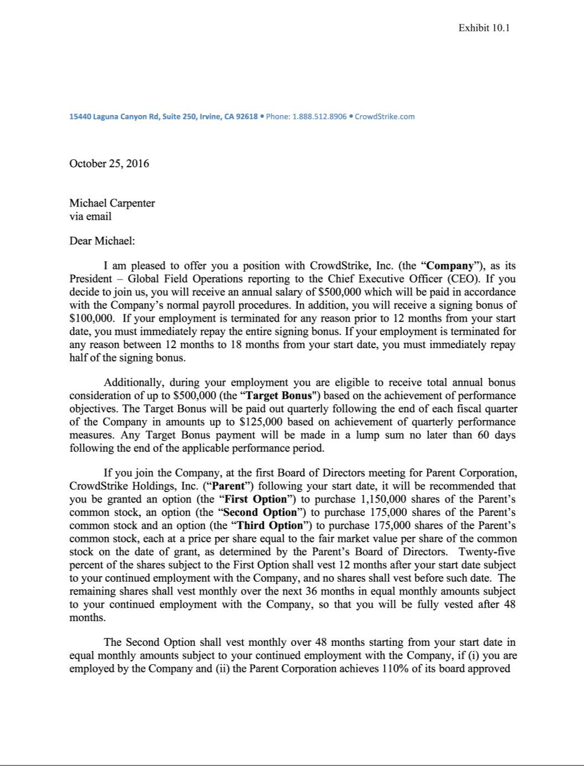

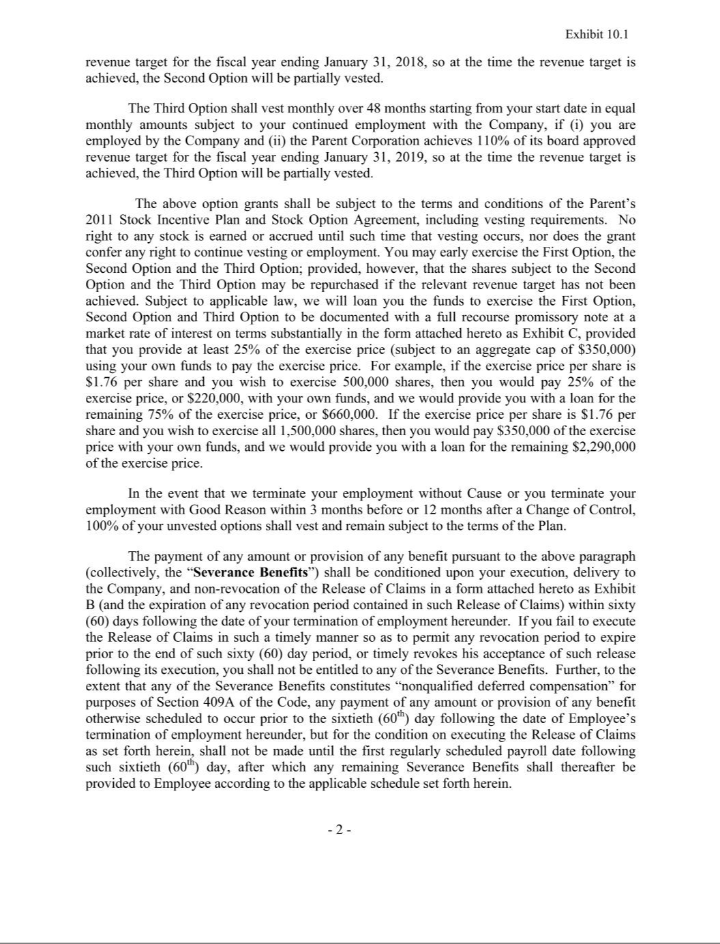

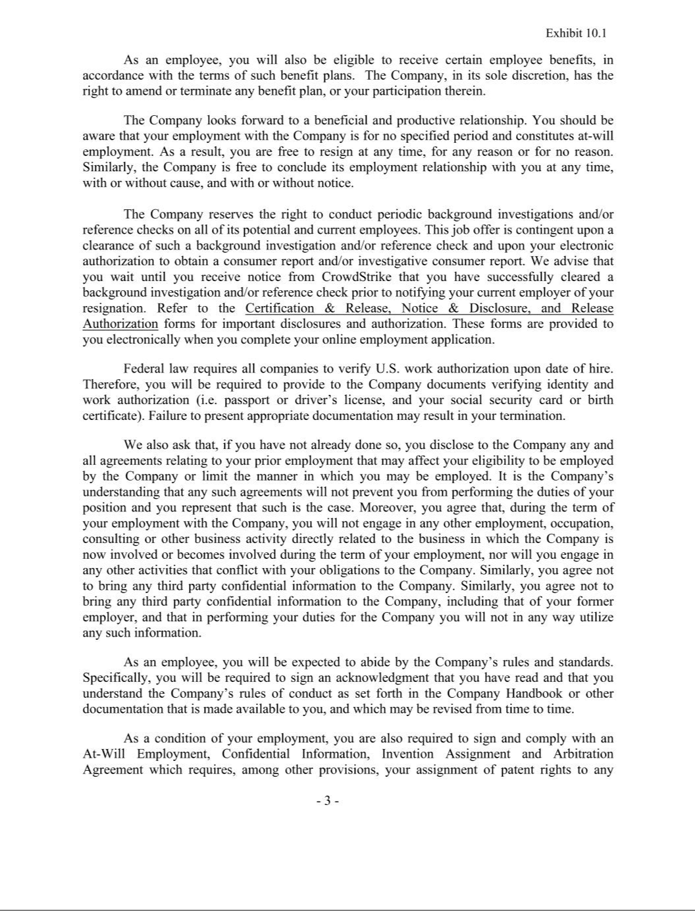

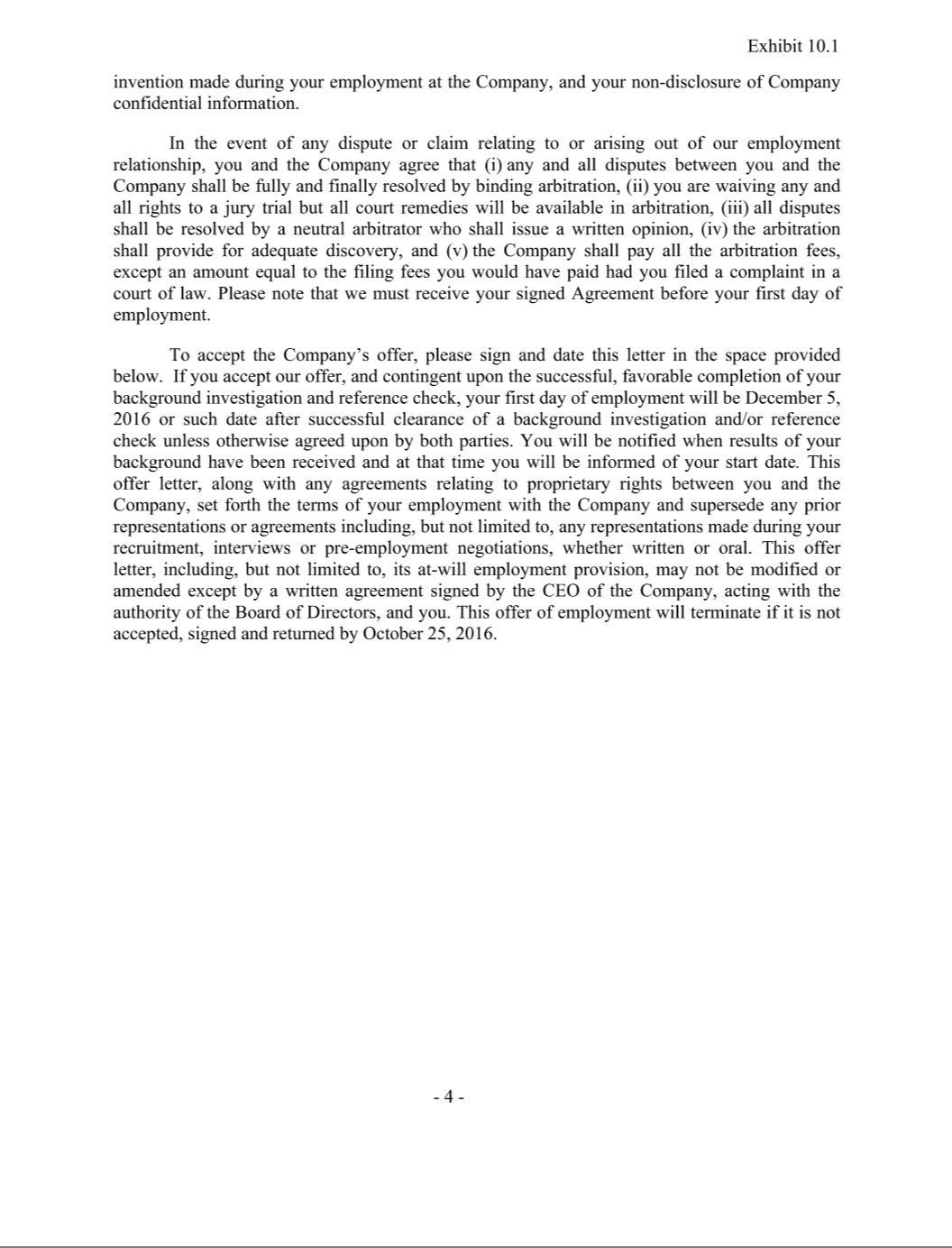

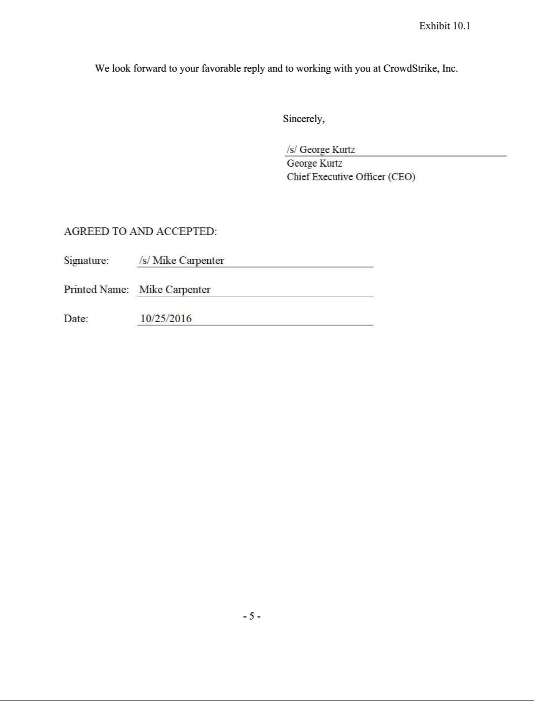

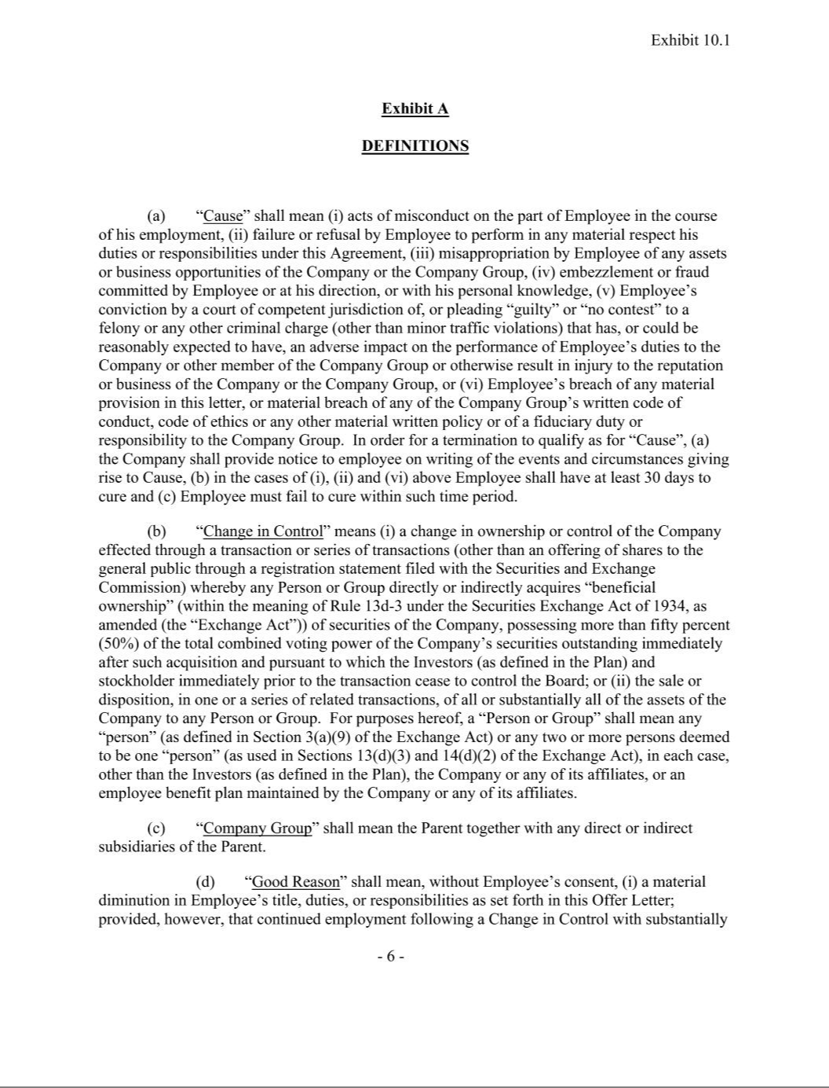

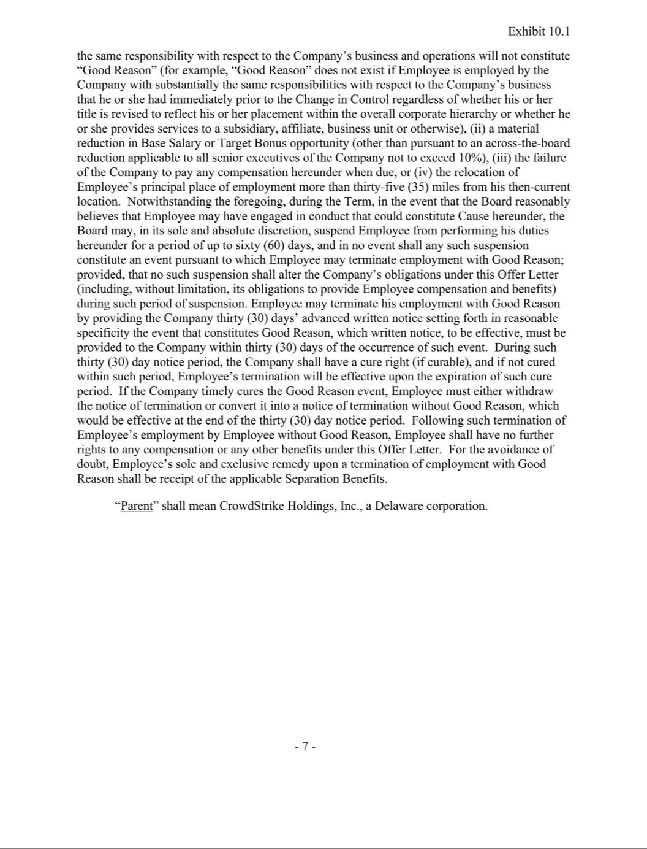

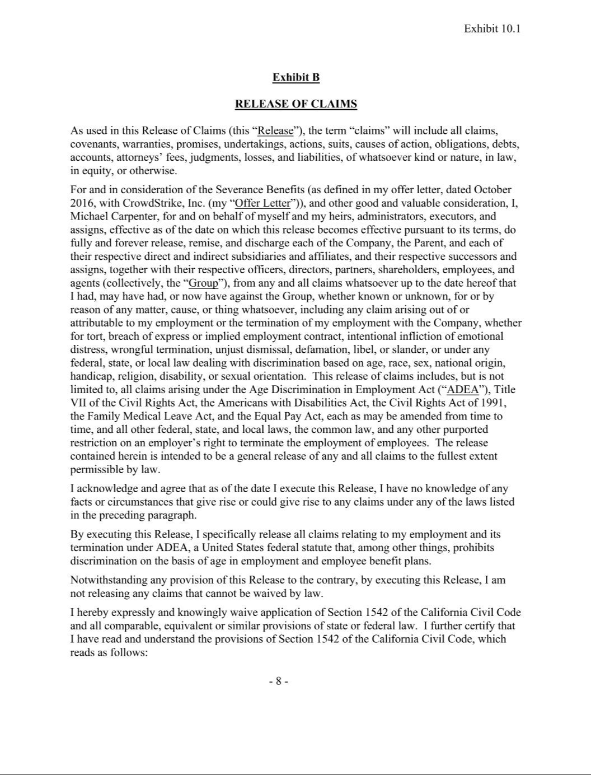

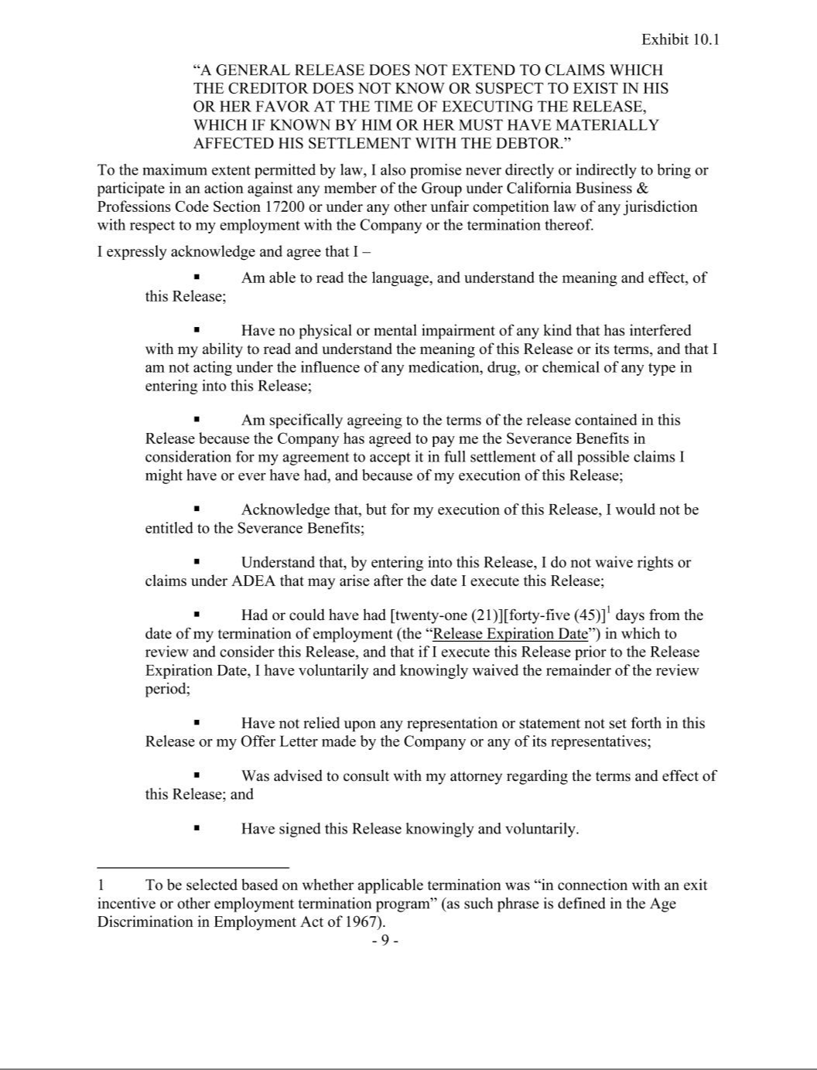

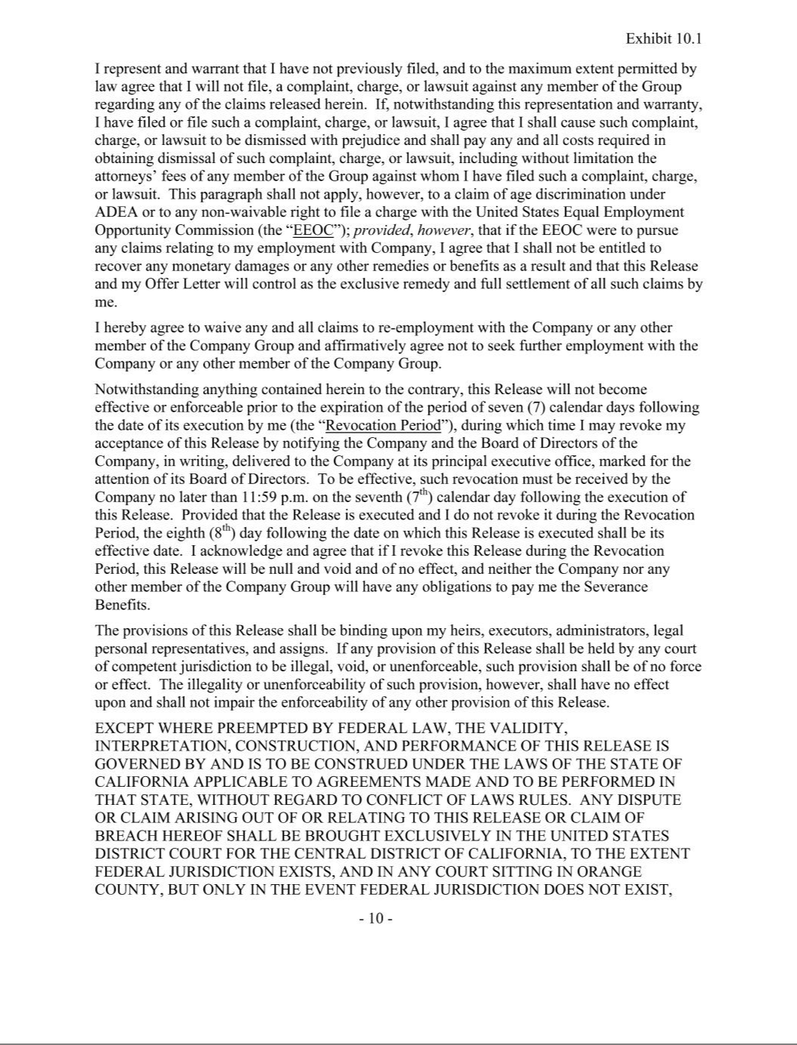



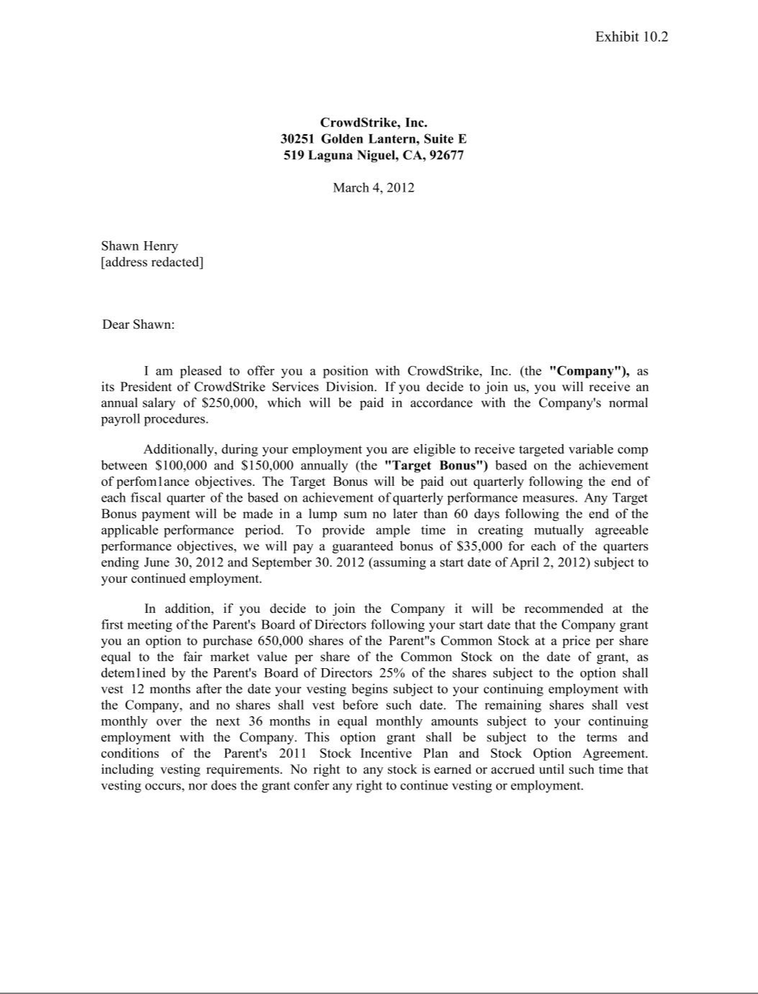

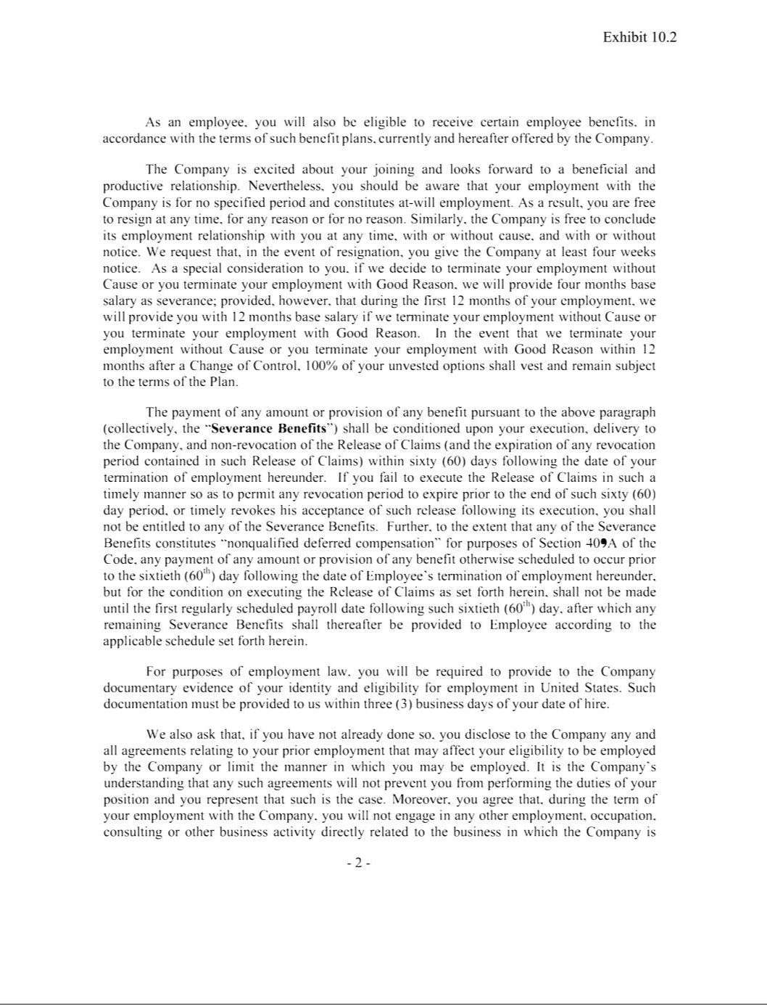

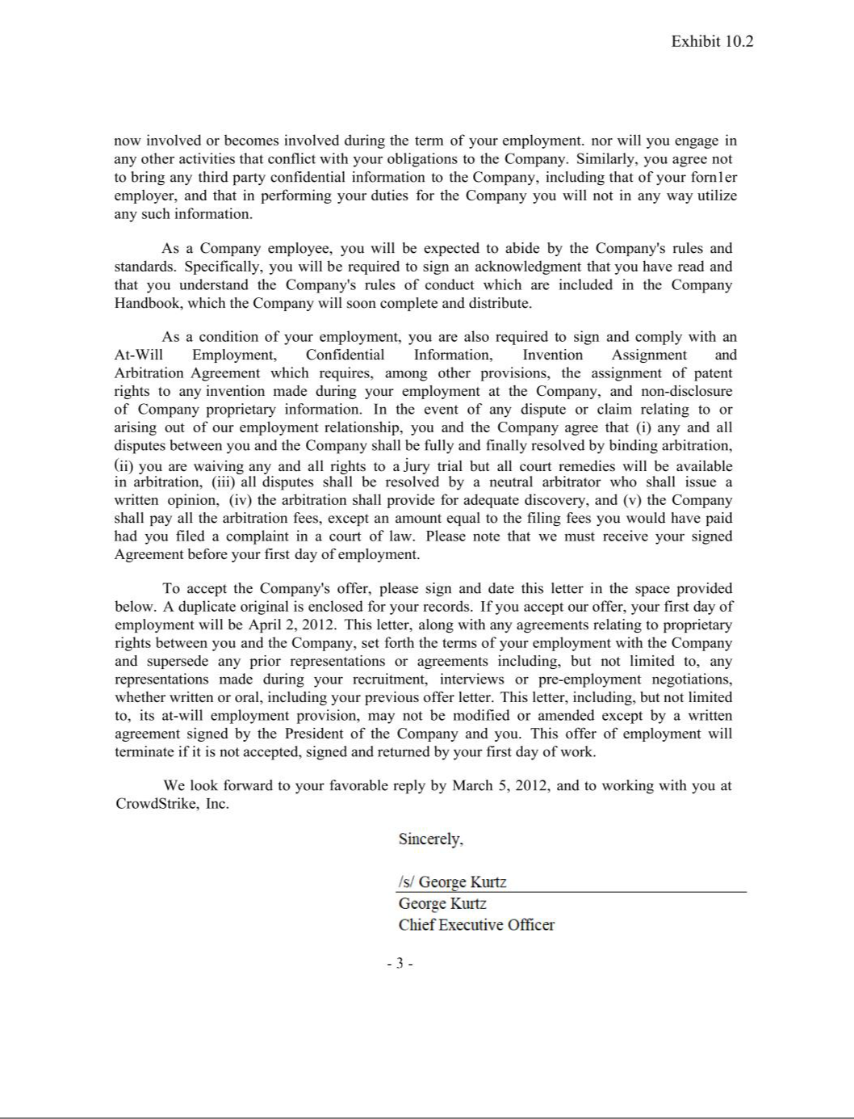

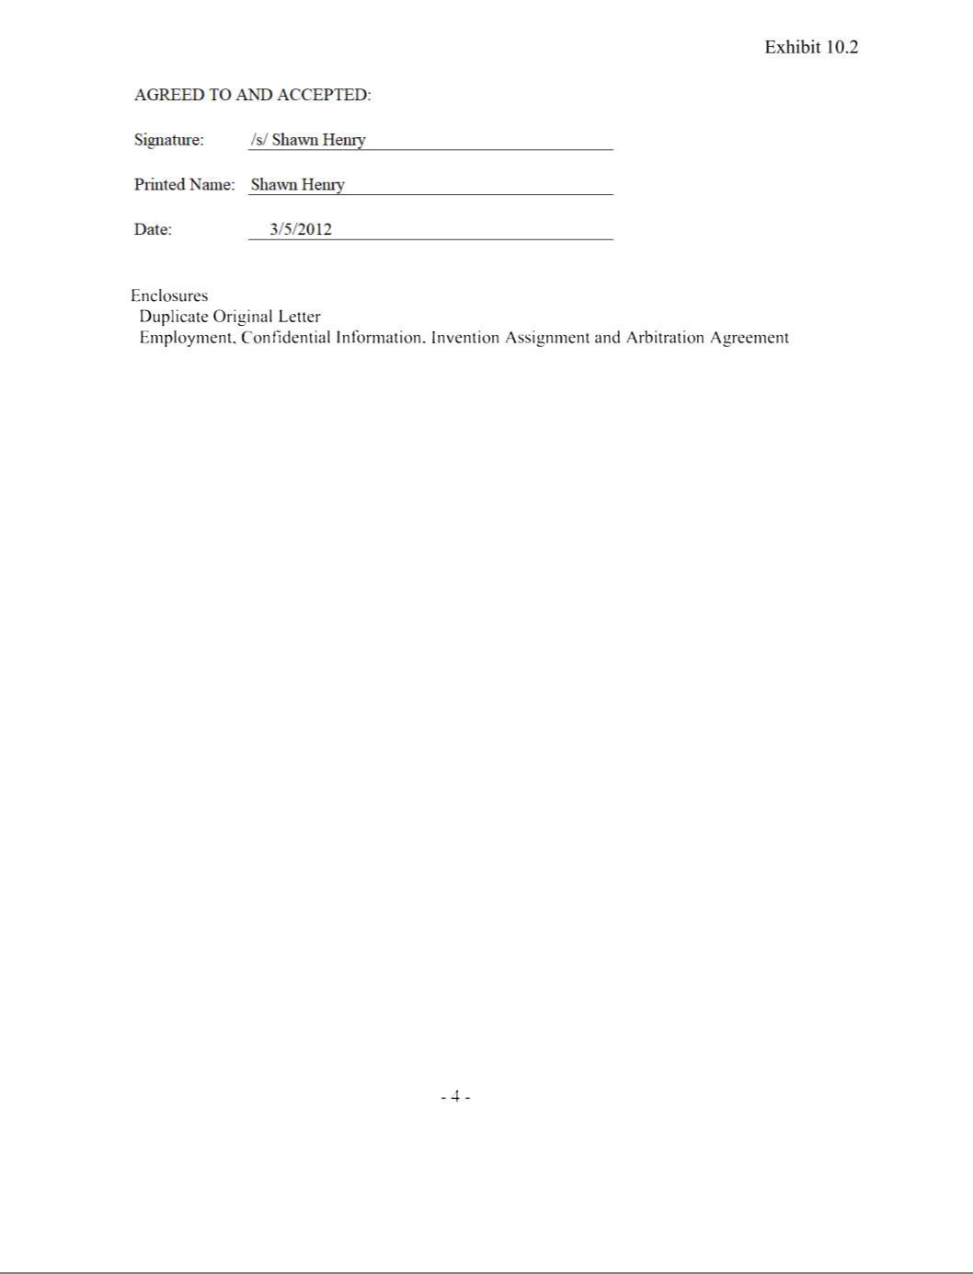

Exhibit 31.1

CERTIFICATION OF PRINCIPAL EXECUTIVE OFFICER PURSUANT TO EXCHANGE ACT RULES 13a-14(a) AND 15d-14(a), AS ADOPTED PURSUANT TO SECTION 302 OF THE SARBANES-OXLEY ACT OF 2002

I, George Kurtz, certify that:

- I have reviewed this Quarterly Report on Form 10-Q of CrowdStrike Holdings, Inc.;

- Based on my knowledge, this report does not contain any untrue statement of a material fact or omit to state a material fact necessary to make the statements made, in light of the circumstances under which such statements were made, not misleading with respect to the period covered by this report;

- Based on my knowledge, the financial statements, and other financial information included in this report, fairly present in all material respects the financial condition, results of operations and cash flows of the registrant as of, and for, the periods presented in this report;

- The registrant's other certifying officer(s) and I are responsible for establishing and maintaining disclosure controls and procedures (as defined in Exchange Act Rules 13a-15(e) and 15d-15(e)) and internal control over financial reporting (as defined in Exchange Act Rules 13a-15(f) and 15d-15(f)) for the registrant and have:

  - Designed such disclosure controls and procedures, or caused such disclosure controls and procedures to be designed under our supervision, to ensure that material information relating to the registrant, including its consolidated subsidiaries, is made known to us by others within those entities, particularly during the period in which this report is being prepared;

  - Designed such internal control over financial reporting, or caused such internal control over financial reporting to be designed under our supervision, to provide reasonable assurance regarding the reliability of financial reporting and the preparation of financial statements for external purposes in accordance with generally accepted accounting principles;

  - Evaluated the effectiveness of the registrant's disclosure controls and procedures and presented in this report our conclusions about the effectiveness of the disclosure controls and procedures, as of the end of the period covered by this report based on such evaluation; and

  - Disclosed in this report any change in the registrant's internal control over financial reporting that occurred during the registrant's most recent fiscal quarter (the registrant's fourth fiscal quarter in the case of an annual report) that has materially affected, or is reasonably likely to materially affect, the registrant's internal control over financial reporting; and

- The registrant's other certifying officer(s) and I have disclosed, based on our most recent evaluation of internal control over financial reporting, to the registrant's auditors and the audit committee of the registrant's board of directors (or persons performing the equivalent functions):

  - All significant deficiencies and material weaknesses in the design or operation of internal control over financial reporting which are reasonably likely to adversely affect the registrant's ability to record, process, summarize and report financial information; and

  - Any fraud, whether or not material, that involves management or other employees who have a significant role in the registrant's internal control over financial reporting.

Date: June 4, 2021

CROWDSTRIKE HOLDINGS, INC.

By: | /s/ George Kurtz
Name: | George Kurtz
Title: | President, Chief Executive Officer, and Director
 | (Principal Executive Officer)

Exhibit 31.2

CERTIFICATION OF PRINCIPAL FINANCIAL OFFICER PURSUANT TO EXCHANGE ACT RULES 13a-14(a) AND 15d-14(a), AS ADOPTED PURSUANT TO SECTION 302 OF THE SARBANES-OXLEY ACT OF 2002

I, Burt W. Podbere, certify that:

- I have reviewed this Quarterly Report on Form 10-Q of CrowdStrike Holdings, Inc.;

- Based on my knowledge, this report does not contain any untrue statement of a material fact or omit to state a material fact necessary to make the statements made, in light of the circumstances under which such statements were made, not misleading with respect to the period covered by this report;

- Based on my knowledge, the financial statements, and other financial information included in this report, fairly present in all material respects the financial condition, results of operations and cash flows of the registrant as of, and for, the periods presented in this report;

- The registrant's other certifying officer(s) and I are responsible for establishing and maintaining disclosure controls and procedures (as defined in Exchange Act Rules 13a-15(e) and 15d-15(e)) and internal control over financial reporting (as defined in Exchange Act Rules 13a-15(f) and 15d-15(f)) for the registrant and have:

  - Designed such disclosure controls and procedures, or caused such disclosure controls and procedures to be designed under our supervision, to ensure that material information relating to the registrant, including its consolidated subsidiaries, is made known to us by others within those entities, particularly during the period in which this report is being prepared;

  - Designed such internal control over financial reporting, or caused such internal control over financial reporting to be designed under our supervision, to provide reasonable assurance regarding the reliability of financial reporting and the preparation of financial statements for external purposes in accordance with generally accepted accounting principles;

  - Evaluated the effectiveness of the registrant's disclosure controls and procedures and presented in this report our conclusions about the effectiveness of the disclosure controls and procedures, as of the end of the period covered by this report based on such evaluation; and

  - Disclosed in this report any change in the registrant's internal control over financial reporting that occurred during the registrant's most recent fiscal quarter (the registrant's fourth fiscal quarter in the case of an annual report) that has materially affected, or is reasonably likely to materially affect, the registrant's internal control over financial reporting; and

- The registrant's other certifying officer(s) and I have disclosed, based on our most recent evaluation of internal control over financial reporting, to the registrant's auditors and the audit committee of the registrant's board of directors (or persons performing the equivalent functions):

  - All significant deficiencies and material weaknesses in the design or operation of internal control over financial reporting which are reasonably likely to adversely affect the registrant's ability to record, process, summarize and report financial information; and

  - Any fraud, whether or not material, that involves management or other employees who have a significant role in the registrant's internal control over financial reporting.

Date: June 4, 2021

CROWDSTRIKE HOLDINGS, INC.

By: | /s/ Burt W. Podbere
Name: | Burt W. Podbere
Title: | Chief Financial Officer (Principal Financial Officer)

Exhibit 32.1

CERTIFICATION OF PRINCIPAL EXECUTIVE OFFICER AND PRINCIPAL FINANCIAL OFFICER

PURSUANT TO 18 U.S.C. SECTION 1350,

AS ADOPTED PURSUANT TO SECTION 906 OF THE SARBANES-OXLEY ACT OF 2002

I, George Kurtz, the President and Chief Executive Officer of CrowdStrike Holdings, Inc., certify, pursuant to 18 U.S.C. Section 1350, as adopted pursuant to Section 906 of the Sarbanes-Oxley Act of 2002, that the Quarterly Report on Form 10-Q of CrowdStrike Holdings, Inc. for the fiscal quarter ended April 30, 2021 fully complies with the requirements of Section 13(a) or 15(d) of the Securities Exchange Act of 1934 and that information contained in such Quarterly Report on Form 10-Q fairly presents, in all material respects, the financial condition and results of operations of CrowdStrike Holdings, Inc.

Date: June 4, 2021

By: | /s/ George Kurtz
Name: | George Kurtz
Title: | President, Chief Executive Officer, and Director
 | (Principal Executive Officer)

I, Burt W. Podbere, the Chief Financial Officer of CrowdStrike Holdings, Inc., certify, pursuant to 18 U.S.C. Section 1350, as adopted pursuant to Section 906 of the Sarbanes-Oxley Act of 2002, that the Quarterly Report on Form 10-Q of CrowdStrike Holdings, Inc. for the fiscal quarter ended April 30, 2021 fully complies with the requirements of Section 13(a) or 15(d) of the Securities Exchange Act of 1934 and that information contained in such Quarterly Report on Form 10-Q fairly presents, in all material respects, the financial condition and results of operations of CrowdStrike Holdings, Inc.

Date: June 4, 2021

By: | /s/ Burt W. Podbere
Name: | Burt W. Podbere
Title: | Chief Financial Officer
Title: | (Principal Financial Officer)

